Task Team CARIBE WAVE 26
UNESCO/IOC
ICG CARIBE-EWS

CARIBE WAVE 2026

Supplement Report

Kimberly Maisonet González
Christa von Hillebrandt-Andrade
International Tsunami Information Center Caribbean Office
Gisela Báez-Sánchez
Chair –Task Team CARIBE WAVE 26
April 2026

Summary of CARIBE WAVE

The CARIBE WAVE exercise is conducted within the framework of the UNESCO Intergovernmental Coordination Group for Tsunamis and other Coastal Hazards for the Caribbean and Adjacent Regions (CARIBE-EWS). The 2026 annual tsunami exercise took place on March 19th to test Tsunami Warning Systems and promote tsunami preparedness in the Caribbean and adjacent regions. The exercise was coordinated by the CARIBE WAVE Task Team, the NOAA International Tsunami Information Center Caribbean Office (ITIC-CAR), and supported by the Caribbean Tsunami Information Center (CTIC), Pacific Tsunami Warning Center (PTWC), and the Central America Tsunami Advisory Center (CATAC). It was left up for Member States and Territories to choose between the Cayman Islands and Kick ‘em Jenny scenarios and to decide the level of participation and activity to be held in their country.
CARIBE WAVE exercises focus on communications and evaluating procedures and programs within Member States and Territories. The Pacific Tsunami Warning Center (PTWC), the Regional Tsunami Service Provider, issued a “Dummy” message through the different warning systems at 1500 UTC to test communications with Tsunami Warning Focal Points (TWFP) and National Tsunami Warning Centers (NTWC). The PTWC used different methods of communication to test and disseminate the message: The World Meteorological Organization (WMO), Advanced Weather Interactive Processing System (AWIPS), Aeronautical Information Replacement System (AIRS), NOAA Weather Wire, GEONETCast Americas, and Email. According to feedback, the dummy message was successfully received. CATAC also disseminated simulated products for the Cayman Islands Scenario via email, WhatsApp, Telegram, SMS, and their website. All its stakeholders received the message through one method or other, but there were reported issues particularly with email.

Over 600,000 people from across the entire Caribbean basin had participated, according to member states and territories. The majority of the participants from across the region were from K-12 Schools and Districts, local government, as well as preparedness organizations. Social media platforms, which have become the primary source for communicating tsunami awareness, reached many people worldwide during the exercise.

Sea level data availability is important to forecast and confirm a real tsunami event. If a tsunami had occurred during the day of the exercise, data of 86 of the 182 sea-level stations in the region would have been available for event analysis. The only Deep Ocean Assessment and Reporting on Tsunamis (DARTs) in the Atlantic and Caribbean that was included in the simulated PTWC products was operational during the exercise. CARIBE WAVE has been improving and validating tsunami preparedness since 2011, which is why tsunami exercises are crucial to maintain readiness in case of a real tsunami event.

Supplement Survey Results

Caribe Wave 2026 Survey Report from TWFP/TNC

CARIBE WAVE 26 exercise was conducted at various levels and sophistications. The survey was available through the Survey Monkey services from the start of the exercise on March 19 and extended through April 13. The following Member States and Territories participated in the post-exercise evaluation:

- Antigua and Barbuda
- Aruba
- Bahamas
- Barbados
- Belize
- Colombia
- Costa Rica
- Curaçao
- Dominica
- Dominican Republic
- France (Guadeloupe, Martinique, Saint Martin, Saint Barthélemy)
- Grenada
- Guatemala
- Guyana
- Haiti
- Honduras
- Jamaica
- Mexico
- Netherlands (Bonaire, Saba, Sint Eustatius)
- Nicaragua
- Panama
- Saint Kitts and Nevis
- Saint Lucia
- Saint Vincent and the Grenadines
- Trinidad and Tobago
- UK Anguilla
- UK Bermuda
- UK British Virgin Islands
- UK Cayman Islands
- US Puerto Rico
- US Virgin Islands
- Venezuela

Contact Information – Agency

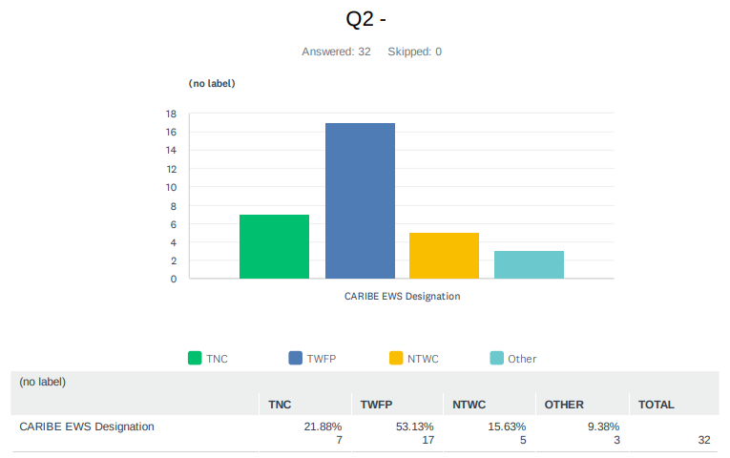
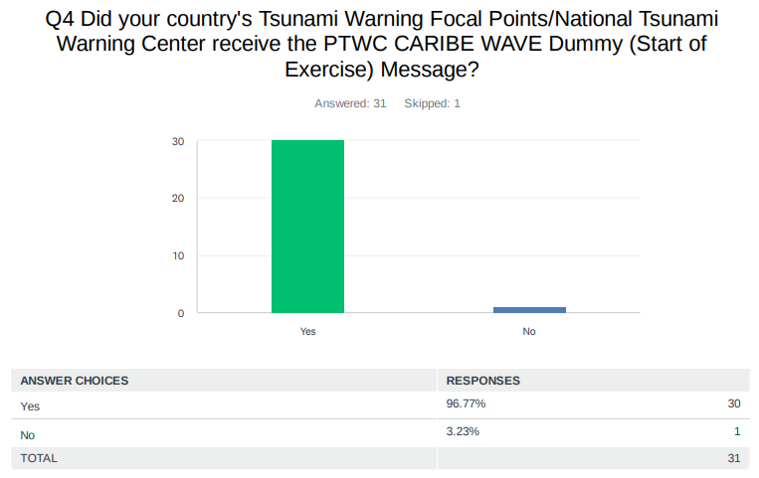
Comments:

Anguilla: They were not at the station | Backup persons would have received the messages but only after we brought it to their attention.

Guyana: It was received on time (1500 UTC).

Jamaica: The TNC and the NTWC received the messages.

Panama: Time: 15:00 UTC

US Puerto Rico: 11:00 am

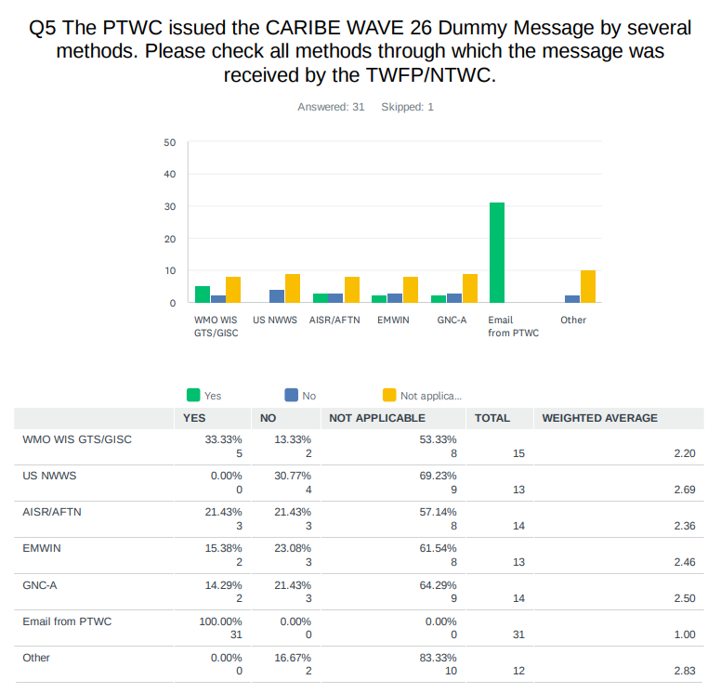

Comments:

Panama: All the messages in the right order.

UK Anguilla: We monitor CAP messages but were not used in the exercise.

UK British Virgin Islands: Phone PRSN.

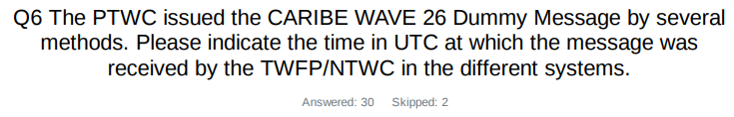
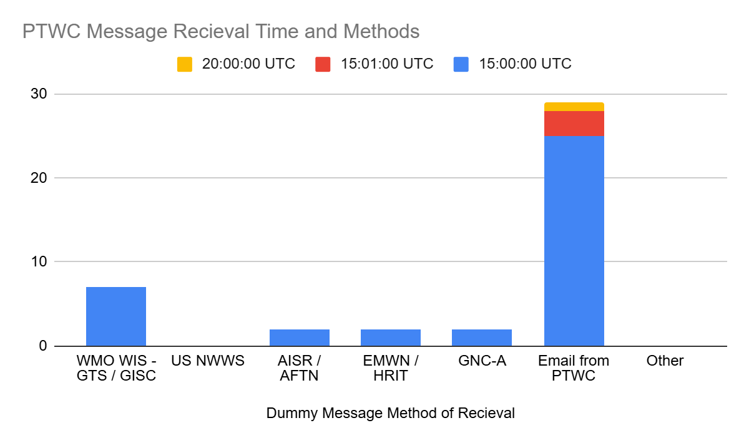
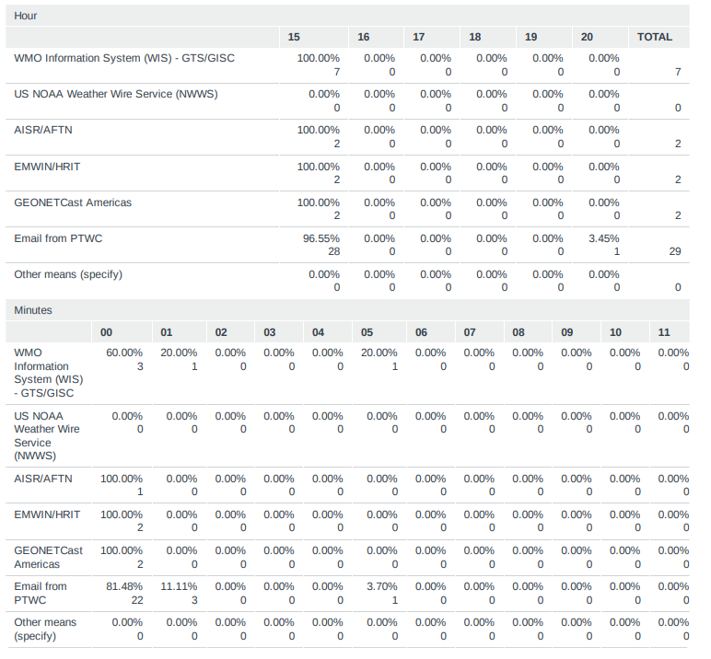
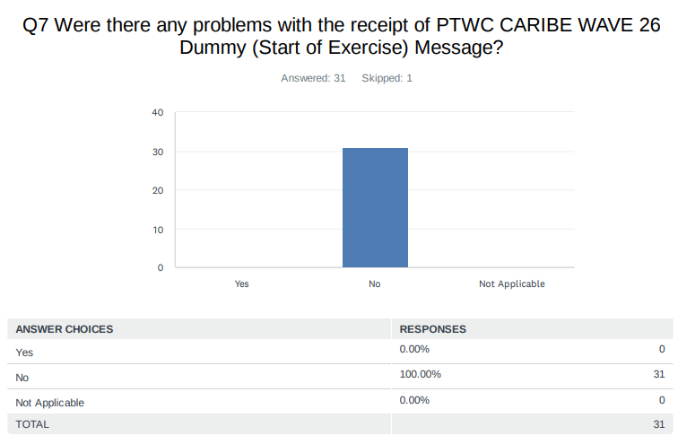

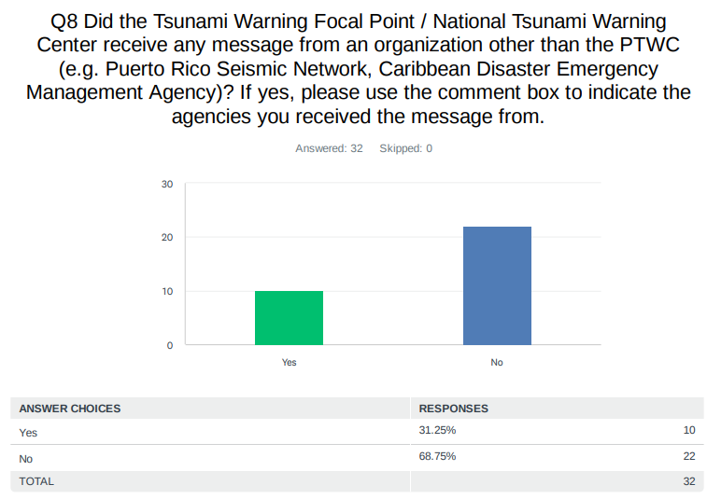
Comments:

Belize: CATAC

Costa Rica: CATAC

Guatemala: Central American Tsunami Advisory Center, CATAC.

Honduras: CATAC

Nicaragua: CATAC

Panama: CATAC

UK British Virgin Islands: PRSN

US Puerto Rico: PRSN

US Virgin Islands: Puerto Rico Seismic Network (PRSN)

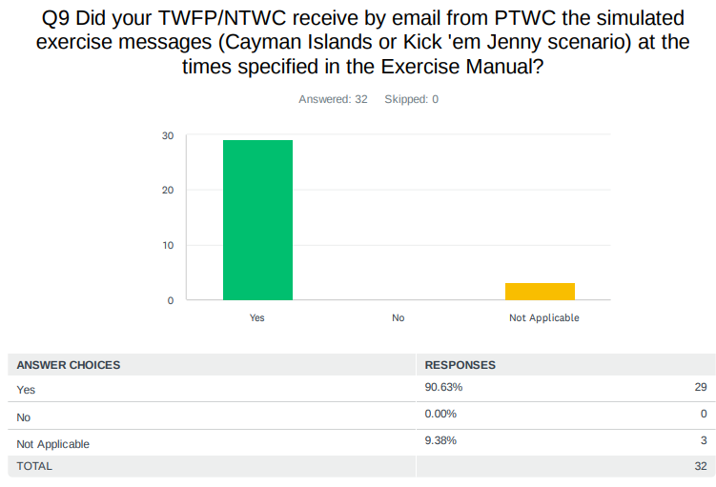
Comments:

UK Anguilla: They team at the 911 center weren't present.

UK - Cayman Islands: Initial Dummy Start of Exercise message received twice at
1500 UTC and 1501 UTC.

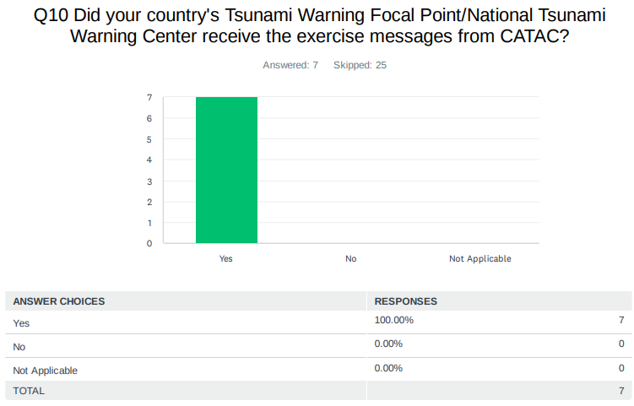

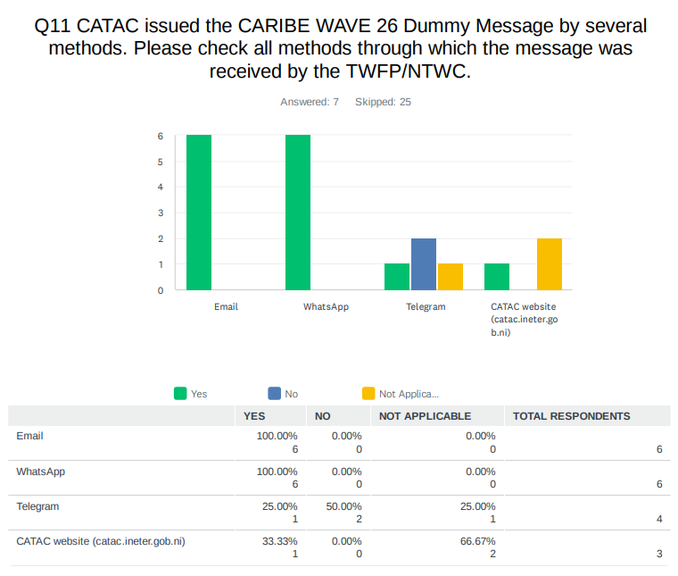
Comments:
Costa Rica: We only received one email corresponding to message #5 at 17:49
Nicaragua: SMS
Panama: All the messages (Dummy - Message 5) were receive complete by WhatsApp. Incomplete by Email.

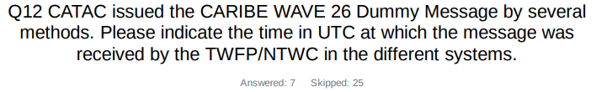
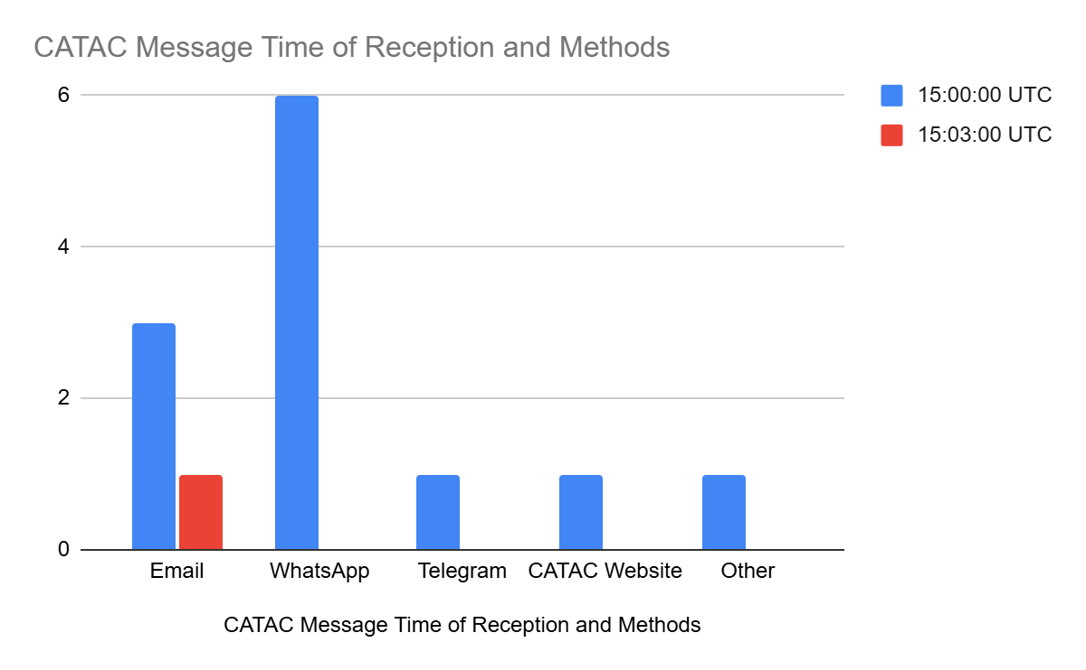
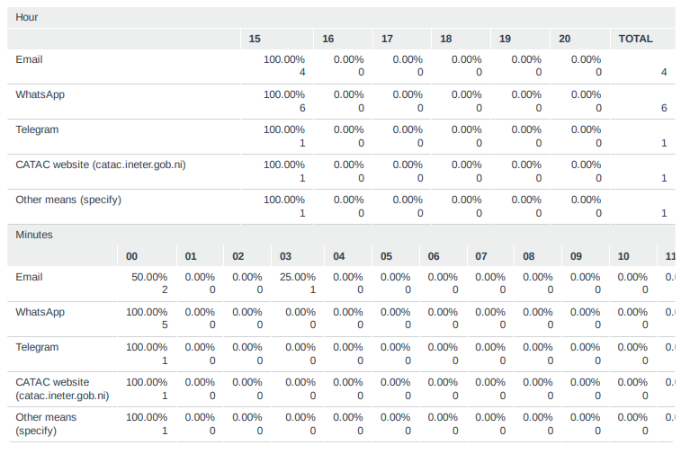

Comments:
Costa Rica: We only received the dummy message by WhatsApp.
Nicaragua: SMS
Panama: We marked 15 Hour 00 Minutes Email by mistake.

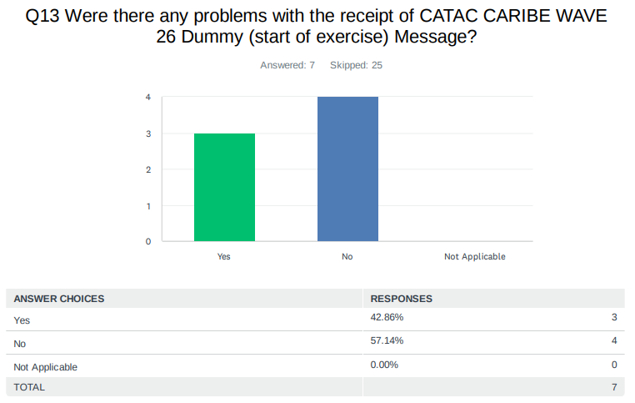
Comments:
Costa Rica: we did not receive it by email.
Honduras: I didn't get many emails, and I didn't get any messages on Telegram.
Panama: I really didn´t receive the Dummy (by Email) by CATAC.

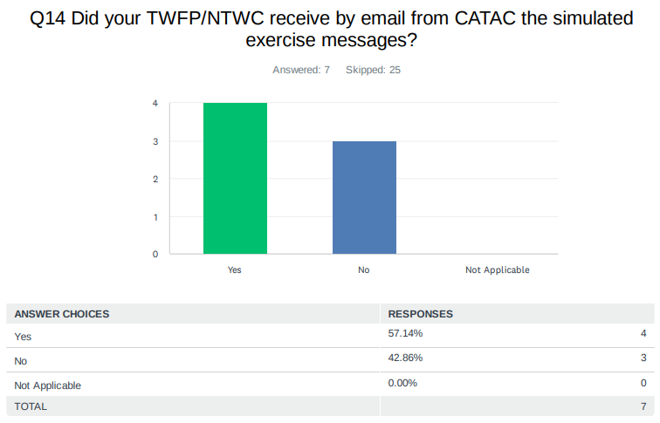
Comments:
Costa Rica: only by WhatsApp. By email only message #5.
Honduras: Just a message.
Mexico: We Only Received The Dummy Message.
Panama: We receive the simulated exercise messages but incomplete.

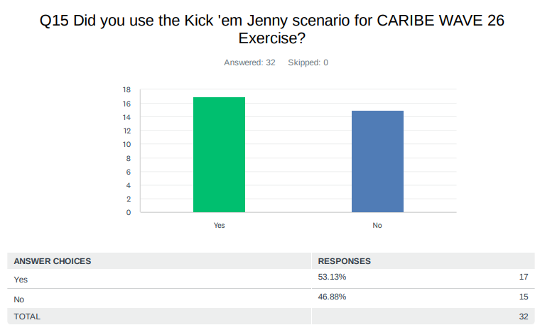

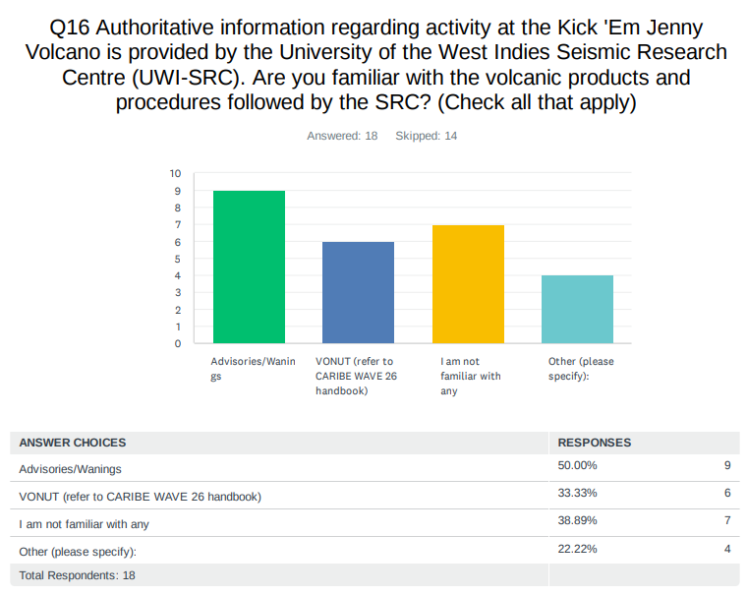

Comments:

France: EMIZA and NTWC from Guadeloupe and Martinique are familiar, while St Martin/St Barth NTWC not.

NL-Bonaire, Saba, Sint Eustatius: VONAs are received operationally for aviation monitoring.

UK British Virgin Islands: The color codes used.

US Puerto Rico: At PRSN

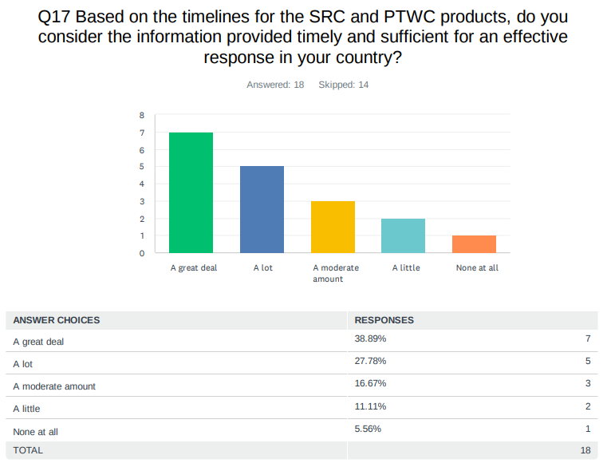
Comments:

NL-Bonaire, Saba, Sint Eustatius: Upon receipt of the third message sequence number, wave arrival was already imminent for our areas, leaving little time for preparation. Improved forecasting or rough estimations of arrival times would enable more timely responses.

UK British Virgin Islands: It gave us a few hours lead.
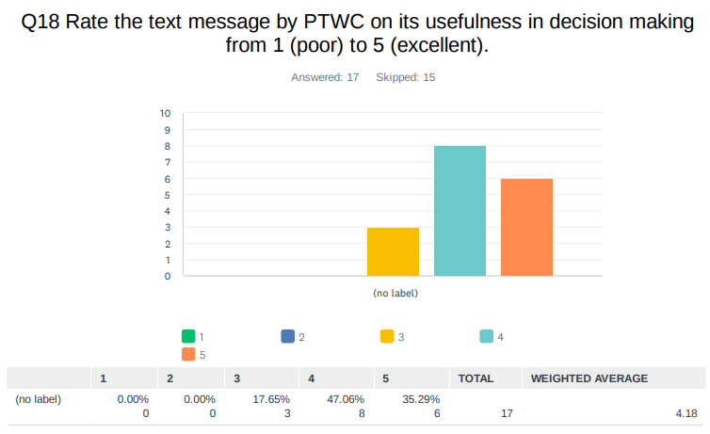

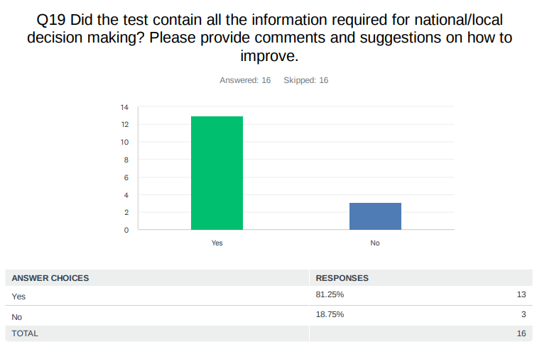
Comments:

France: For Martinique, our closest territory, it was OK, but for Guadeloupe, it is the contrary: Some confusion arose because this territory was not present in the initial list of potentially impacted territories, but was impacted later.

Guyana: Unfortunately , Guyana was not mentioned in any of the messages.

NL-Bonaire, Saba, Sint Eustatius: Yes. The stakeholders could be warned of incoming waves well on time. However, in this scenario, accurate arrival times could not be forecast. Providing a rough range of estimated arrival times based on typical or modelled tsunami wave speeds could still have helped stakeholders anticipate when waves might occur.

Saint Lucia: Give timelines for impact where possible.

UK Anguilla: Anguilla was not listed at first, which prompted us to do some calculations using the TTTC. That also was an interesting experience. The team is new, and we need some more training on those tools.

US Puerto Rico: There was an error in PTWC products (Spanish version). An Earthquake of 6.2 was mentioned not a volcano.

Venezuela: In this case, Venezuela used the PTWC's initial message, and the SSATV generated the subsequent messages, due to differences in the timing of the messages issued by the PTWC and the calculations produced by the numerical model run in Venezuela.
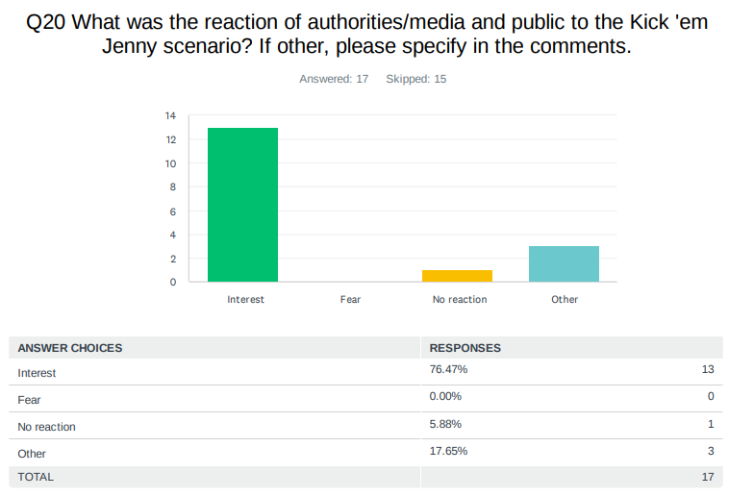
Comments:

Colombia (translated from Spanish): A tabletop exercise was performed, therefore a broader scope was not achieved.

UK Anguilla: We did not message the source type of the threat in our initial message but the updates to key agencies had the additional information.

UK British Virgin Islands: Provided the public and opportunity to test evacuation plans not not necessarily playing the exercise.

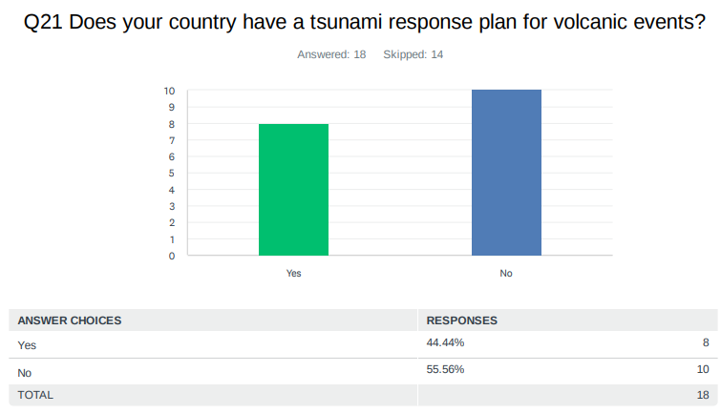
Comments:

France: It is yes for volcanic territories of Martinique and Guadeloupe, but it is under construction for St Martin/St Barth.

NL-Bonaire, Saba, Sint Eustatius: Responsibility for responding to such events lies with local governments on the islands. Our warning procedures for volcanic-induced tsunamis are the same to those applied to earthquake-induced tsunamis.

Saint Lucia: We have a volcanic eruption response plan as well as specific communities preparing TRR certification.

UK British Virgin Islands: We have not dealt with volcanic evacuation of national but not tsunami related in line of volcanic eruption.

US Virgin Islands: Initial experience for the USVI based on eruptive activity of La Soufriere Volcano on St. Vincent and messages by Chip McCreery on 24 April 2021. None of the USVI 44-warning sirens had been repaired at that time. Sirens became operational in August 2022.

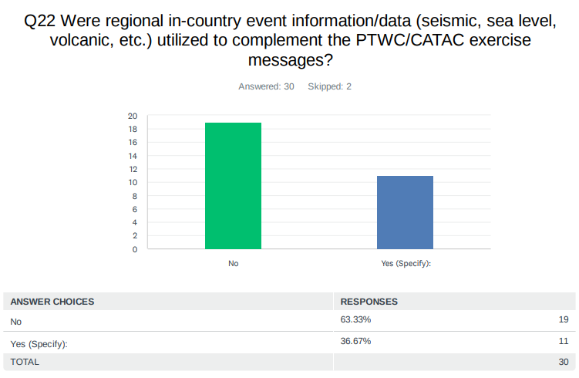
Comments:

Colombia (translated from Spanish): Sea level stations. Naval Island, Cartagena, Santa Marta and San Andres.

Curaçao: Threshold Check: Determine alert level.

France: The Volcanological and Seismological Observatories of Guadeloupe (OVSG) and Martinique (OVSM). and the BRGM.

Guyana: Guyana utilized information from other country data to access the dangers of this event.

Honduras: Simulation of wave arrival using TSUCAT.

Mexico: We employed synthetic data derived from our tide gauge network.

UK Anguilla: We pulled up the sea level stations and part of the monitoring and showed it to the team in the office but did not monitor throughout the exercise. Basically it was just mentioned.

UK British Virgin Islands: We tested evacuation based on timing.

US Puerto Rico: At PRSN.

US Virgin Islands: Activation of US Virgin Islands EOCs were based on the information / data provided in the exercise messages.

Venezuela: From Funvisis. Different numerical modeling programs were run to obtain additional information on arrival times and expected wave height.
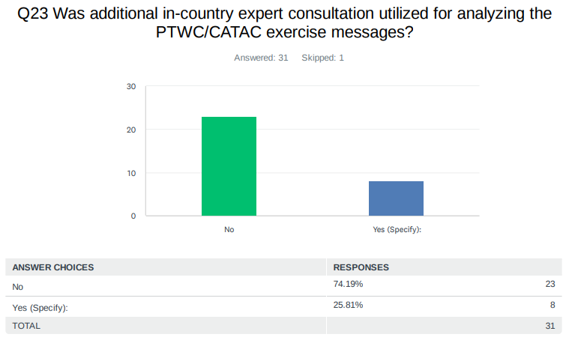
Comments:

Aruba: Met Office and Crisis Management Office

NL-Bonaire, Saba, Sint Eustatius: The Kick'em Jenny exercise eruption was analyzed by the KNMI volcanologist and additional information could be provided to the stakeholders about this event.

Panama: We did inside the Geosciences Institute.

Trinidad and Tobago: UWI SRC and local Hydrographic Unit were consulted.

Saint Kitts and Nevis: Fire Chief.

Saint Lucia: Met Services, NEMO.

UK British Virgin Islands: We tested evacuation based on timing.

Venezuela: Various experts in the field of earthquake geology and seismology were consulted, given that there is not much experience with submarine volcanoes and we felt the need to continue preparing our coastal communities with the international Caribe Wave exercises.

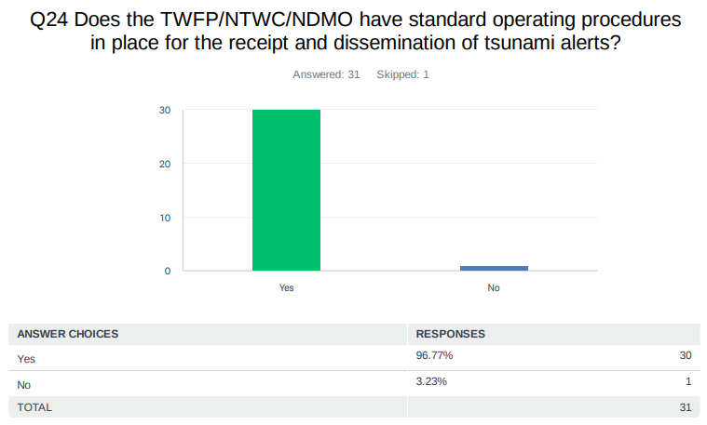
Comments:

Bahamas: All disaster response and dissemination of information is outlined in the Disaster Act but not in detail as it pertains to tsunami.

Belize: National and departmental SOPs are currently being finalized.

Colombia (translated from Spanish): National Tsunami Detection and Warning Protocol.

Jamaica: Jamaica has a National Tsunami Plan and SOPs.

NL-Bonaire, Saba, Sint Eustatius: 24/7 operation.

UK Anguilla: But we realized the new staff are not familiar with these SOP, that has been addressed.

US Virgin Islands: Information is received at US Virgin Islands 9-1-1 ECC and elevated to the senior official of the agency (Director). A WhatsApp group exists for quick distribution of information.

Venezuela: Our risk management authorities have a protocol in place for earthquakes and tsunamis, and there is an operational order for these situations.

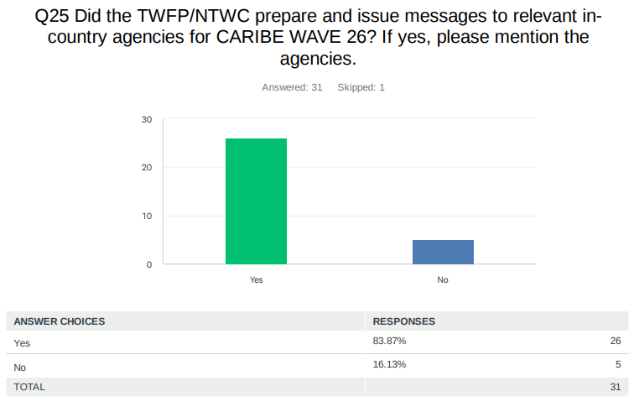
Comments:

Aruba: Met Office and Crisis Management Office.

Barbados: The department of emergency management and the volunteer arm, Barbados Coast Guard, Barbados Fire Service, Barbados Police Service, along with their marine arm, just to name a few.

Belize: NEMO

Colombia (translated from Spanish): The Colombian National Tsunami Warning Center issued the bulletins and sent them to the National Unit for Disaster Risk Management and the Colombian Geological Service.

Costa Rica: CNE

Dominican Republic: To the COE.

France: Municipalities, emergency services including sea rescue service, network operators, state services.

Grenada: The TWFP issued bulletins to the National Disaster Management Agency (NaDMA).

Haiti: Direction Générale de Protection Civile (DGPC), Bureau des Mines et de l'Energie (BME), Croix Rouge Haitienne (CRH).

Honduras: COPECO's territorial structure and emergency committees in coastal areas.

Jamaica: Messages were disseminated to the National Tsunami Response Team by email and telephone.

NL-Bonaire, Saba, Sint Eustatius: 1) Local BES governments (Saba, St. Eustatius, Bonaire) 2) Rijksvertegenwoordiger 3) DCC IenW 4) Meldkamer BES

Panama: Agency: Sistema Nacional de Protección Civil (SINAPROC)

Trinidad and Tobago: Emergency response agencies and maritime stakeholders.

UK British Virgin Islands: NEOC/NDMP- all key agencies public.

UK Cayman Islands: All residents/visitors of the Cayman Islands who have the National Emergency Notification System (NENS) App downloaded. (approx. 10,000+) persons.

US Puerto Rico: PREMB to EOC members, PREMB zones and municipalities. PRSN to PREMB - TWFP, NWS- SJ, PREMB zones and municipalities, TsunamiReady Communities and Supporters, DDM, VITEMA, BVI police and 911 (PR and US VI).

US Virgin Islands: Exercise messages sent via Email to Governor and Cabinet Officials. Additionally, the monthly Emergency Management Council meeting was be held at that same time with participants from most of the local agencies.

Venezuela: The Venezuelan Seismological and Tsunami Warning Service of Funvisis issued various dissemination messages to the authorities of the National Directorate of Civil Protection and Disaster Management, who in turn issued messages to the different coastal states and municipalities.
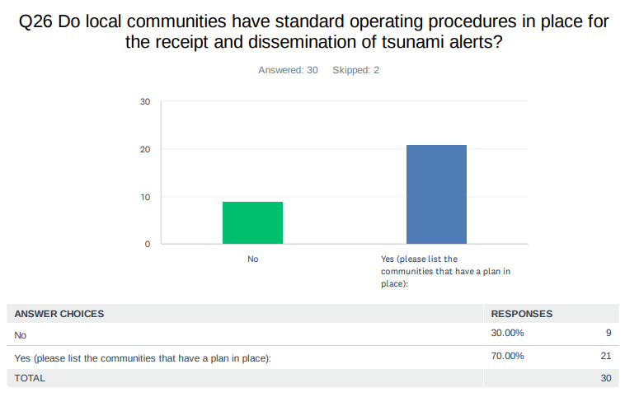
Comments:

Aruba: Schools Hotels and Public Entity

Costa Rica: Cahuita

Dominican Republic (translated from Spanish): In communities across the country, we have prevention, mitigation, and response committees that cover all types of alerts issued regarding both weather and tsunamis.

France: very few local communities have plan.

Grenada: The parish of St. Patric and sister islands Carriacou and Petite Martinique.

Haiti: Cap-haitien, Fort-Liberte, Jeremie.

Honduras: OMOA, TORNABE.

Jamaica: Alligator Pond, Treasure Beach, Port Maria and Old Harbour Bay.

Mexico: MANZANILLO, ZIHUATANEJO, PUERTO VALLARTA, ACAPULCO, HUATULCO, LAZARO CARDENAS.

Nicaragua: All coastal communities, organized within SINAPRED.

NL-Bonaire, Saba, Sint Eustatius: Local governments are responsible for this. The local governments decide the response to warnings given to them.

Saint Kitts and Nevis: Some communities have.

Saint Lucia: The use of cell broadcast SMS and flash notification whats app notification ringing of church bells sirens and loud speaker announcements.

Saint Vincent and the Grenadines: there is an existing SOP for communities between Argyle to Kingstown namely ( Kingstown, Arnos vale, Villa, Indian Bay, Calliaqua, Ratho Mill, Brighton, Diamond & Stubbs). Tsunami SOPs were also completed for coastal communities on Union Island

UK Anguilla: Anguilla (Coastal communities)

UK British Virgin Islands: All information come from central government

UK Cayman Islands: Education Sector

US Puerto Rico: TsunamiReady communities (municipalities)

US Virgin Islands: Local Agencies have plans (Legislature, Port Authority, Emergency Management, Tourism, Police) as well as public schools (VI Department of Education).

Venezuela: In this 2026 exercise, the incorporation of all coastal and non-coastal communities began; it can be said that we started with operational procedures.

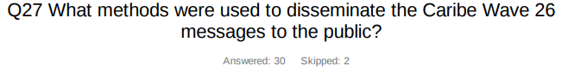
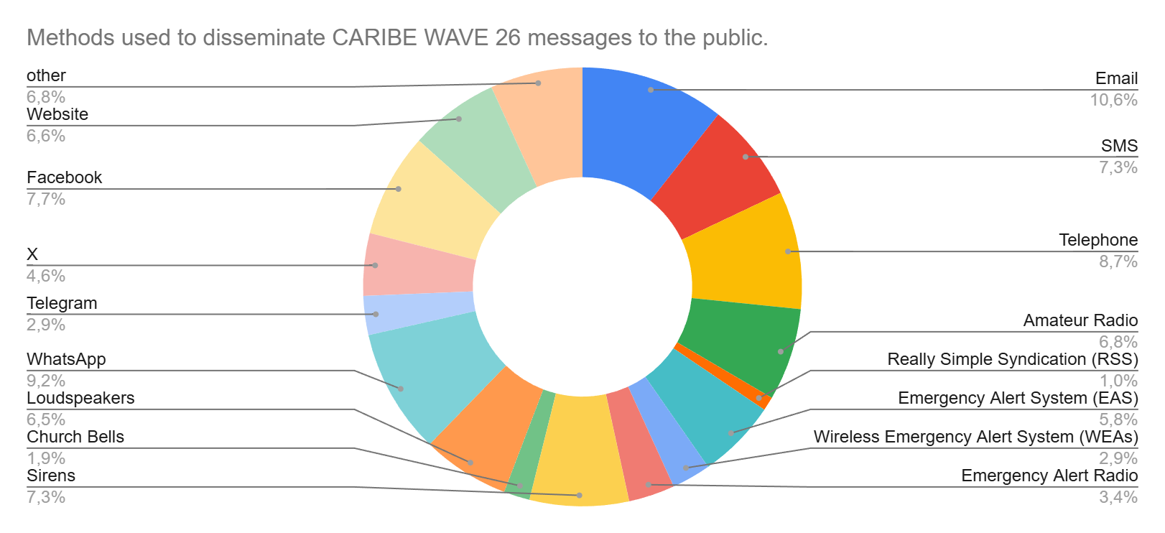
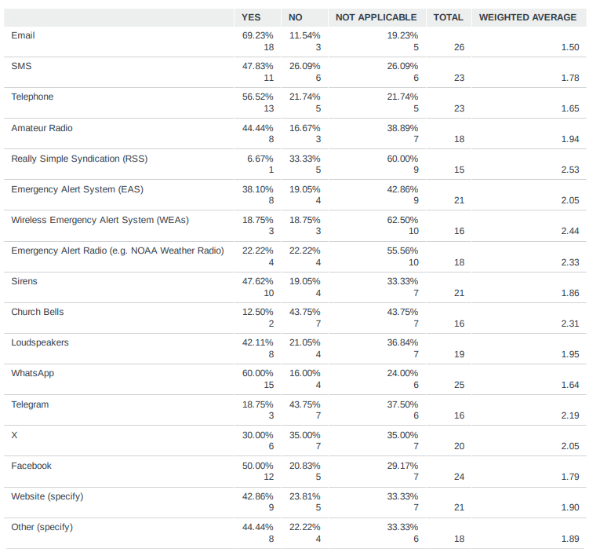
Comments:

Aruba: Know Now App

Barbados: department of emergency Instagram, radio interrupts

Costa Rica: UNA Costa Segura App

Dominican Republic (translated from Spanish): Radio frequency communication is used with the emergency operations center.

France: EAS : our cell-broadcast system : FR-Alert

Guyana: Common Alert Protocol (CAP)

Jamaica: www.odpem.org.jm and odpem social media pages

Mexico: in the Web Page https://diredimoat.semar.gob.mx/cat/centroAlertasTsunamis.html

Panama: Instagram

Saint Lucia: Radio and television broadcast interruption

US Puerto Rico: Instagram

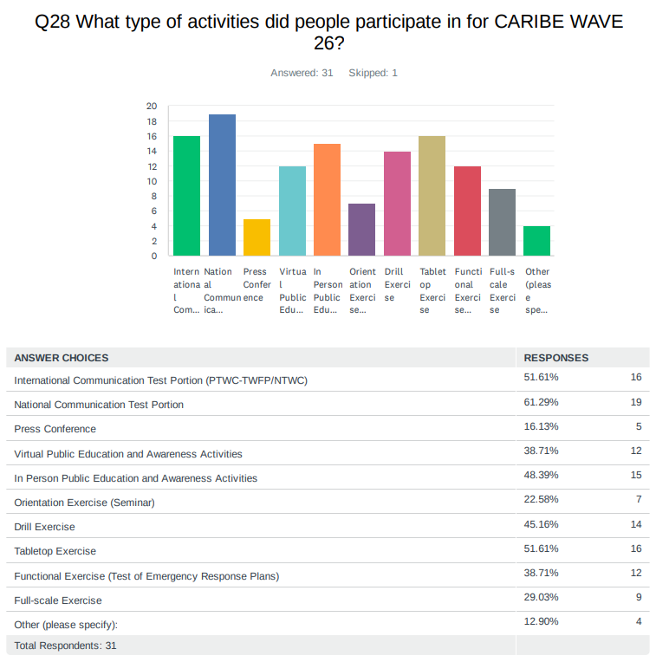
Comments:

Bahamas: The Bahamas did not participate in this year’s Caribe Wave exercise due to key operational components not being fully in place to support effective engagement. Efforts are currently underway to address these gaps, with a view to participating in future exercises.

US Puerto Rico: State Communication Test Portion

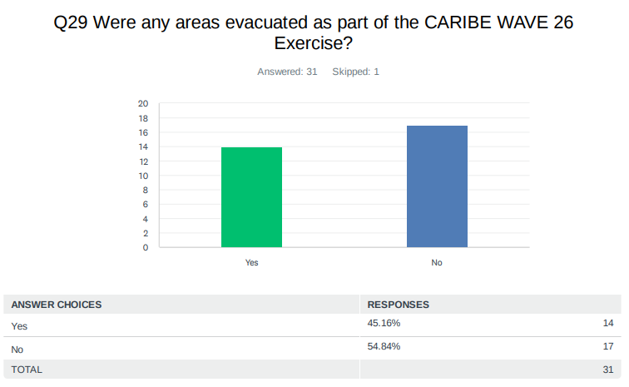
Comments:

Antigua and Barbuda: Evacuation was by participating organizations.

Aruba: Hotels, Schools and Public Entity.

Dominica: The areas that were evacuated were the Coulibistrie Primary School and Castle Bruce primary school.

France: A beach in Saint-Martin and 2 schools in Saint-Barthélemy, Schools in Martinique and Guadeloupe.

Grenada: 2 schools.

Honduras: The Omoa community.

Jamaica: The township of Port Maria in St. Mary was evacuated.

Saint Lucia: schools Business places in three southern communities.

UK Anguilla: We did the evacuation exercise two days before CARIBEWAVE.

UK British Virgin Islands: Participation for all areas of the BVI.

UK Cayman Islands: Full Scale exercise at hotel with vertical evacuation using CERT (Community Emergency Response Team) volunteers role playing as guests.
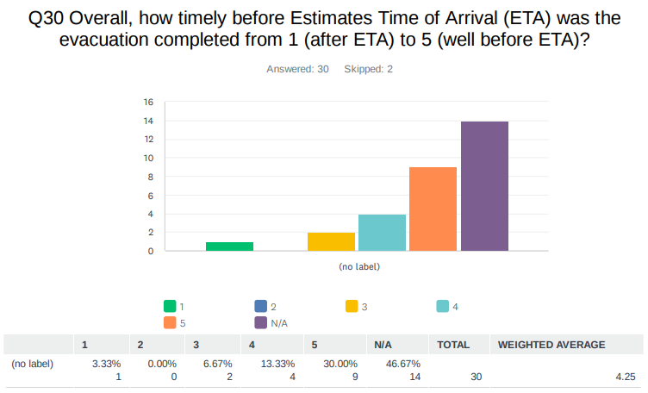

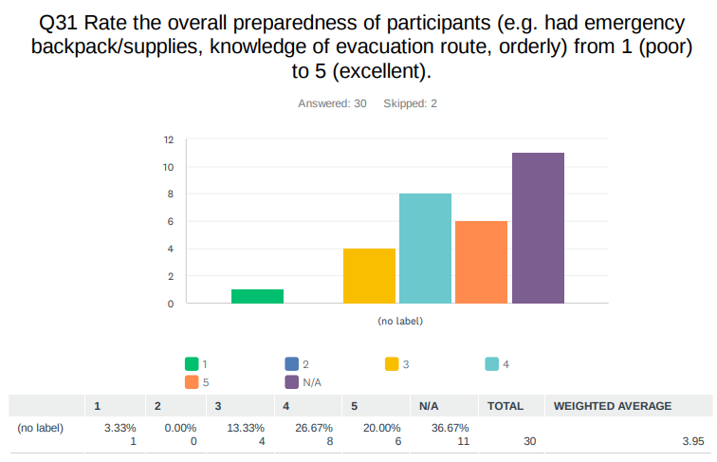

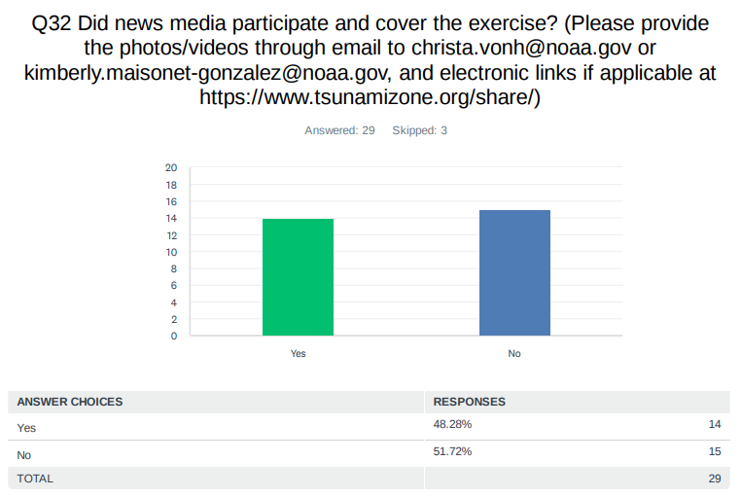
Comments:

Dominica: There was no news media throughout the exercise, but we used the Office of Disaster's facebook page inorder to alert the public.

France: It depends on islands.

Guatemala: https://www.facebook.com/share/1HcU6cUoLk/?

Honduras: Media outlets affiliated with Copeco and Codem in Omoa.

Jamaica: CVM TV, NCU Radio, Irie FM Outside Broadcast, TVJ,

Venezuela: There are many photos and different media outlets.

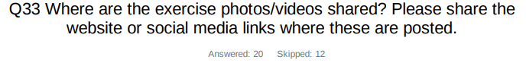
Aruba: facebook/cmo

Barbados: https://starcomnetwork.net/blog/2026/03/20/dem-conducts-school-drills-to-strengthen-preparedness-for-tsunami-and-earthquakethreats/ https://drive.google.com/drive/folders/15dRWvxUFhTW4mrkOrV-UIC_2B6orjg-S?usp=drive_link

Colombia: https://www.instagram.com/reel/DWH-X5JDqOw/?igsh=aTFoYzdzNmp6dm5x

Dominican Republic: https://www.facebook.com/story.php?story_fbid=1255585096754602&id=100069093704563&rdid=vXchxd83JxiA70cv# , https://www.instagram.com/p/DWFCZdDFvx6/?igsh=MWZveW5vdWhvaWl5Mw%3D%3D

Grenada: GIS Grenada (https://www.facebook.com/share/v/18c9B8jSv6/?mibextid=wwXIfr) Time 19:40

Guatemala: https://www.facebook.com/share/1HcU6cUoLk/?mibextid=wwXIfr ----- https://www.facebook.com/share/r/1B23rVtRUx/? mibextid=wwXIfr

Haiti: https://www.facebook.com/share/p/1H1dAdLjAd/ https://www.facebook.com/share/p/1B5TdLYxoV/

Jamaica: https://www.odpem.org.jm/odpem_in_the_media/caribe-wave-tsunami-exercise-2026/

Saint Lucia: All nemo social platforms some news stations

Saint Kitts and Nevis: Drone Operators from GIS Lab

UK Anguilla: WhatsApp only

UK Cayman Islands: https://www.facebook.com/caymanprepared/

US Puerto Rico: facebook.com/NMEADpr and facebook.com/redsismicadepuertorico

US Virgin Islands: https://stcroixsource.com/2026/03/17/usvi-encouraged-to-take-part-in-caribe-wave-2026-tsunami-preparedness-exercise/

Venezuela:
https://www.instagram.com/reels/DWB98XVAP76/ https://www.instagram.com/reels/DV9IgVggWC5/ https://www.instagram.com/reels/DV1h5_0kYCf/ https://www.pcivil.gob.ve/2026/03/sngr-se-prepara-para-el-caribe-wave-2026/ https://www.instagram.com/p/DV_grriDbGb/ https://www.facebook.com/watch/?v=2143411249817436 https://www.onsa.org.ve/comunidad/forum/viewtopic.php?t=6183 https://www.instagram.com/reels/DV6ynYjASXX/ https://www.instagram.com/reels/DV38w60DoOn/ https://www.instagram.com/reels/DV8t-0PEYaP/ https://www.instagram.com/reels/DWCDmmGD-u1/ https://www.instagram.com/reels/DWCDmmGD-u1/ https://www.instagram.com/reels/DWCOdQggedc/ https://www.instagram.com/p/DU3knXTDifT/ https://www.pcivil.gob.ve/2026/03/sngrse-prepara-para-el-caribe-wave-2026/ https://www.globovision.com/nacional/53169/costa-de-venezuela-preparadas-para-participar-en-elsimulacro-de-tsunami-caribe-wave-2026 https://www.facebook.com/BajoLaLupaInfo/posts/hoyesnoticia-la-reedanmaritimae-recuerdaque-este-19mar-se-llevar%C3%A1-a-cabo-el-eje/1446786730793386/ https://primicia.com.ve/nacion/activan-regiones-para-elsimulacro-de-tsunami-caribe-wave-2026/ https://www.pcivil.gob.ve/2026/03/dnpcad-invita-a-los-venezolanos-a-participar-en-elsimulacro-caribe-wave-2026/ https://www.instagram.com/p/DUnwdKUkTTF/ https://www.facebook.com/watch/?v=1428464265673650 https://ultimasnoticias.com.ve/actualidad/activadas-las-regiones-para-el-simulacro-de-tsunami-del-caribe-wave-2026/ https://www.instagram.com/p/DWBp0TslToI/ https://lamananadigital.com/afinan-detalles-para-el-ejercicio-internacional-caribe-wave2026/ https://www.instagram.com/reels/DWB98XVAP76/ https://www.pcivil.gob.ve/2026/03/dnpcad-invita-a-los-venezolanos-aparticipar-en-el-simulacro-caribe-wave-2026/ https://www.instagram.com/reels/DWFpqgvEZgT/ https://www.instagram.com/reels/DWGuKGIgd-c/ https://radiomiraflores.net.ve/venezuela-fortalece-la-cultura-preventiva-en-el-caribewave-2026/ https://fusernews.com/venezuela-afianza-respuesta-ante-tsunamis-en-el-caribe-wave-2026/ http://www.miranda.gob.ve/index.php/gobernacion-de-miranda-culmina-con-exito-simulacro-internacional-caribe-wave-2026/ https://elperiodiquito.com/venezuela/79894/desarrollan-simulacro-internacional-caribe-wave-2026/ https://www.instagram.com/p/DWFT4kWkenO/ https://www.facebook.com/teleSUR/posts/venezuela-realiz%C3%B3-con-%C3%A9xitoel-ejercicio-internacional-caribe-wave-2026-poniendo/1441161271386238/ https://www.minec.gob.ve/venezuela-fortalece-la-culturapreventiva-en-el-caribe-wave-2026/ http://www.psuv.org.ve/temas/noticias/venezuela-fortalece-cultura-gestion-riesgo-ejerciciointernacional-caribe-wave-2026/ https://www.instagram.com/reels/DVD6MTkkSBE/ https://fusernews.com/venezuela-afianzarespuesta-ante-tsunamis-en-el-caribe-wave-2026/ https://www.instagram.com/reels/DWFNTdpkZkV/ https://notizulia.net/zulia-seprepara-para-el-simulacro-internacional-de-tsunami-caribe-wave-2026/ https://www.instagram.com/reels/DWDQZJGjvZj/ http://www.funvisis.gob.ve/noticia.php?id=2880 https://www.instagram.com/reels/DWHqxhLj34-/ https://www.pcivil.gob.ve/2026/03/venezuela-efectuo-con-exito-el-ejercicio-internacional-caribe-wave-2026/ www.funvisis.gob.ve › noticia www.mpprijp.gob.ve › prensa › reporte › unes-participa-en-el-caribe-wave... unesdoc.unesco.org › ark: › pf0000392226_spa www.facebook.com › teleSUR › posts › venezuela-realizó-con-éxito-el-ejer... avn.info.ve › costas-de-venezuela-se-suman-este-juevesal-simulacro-de-tsu... ultimasnoticias.com.ve › Pulso Regional www.instagram.com › reel

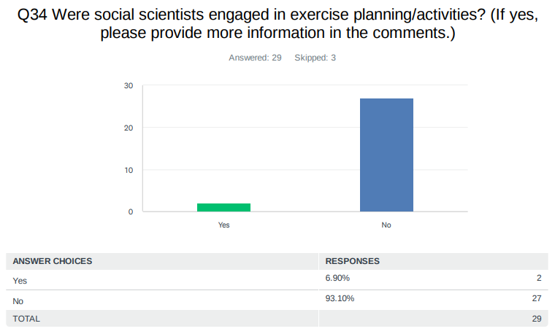
Comments:

France: As far as I know, there was one in St Barthélémy, but their NTWC answered no to this question.

Jamaica: The Social Development Commission (SDC). The SDC has trained social scientists with degrees in social work and social development. The SDC helped to mobilize the communities for the community-based meetings that were organized.

Venezuela: Yes, indeed, social scientists participated in both the planning and activities of CW 2026. Their contribution is significant in working with communities and in identifying elements that contribute to understanding seismic risk as a social phenomenon. Researchers conducted workshops and seminars on the Caribe Wave 26 exercise, and materials were sent for Civil Protection and Disaster Management at the local and regional levels.
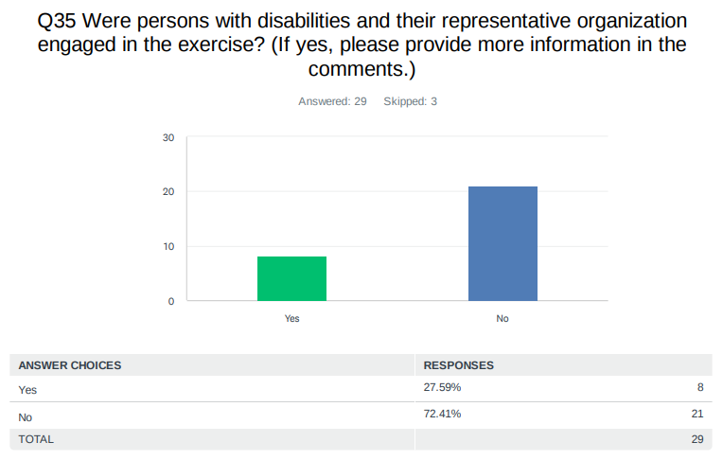
Comments:

Aruba: Schools with Special Needs Kids.

Barbados: Barbados Council for the Disabled gave a presentation at the Crane Hotel.

France: Probably during school evacuations, but no formal information is available.

Haiti: One hundred people with disabilities have participated.

Jamaica: Jamaica Council for Persons with Disabilities (JCPD) is on the National Tsunami Contact List. Previously we had reached out to other actors such as the Jamaica Society for the Blind and the Jamaica Combined Disabilities Association (an NGO) and would have been engaged as part of the exercise. The SMS blasts achieved through DIGICEL and FLOW would also have reached Persons with Disabilities (PWD).

UK Cayman Islands: Participants were encouraged to plan on how they would vertically evacuate persons with limited mobility. A school for persons with disabilities participated and activated their plan for wheelchair users.

US Puerto Rico: "Intérpretes de lenguaje de señas de Puerto Rico (Jesús Burgos)" and National Federation for the Blind.

Venezuela: People with disabilities were monitored by state and can be seen on the Kobox dashboard. https://lookerstudio.google.com/reporting/45ee8b95-a87d4a7e-858d-2d9da2b4f018/page/Q64KF
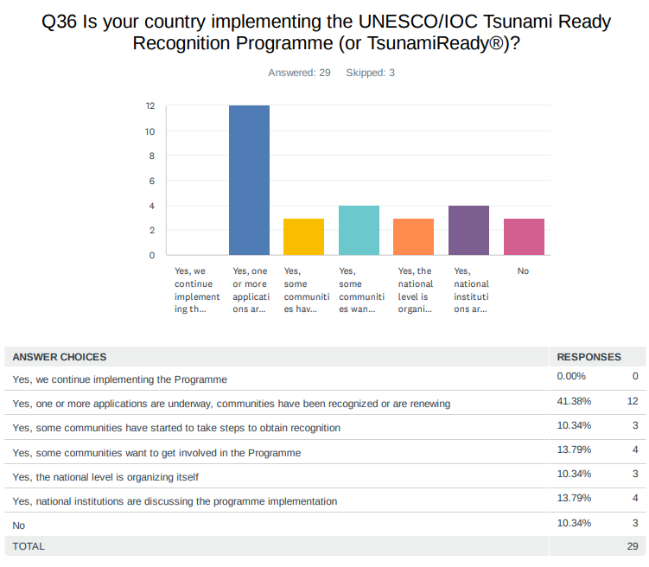
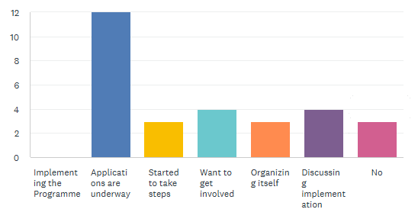
Comments:

Dominican Republic (translated from Spanish): The communities of San Felipe, Puerto Plata and Nigua, Palenque and Haina have taken steps to create spaces for this purpose

France: We have one community TR, Saint-Barthélemy has started to take steps to obtain recognition, other communities would like to get involved.

Honduras: Honduras is currently working on the renewal of the Tsunami Ready recognitions for the communities of Cedeño, Omoa, and Tornabé.

Jamaica: Old Harbour Bay - Tsunami Ready, Port Maria is working towards recognition hence the drill. Outstanding development of the tsunami hazard model for Port Maria. There is the existence of a hazard map for evacuation. However the technical assistance is needed to develop the hazard model.

Mexico: On December 23, 2025, the AGREEMENT was published in the official gazette of the federation, through which the Act of Integration of the National Council of the Tsunami Ready Program in Mexico, the Internal Regulations of the National Council of the Tsunami Ready Program in Mexico and the Guidelines for the Recognition of Coastal Localities in the Tsunami Ready Program in Mexico are published.

NL-Bonaire, Saba, Sint Eustatius: Decision for this has to be made by the local governments.

Panama: DIPECO Project - 2019 in Barú District, Chiriquí Province.

UK British Virgin Islands: We currently have the territory tsunami recognized.

UK Cayman Islands: Grand Cayman is low-lying, 7 ft above sea level with little to no high points for evacuation routes/points which is one of the criteria in the programme that are not applicable to Grand Cayman.

US Puerto Rico: 47 communities

US Virgin Islands: Completed: St. Croix, St. Thomas, St. John Underway: Water Island

Venezuela: Yes, community activities continue in support of the tsunami ready program, resources are being prepared for the respective visits and observations, this year progress was made in the signage of some coastal communities and they are preparing to enter the TsunamiReady program.

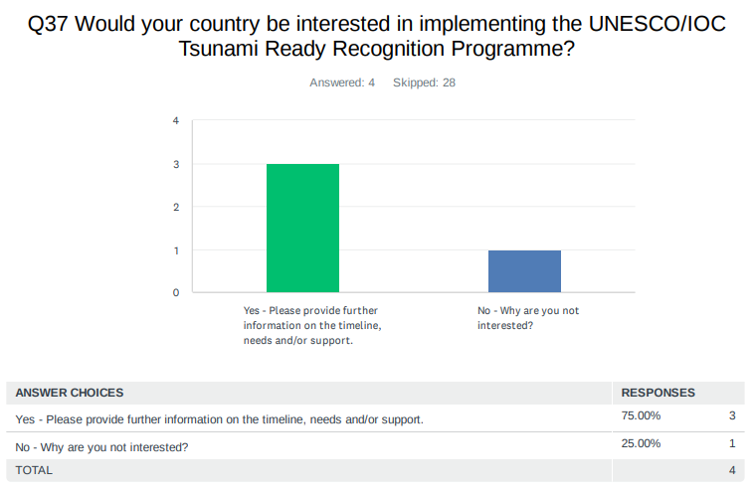
Comments:

NL-Bonaire, Saba, Sint Eustatius: We as TWFP cannot decide that for the local governments.

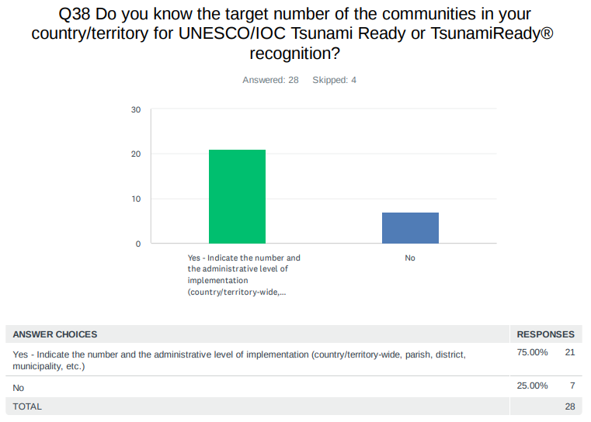
Comments:

Aruba: 35,000 Tourism West and South Coast.

Bahamas: 20 islands with over 75 settlements.

Barbados: They are four, Sherman's St. Lucy to Mullins in St. Peter, Rendezvous, Christ Church to Garrison St. Michael, Porters St. James to Batts rock and Walmer Lodge to Bridge Gap, St. Michael.

Belize: 1 City

Colombia (translated from Spanish): Two Municipalities in the Colombian Pacific by the year 2030.

Costa Rica: 15 municipalities in the Pacific and 3 in the Caribbean.

Grenada: 4: Coastal areas of St. George, Coastal areas of St. Patrick, Island of Carriacou, Island of Petite Martinique.

Haiti: 12 (Cap-haitien, Port-de-paix, Fort-Liberte for renewing, Mole Saint Nicolas, Gonaives, Arcahaie, Port-au-prince, Les Cayes, Aquin, Jeremie, Anse d'Hainaut, Anse a veau

Honduras: The target number is 5 communities at the municipality/community level: Omoa, Cedeño, Tornabé, Nueva Armenia, and Corozal.

Jamaica: A total of 137 districts/communities form part of the Tsunami Inundation Extent (Blue Line). All the coastal communities selected which form part of the tsunami inundation extent (blue line) were selected based on the criteria developed with the assistance of the ITIC- CAR.

Mexico: 6 states and 44 municipies 1. Jalisco 1.1. Puerto Vallarta 1.2. Cabo Corrientes 1.3. Tomatlán 1.4. La Huerta 1.5. Cihuatlán 2. Michoacán 2.1. Aquila 2.2. Coahuayana 2.3. Lázaro Cárdenas 3. Colima 3.1. Manzanillo 3.2. Armería 3.3. Tecomán 4. Guerrero 4.1. La Unión 4.2. Zihuatanejo de Azueta 4.3. Petatlán 4.4. Tecpan de Galeana 4.5. Atoyac de Álvarez 4.6. Coyuca de Benítez 4.7. Acapulco de Juárez 4.8. San Marcos 4.9. Florencio Villarreal 4.10. Copala 4.11. Marquelia 4.12. Cuajinicuilapa 5. Oaxaca 5.1. Santa María Huatulco 5.2. San Pedro Pochutla 5.3. Santa María Tonameca 5.4. Santo Domingo de Morelos 5.5. San Pedro Huamelula 5.6. Salina Cruz 5.7. Santiago Astata 5.8. San Mateo del Mar 5.9. San Francisco Ixhuatán 5.10. San Dionisio del Mar 5.11. Juchitán de Zaragoza 5.12. Santa María del Mar 5.13. Santa María Colotepec 5.14. Santa María Mixtequilla 5.15. Tehuantepec 6. Chiapas 6.1. Tonalá 6.2. Pijijiapan 6.3. Mapastepec 6.4. Acapetahua 6.5. Mazatán 6.6. Tapachula

Panama: Population: 56,307 habitants Barú District (Puerto Armuelles, Limones, Progreso, Baco, Rodolfo Aguilar Delgado).

Saint Kitts and Nevis: country/territory wide.

Saint Lucia: 18

Saint Vincent and the Grenadines: we have divided mainland St. Vincent into island five (5) tsunami zones for which we intend to implement tsunami ready recognition programme. In addition we intend to implement tsunami recognition programmes on 5 grenadine islands (Bequia, Mayreau, Canouan, Union Island and Mustique).

UK Anguilla: 1

UK British Virgin Islands: Territory wide The Virgin Islands

UK Cayman Islands: Entire Country - all three Cayman Islands

US Puerto Rico: 47

US Virgin Islands: 3 of 4 Islands are Tsunami Ready (St. Croix, St. Thomas, St John). Recently Water Island has expressed an interest in becoming TsunamiReady.

Venezuela: We don't have a definitive number yet, but the evaluation is already underway based on the results collected using the KoboxCaribe Wave tool.

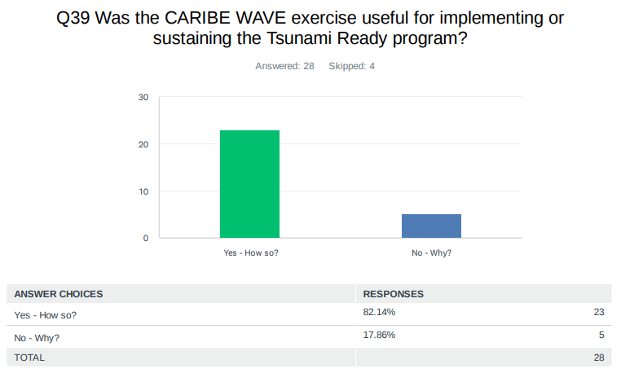
Comments:

Aruba: Problem Areas and Sirens.

Bahamas: The Bahamas did not participate in this year’s Caribe Wave exercise due to key operational components not being fully in place to support effective engagement. Efforts are currently underway to address these gaps, with a view to participating in future exercises.

Barbados: The Caribe wave exercise is used to test the 12 indicators required for tsunami ready recognition.

Belize: The exercise will enable us to be prepared and test communication channels as well as test SOPs, once they have been finalized.

Colombia (translated from Spanish): The institutions are still debating the implementation program for the two communities in the Colombian Pacific.

Costa Rica: it was not possible to involve the public nor other institutions this year

Curaçao: Sending warnings to national/local emergency management agencies, media and the public. Monitor coastal stations to confirm arrival times and update messages (cancel or upgrade/downgrade).

Dominican Republic (translated from Spanish): It makes us aware of our weaknesses and helps us turn them into strengths so we are prepared for any tsunami situation.

Grenada: It refreshes the SOPs for the communities that have already been deemed tsunami ready and identifies the key areas of focus for recertification.

Guatemala: No, because the national exercise was inter-institutional. Our communities want to be part of the recognition program, but we need support since only one department within the entire institution is currently monitoring tsunamis. Therefore, we would appreciate your guidance on the process for registering new communities in the program.

Guyana: It assesses the preparedness for the country.

Haiti: The CARIBE WAVE exercice was useful to test the lines of communication.

Honduras: Yes. The CARIBE WAVE exercise was useful for sustaining and strengthening the Tsunami Ready program, as it helped reinforce communication, coordination, and preparedness efforts at both the national and community levels.

Jamaica: Port Maria falls within the tsunami inundation extent which justifies its selection. Port Maria still is the beneficiary of the Tsunami project which started in 2022. These types of interventions raises the tsunami hazard to prominence and strengthens the Tsunami programme. Since the Tsunami Recognition programme, the ODPEM has also embarked on the development of a Tsunami Ready Community Selection Criteria (2025) to prioritize the selection of communities in the future.

Nicaragua: Together with the 4 yearly National Exercises organized by SINAPRED it helps to promote and improve the National Tsunami Warning System.

Panama: Yes, mostly the CARIBE WAVE 2019 (Messages and evacuation procedures)

Saint Kitts and Nevis: Provided scope for testing or systems and identify any gaps that may prevent us from being prepared in the event of.

Saint Lucia: It gives an opportunity to test the plan with real life scenarios on a large scale

Saint Vincent and the Grenadines: Not applicable for us this year, but oftentimes the exercise is used to describe the tsunami-ready program and to explain various elements of the tsunami science and response measures for SVG

Trinidad and Tobago: It allowed key agencies to practice the local protocol/SOP.

UK Anguilla: It made us realise that we have to advanced a backup up for the current TWFP 24 hour.

UK British Islands: Allow us to test our systems, routes, check signage, cross reference maps.

UK Cayman Islands: It highlights that tsunamis are a real threat and that despite them typically being sudden onset events there are ways to prepare.

US Puerto Rico: One of the requirements for TsunamiReady recognition is the participation in a tsunami exercise.

US Virgin Islands: Education to our community of 87,000 plus visitors. Additional importance for Tourist who arrive either via Cruise Ship or Airport.

Venezuela: Yes, this year coastal communities continue their preparations to be recognized in the future as TsunamiReady communities.

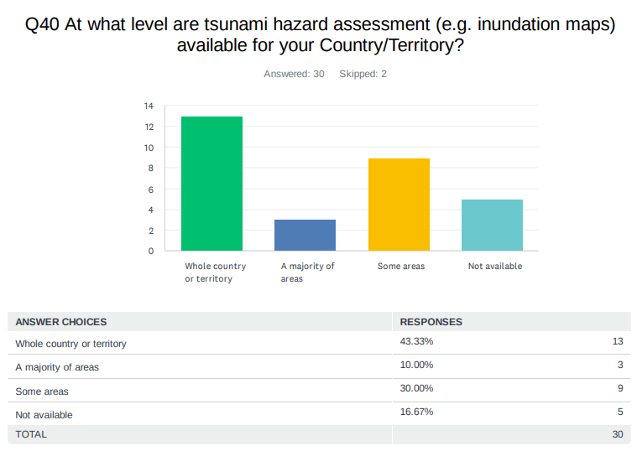

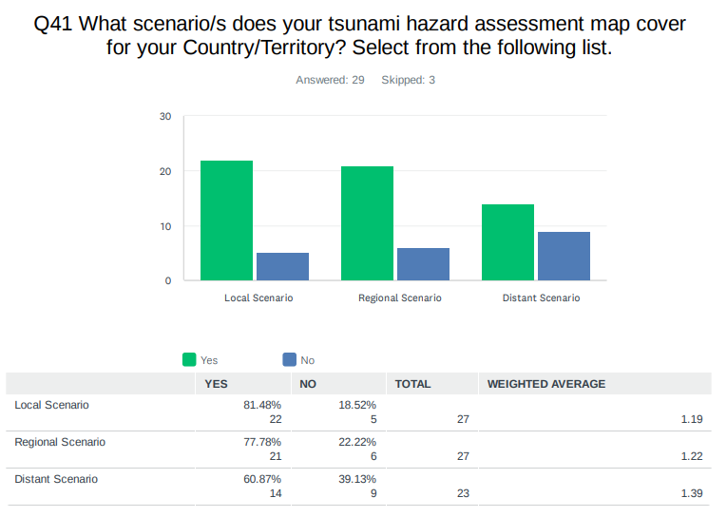
Comments:

Jamaica: The scenarios are captured in the National Tsunami Plan.

Mexico: We have regional tsunami risk assessment maps, but at the municipal level, work is still underway to develop them.

Panama: CATAC (Local Scenario)

Saint Lucia: We have a flood inundation map not a tsunami hazard assessment map.

UK Cayman Islands: Large magnitude earthquake south of Grand Cayman on the Oriente fault.

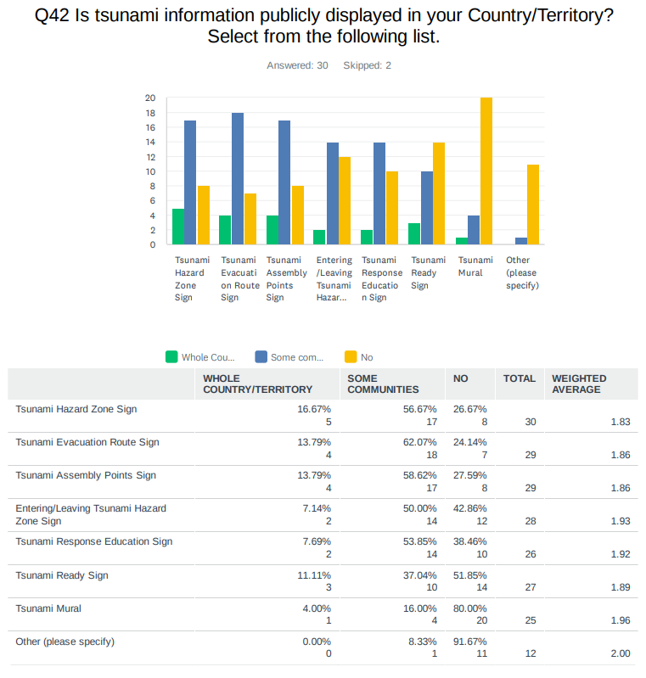
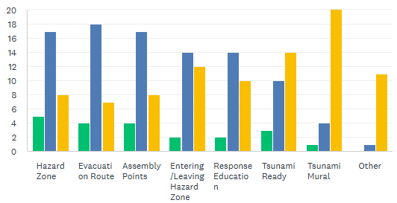
Comments:

Bahamas: 50-75 signs taking into consideration the family islands.

Belize: These are still in the planning stages.

Grenada: 50 (A large number has been damaged during Hurricane Beryl 2024)

Haiti: About 200 hundred. The majority are vandalized.

Mexico: Not all tsunami risk sites have tsunami warning signs. There are over 2,000 km of coastline across 6 states and 44 municipalities, with countless coastal communities in each. We are still working on this, promoting the Tsunami Ready Program.

Saint Vincent and the Grenadines: 39

US Puerto Rico: Pavement paint signs for the evacuation route.

Venezuela: This year, 60 more signs were added to some communities.

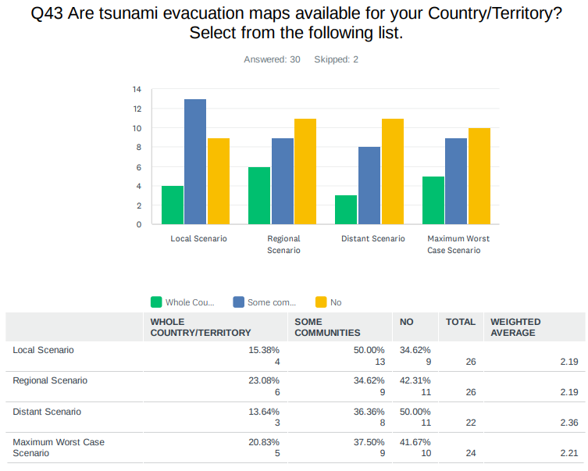
Comments:

Aruba: Numerical Modeling.

Barbados: model from PMEL.

Costa Rica: fixed height/distance and numerical modeling.

France: Fixed height.

Grenada: Numerical modeling.

Haiti: numerical modeling.

Jamaica: The model used for the Old Harbour Bay Model was done by the University of Cantabria out of Spain and finalised by the University of Costa Rica. Port Maria will more than likely be done by the University of Costa Rica. Efforts to garner bathymetry of selected areas of the coastline is ongoing.

Mexico: We use the elevation model of the Institute of Geography and Statistics, along with scenarios from a tsunami synthesizer model that calculates the height of the wave upon reaching the coast, and depending on the size of the wave is the level elevation that we mark on the map.

NL-Bonaire, Saba, Sint Eustatius: Local governments asked about a safe elevation for evacuating areas though. Provision of such maps would be helpful for the stakeholders.

Saint Vincent and the Grenadines: census data, bathymetry survey data, demographic information (Vulnerability and Capacity Assessments), digital elevation maps

UK British Virgin Islands: Coast of main islands.

UK Cayman Islands: Not applicable as Grand Cayman and Little Cayman are flat, no high points for an evacuation assembly point.

US Puerto Rico: MOM numerical modeling.

US Virgin Islands: Fixed height of 82 feet (25M).

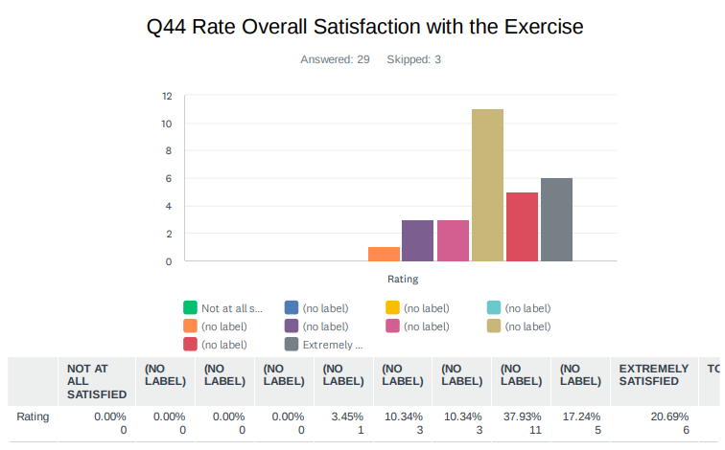
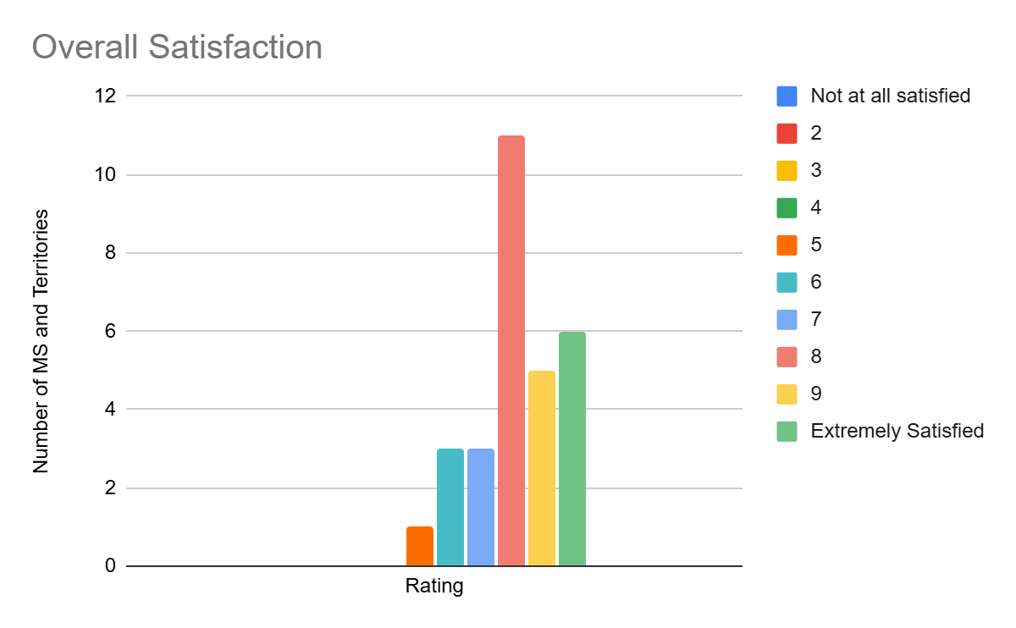
Comments:

Barbados: Largest issue was communication along with CAP. CAP and radio interrupts only allowed on two stations.

Jamaica: Caribe Wave 2026 commanded a greater reach this year with the addition of the SMS messages.

Panama: We have no support for field and evacuation procedures.

UK Anguilla: Most of our pre was pertaining to earthquakes related. So these products were a bit different and took some time for us to read.

UK British Virgin Islands: Less participation this year.

US Virgin Islands: Many of the schools had testing going on at the same time and were unable to participate in the evacuation drill.

Venezuela: It was very good, because we had to think about a tsunami product of a volcanic eruption, imagine a landslide have the potential to producing a tsunami, and educate our authorities and staff about the possibility of a volcanic eruption that affects us.

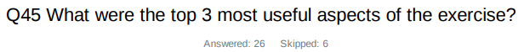
Country | Exercise Caribe Wave 26
Aruba | Receiving the message, Activate the Early Warning System, Coordination of National Coordination Center.
Barbados | Provisions of the updating of SOP Usage of this exercise for public awareness Areas to be worked on by all agencies involved in exercise.
Belize | 1. We are able to test communication channels.  2. We will be able to test SOPs, when finalized.  3. We will be able to test readiness.
Colombia  (translated from Spanish) | 1) The exercise contributed to the preparation of personnel for this type of volcanic scenario.  2) Communications functioned well between the Tsunami Service Provider and the Tsunami Warning Center.  3) Information was shared effectively among the entities of the National Tsunami Detection and Warning System.
Curaçao | The exact time coordination  Possible impacts and gauge measurements  Sea level station monitoring
Dominican Republic  (translated from Spanish) | Put into practice the efficiency and response of the early warning system. Address weaknesses in bulletin preparation. Verify proper communication with other operational entities when issuing alerts and mobilizing the population.
France | 1.This allowed us to test the public alert system.  2. This allowed us to test the downward alert chain and the coordination and the mobilization of several services.  3. This allowed us to test the routes and identified refuge areas for some communities.
Grenada | Identifying the key areas for TRR recertification Testing Communication Testing SOPs for evacuation in Carriacou and Petite Martinique.
Guatemala | The time it takes to issue alerts in Guatemala has improved over the years, as has inter-institutional communication. In this exercise, we evaluated the responses of the regional offices and the participation of all seismology personnel in the drill.
Guyana | Timeliness, accuracy and information.
Haiti | 1.- Orientation seminar  2.- The receipt of PTWC messages on time.  3.- the greater number of participants for Haiti until date
Honduras | 1. Testing and improving communication procedures between PTWC, TWFP/NTWC, and national institutions.  2. Strengthening coordination among national, regional, and local authorities involved in tsunami preparedness and response.  3. Reinforcing community preparedness and supporting the sustainability and renewal of the Tsunami Ready program.
Jamaica | The Parish Court Office in Port Maria evacuated including the judges in their regalia. The six sirens installed in Port Maria under the DECOM programme (formerly the JICA project) were synchronised and activated and went off promptly at 15:00 UTC.
Nicaragua | The tests of the dissemination of warning messages with social networks.
Panama | 1. Communication procedures  2. Organization in general  3. Scenarios selected
NL- Bonaire, Saba, Sint Eustatius | - new scenario which is of interest for local stakeholders  - PTWC message distribution test  - in-country communication tests
Saint Kitts and Nevis | 1. Tabletop exercise of Cruise Ships in port  2. Getting the response from the people in society that participated in the exercise
Saint Lucia | 1. Gaps Identified within first local level communication systems from MET to NEMO  2. Supervisory Disconnect: A "somewhat chaotic" transition to the assembly point occurred due to a lack of consistent leadership  3. Significant concerns were identified regarding the capacity of the evacuation locations should as many populations as possible and the wider communities.
Saint Vincent and the Grenadines | The PTWC product Caribewave workshops Testing the communication procedures of the tsunami exercise.
UK Anguilla | New scenario. Anguilla getting to use the TTTC.
UK- British Virgin Islands | System testing Public Feedback Public Awareness.
UK Cayman Islands | The provision of estimated arrival times for the different islands within the Cayman Islands. (Little Cayman was not listed).  The realistic timeline as these events can be extended.  The education information embedded in the messages such as a tsunami being a series of waves and the time between can be five  minutes to one hour.
US Puerto Rico | The opportunity of practice with a volcano scenario. That we could include the sign language. More agencies participation.
US Virgin Islands | 1. Participates registration on the CaribeWave 26 website.  2. Testing with WEP (IPAWS)  3. Exercising the Island Emergency Operations Centers for a Short Notice exercise such as Kick'em Jenny.
Venezuela | 1. The opportunity to educate authorities about tsunami risk and observe how they assume their responsibility by working together as a unified government.  2. To advance educational efforts regarding tsunami risk in our coastal areas and all educational zones.  3. To understand and analyze, from a scientific perspective, the potential scenario of a volcanic eruption and the resulting underwater displacement that could generate a tsunami.

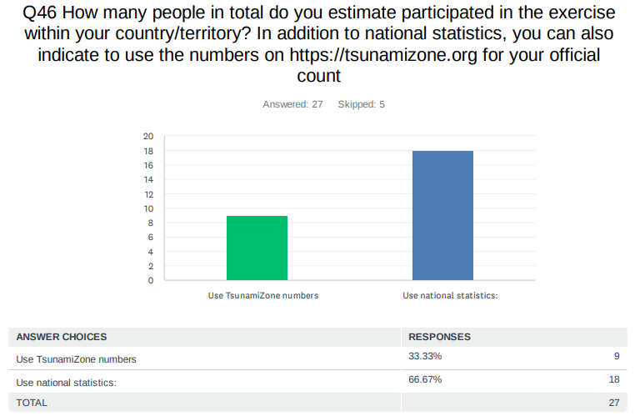

Country |  | Participants according to Member States
Antigua and Barbuda |  | 9,163*
Aruba |  | 32,347
Bahamas |  | 2*
Barbados |  | 1,400
Belize |  | 2
Brazil |  | 14*
Colombia |  | 30
Costa Rica |  | 4
Cuba |  | 0*
Curaçao |  | 5*
Dominica |  | 250*
Dominican Republic |  | 431
France |  | 104,263
Grenada |  | 200
Guatemala |  | 25
Guyana |  | 10
Haiti |  | 28,000
Honduras |  | 2,219
Jamaica |  | 15,000
Mexico |  | 8,100
Netherlands  (Bonaire, Saba, Sint Eustatius, other) |  | 55
Nicaragua |  | 50
Panama |  | 6,054
Saint Kitts and Nevis |  | 7,501*
Saint Lucia |  | 750
Saint Vincent and the Grenadines |  | 20
Sint Maarten |  | 15*
Suriname |  | 0*
Trinidad and Tobago |  | 252*
United Kingdom | Anguilla | 65
United Kingdom | Bermuda | 325*
United Kingdom | British Virgin Islands | 6,032
United Kingdom | Cayman Islands | 10,961
United Kingdom | Montserrat | 0*
United Kingdom | Turks and Caicos | 425*
United States | Puerto Rico | 220,428
United States | US Virgin Island | 21,526
Venezuela |  | 161,368
TOTAL |  | 619,340

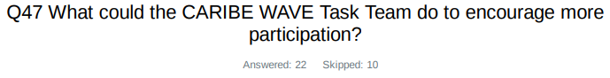
Country | Exercise Caribe Wave 26
Aruba | Wave Height 3 meter scenario.
Bahamas | Both BDM and DRM may require further communication and engagement from the PTCW. This is vital for the awareness and preparation if a tsunami possibly impacts the Bahamas.
Barbados | Maybe have multiple dates for exercise so nations can choose when they would like to participate.
Dominican Republic  (translated from Spanish) | Encourage the population to safeguard their lives and the lives of others through social media.
France | Video spots. Provide certificates or goodies to individuals or agencies that actively take part in the exercise
Grenada | More visual aids for public awareness Encourage participating states to utilize more public awareness through social media, traditional media and community engagement.
Guatemala | Perhaps the Caribe Wave Task Team could provide us with more training sessions, along with additional outreach materials to share with the public and with more communities.
Guyana | Public knowledge and education on Tsunami risks and dangers.
Haiti | Translate the manual of participant in Spanish and French.
Honduras | The CARIBE WAVE Task Team could encourage more participation by sharing information earlier, simplifying guidance for registration and implementation.
Jamaica | This year Caribe Wave task team reached out to entities who would have participated previously.
Mexico | We believe that the Caribbean Wave Task Team has made a great effort and done a great job, and that those who have the most work to do are the countries participating in the simulation exercise.
Nicaragua | we will try to combine the National Exercise with the Caribe Wave.
Panama | Webinars and meetings.
Saint Kitts and Nevis | Probably add a competition component to the exercise where different groups will compete to determine the best team that evacuated etc.
Saint Lucia | Greater public sensitization to raise the awareness.
Saint Vincent and the Grenadines | - greater public awareness across the regional utilizing all available media forms  - support local authorities with their tsunami-ready recognition and caribewave exercise educational and promotional activities.
Trinidad and Tobago | Support with Tsunami SOP writing.
UK Cayman Islands | Make participation competitive among areas e.g. British Overseas Territories awarding a virtual badge.
US Puerto Rico | A video encouraging people to participate a month before the exercise.
US Virgin Islands | Send notices to the Amateur Radio Operator Clubs.
Venezuela | It would be interesting to incorporate social science practitioners into the Caribe Wave regarding the options and needs of their contributions to research and action. Where the disaster is an occasion of crisis or social stress, observable in time and space, in which societies or their components (communities, regions, etc.) suffer physical damage or loss and alterations in their routine functioning.

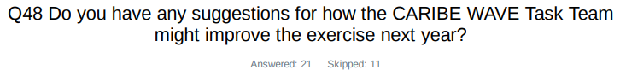
Country | Exercise Caribe Wave 26
Barbados | Hotel sector participation due to the tourist season poses a big problem for hotels' full participation.
Costa Rica | Starting the webinars at a different time. They are at 12 noon for Central America which is lunch time at public institutions, thus it's very hard to have people from public institutions to participate.
Guatemala | Perhaps the CARIBE WAVE Task Team could propose a scenario with a larger magnitude, since in recent exercises for Guatemala the alerts have not been significant for the coasts. In other words, the modeled wave heights have excluded Guatemala from the alert messages, and therefore the country has only issued tsunami alerts without expected coastal impacts.
Guyana | Create more real time scenarios and public engagement.
Jamaica | Reaching out to entities outside of the ODPEM can only auger well for the programme.
Panama | CARIBE WAVE Task Team are doing pretty well, very consistent.
Nicaragua | the ue of Social networks for the dissemination of warning messages should be promoted.
NL- Bonaire, Saba, Sint Eustatius | Minor detail: The text inside the distributed messages were not capitalized as in regular tsunami messages.
Saint Kitts and Nevis | 1. Improve the data collection processes.  2. Introduce real time obstacles in the evacuation process
Saint Lucia | Create standardized Caribe Wave specific PSAs which cold be used to to promote the activity and raise awareness o tsunami threats.
Saint Vincent and the Grenadines | - support local authorities with their tsunami-ready recognition and caribewave exercise educational and promotional activities  - more training to enhance the capacity to support exercise development
UK Cayman Islands | Allow local Emergency management agencies have access to participants contact information to allow for localized briefing.
US Puerto Rico | Take under consideration the time. This year for example, the exercise was at lunch time, so it was harder for school to participate.
Venezuela | This year, unfortunately, we did not receive the PTWC messages for the submarine volcano scenario adapted to the timelines generated by our numerical models. For this reason, we adopted the messages and alerts based on the timelines generated by the numerical models calculated by the Funvisis seismologists in order to maintain coordination for Exercise Caribe Wave 2026, adhering to the estimated timelines and respecting the PTWC messages. I would like to improve communication between countries, so that emergency management offices operating communications can be seen in real time.

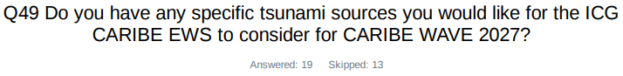
Country | Exercise Caribe Wave 25
Barbados | Fault zone just east of Barbados.
France | Regional seismic scénario (1 to 3 hours before ETA and a couple of hours of inundation) with significant coastal impact.
Haiti | sources generating tsunami with inundation.
Honduras | A fault closer to the Islas de la Bahía.
Mexico | Honduras 8/9/1856 Ms 7.5 Earthquake
Panama | North Panama Deformed Belt (Oriental segment, close to Panama-Colombia border).
Puerto Rico | A local scenario for PR and VI.
Saint Lucia | seismic trigger originating along the Caribbean tectonic plates.
SVG | The eastern Caribbean plate or seismically active zone around Antigua and Martinique
UK Cayman Islands | Cayman 7.8M earthquake from January 2020
Venezuela | I would like to suggest the scenario of the 1900 earthquake on the coasts of Venezuela.

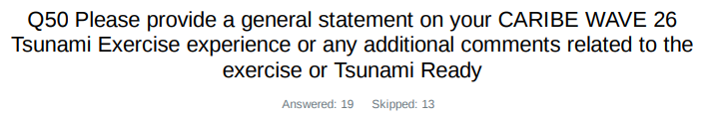

Country | Exercise Caribe Wave 26  General Statements
Aruba | Keep the impact scenario above 3 meter.
Barbados | The Caribe Wave 26 exercise was good overall, as it included more processes than in previous years. The submarine source was also a great option for Barbados and the Windward Islands. Additionally, it allowed for the refinement of procedures for testing and approving plans for tsunami hazards.
France | Caribe Wave provides each territorial crisis management service with the opportunity to test its procedures and tools at least once a year, using historical or realistic scenarios. This exercise served as a reminder to the population of the need to prepare for this type of crisis.  This year, the exercise gave all the French West Indies the opportunity to test a near-field wave, reaching the coast in less than an hour. Because of the volcano scenario, the challenge this year was to make decisions before knowing the impact on the territories. The tsunami alert through NAVAREA was tested for the first time. The PTWC message was received by CROSS-AG (MRCC) and the FAA (Deputy National Coordinator).  A questionnaire was distributed to the population of St MArtin/St Barth via various channels (FR-Alert (our cell-broadcast system), WhatsApp group, Facebook), and this should allow us to identify areas for improvement in terms of public alerts. This exercise also provided the opportunity to test the WhatsApp alert system for the first time in a real-world scenario. It proved to be one of the fastest and most effective tools to implement in the event of a tsunami.
Grenada | Overall, CARIBE Wave 26 was a successful exercise that was well participated. The pilot use of drone technology for data collection and communication via the loudspeaker was a success at the muster points.
Guatemala | On March 19, all personnel from the Seismology Section of the Department of Geophysical Research and Services in Guatemala participated in the CARIBE WAVE 26 exercise. Each staff member was assigned to handle one of the alerts during the exercise. Based on these alerts, bulletins were generated with information relevant to Guatemala. All bulletins were sent by email to CONRED personnel (the national disaster coordination agency) and to INSIVUMEH’s regional offices along the country’s coasts. Confirmation responses were requested from recipients as part of an internal communication evaluation.
Haiti | This is a good exercice. This is the first time Haiti has a great number of participants although the bad socio-political situation. Hope an improvement of the situation in Haiti letting have a better exercice.
Jamaica | Caribe Wave was observed on March 19, 2026. The focus was on Port Maria in St. Mary, but several other parishes also observed an activity. The sirens were tested in Port Maria and saw the participation of schools, Port Maria Preparatory and High, Port Maria Primary and Marymount High Schools. Several agencies also participated included the Ministry of Health and Wellness, Ministry of Labour and Social Security, The Social Development Commission, the St. Mary Parish Court, Jamaica Fire Brigade, Jamaica Constabulary Force, Jamaica Public Service Company, Pagee Beach Fishing Cooperative among other actors. Special commendations to FLOW and DIGICEL for blasting tsunami messages to thousands of persons both nationally and through the parish of St. Mary and neighboring parishes such as Portland, St. Ann and Trelawny. A total of ten Municipal Corporations along with the ODPEM registered on tsunamizone.org. Other entities which registered activities included the Jamaica Energy Partners, Old Harbour Bay, Jamaica Bauxite Institute and the Maritime Authority. One community group from St. Mary also registered as well as one individual was reflected on the site. For the Port Maria Exercise there was a general unresponsiveness of the business centre. Greater sensitization is needed but it was an excellent attempt, and commendations are in order for Mr. Adrian Tate, Parish Disaster Coordinator and Mr. Marlon Brown, Regional Disaster Coordinator.  Worthy of note also, the Validation Session for the Treasure Beach Tsunami Response Plan was held on March 21. Other Tsunami Sessions were held at the New Hope Primary in Whitehouse in Westmoreland, the St. Thomas Municipal Corporation, Public Education Transect Walks in Clarendon (southeast Clarendon coastal communities)  On March 12, St. Catherine MC hosted a radio training for MDAs, Jamaica Energy Partners and the South Jamaica Power Company (LNG Plant) and community actors and the testing of the sirens in Old Harbour Bay.
Mexico | Participation in the CARIBE WAVE 26 exercise represented a valuable opportunity to strengthen community preparedness for tsunamis in the Caribbean region. Through the simulation, response protocols were activated, reaction times were evaluated, and coordination among local, national, and regional institutions was fostered.  These types of exercises not only reinforce technical capabilities but also promote a culture of resilience. In particular, the Tsunami Ready program approach has proven to be an effective tool for empowering coastal communities by integrating education, signage, evacuation routes, and early warning systems.  We reiterate our commitment to continuous improvement, the inclusion of local stakeholders, and the expansion of the Tsunami Ready program's coverage, recognizing that preparedness saves lives and strengthens the social fabric in the face of natural hazards.  We also respectfully request that, if possible, you develop, as supporting materials, animations of the tsunami wave travel time simulation along the Caribbean, naturally depending on the source.
Nicaragua | For us it was important to test for the first time in a Caribe Wave the dissemination of messages using the social networks on the regional and international scale
Panama | The CARIBE WAVE 2026 exercise on March 19,2026 covered the main objectives in terms of communications procedures (for us). In our case, we worked with the Cayman Islands scenario considered seismically and tectonically interesting, even we also wanted to work with Kick-´em-Jenny scenario to improve the volcanic experience. We are expectíng a more active CARIBE WAVE 2027 for Panama, including training in tsunami awareness (basic concepts, risks, warning systems, community preparedness, evacuation procedures) in selected communities.
Saint Kitts and Nevis | The overall experience was informative. In essence society appreciates the activity and looks forward to it. Ways and means to improve the drill should always be considered. There should also be more public awareness to bring about a change in attitude towards implementing these types of exercises. Consider using technological advancement to support the overall exercise.
Saint Lucia | Overall the Caribe Wave 26 exercise was successful in Saint Lucia, we had greater participation, notably the inclusion of banks business places and administration centers. The involvement of the police and fire service proved to be a great asset. The exercise provided an opportunity to identify gaps which we are working on filling going forward.
Saint Vincent and the Grenadines | The beginning of 2026 posed some logistical challenges that restricted our usual involvement in the annual exercise. We have discussed these challenges and shortfalls and concluded with a renewed commitment to greater and meaningful participation going forward.
Trinidad and Tobago | Good experience with testing response for tsunami generation by volcanic activity.
UK- Cayman Islands | Hazard Management Cayman Islands is grateful to UNESCO for your valuable partnership and support.  The CARIBE WAVE tsunami exercises are a great opportunity to share the focus among various hazards as the Caribbean tends to remain focused on Hurricanes.  The Cayman scenario used in the CARIBE WAVE 26 Tsunami exercise was taken from a real event of the 7.6M earthquake which occurred on 8 February 2025 on the Swan Islands Fault.  The actual event was a unique one for the Cayman Islands as it was similar in magnitude to the 7.8M 2020 Earthquake. However, the 8 February 2025 earthquake did NOT generate shaking within the Cayman Islands but did generate a tsunami threat. This tested our response as the guidance is "if an earthquake is long and strong, get gone!". This guidance was not applicable to the 2025 earthquake despite it being a considerably large magnitude earthquake. Therefore, the simulated exercise was a replay of the real event (no shaking).  Persons were caught off guard by the real tsunami threat from the 2025 and CARIBE WAVE 26 Cayman scenario allowed the people of the Cayman Islands to get a second chance and practice what their response should have been.  Feedback for PTWC:  -Messages information heavy and critical/time-sensitive information can get lost.  -Offering different measurements meters and feet could be beneficial as communities are diverse.
USA- Puerto Rico | The CARIBE WAVE 26 exercise was a great opportunity to explain to the population that a volcano can generate a tsunami that affect PR even when we don't have volcanoes in the island. It was also a good exercise to evaluate the communication with different agencies.
USA-US Virgin Islands | Our Islands of St. Thomas and St. John both had a power outage occur just after the EAS message went out. Many individuals didn't participate due to the power outage. However, the Island of St. John did stand-up its Emergency Operations Center and exercise its Continuity of Operations Plan (COOP) to a location with an operational microgrid as well as used PACE emergency communications - Starlink - to communicate to the Emergency Operation Center on the Island of St. Croix. An exercise scenario based on a significant impact to the Island of St. John ran for 2-hours with injects to Emergency Support Function Staff and ending with a mock Press Release. Additionally, the Territory exercised its Continuity of Government Plan (COG) (Legislative Branch, Executive Branch, and Judicial Branch) for accountability of senior leaders.  The EAS / IPAWS message went to and was received by mobile phone, radio stations, and television stations. Great success!  A formal after action review (AAR) conducted the following week by the Emergency Management Agency / VIGTEMA on the EOC response, COG, COOP, and EAS.
Venezuela | This year's Caribe Wave 26 exercise was very active. Contacts were re-established with top authorities, and the new authorities were successfully incorporated into the exercise. The Vice Ministry of Risk Management decided to include the entire national territory, encompassing both coastal and inland states, in coordination with scientists and communities. With great enthusiasm, state and municipal civil protection agencies, drawing on their experience in previous exercises, embraced participation, adapting their own methodologies and reporting to the main situation room located at the SSATV (Social Security and Television System) in Funvisis (National Fund for the Development of the State of Veracruz) and two secondary rooms in La Carlota and La Guaira. Coordination with the authorities in these rooms utilized the updated and adapted Kobox platform, developed by Funvisis, to collect key indicators. This allowed for an assessment of the capabilities and progress of coastal areas in their TsunamiReady preparedness. The operational order for the exercise, prepared by the Vice Ministry of Risk Management and Civil Protection and its team, entitled "Operations Order" for Caribe Wave, was also in place. The participation of amateur radio operators further strengthened communications. We must restore international communications with other warning centers in the region to obtain confirmation and exchange data, among other things.  The assessment of coastal areas that can be prepared for the TsunamiReady program continues.

