Task Team CARIBE WAVE 26
UNESCO/IOC
ICG CARIBE-EWS

CARIBE WAVE 2026

Media Report

International Tsunami Information Center Caribbean Office (ITIC-CAR)
April 2026

Table of Contents

Contents 2
UNESCO-IOC 4
PRSN 4
Tsunami Zone 5
Official CARIBE WAVE 26 Webpage (caribewave.org) 6
Antigua and Barbuda 7
Aruba 9
Barbados 10
Cayman Islands 13
Colombia 14
Costa Rica 15
France 15
Saint Martin 15
Saint Barthelemy 16
Grenada 17
Guatemala 19
Haiti 20
Honduras 23
Jamaica 26
Mexico 30
Netherlands 30
Sint Maarten 30
Saint Kitts and Nevis 34
Saint Lucia 37
Trinidad and Tobago 39
United Kingdom: 40
Anguilla 40
Bermuda 40
British Virgin Islands 42
Cayman Islands 46
United States: 48
Puerto Rico 48
U.S. Virgin Islands 54
Venezuela 56

CARIBE WAVE 2026
Regional Tsunami Exercise

The CARIBE WAVE exercise is conducted within the framework of the UNESCO/IOC Intergovernmental Coordination Group for Tsunamis and other Coastal Hazards Warning System for the Caribbean and Adjacent Regions (ICG/CARIBE-EWS). The fifteenth annual tsunami exercise CARIBE WAVE took place on 19 March 2026. It was carried out with the purpose of validating and advancing tsunami resilient communities in the Caribbean and Adjacent Regions. The exercise was coordinated by the CARIBE WAVE 26 task team, the NOAA International Tsunami Information Center Caribbean Office, and supported by the Caribbean Tsunami Information Center and Pacific Tsunami Warning Center.
Over 600,000 people from the entire Caribbean basin were registered to participate in the exercise according to member states and territories. Registered participants included designated Tsunami Warning Focal Points (TWFPs), National Tsunami Warning Center (NTWCs), as well as emergency and preparedness organizations, K-12 Schools, government, healthcare, business, among others. It was left up to the Member States and Territories to determine the level of participation and activity to be held in their country, and to use the simulated messages for one of the two tsunami scenarios: Cayman Islands and Kick‘em Jenny.
Most countries and territories publicized the exercise through social media to encourage the participation of the community. The hashtag #CARIBEWAVE was commonly used to track their activities online, resulting in worldwide reach. Several Emergency Management agencies from countries informed citizens through online article publications and social media posts that their country would participate in the exercise. The International Tsunami Information Center Caribbean Office (ITIC-CAR) and the Puerto Rico Seismic Network (PRSN) also published informative posts related to tsunami awareness in preparation for CARIBE WAVE.
This report includes 119 associated publications accessed through the internet from 29 Member States and Territories in the Caribbean and Adjacent Regions, as well as international organizations.

UNESCO-IOC
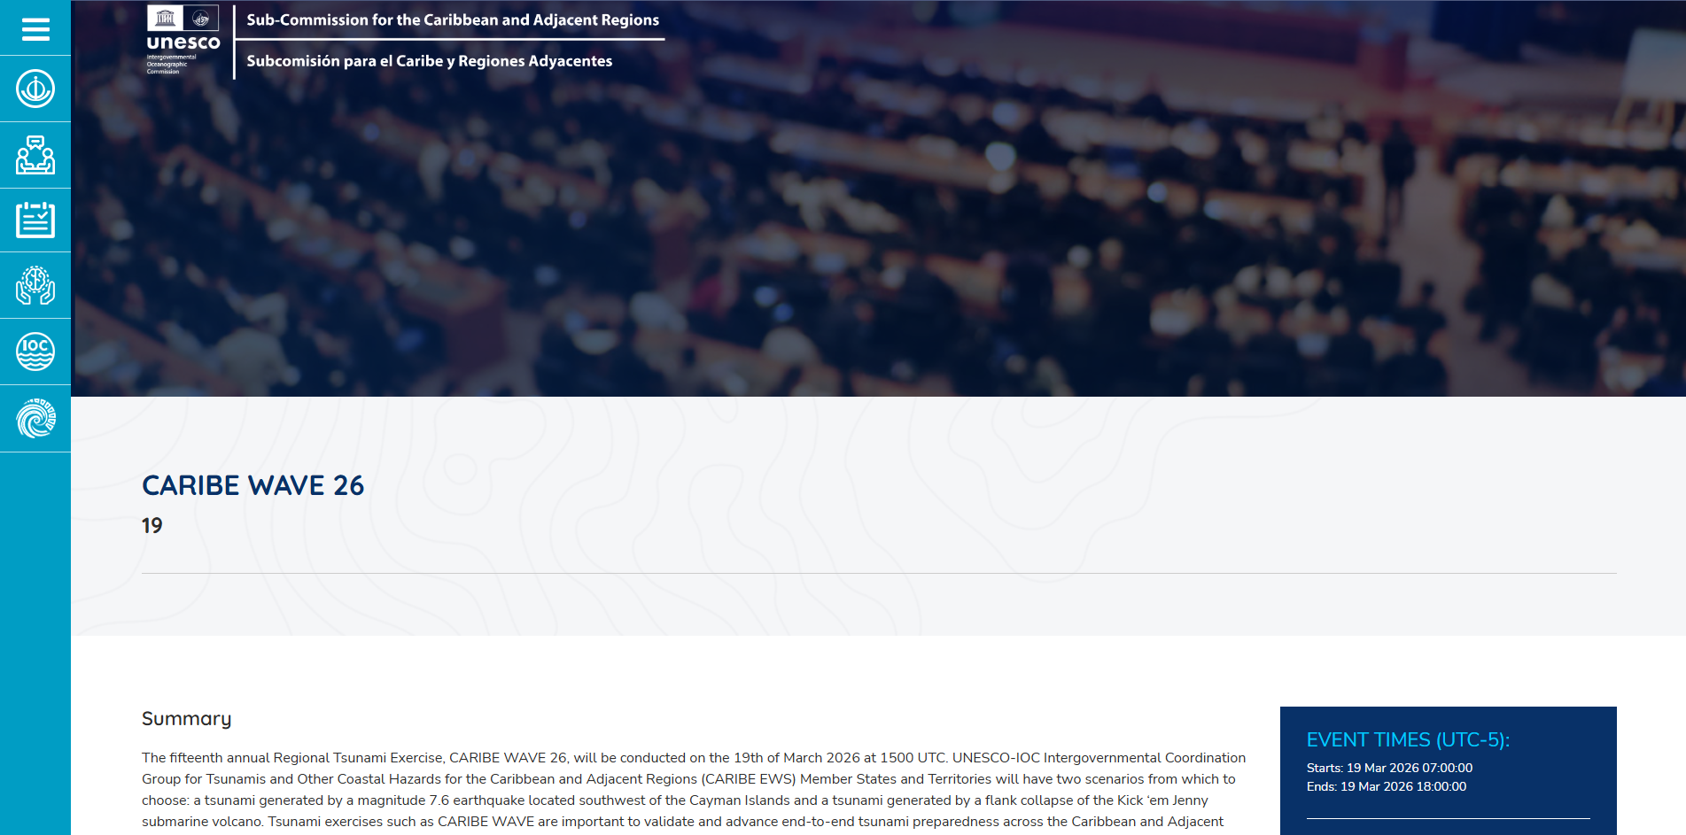
Retrieved from: https://iocaribe.ioc-unesco.org/en/event/3140

PRSN
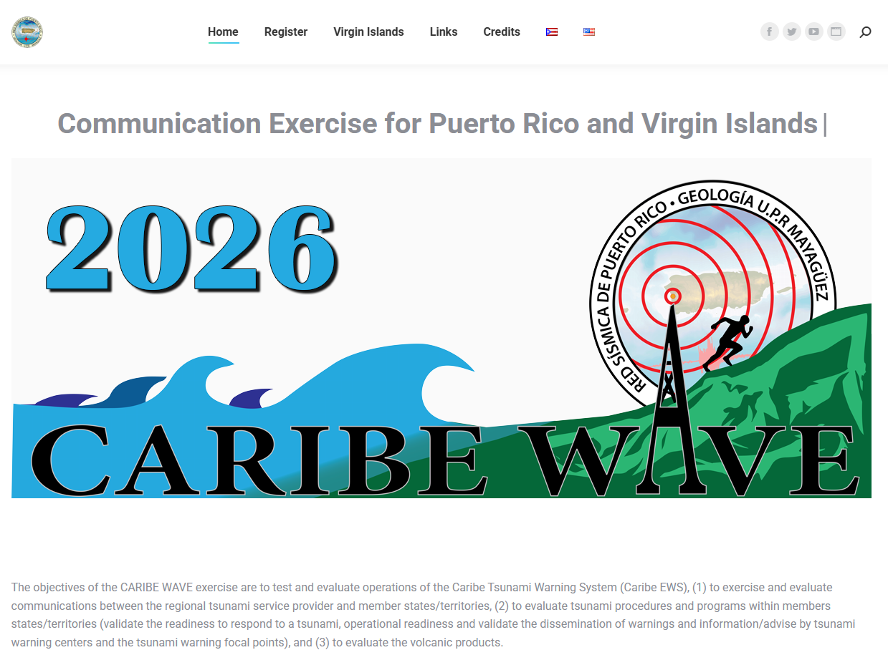
Retrieved from: https://caribewave.uprm.edu/index.php/en/home/

Tsunami Zone
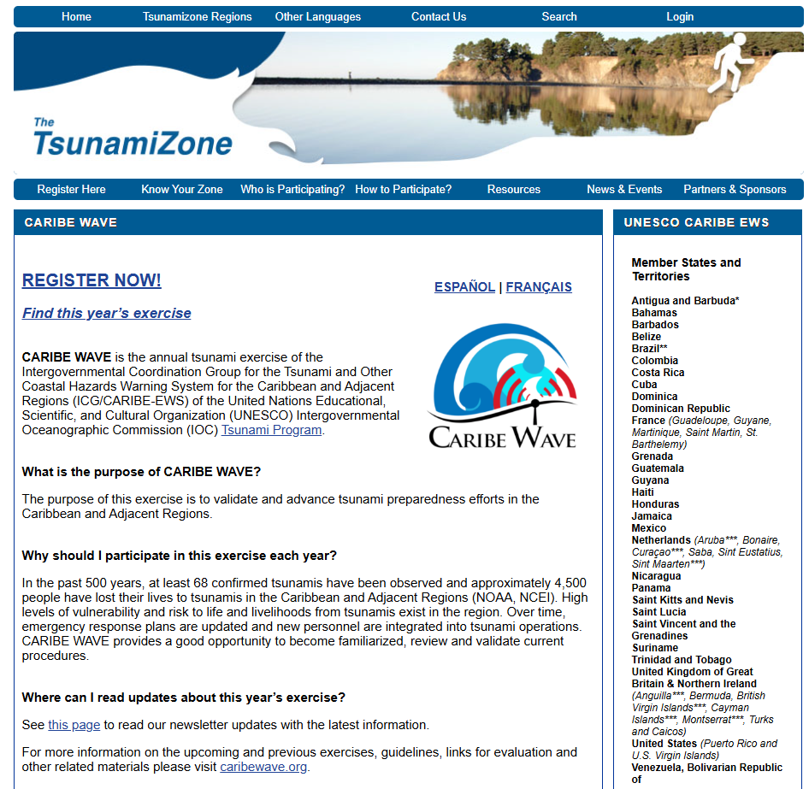
Retrieved from: https://www.tsunamizone.org/caribewave/

Official CARIBE WAVE 26 Webpage (caribewave.org)

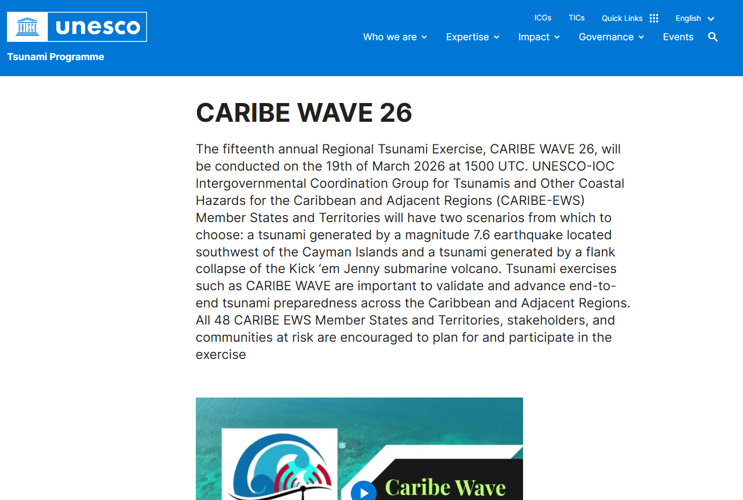
Retrieved from: https://tsunami.ioc.unesco.org/en/caribewave26

Antigua and Barbuda
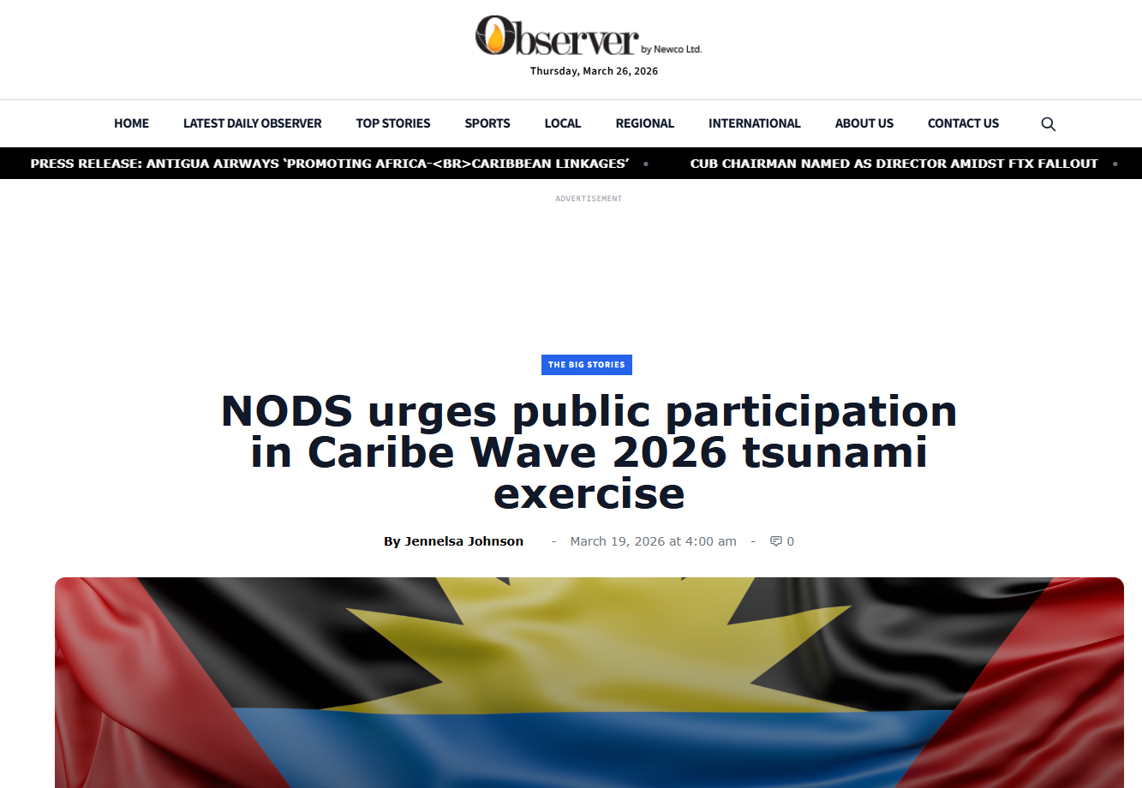
Date of publication: March 19, 2026
Retrieved from: https://antiguaobserver.com/nods-urges-public-participation-in-caribe-wave-2026-tsunami-exercise/

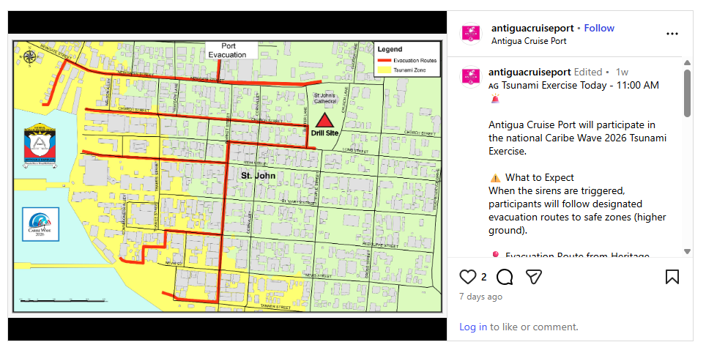
Date of publication: March 19, 2026
Retrieved from: https://www.instagram.com/p/DWENKJHABFF/

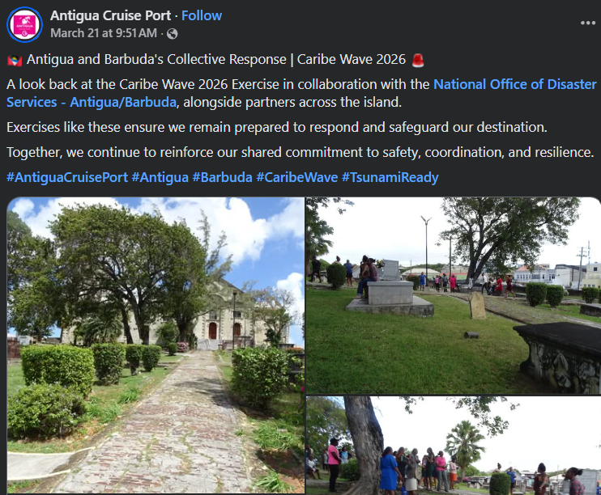
Date of publication: March 21, 2026
Retrieved from: https://www.facebook.com/antiguacruiseport/posts/pfbid02dmrB4P8nA3c7pUMmgcHNjZyCW8PdjgBXDvr54aNUvmFo6h8g5TE8SxxbF9qpqZ6Fl

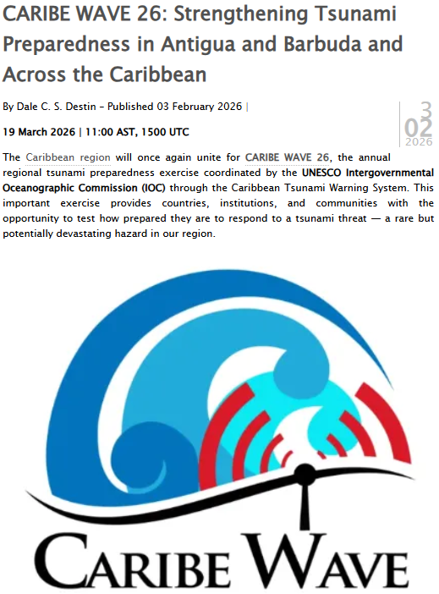
Date of publication: March 19, 2026
Retrieved from: https://268weather.wordpress.com/2026/02/03/caribe-wave-26-strengthening-tsunami-preparedness-in-antigua-and-barbuda-and-across-the-caribbean/

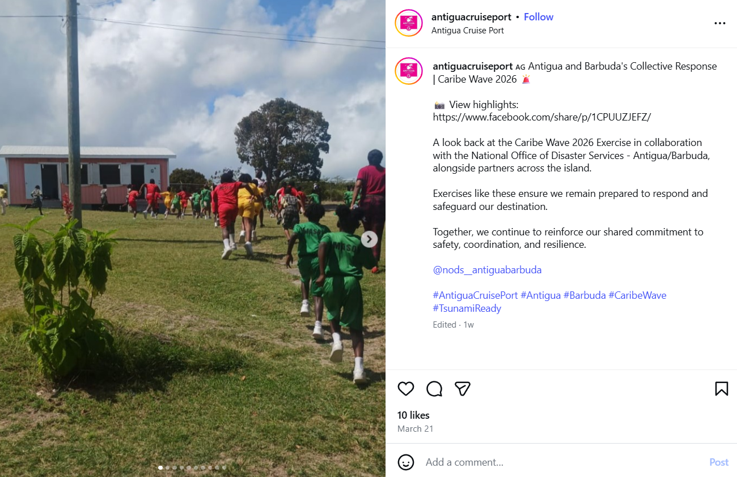
Date of publication: March 21, 2026
Retrieved from: https://www.instagram.com/p/DWJkm5PgHOD/

Aruba

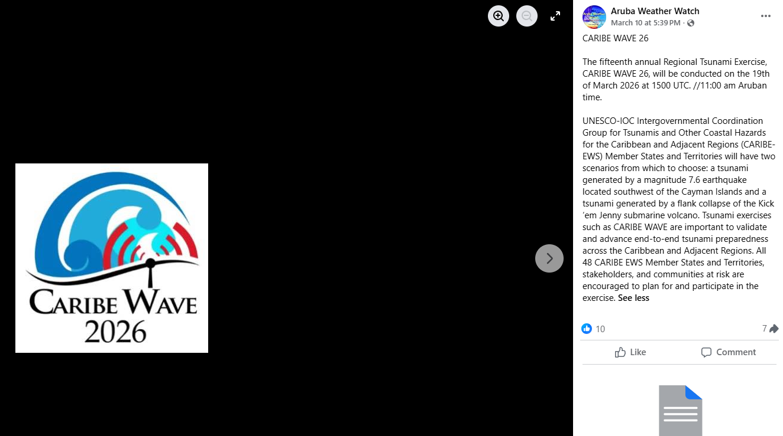
Date of publication: March 10, 2026
Retrieved from: https://www.facebook.com/photo/?fbid=1351394937023835&set=caribe-wave-26the-fifteenth-annual-regional-tsunami-exercise-caribe-wave-26-will

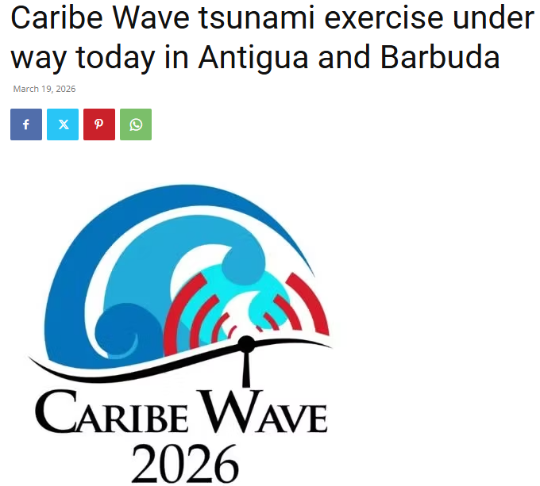
Date of publication: March 19, 2026
Retrieved from: https://antiguanewsroom.com/caribe-wave-tsunami-exercise-under-way-today-in-antigua-and-barbuda/

Barbados
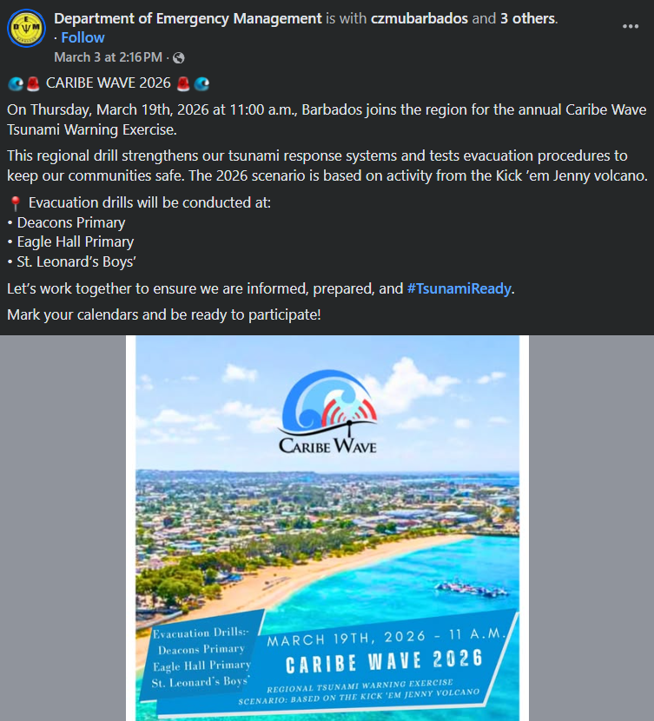
Date of publication: March 3, 2026
Retrieved from: https://www.facebook.com/dem246/posts/pfbid02ovGmcMeUDFqRg4EdHhGXGknKrVE6B6c3D5piw6sQAtwP3FYmD7MhSpE47DsNfDwol

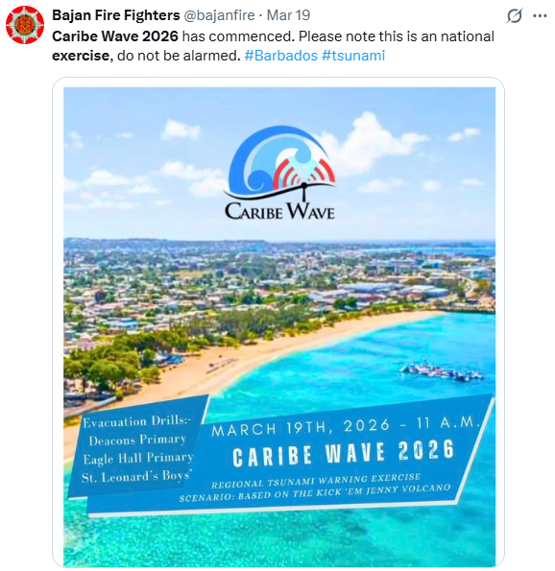
Date of publication: March 19, 2026
Retrieved from: https://x.com/bajanfire/status/2034662458065859024

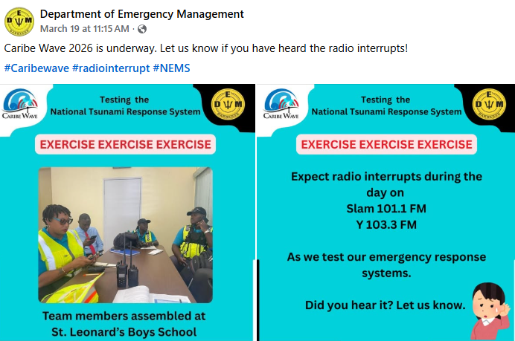
Date of publication: March 19, 2026
Retrieved from: https://www.facebook.com/dem246/posts/caribe-wave-2026-is-underway-let-us-know-if-you-have-heard-the-radio-interrupts-/1255365670071277/

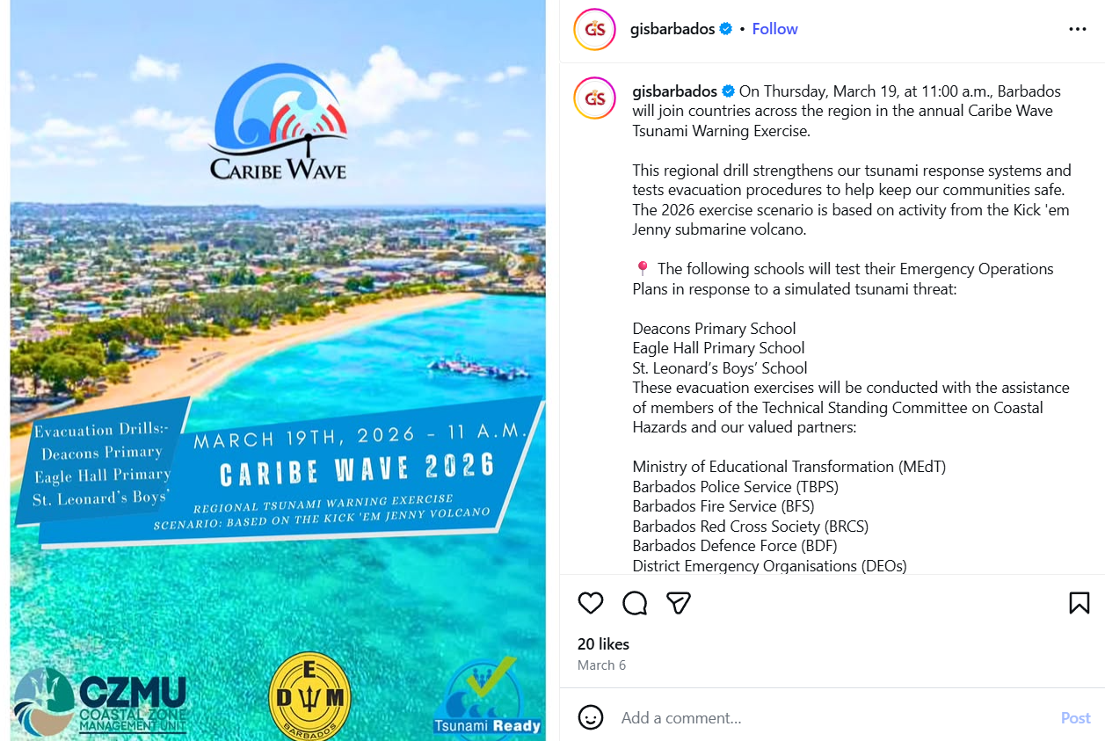
Date of publication: March 6, 2026
Retrieved from: https://www.instagram.com/p/DVjO5pbkZMq/

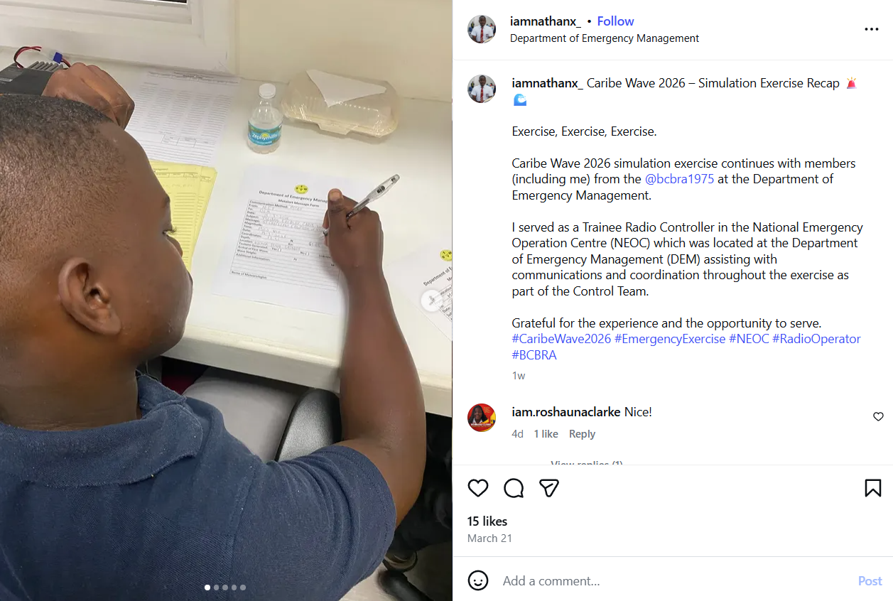
Date of publication: March 21, 2026
Retrieved from: https://www.instagram.com/p/DWJTUbqAOoX/

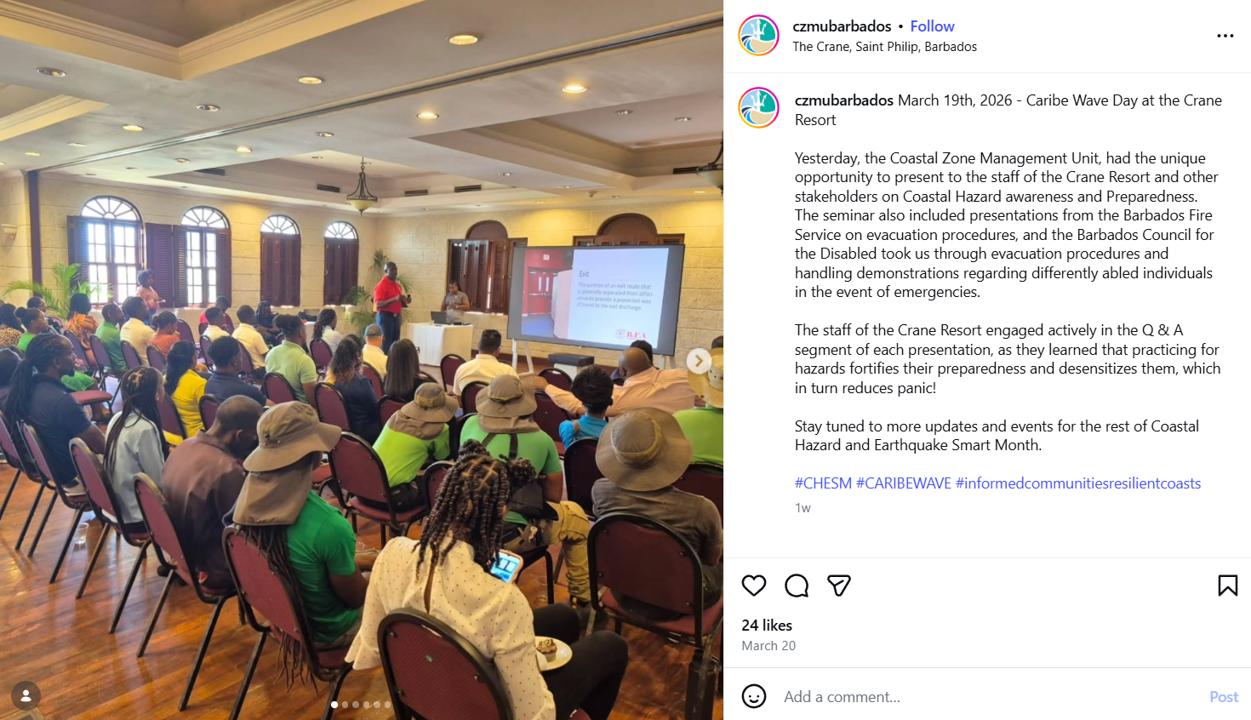
Date of publication: March 20, 2026
Retrieved from: https://www.instagram.com/p/DWHEUClFea2/
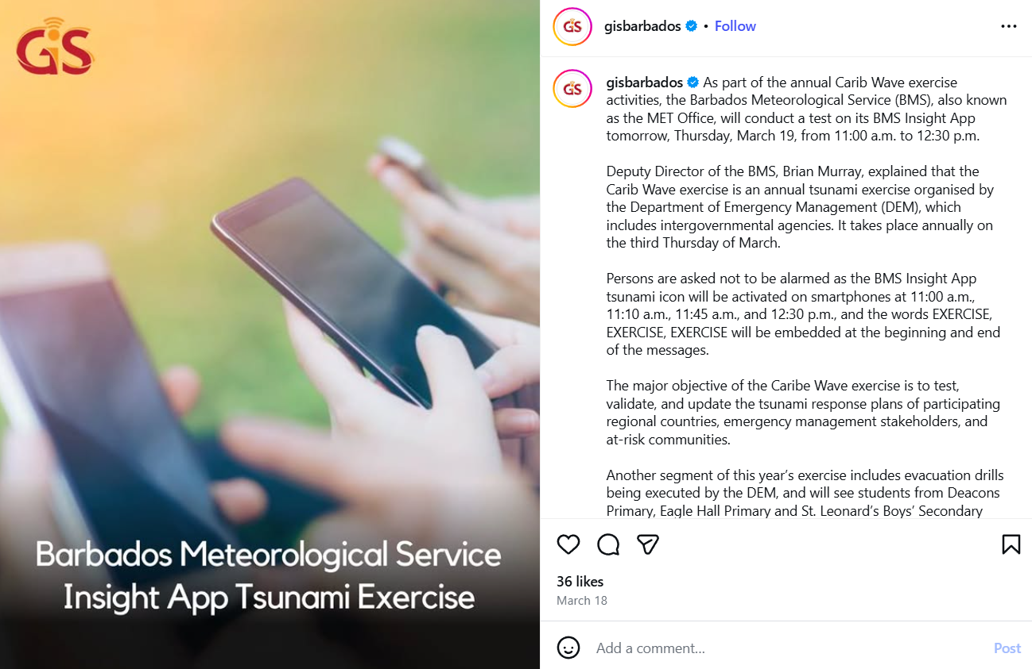
Date of publication: March 18, 2026
Retrieved from: https://www.instagram.com/p/DWCzv60kaFs/

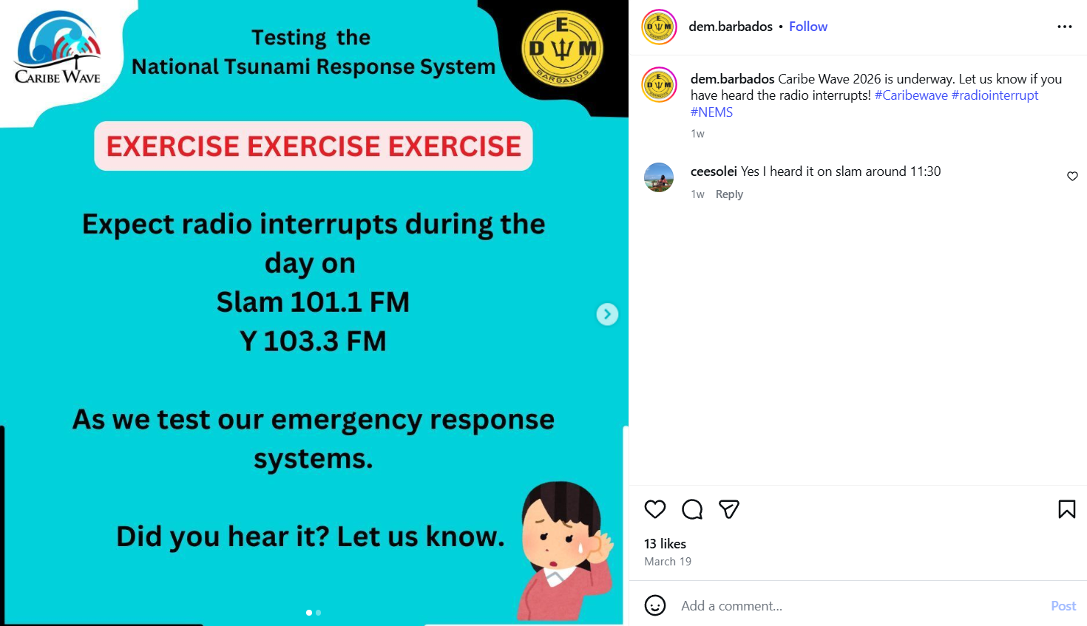
Date of publication: March 19, 2026
Retrieved from: https://www.instagram.com/p/DWEj8Dmlo4F/

Cayman Islands
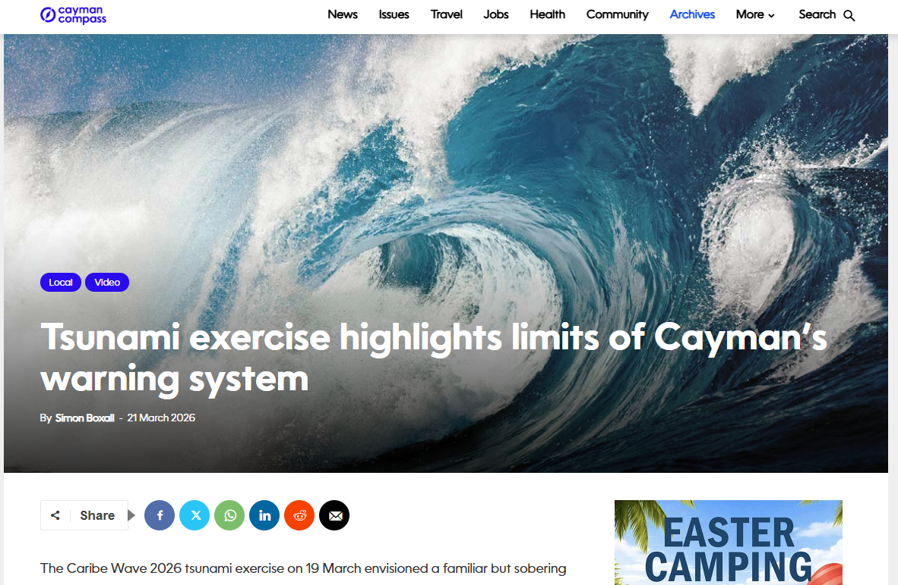
Date of publication: March 21, 2026
Retrieved from: https://www.caymancompass.com/2026/03/21/caribe-wave-exercise-highlights-limits-of-caymans-warning-systems/

Colombia
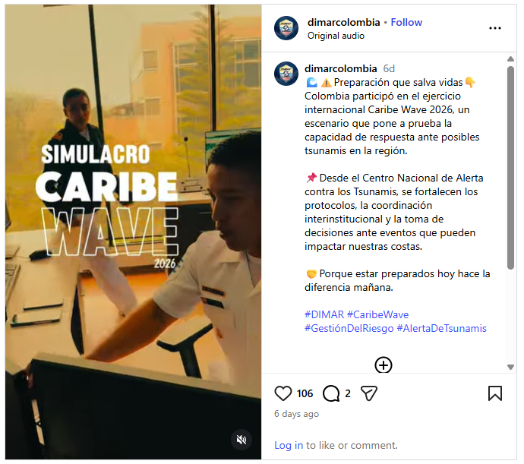
Date of publication: March 20, 2026
Retrieved from: https://www.instagram.com/reel/DWH-X5JDqOw/?hl=en

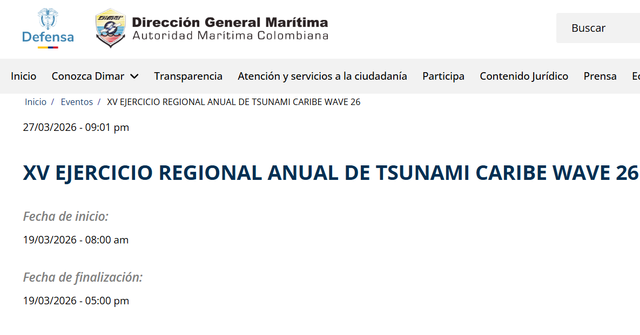
Date of publication: March 27, 2026
Retrieved from: https://www.dimar.mil.co/eventos/xv-ejercicio-regional-anual-de-tsunami-caribe-wave-26

Costa Rica
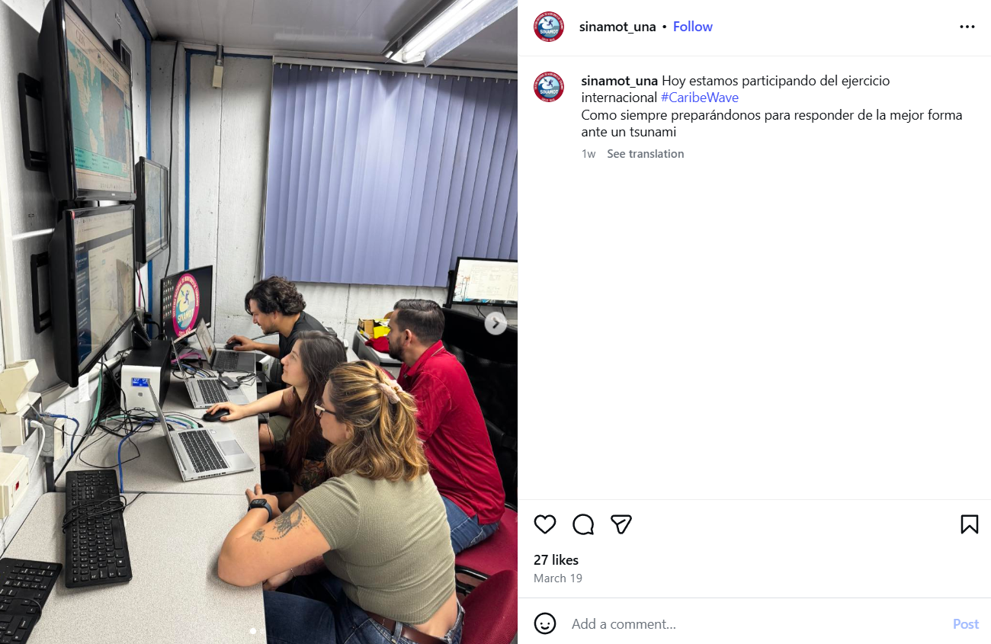
Date of publication: March 19, 2026
Retrieved from: https://www.instagram.com/p/DWEu4LkkijS/

France

Saint Martin

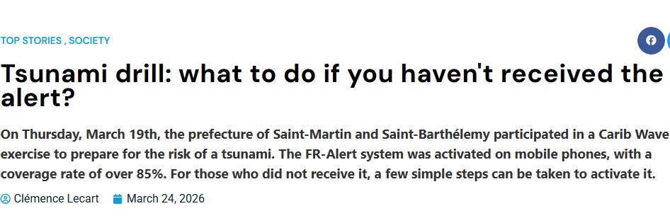
Date of publication: March 24, 2026
Retrieved from: https://www.lepelican-journal.com/exercice-tsunami-comment-faire-si-lon-na-pas-recu-lalerte/?reload=true

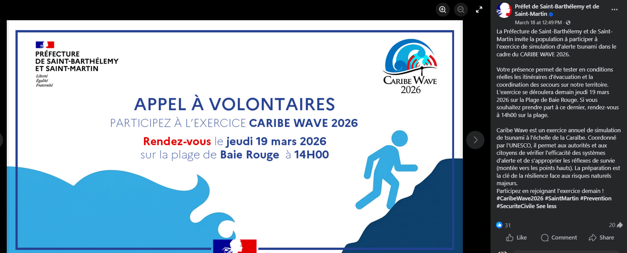
Date of publication: March 18, 2026
Retrieved from: https://www.facebook.com/photo.php?fbid=1319304616899425&set=a.292459532917277&type=3

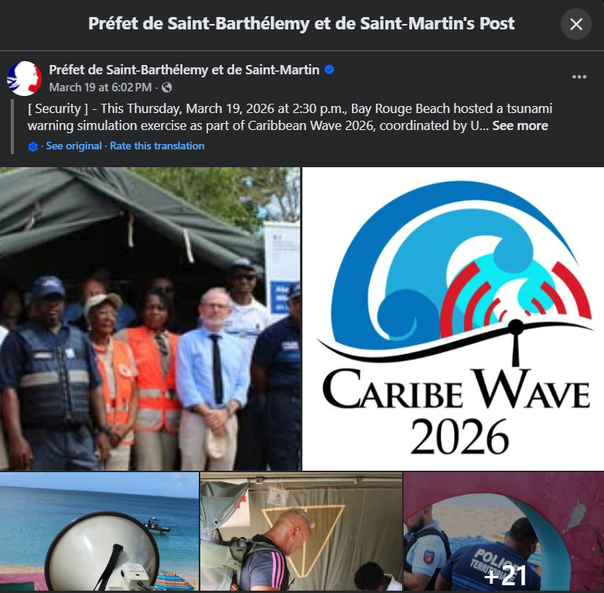
Date of publication: March 19, 2026
Retrieved from: https://www.facebook.com/prefet971/posts/pfbid0D8WW82d2ShJ9M3Fai4nHisU7MzbY5iQ4fmteqBHMBqgZp9W3k1P99ZG69bWX76P4l

Saint Barthelemy
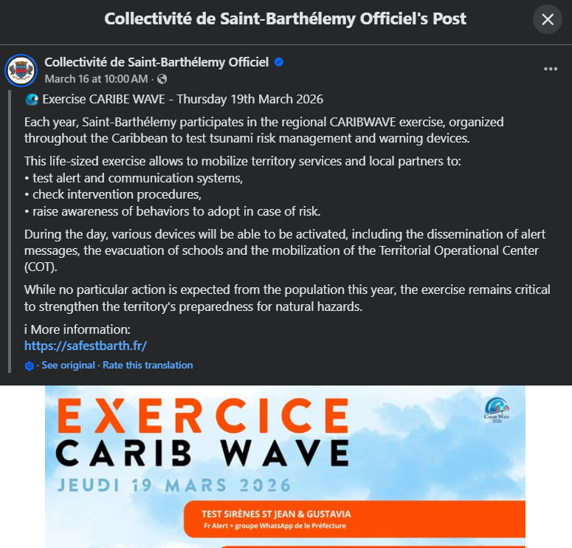
Date of publication: March 16, 2026
Retrieved from: https://www.facebook.com/comstbarth/posts/-exercice-caribe-wave-jeudi-19-mars-2026chaque-ann%C3%A9e-saint-barth%C3%A9lemy-participe-/1258933759664655/

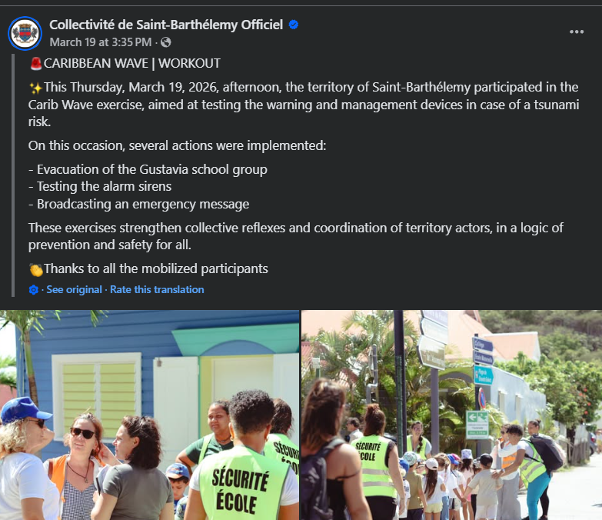
Date of publication: March 19, 2026
Retrieved from: https://www.facebook.com/comstbarth/posts/pfbid02QJfpAQSB3awM3qxeNj7nwYPudBL7Ta3pNHarYnP1DZqEpXLR56oHvvjmdCFvijk1l

Grenada
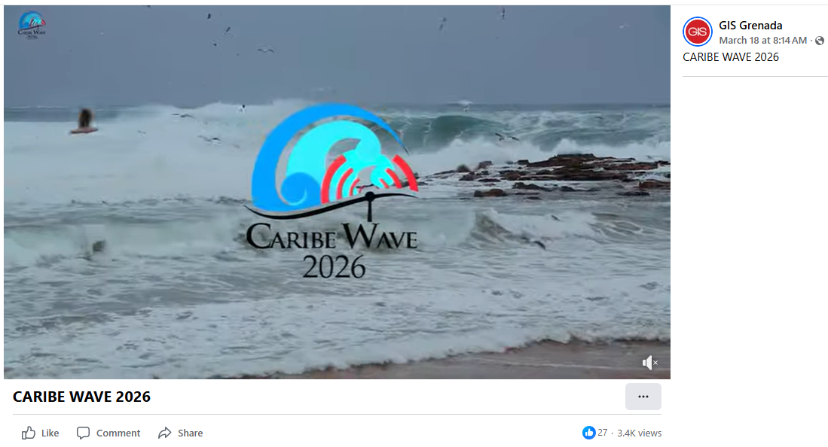
Date of publication: March 18, 2026
Retrieved from: https://www.facebook.com/gisgrenada/videos/1522800369474863/

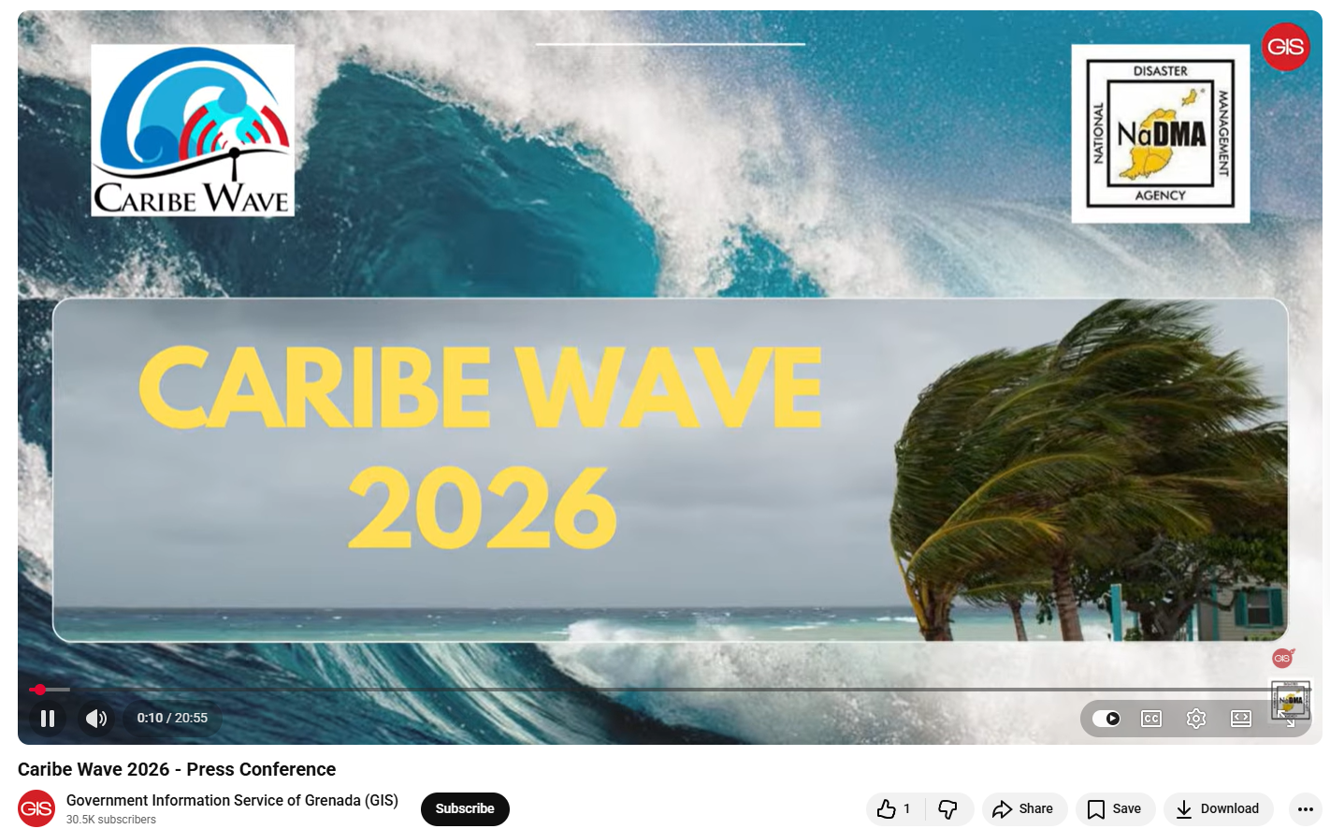
Date of publication: March 16, 2026
Retrieved from: https://www.youtube.com/watch?v=qZus2VQaGyc
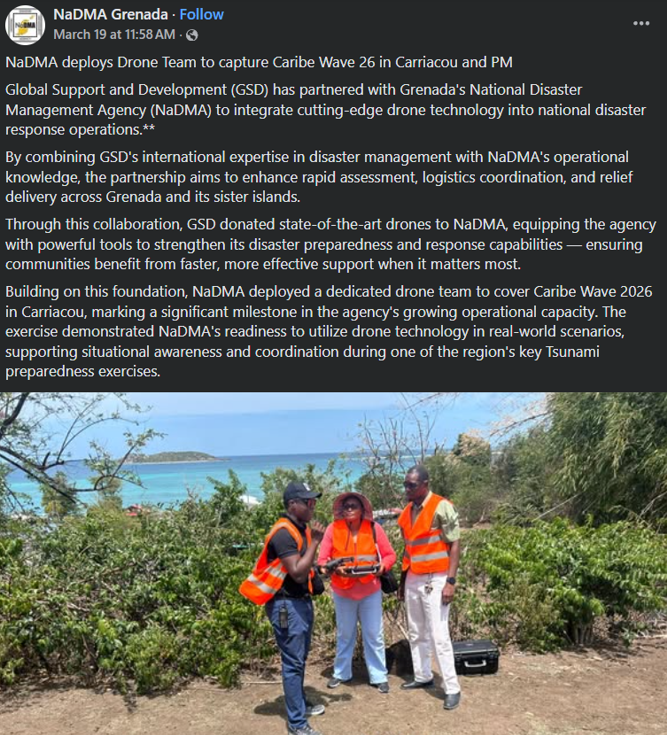
Date of publication: March 19, 2026
Retrieved from: https://www.facebook.com/nadmagnd/posts/pfbid02LNXdBKsgAUufrWDG2ZwDw16aDhxFUXg24V7ohwBXc9uJZqn9HSw2RbJoVscoKnmVl

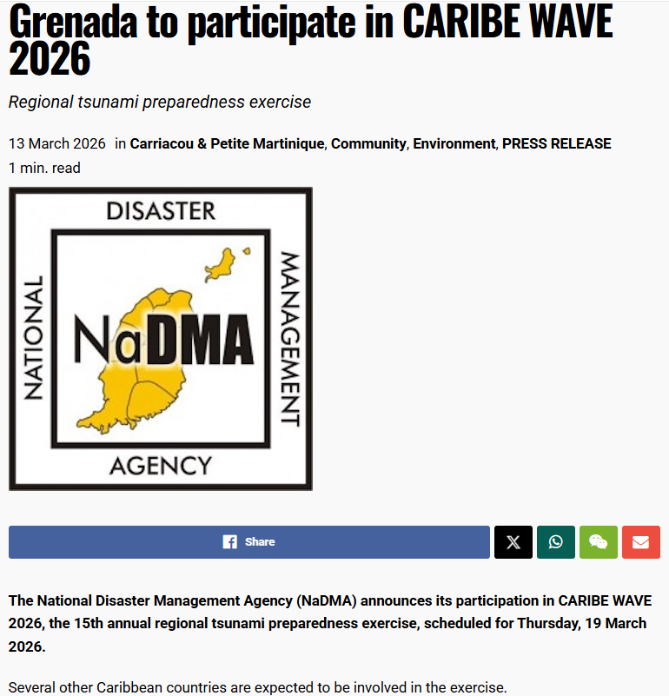
Date of publication: March 13, 2026
Retrieved from: https://nowgrenada.com/2026/03/grenada-to-participate-in-caribe-wave-2026/
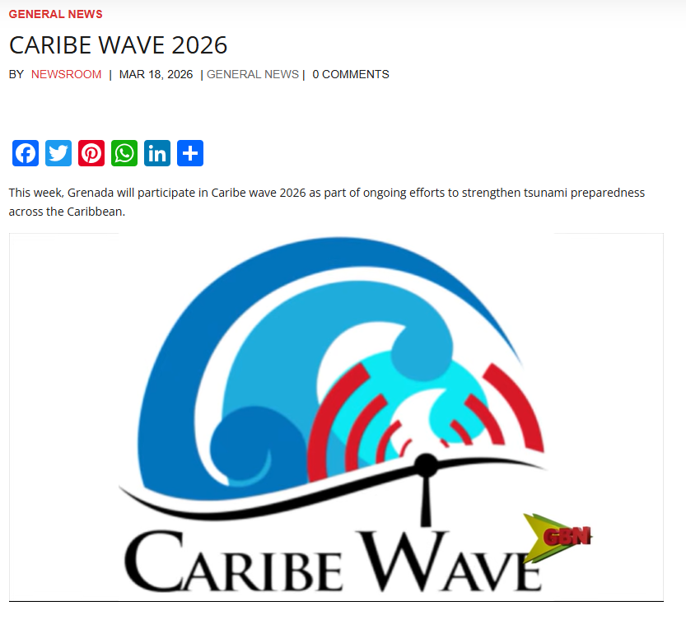
Date of publication: March 18, 2026
Retrieved from: https://gbn.gd/caribe-wave-2026/

Guatemala
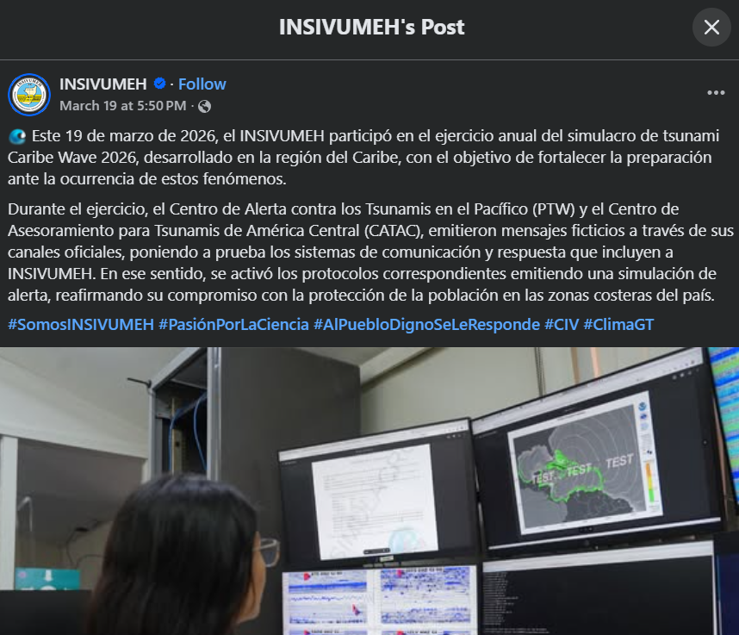
Date of publication: March 19, 2026
Retrieved from: https://www.facebook.com/100064673203154/posts/1377708644394896/?mibextid=wwXIfr%20-----%20https%3A%2F%2Fwww.facebook.com%2Fshare%2Fr%2F1B23rVtRUx%2F%3Fmibextid%3DwwXIfr&rdid=CXF4LUGB5v2sWphY#

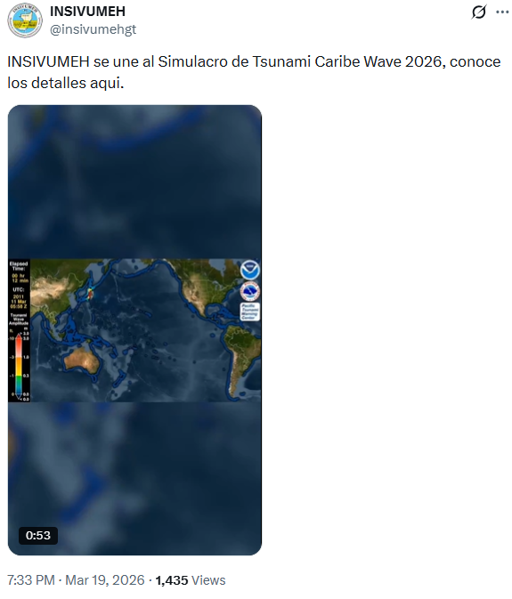
Date of publication: March 19, 2026
Retrieved from: https://x.com/insivumehgt/status/2034775233471631743

Haiti

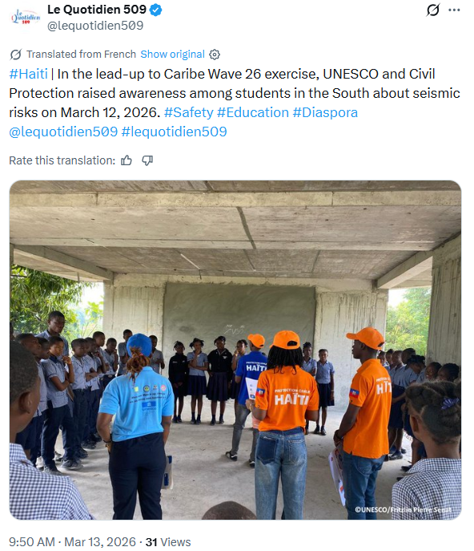
Date of publication: March 13, 2026
Retrieved from: https://x.com/lequotidien509/status/2032454129118007800

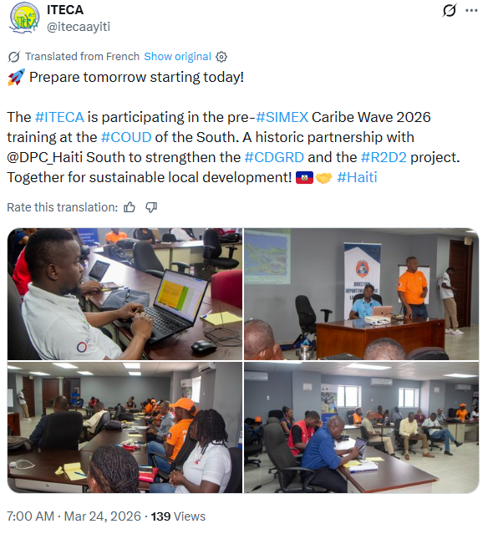
Date of publication: March 24, 2026
Retrieved from: https://x.com/itecaayiti/status/2036397614736834914

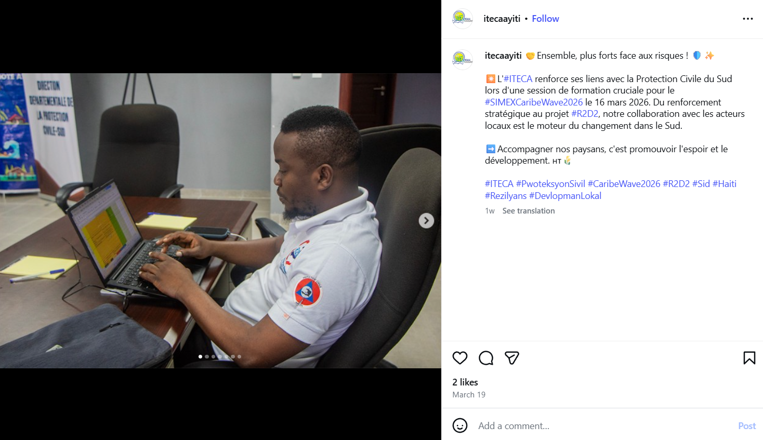
Date of publication: March 19, 2026
Retrieved from: https://www.instagram.com/p/DWEjcUWCpjN/

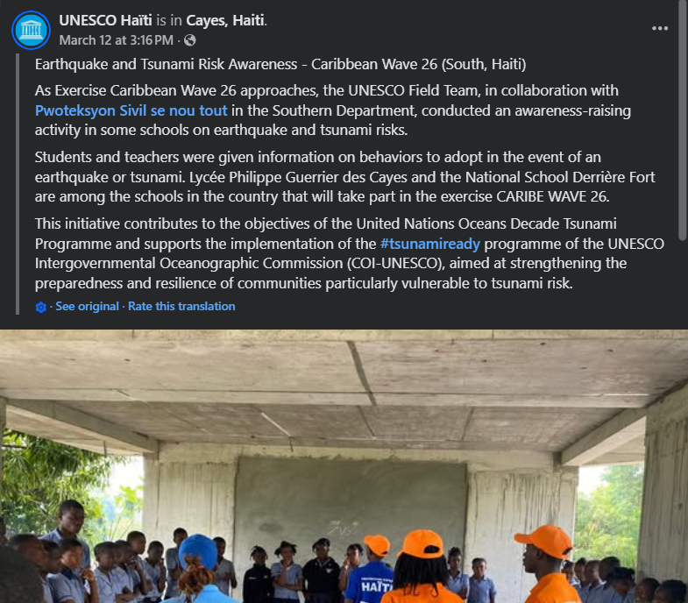
Date of publication: March 12, 2026
Retrieved from: https://www.facebook.com/UnescoHaiti/posts/sensibilisation-sur-les-risques-sismiques-et-de-tsunami-caribe-wave-26-sud-ha%C3%AFti/946077971100030/

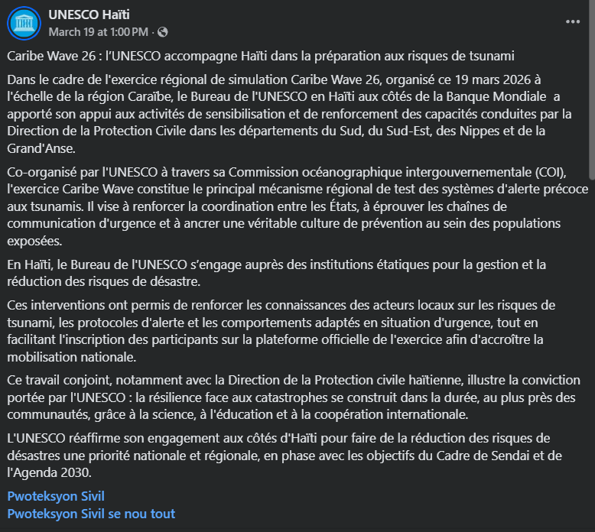
Date of publication: March 19, 2026
Retrieved from: https://www.facebook.com/UnescoHaiti/posts/pfbid0KBQF5CauJ8K7hW4JYm89AgpanZ2BGCdvasA2Up9poSDk1RVGJ39v64W8eGQQw2o2l

Honduras
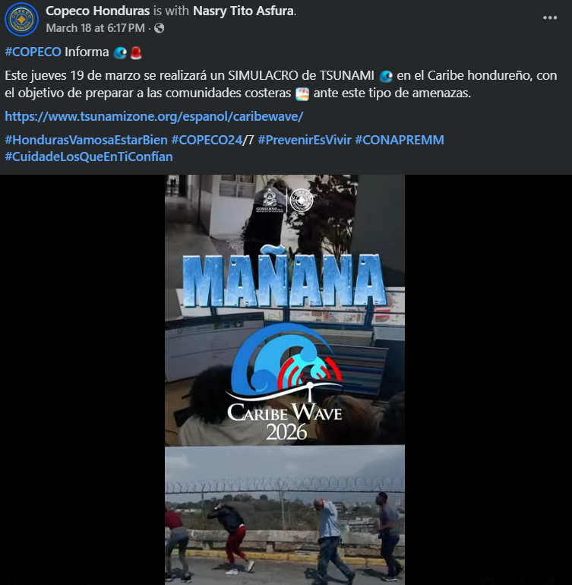
Date of publication: March 18, 2026
Retrieved from: https://www.facebook.com/reel/2409333399513804

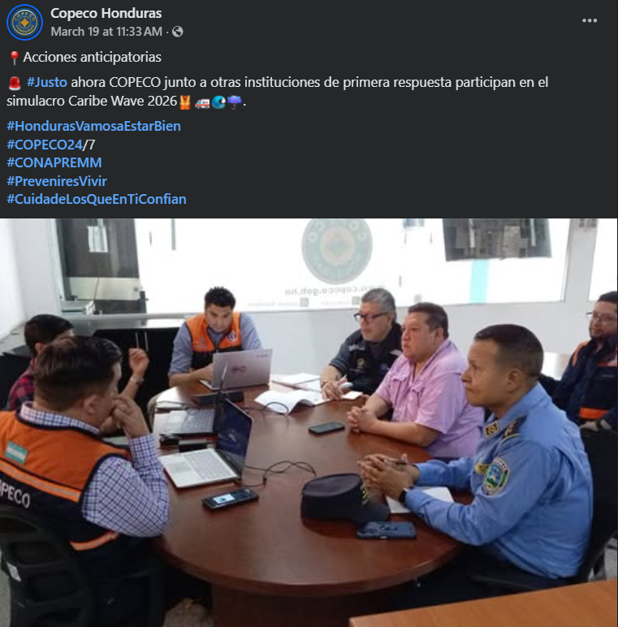
Date of publication: March 19, 2026
Retrieved from: https://www.facebook.com/permalink.php?story_fbid=pfbid0JcxsCqELNUED3NgZo74PG4ahc9ESSuz5rXpoGjshpFbGxxj8BwRpNjydxu4N4qAyl&id=61562724550067

Date of publication: March 19, 2026
Retrieved from: https://www.facebook.com/100090372782082/videos/1444983883733018

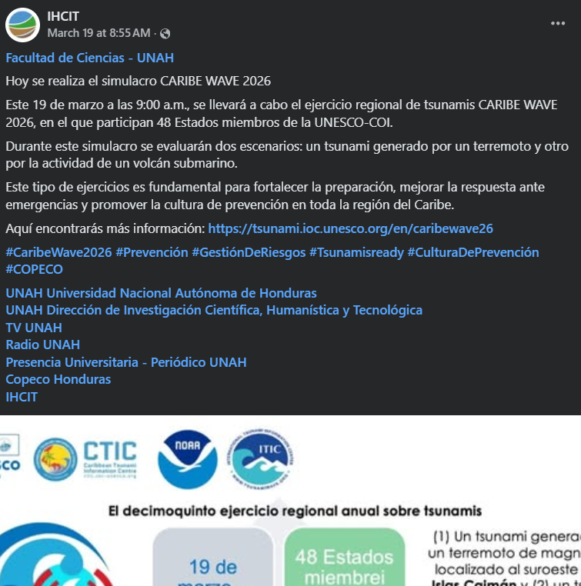
Date of publication: March 19, 2026
Retrieved from: https://www.facebook.com/IHCIT/posts/pfbid02arMVWc9TV9yASzQme2nHXdq2rZZTDSQByVYUokXvpodKUdcpho9abECQTD1nz8YQl

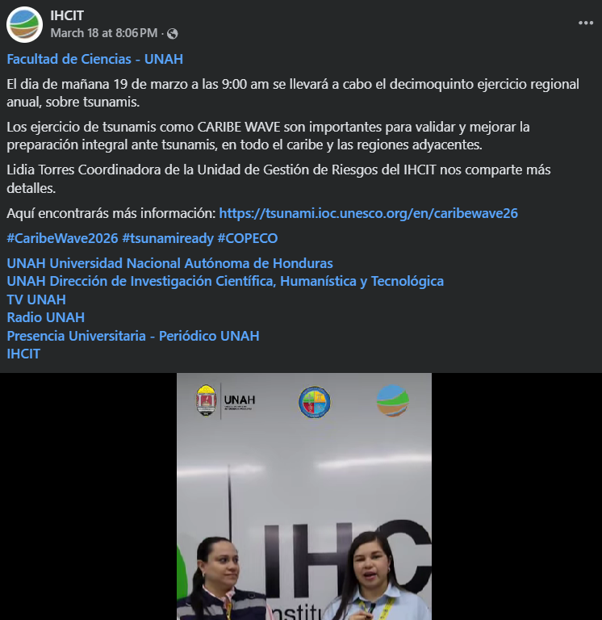
Date of publication: March 18, 2026
Retrieved from: https://www.facebook.com/reel/26170283925964808

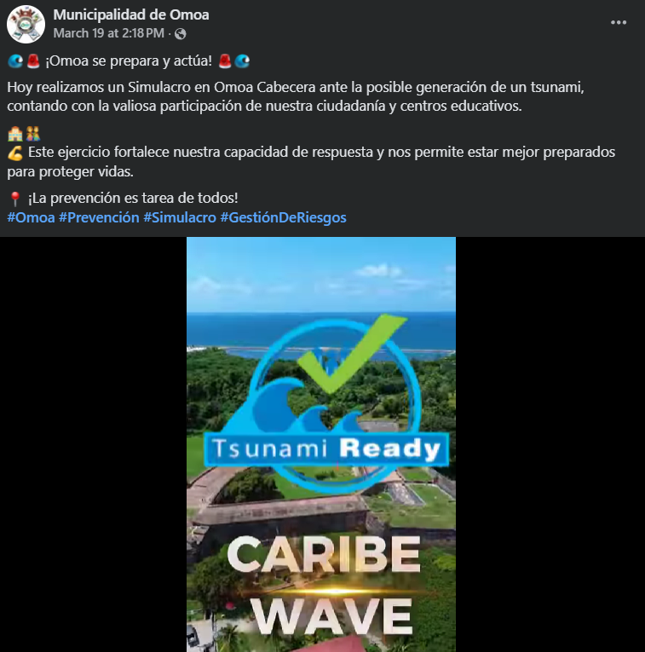
Date of publication: March 19, 2026
Retrieved from: https://www.facebook.com/reel/1256438962581153

Jamaica
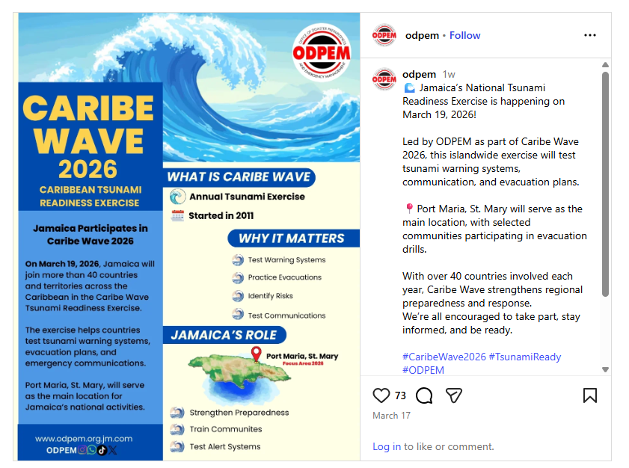
Date of publication: March 17, 2026
Retrieved from: https://www.instagram.com/p/DV_h0pAjgne/

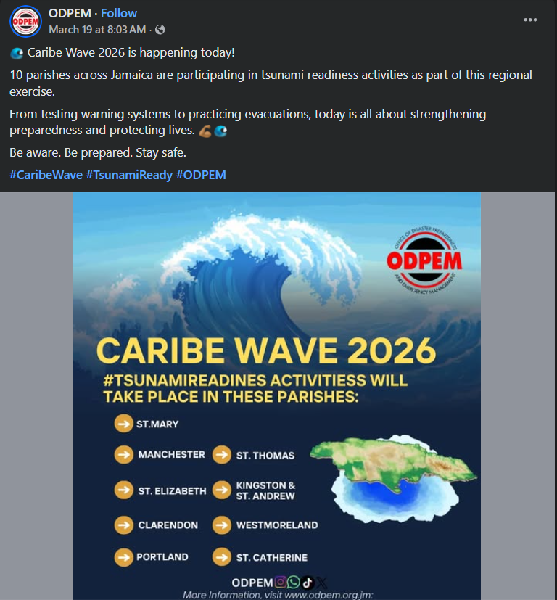
Date of publication: March 19, 2026
Retrieved from: https://www.facebook.com/ODPEM.JA/posts/pfbid02jf8WKigVJtHA3VkwALBKVXZgjk9YeiFLXSpULGkdZHJtgamXSRf6ZNyeMZpfm8nPl

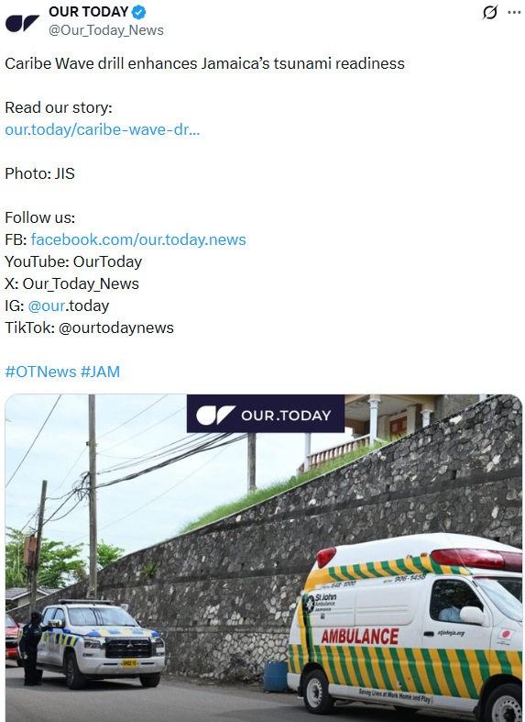
Date of publication: March 24, 2026
Retrieved from: https://x.com/Our_Today_News/status/2036458789931516176

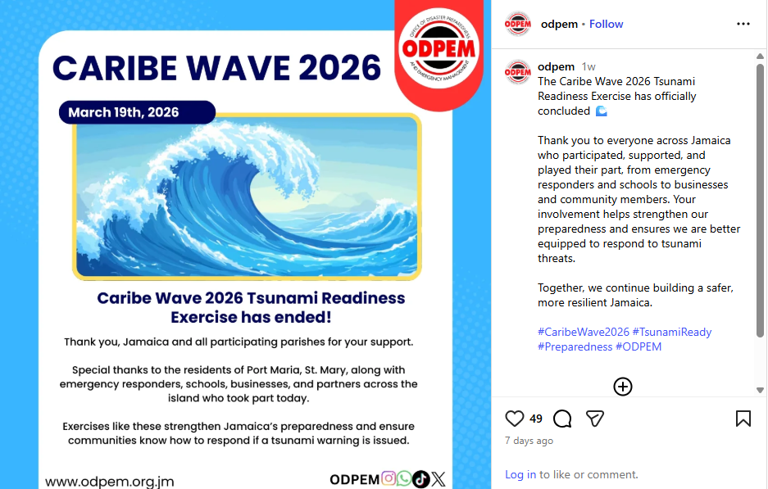
Date of publication: March 19, 2026
Retrieved from: https://www.instagram.com/p/DWFdywxD9Sb/

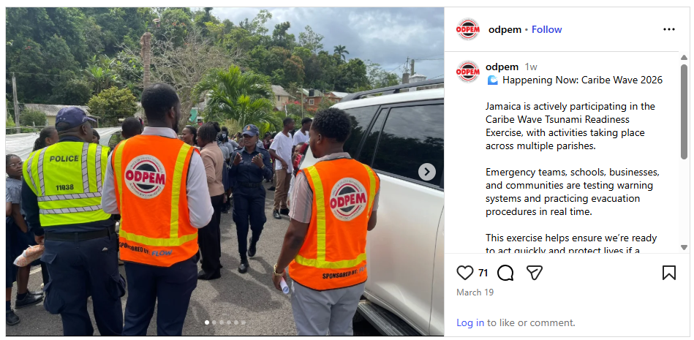
Date of publication: March 19, 2026
Retrieved from: https://www.instagram.com/p/DWEkDB6jmYI/

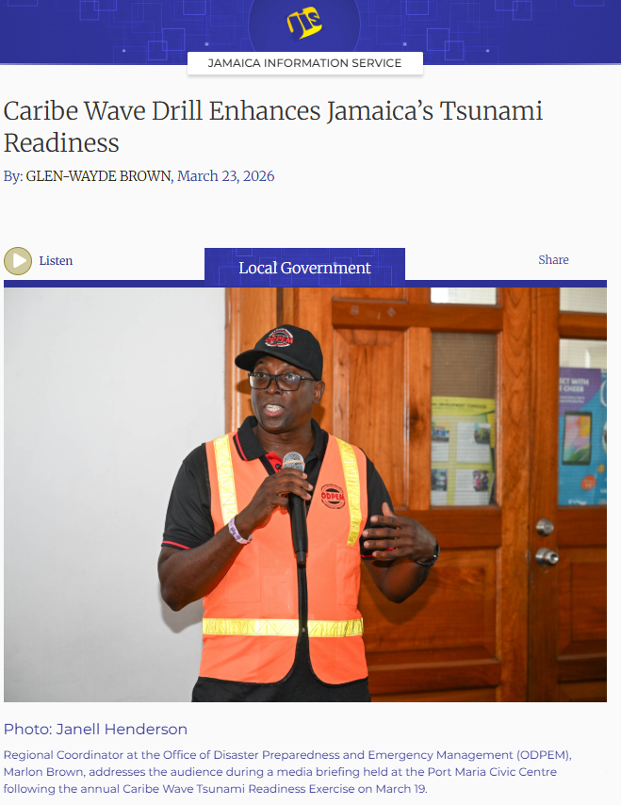
Date of publication: March 23, 2026
Retrieved from: https://jis.gov.jm/caribe-wave-drill-enhances-jamaicas-tsunami-readiness/

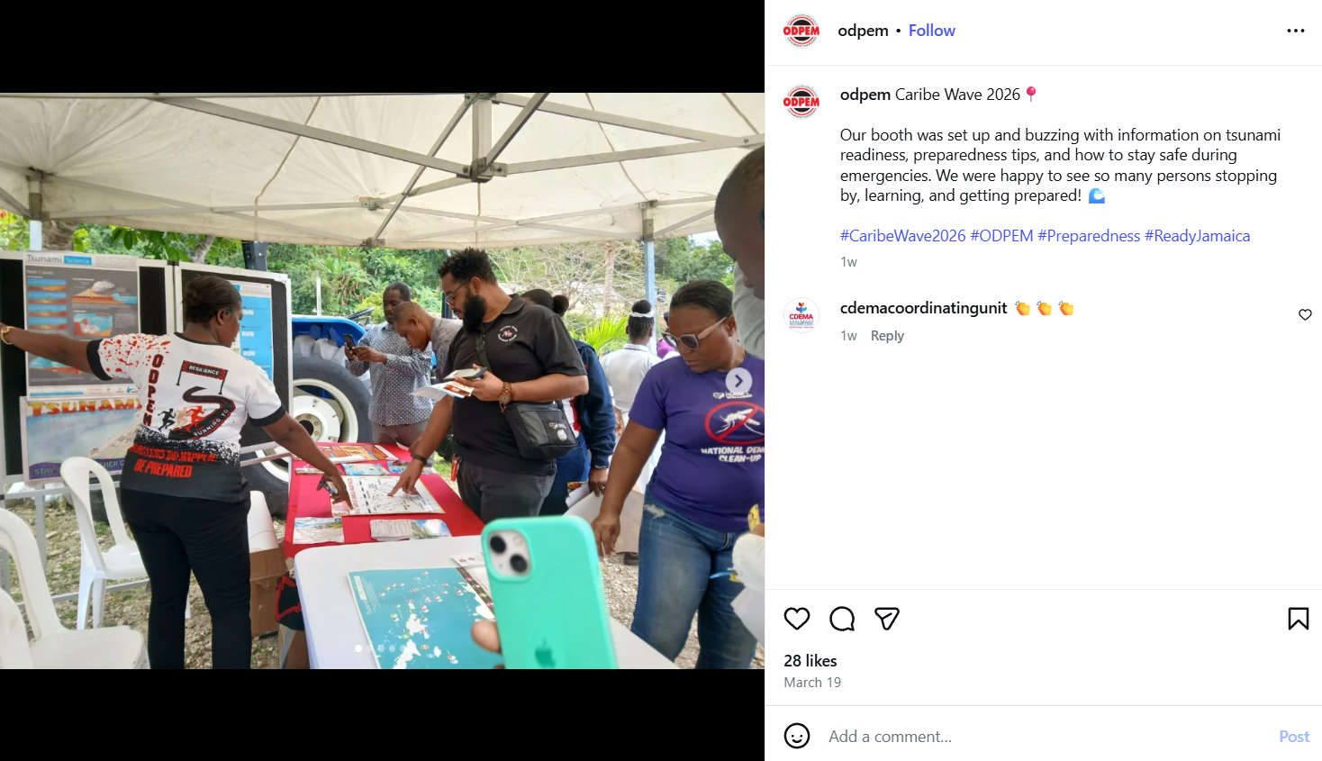
Date of publication: March 19, 2026
Retrieved from: https://www.instagram.com/p/DWFLbOgD7ek/

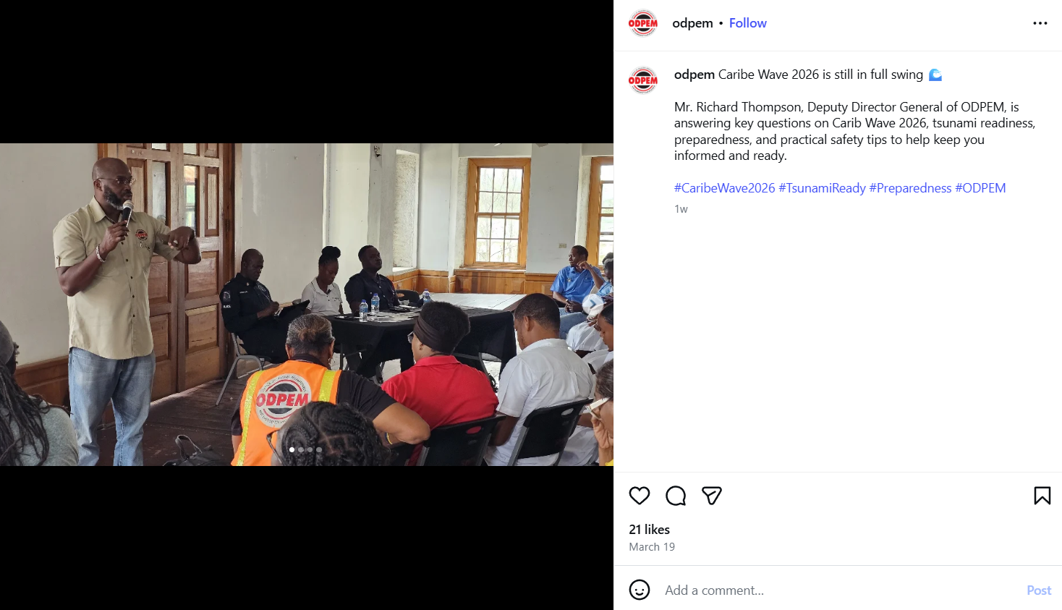
Date of publication: March 19, 2026
Retrieved from: https://www.instagram.com/p/DWE-U61j3ci/

Mexico
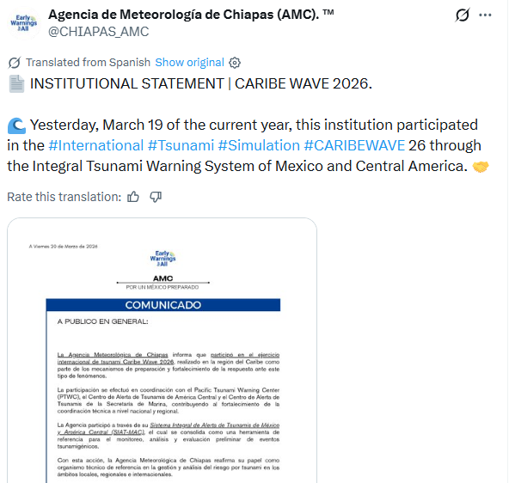
Date of publication: March 20, 2026
Retrieved from: https://x.com/CHIAPAS_AMC/status/2035122907043508616

Netherlands

Sint Maarten
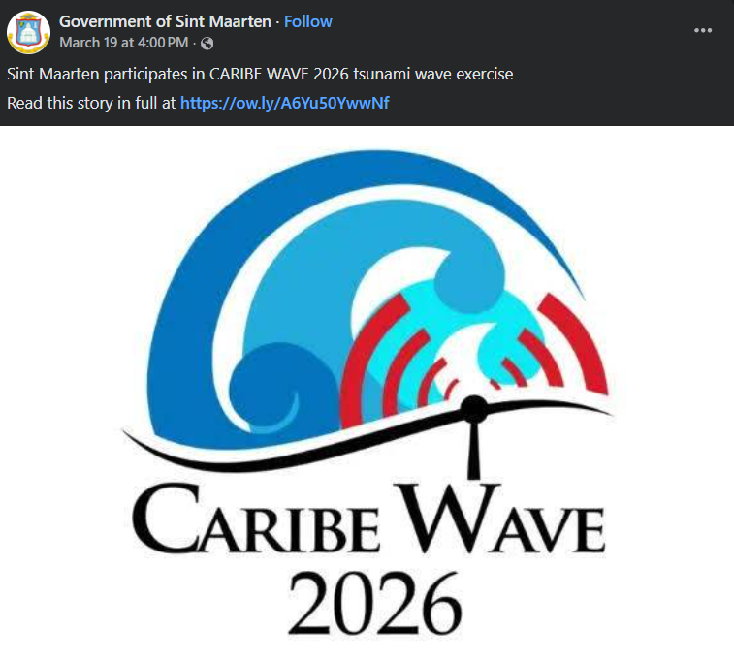
Date of publication: March 19, 2026
Retrieved from: https://www.facebook.com/SXMGOV/posts/pfbid02GrdhUwnStwc8mFhztfixA4H4o1qe6hq1Qd1b5D9x5BeYmht4oJBroxK43Ri7bhsul

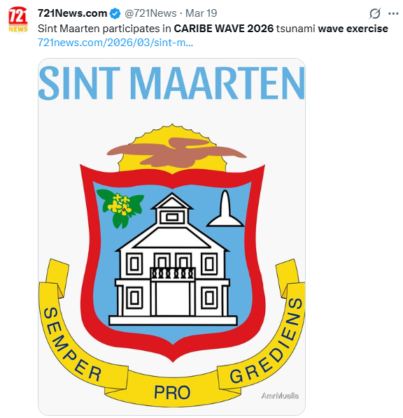
Date of publication: March 19, 2026
Retrieved from: https://x.com/721News/status/2034716398602072104

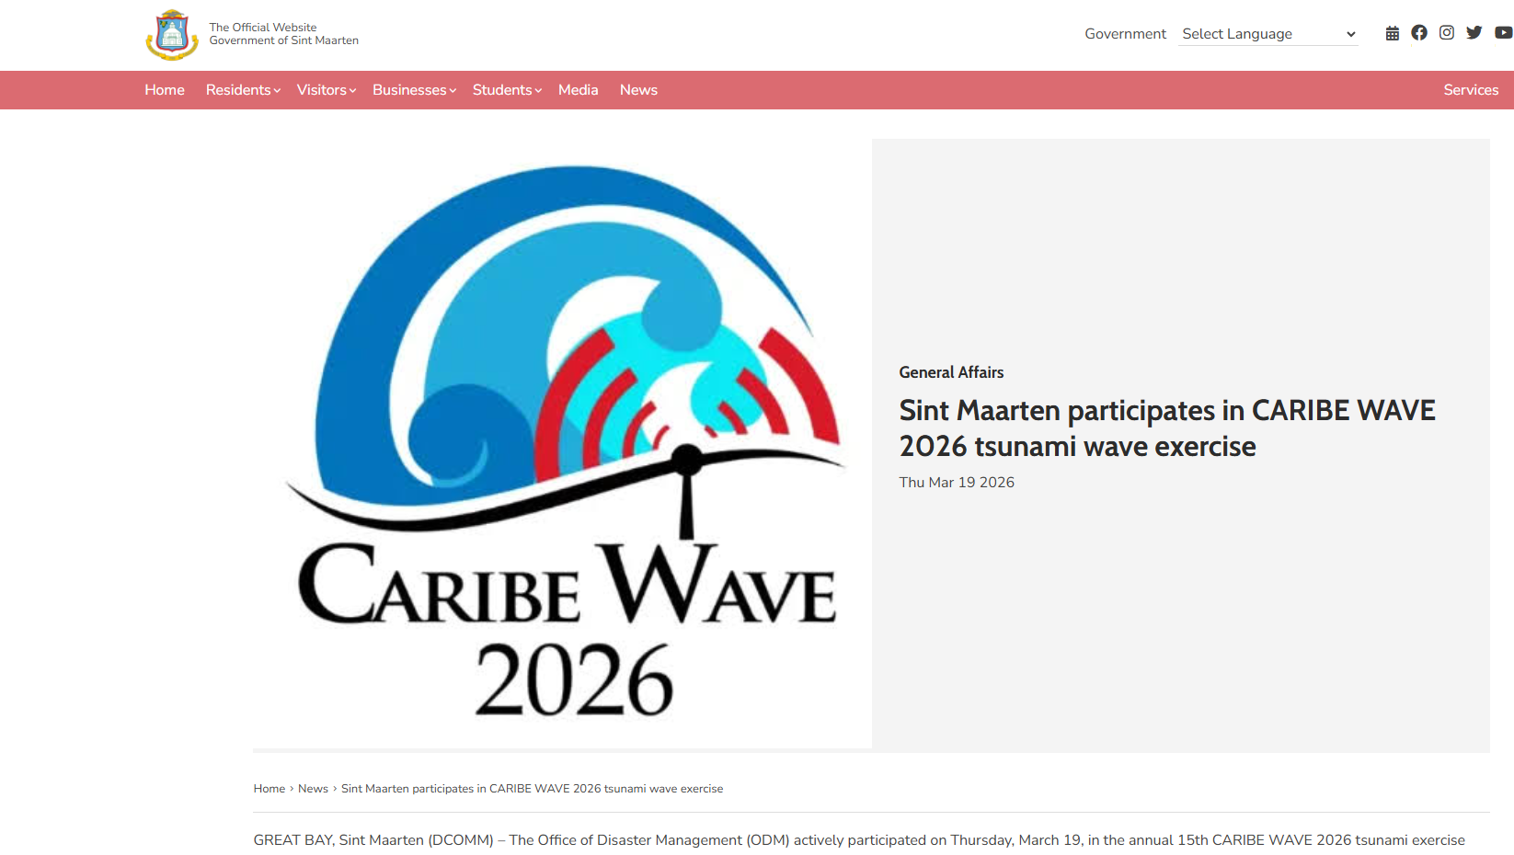
Date of publication: March 19, 2026
Retrieved from: https://www.sintmaartengov.org/news/pages/Sint-Maarten-participates-in-CARIBE-WAVE-2026-tsunami-wave-exercise.aspx

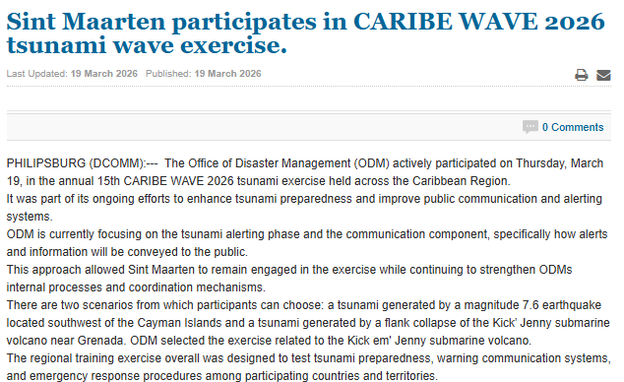
Date of publication: March 19, 2026
Retrieved from: https://smn-news.com/index.php/st-maarten-st-martin-news/50241-sint-maarten-participates-in-caribe-wave-2026-tsunami-wave-exercise.html
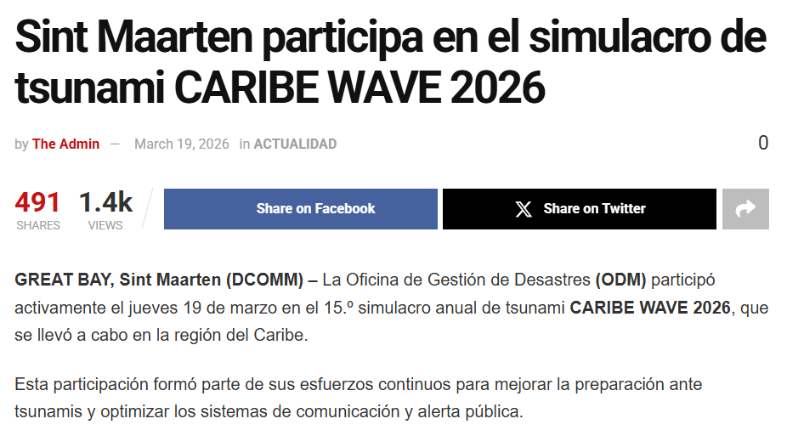
Date of publication: March 19, 2026
Retrieved from: https://sxmislandtime.com/sint-maarten-participa-en-el-simulacro-de-tsunami-caribe-wave-2026/

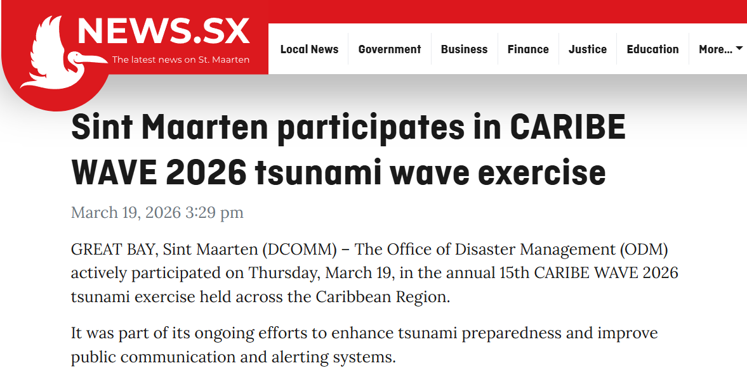
Date of publication: March 19, 2026
Retrieved from: https://news.sx/government/sint-maarten-participates-in-caribe-wave-2026-tsunami-wave-exercise/

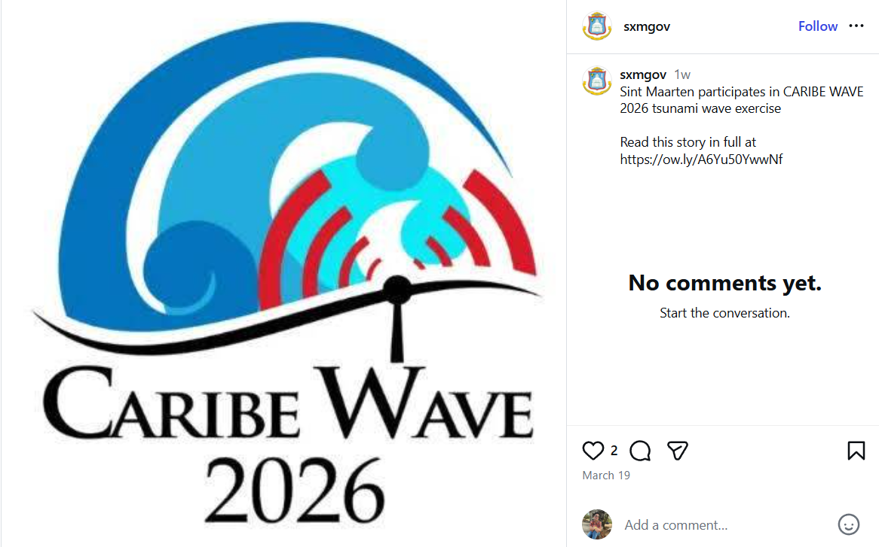
Date of publication: March 19, 2026
Retrieved from: https://www.instagram.com/p/DWFCHyVkeQW/

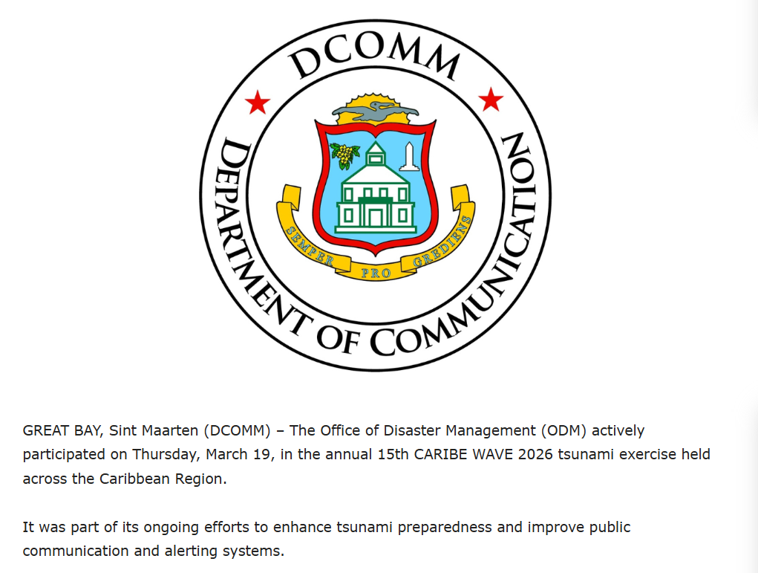
Date of publication: March 19, 2026
Retrieved from: https://www.sxm-talks.com/local-news/sint-maarten-participates-in-caribe-wave-2026-tsunami-wave-exercise-government-of-sint-maarten/

Saint Kitts and Nevis
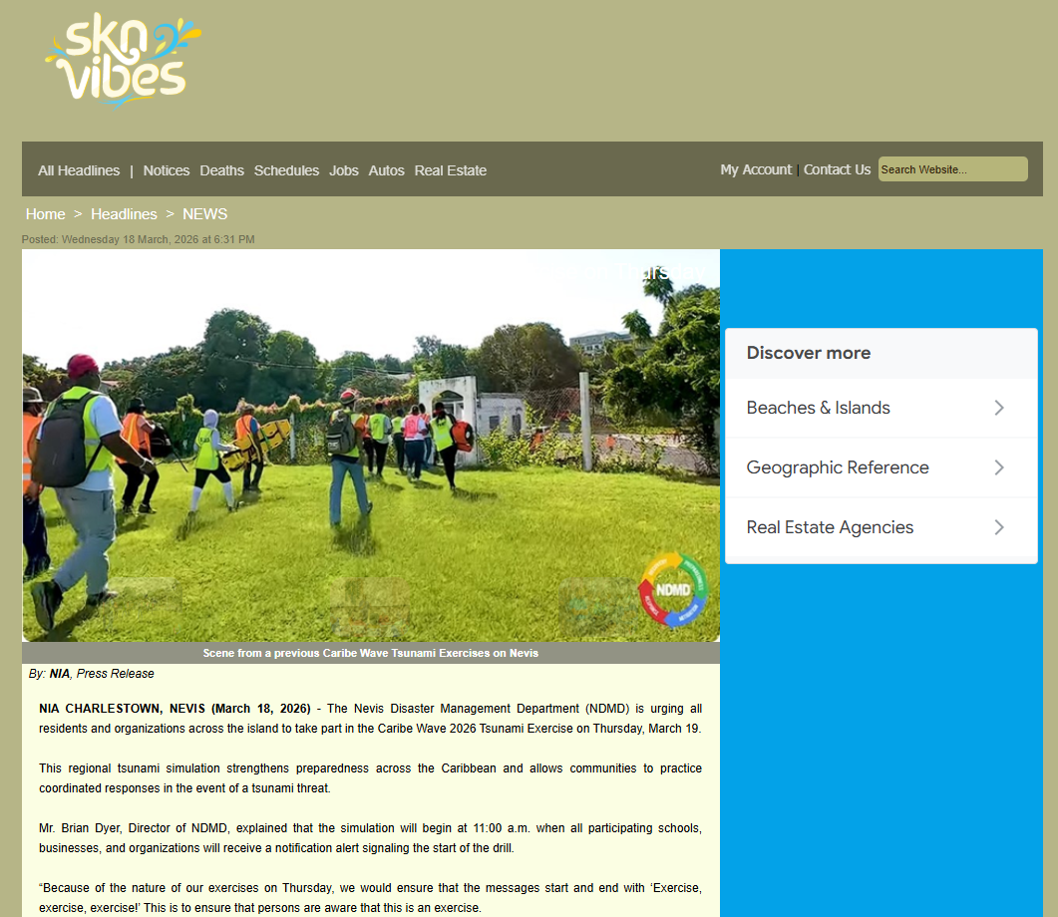
Date of publication: March 18, 2025
Retrieved from: https://www.sknvibes.com/news/newsdetails.cfm/127121#google_vignette

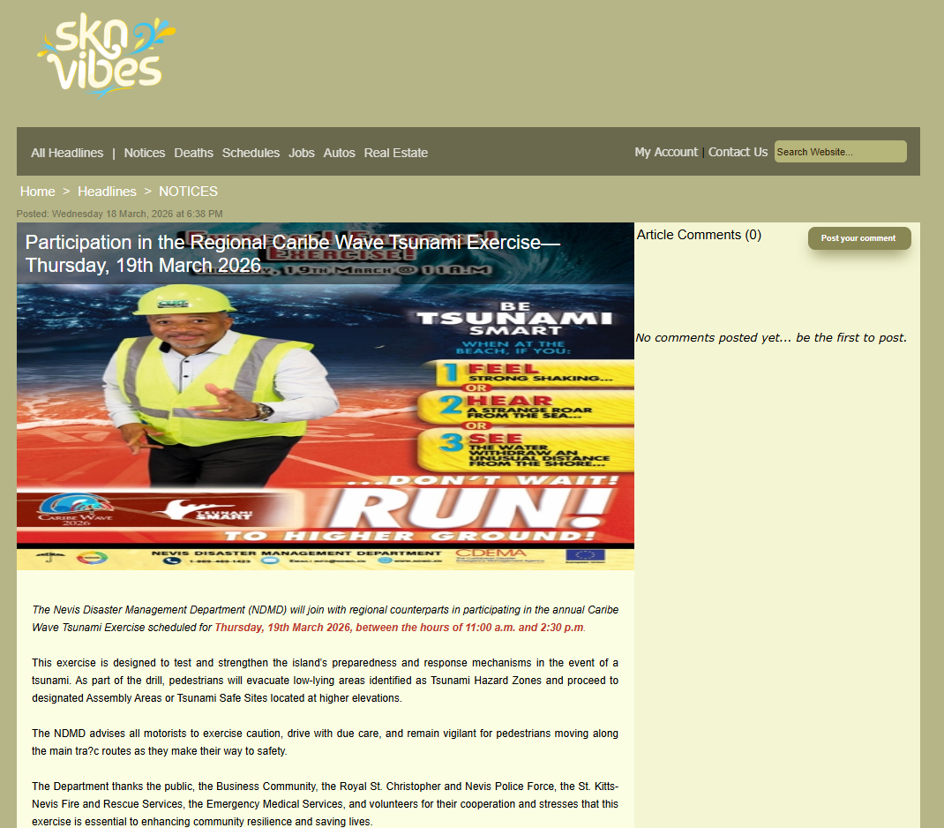
Date of publication: March 18, 2026
Retrieved from: https://www.sknvibes.com/news/newsdetails.cfm/127122

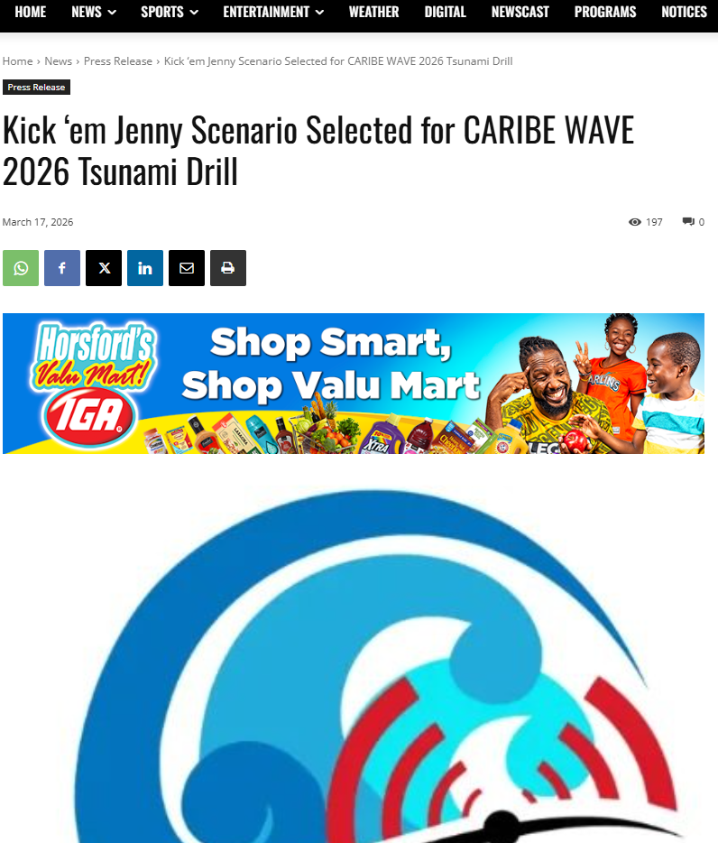
Date of publication: March 17, 2026
Retrieved from: https://www.winnmediaskn.com/kick-em-jenny-scenario-selected-for-caribe-wave-2026-tsunami-drill/

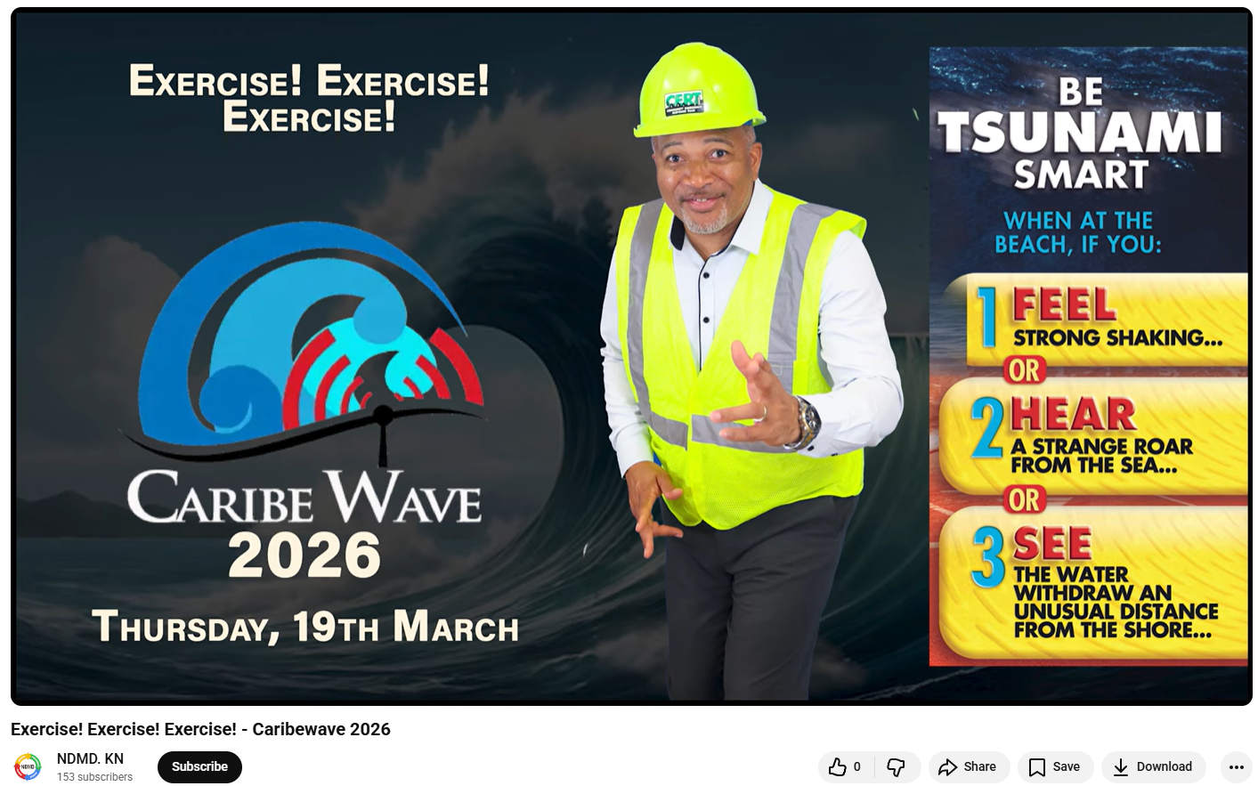
Date of publication: March 17, 2026
Retrieved from: https://www.youtube.com/watch?v=CsQoTViNlgk

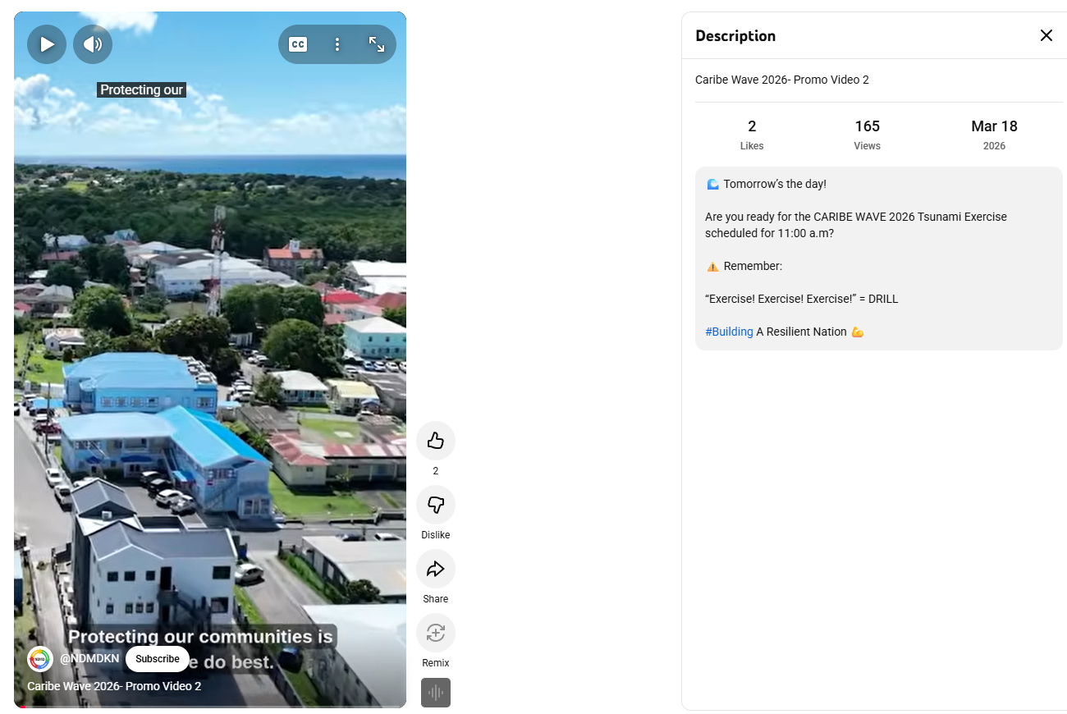
Date of publication: March 18, 2026
Retrieved from: https://www.youtube.com/shorts/wqAWWKUKew4

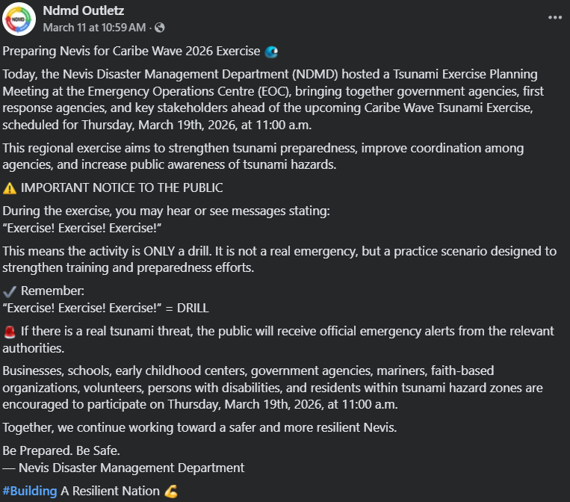
Date of publication: March 11, 2026
Retrieved from: https://www.facebook.com/NDMD.MEDIA/posts/pfbid0zXnJZpERvyK78RaTZ5cv4NajRr2EVwhhfsknhH3akHDcSF17RD5K15Ngo9uGD28il

Saint Lucia
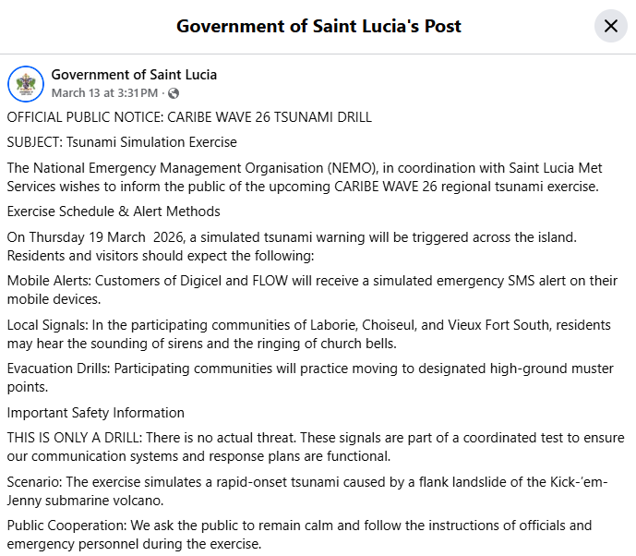
Date of publication: March 13, 2026
Retrieved from: https://www.facebook.com/SaintLuciaGovernment/posts/official-public-notice-caribe-wave-26-tsunami-drill-subject-tsunami-simulation-e/1263780309279770/

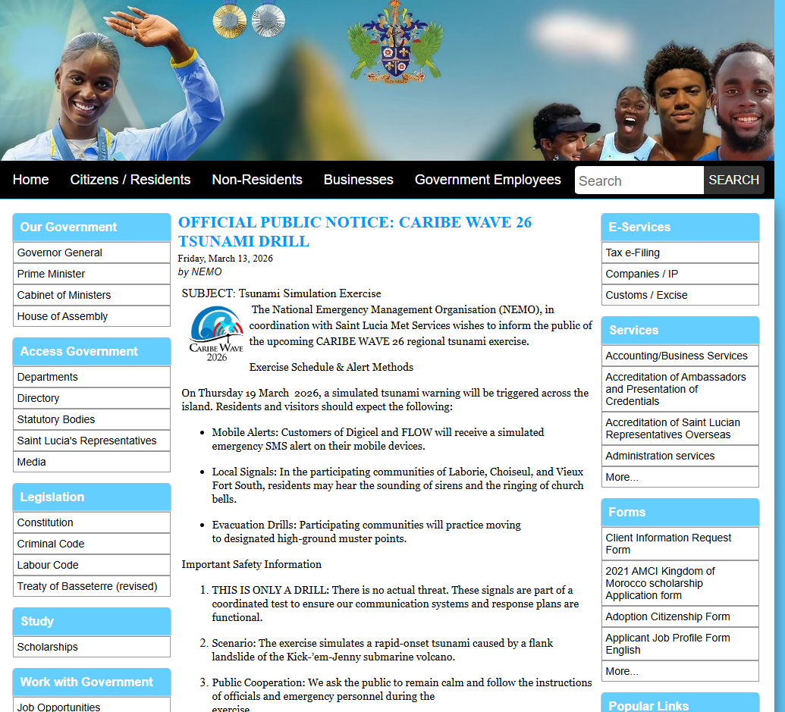
Date of publication: March 13, 2026
Retrieved from: https://www.govt.lc/news/official-public-notice-caribe-wave-26-tsunami-drill

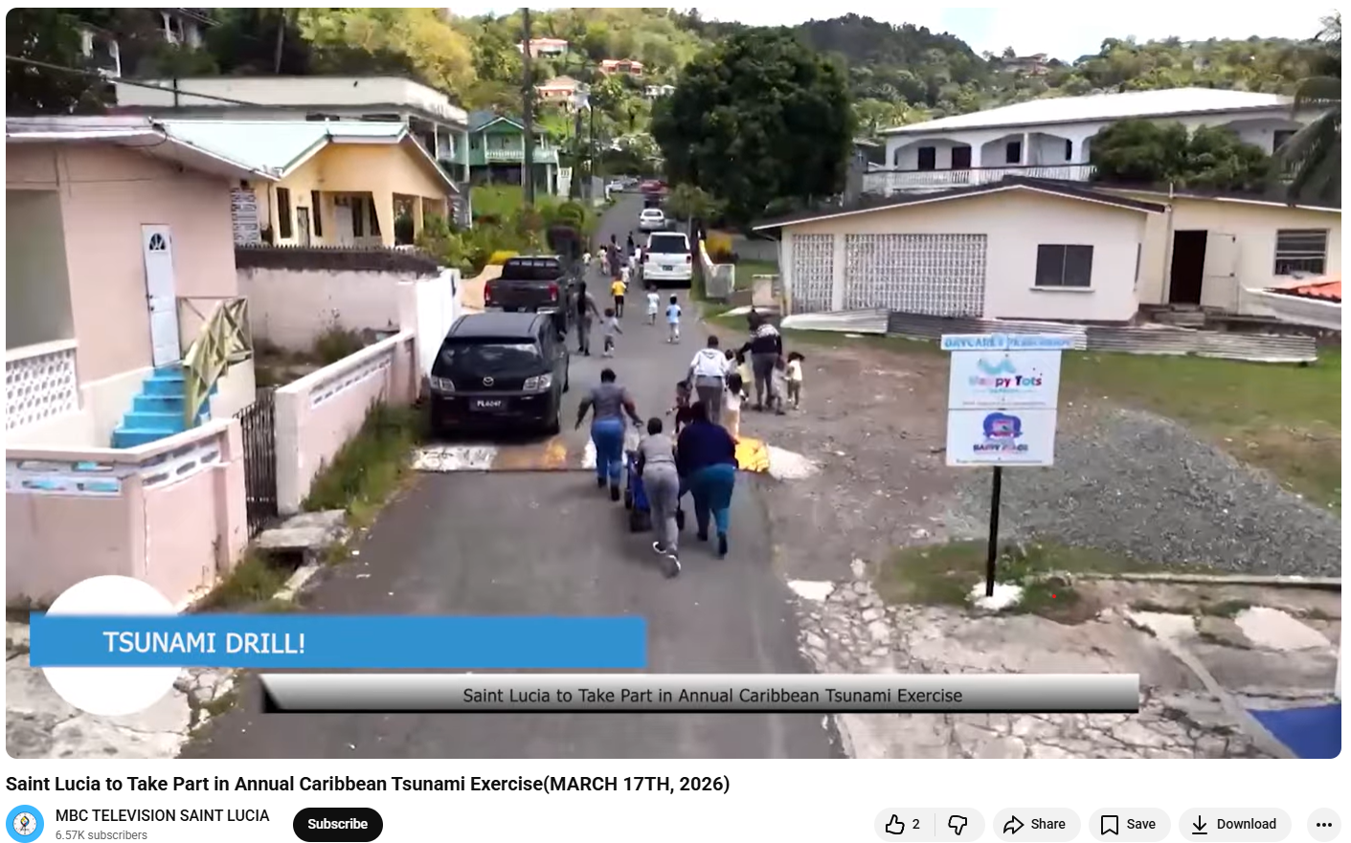Date of publication: March 17, 2026
Retrieved from: https://www.youtube.com/watch?v=pJ3yMWsZ8Dk

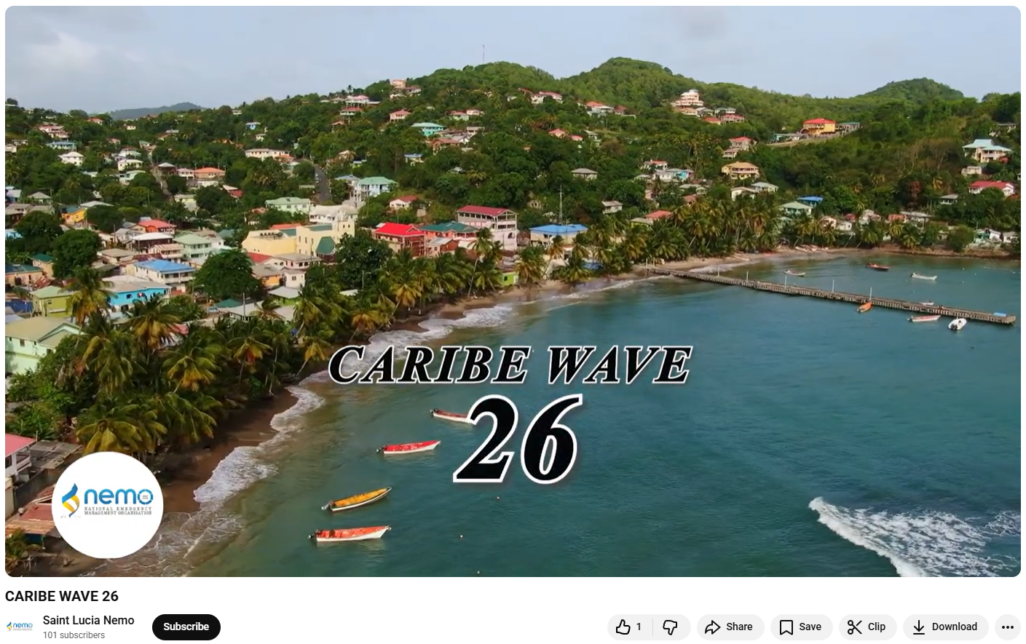
Date of publication: March 24, 2026
Retrieved from: https://www.youtube.com/watch?v=yzw2vCsaT2A

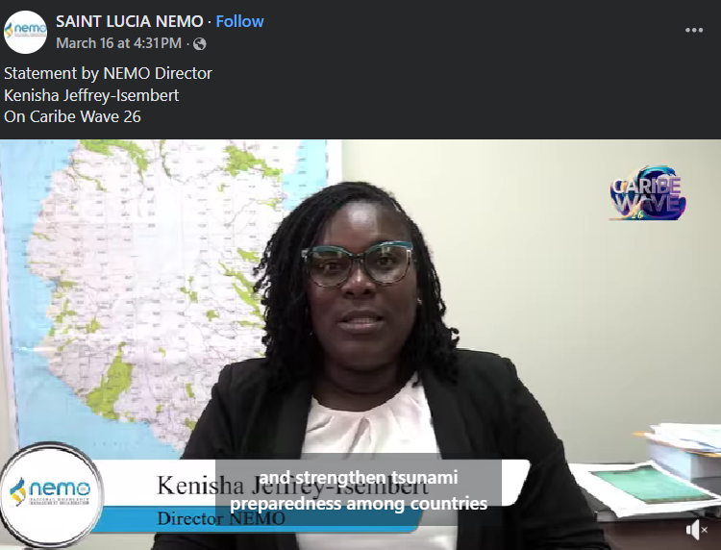
Date of publication: March 16, 2026
Retrieved from: https://www.facebook.com/reel/1413806040064978

Trinidad and Tobago
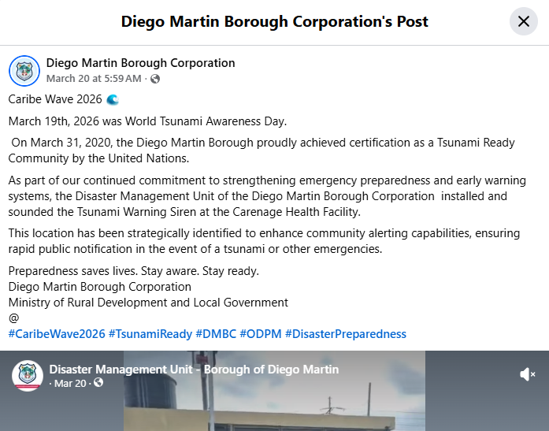
Date of publication: March 20, 2026
Retrieved from: https://www.facebook.com/boroughofdiegomartin/posts/caribe-wave-2026-march-19th-2026-was-world-tsunami-awareness-day-on-march-31-202/1321971969967068/

United Kingdom:

Anguilla
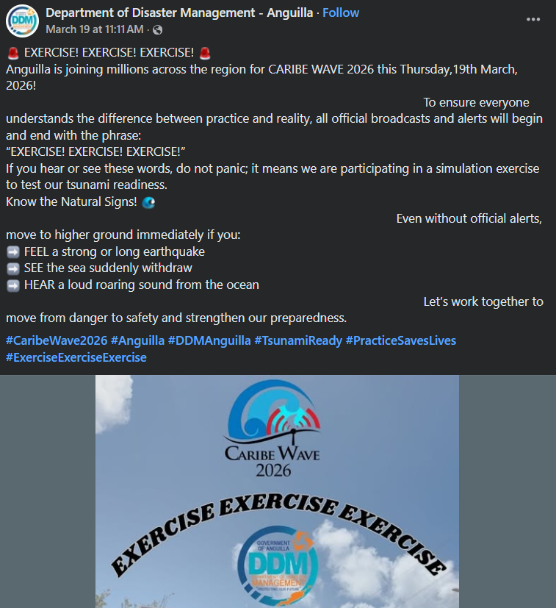
Date of publication: March 19, 2026
Retrieved from: https://www.facebook.com/ddmaxa/posts/pfbid02W5WL6qtn4sFWpfAtQeBxGq7McXXQYnn32mKrx7PpcZjahJCYskppcYfDgEKqZim9l

Bermuda
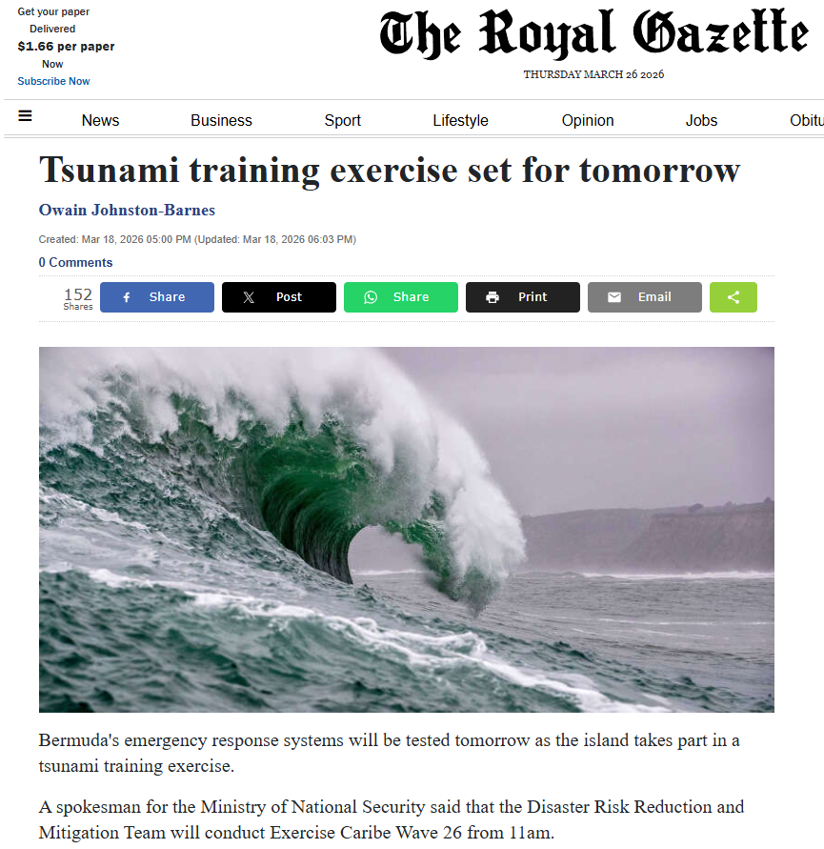
Date of publication: March 18, 2026
Retrieved from: https://www.royalgazette.com/general/news/article/20260318/tsunami-training-exercise-set-for-tomorrow/

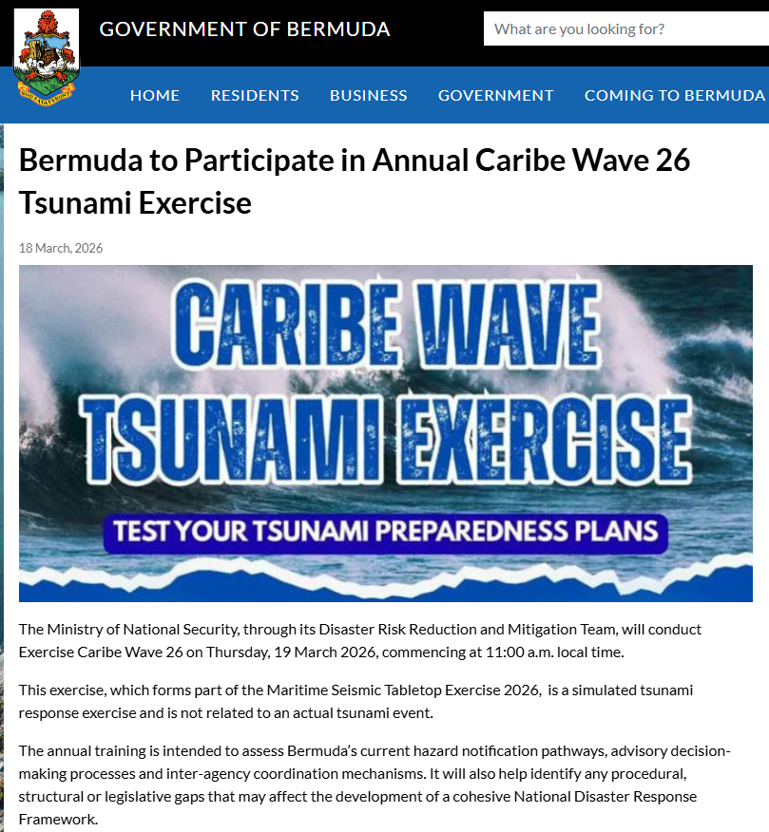
Date of publication: March 18, 2026
Retrieved from: https://www.gov.bm/articles/bermuda-participate-annual-caribe-wave-26-tsunami-exercise

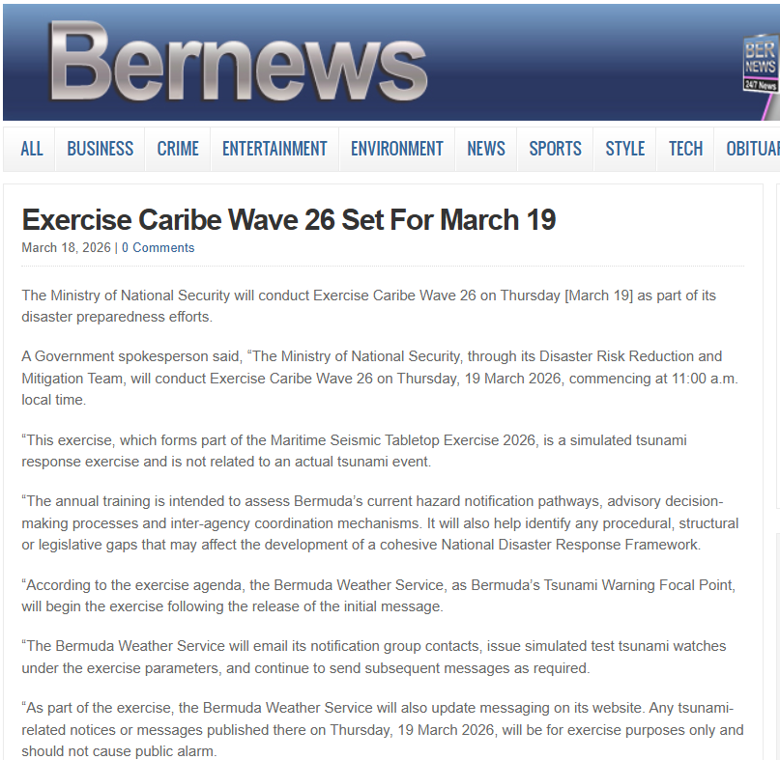
Date of publication: March 18, 2026
Retrieved from: https://bernews.com/2026/03/exercise-caribe-wave-26-set-for-march-19/

British Virgin Islands

Date of publication: March 18, 2026
Retrieved from: https://www.facebook.com/bvi.ddm/posts/thanks-to-jtv-channel-55-for-having-our-deputy-director-michel-ambrose-in-the-st/1371080081716503/

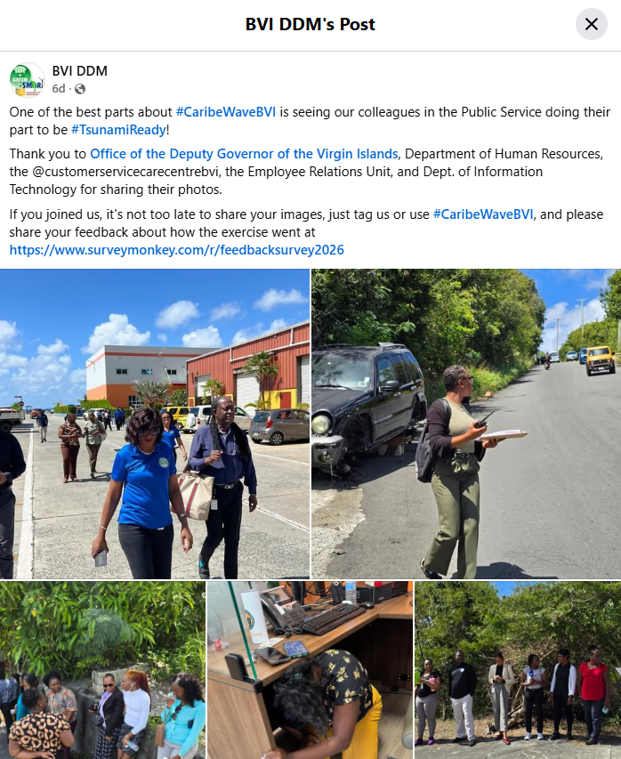Date of publication: March 19, 2026
Retrieved from: https://www.facebook.com/bvi.ddm/posts/pfbid0EjsrtnKpc3mK3ss9SMzR6HE322yn7VmihWwgC7jLFDfAwcnhqrQHwTMZ9HN8LdE2l?rdid=O3dRuoDUIr1SaZ0D#

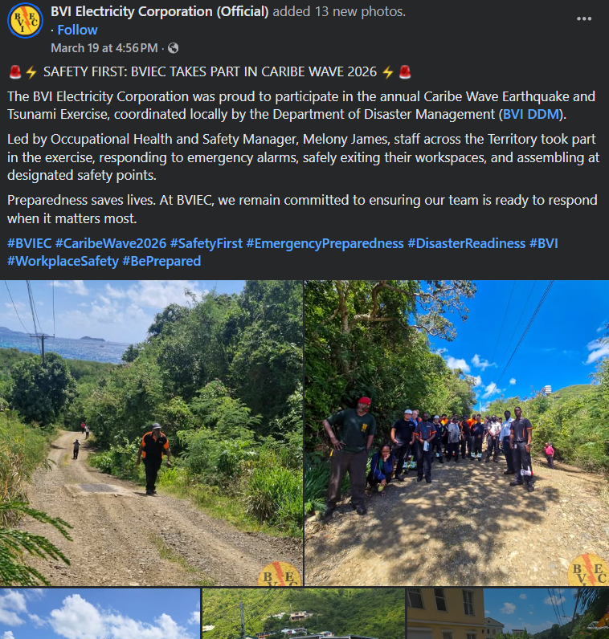
Date of publication: March 19, 2026
Retrieved from: https://www.facebook.com/bvielectricity/posts/pfbid0wrp6NEGEaJvDJ3Y4bMS26hCeL7GL46xzKN8iCTCxc25R1Eo5bPVymG6CCkx1kaXSl

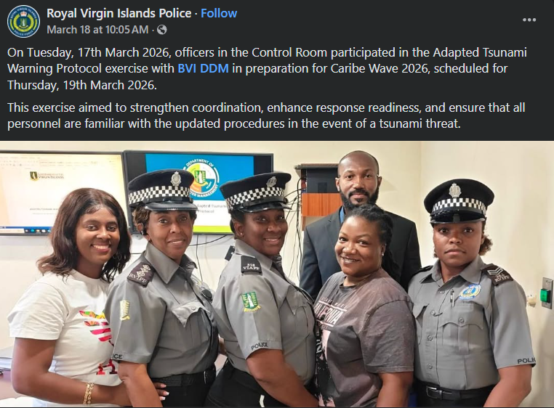
Date of publication: March 18, 2026
Retrieved from: https://www.facebook.com/rvipolice/posts/pfbid0359tft9CyeYnSntBQMdXEVsnTN9pwJEbqhtnVVA6uMywaEqTNm3ZTXEjxrX7QTdUKl
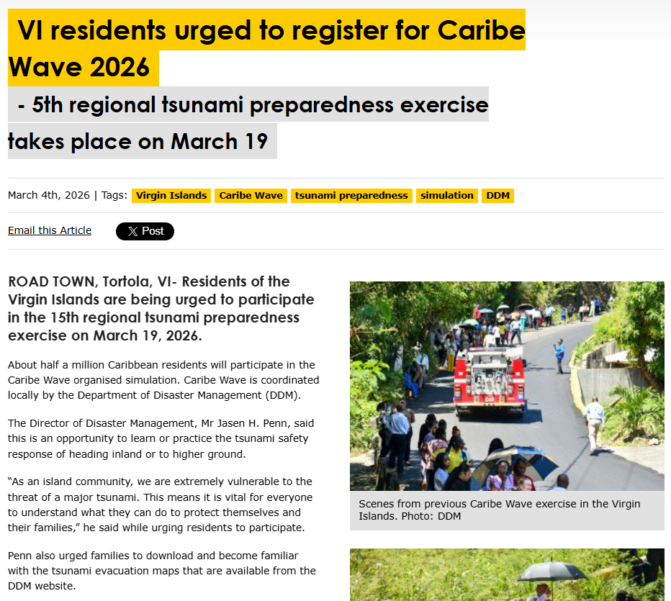
Date of publication: March 4, 2026
Retrieved from: https://www.virginislandsnewsonline.com/en/news/vi-residents-urged-to-register-for-caribe-wave-2026?fbclid=IwY2xjawQzsDpleHRuA2FlbQIxMABicmlkETFucXdnelBVVFpHMm15OUdFc3J0YwZhcHBfaWQQMjIyMDM5MTc4ODIwMDg5MgABHk-HGPNG78liRTpmd70aH7weL2NSJzGZRIv46KSxYqqD55qLSSlpkzBfV9qU_aem_wYYNdCrpWMzc95g31u-RiQ

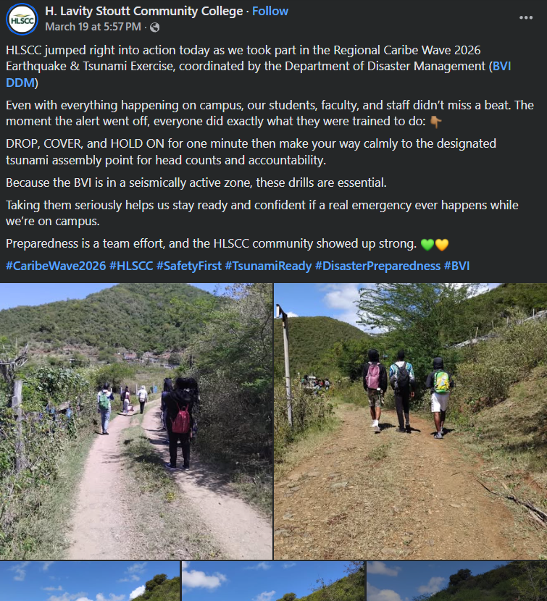
Date of publication: March 19, 2026
Retrieved from: https://www.facebook.com/hlsccvg/posts/pfbid02jjAr3yy3pU5NuWSR6gnHdidhWCtbauUmyUXwb2xjxCUeVC3JZZxcUGLs5TcuKb6Sl

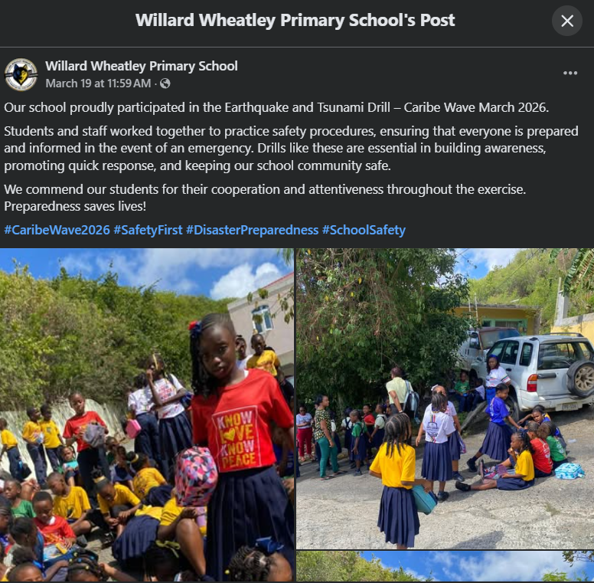
Date of Publication: March 19, 2026
Retrieved from: https://www.facebook.com/permalink.php?story_fbid=pfbid02DgPuFouYuACVPCmUQj6XsQ2oPhLARbAKAtJYaJD1DWjukc8Ec7jo9o5BzvGzZtAel&id=100057044547244

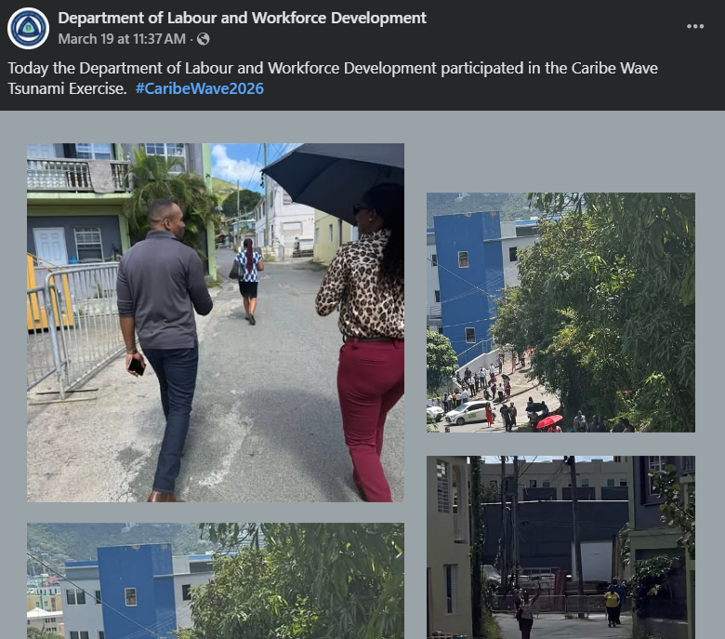
Date of Publication: March 19, 2026
Retrieved from: https://www.facebook.com/permalink.php?story_fbid=pfbid02jSMQY1Nrh2wMBuC9NLL7rqmPJvmv4GXXkuxGfpLNcd9ynqZiQVLFzpXJdrM3dkhjl&id=61573028992570

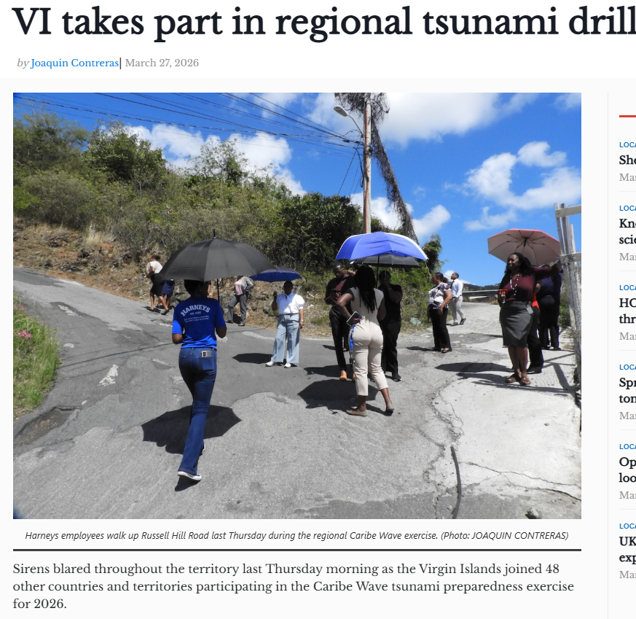
Date of Publication: March 27, 2026
Retrieved from: https://www.bvibeacon.com/vi-takes-part-in-regional-tsunami-drill/

Cayman Islands

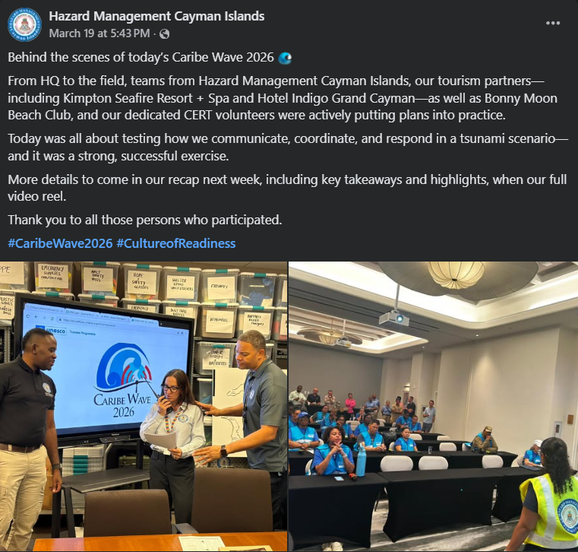
Date of publication: March 19, 2026
Retrieved from: https://www.facebook.com/caymanprepared/posts/pfbid09nstfkvD5sWQ4kDCrm8fnPhhebAfUDCyvj6Qeq4FKr1Adh2kLnM1ZK8eprCAZr9Kl

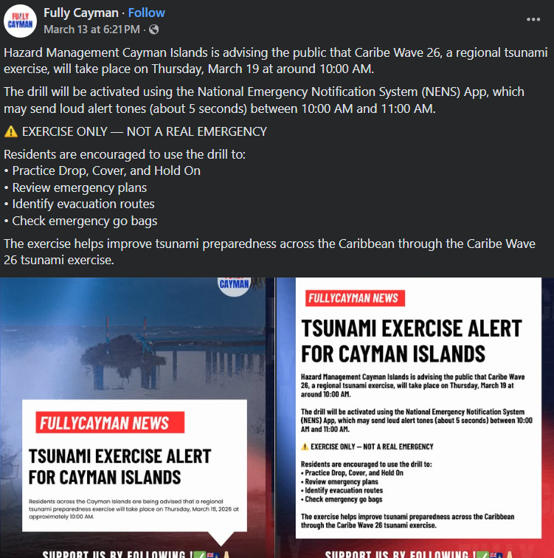
Date of publication: March 13, 2026
Retrieved from: https://www.facebook.com/permalink.php?story_fbid=pfbid03FGG3HTc5FYMksNXrnLPMKh1dNH3R6fb4dMszBnRUrVsrF9pWNr6TxSwp468nTqTl&id=61586215945163

Turks and Caicos
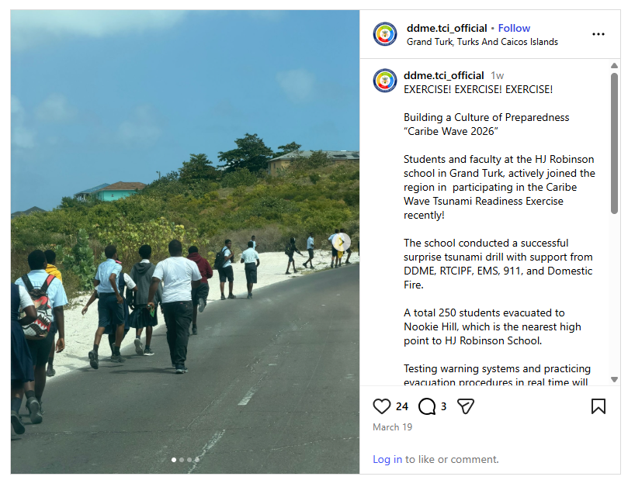
Date of publication: March 19, 2026
Retrieved from: https://www.instagram.com/p/DWFAlIcFEdN/

United States:

Puerto Rico
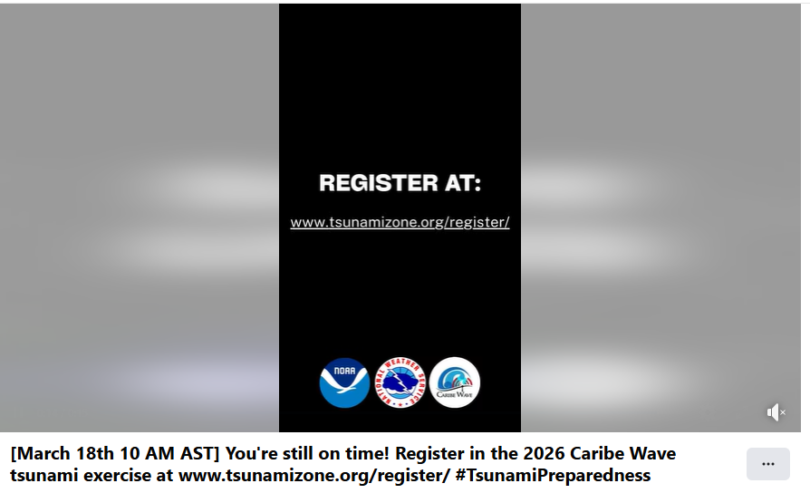
Date of publication: March 18, 2026
Retrieved from: https://www.facebook.com/NWSSanJuan/videos/march-18th-10-am-ast-youre-still-on-time-register-in-the-2026-caribe-wave-tsunam/943537751659070/?locale=km_KH

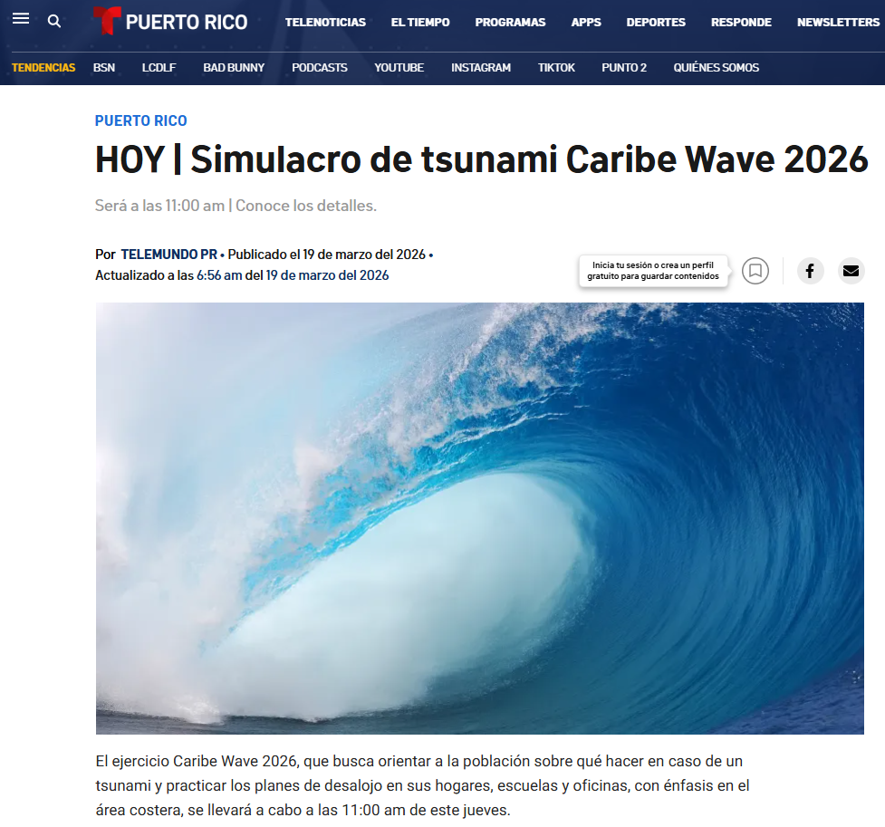
Date of publication: Mar 19, 2026
Retrieved from: https://www.telemundopr.com/noticias/puerto-rico/hoy-simulacro-de-tsunami-caribe-wave-2026/2796138/

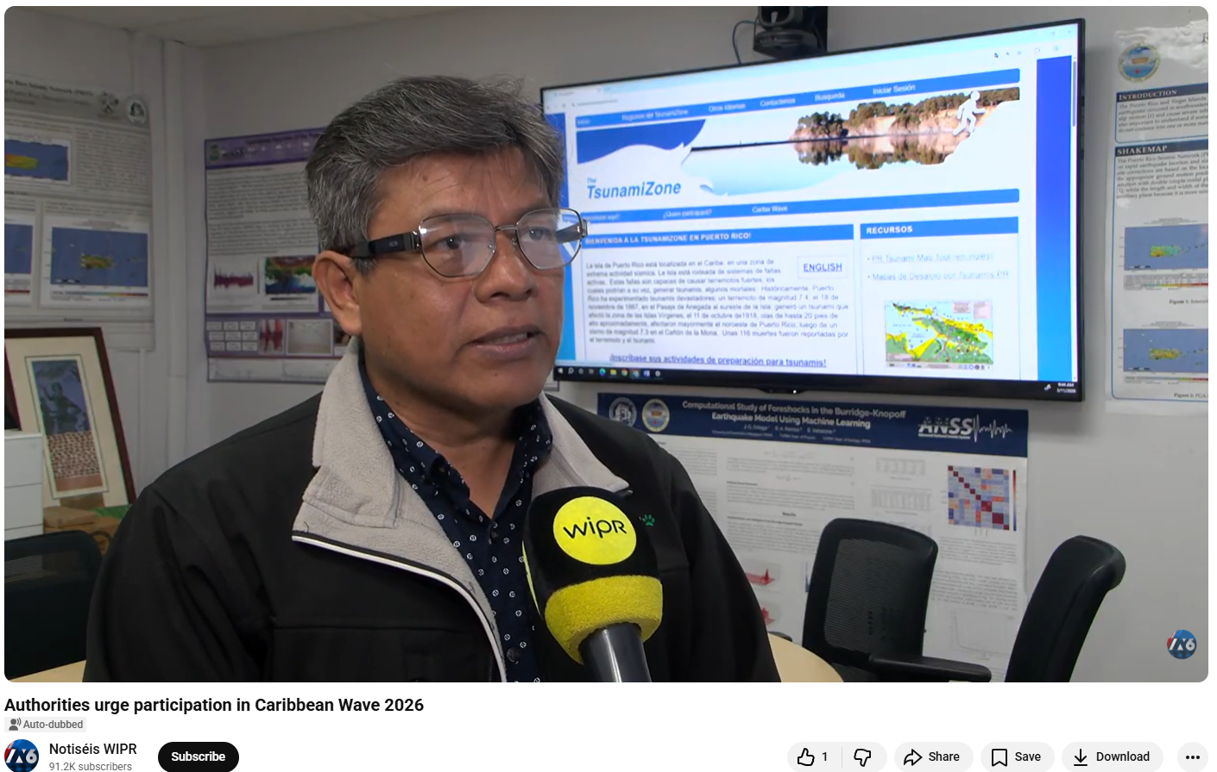
Date of publication: Mar 11, 2026
Retrieved from: https://www.youtube.com/watch?v=TXwnSotjOKE

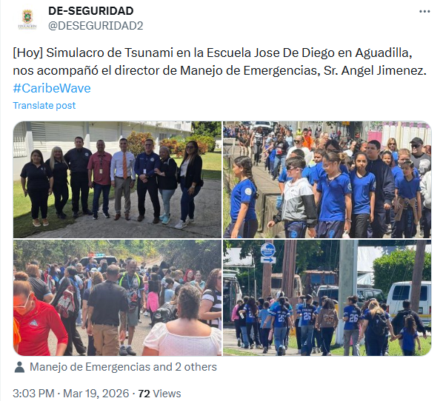
Date of publication: Mar 19, 2026
Retrieved from: https://x.com/DESEGURIDAD2/status/2034707406060499203

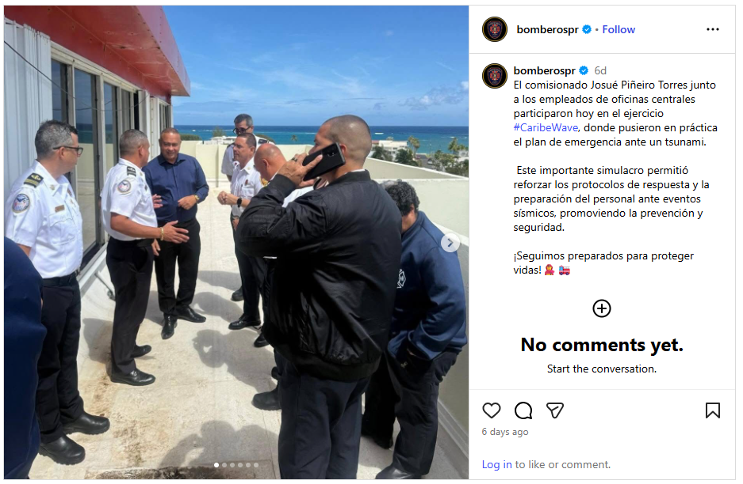
Date of publication: Mar 19, 2026
Retrieved from: https://www.instagram.com/bomberospr/p/DWEonPHkUSK/

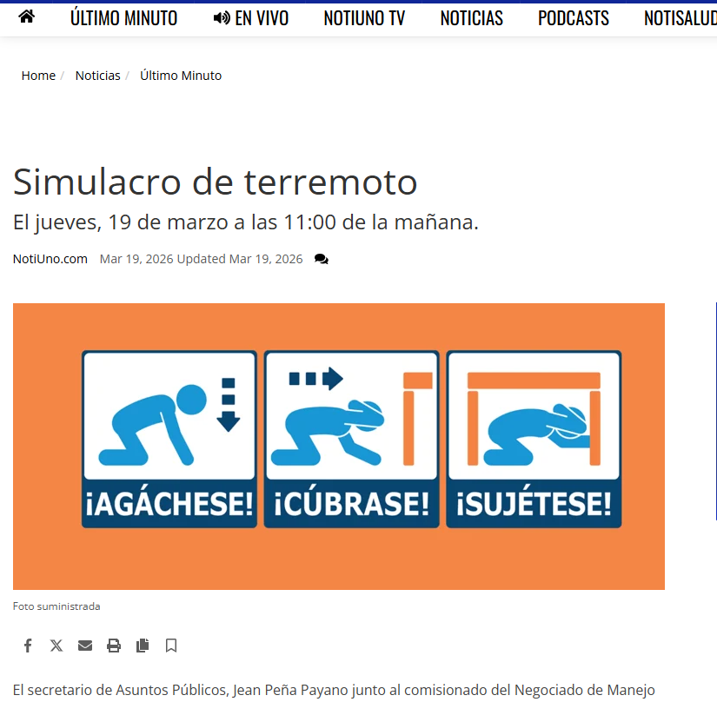
Date of publication: Mar 19, 2026
Retrieved from: https://www.notiuno.com/noticias/ultimo-minuto/simulacro-de-terremoto/article_aca5a7cc-691c-11ee-839d-4f438bb3b456.html

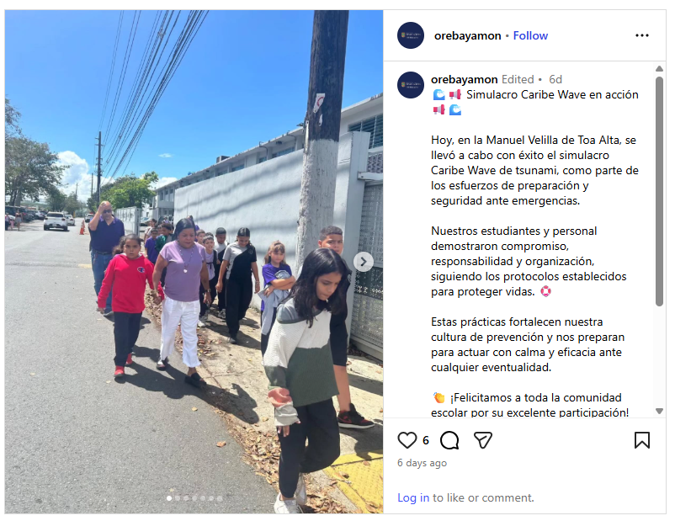
Date of publication: Mar 19, 2026
Retrieved from: https://www.instagram.com/p/DWEpTUuFfYL/?img_index=1

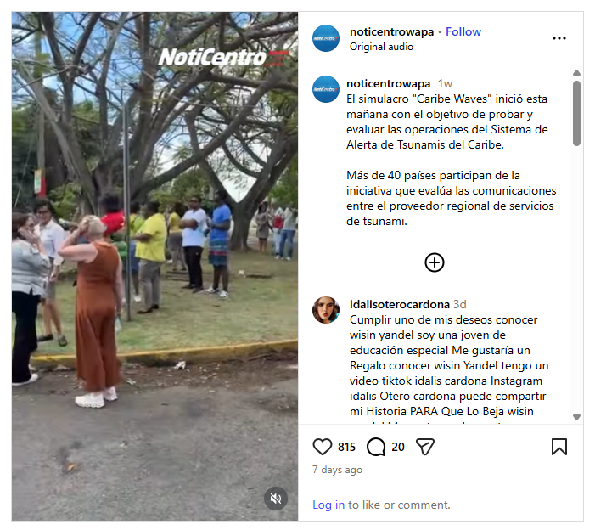
Date of publication: Mar 19, 2026
Retrieved from: https://www.instagram.com/noticentrowapa/reel/DWEku7FDFz6/

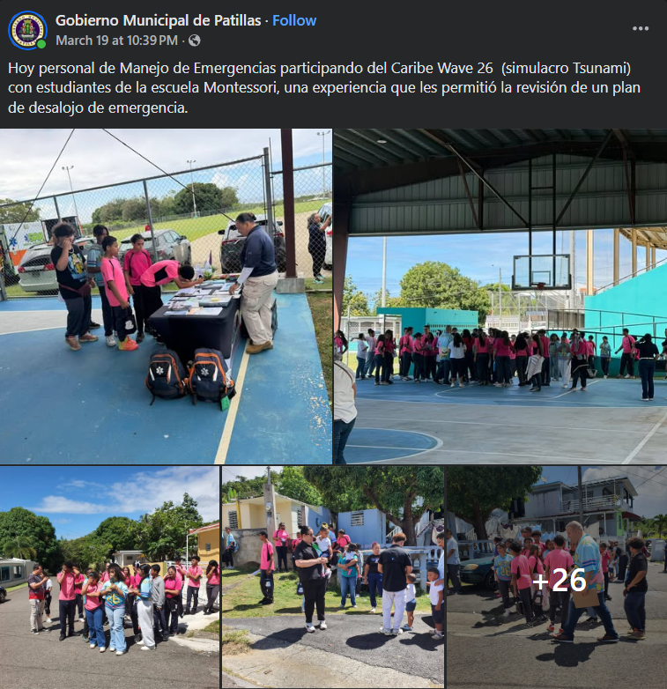
Date of publication: Mar 19, 2026
Retrieved from: https://www.facebook.com/permalink.php?story_fbid=pfbid0WJB9yaLoC1HyMgWhv5z1ur2TJjeVb3Z9KSBBcteNgrUwcKxHD3p9iyLJEjNabEqal&id=100080421197983

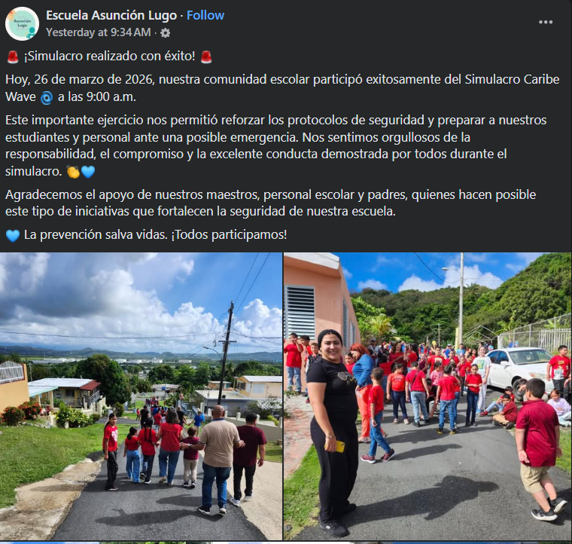
Date of publication: Mar 26, 2026
Retrieved from: https://www.facebook.com/escuelaasuncionlugo/posts/pfbid0XH5GRAZNsXeV1bmFBu8a11VY72YhjZEzGa94HMPjPm5dFuyz7A5u1FBgXsdVKDRPl

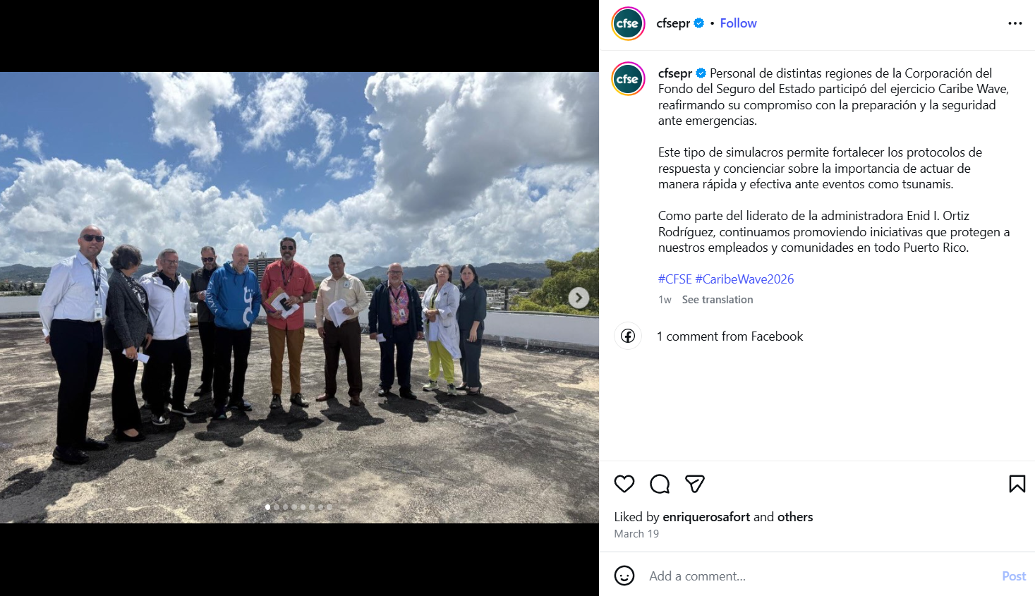
Date of publication: March 19, 2026
Retrieved from: https://www.instagram.com/p/DWEnYRekQxH/

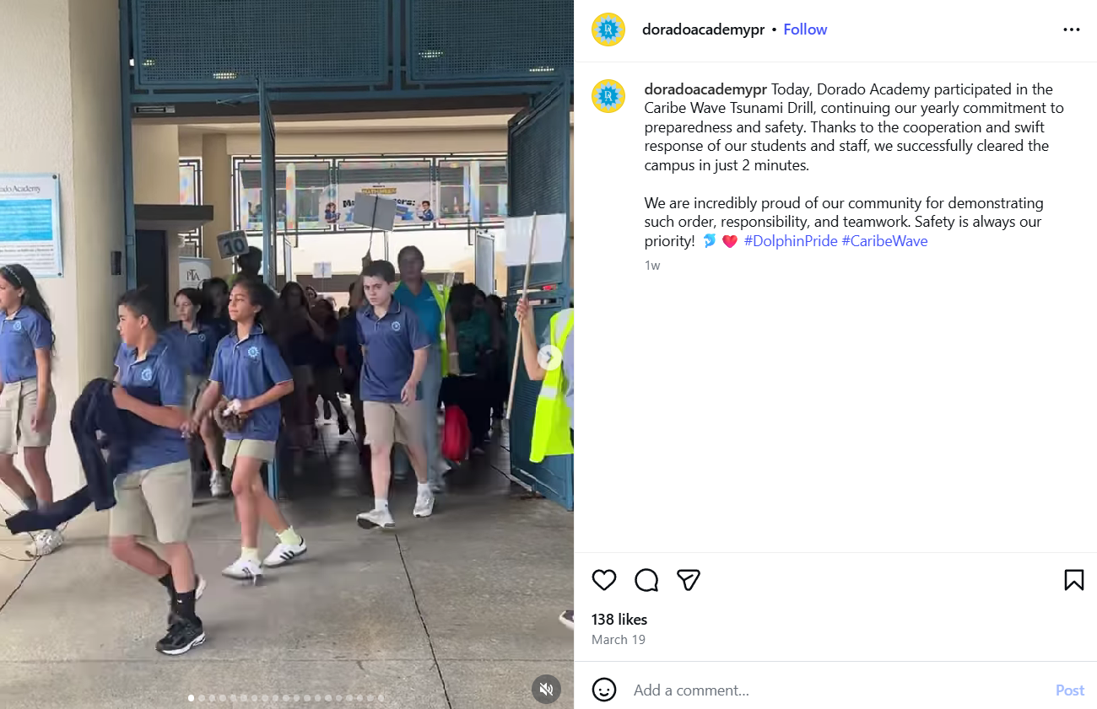
Date of publication: March 19, 2026
Retrieved from: https://www.instagram.com/p/DWE_Ea-AR7G/

U.S. Virgin Islands
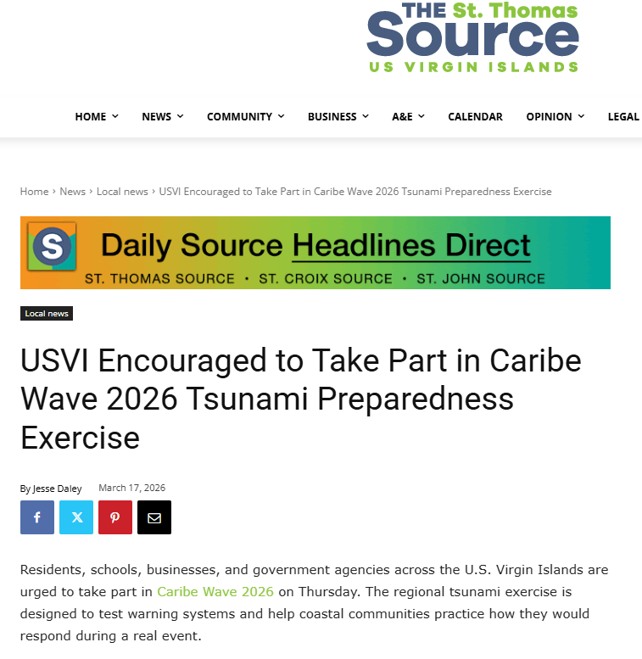
Date of publication: March 17, 2026
Retrieved from: https://stthomassource.com/content/2026/03/17/usvi-encouraged-to-take-part-in-caribe-wave-2026-tsunami-preparedness-exercise/

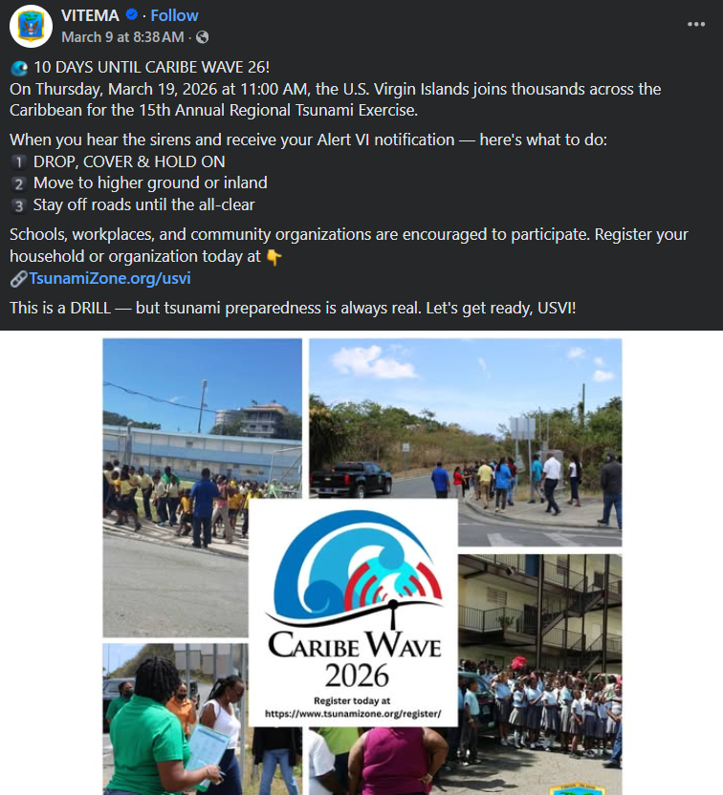
Date of publication: March 9, 2026
Retrieved from: https://www.facebook.com/vitema/posts/pfbid0vhyFykVT19ciMcWNkZgppSY9qRmFjjqiXCjQyKZTLCdeqEwtrmCnXqzAWAbyHGgl

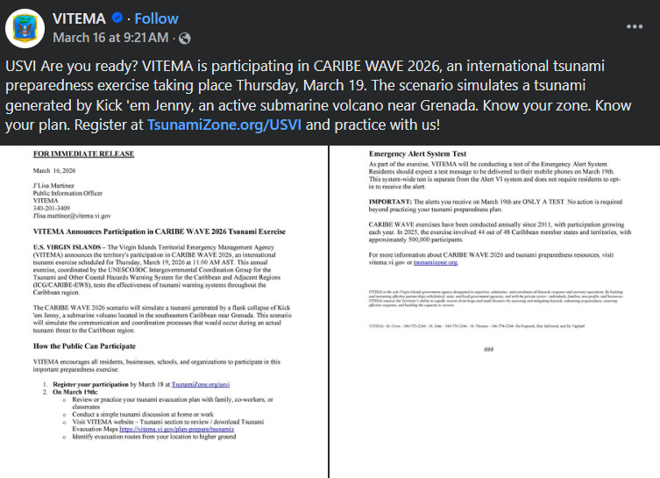
Date of publication: March 16, 2026
Retrieved from: https://www.facebook.com/vitema/posts/pfbid02Vbf7VASFLRHsQ5iLcMsTK595UaT7tXyCUrw3NG6xgPDu5fTtmne6EzdEsPFZLn6xl

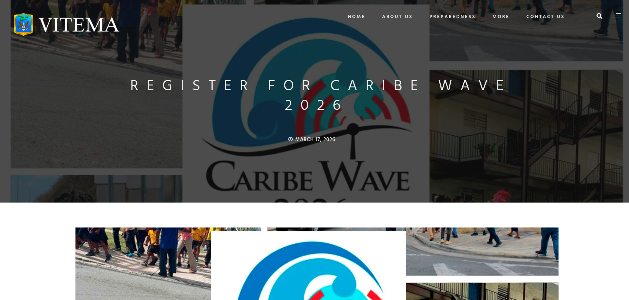
Date of publication: March 17, 2026
Retrieved from: https://vitema.vi.gov/register-for-caribe-wave-2026/

Venezuela
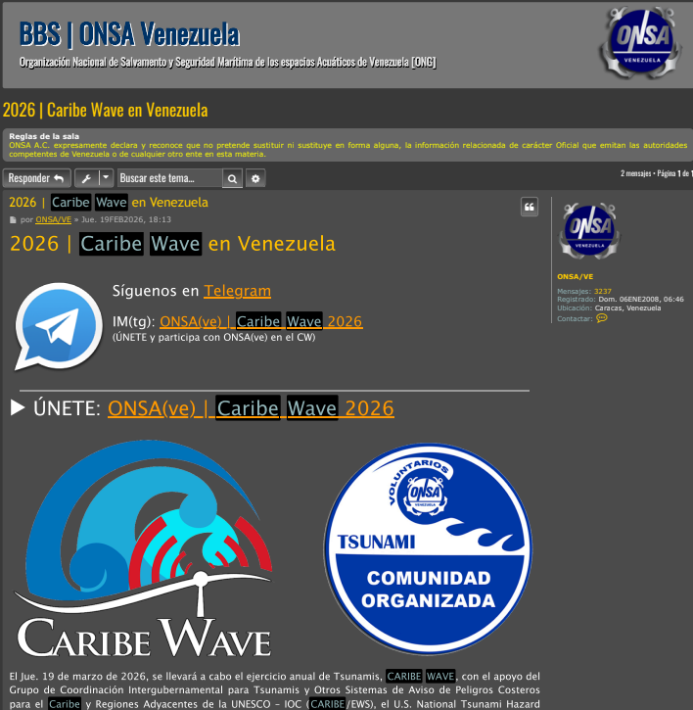
Date of publication: February 19, 2026
Retrieved from: https://www.onsa.org.ve/comunidad/forum/viewtopic.php?p=14996&hilit=caribe+wave#p14996

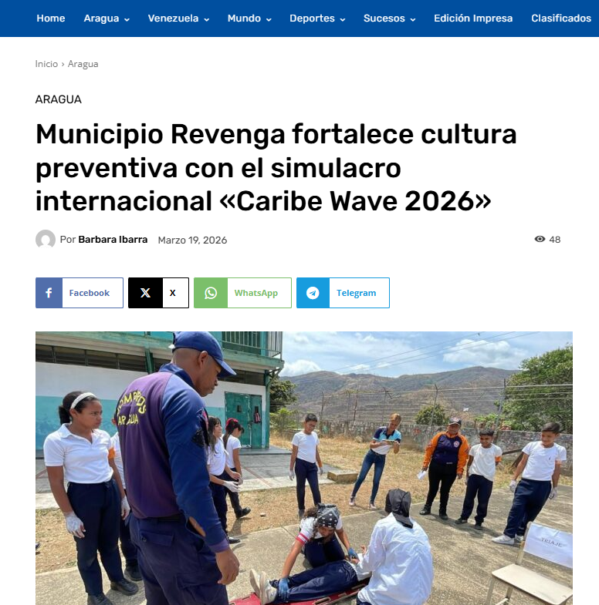
Date of publication: March 19, 2026
Retrieved from: https://elperiodiquito.com/aragua/79767/municipio-revenga-fortalece-cultura-preventiva-con-el-simulacro-internacional-caribe-wave-2026/

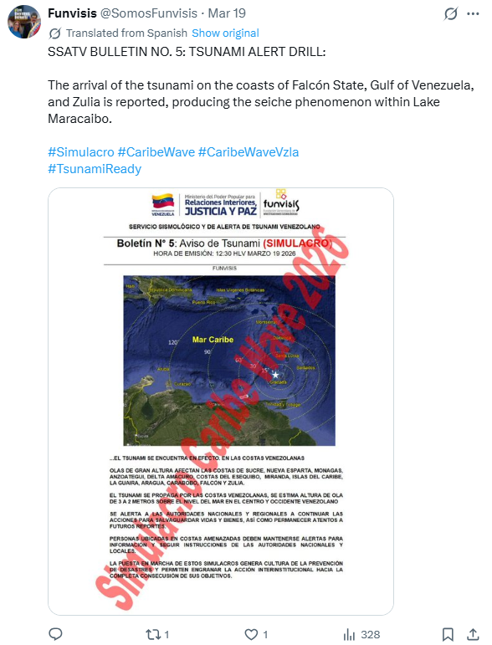
Date of publication: March 19, 2026
Retrieved from: https://x.com/SomosFunvisis/status/2034668724679287183

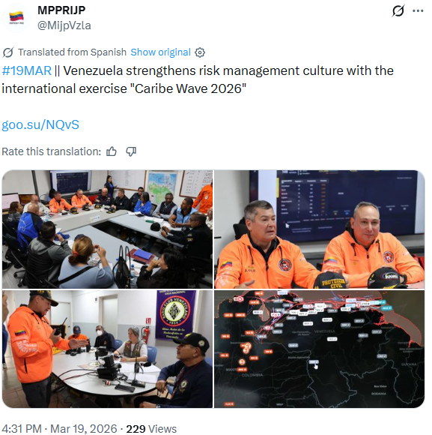
Date of publication: March 19, 2026
Retrieved from: https://x.com/MijpVzla/status/2034729456938414534

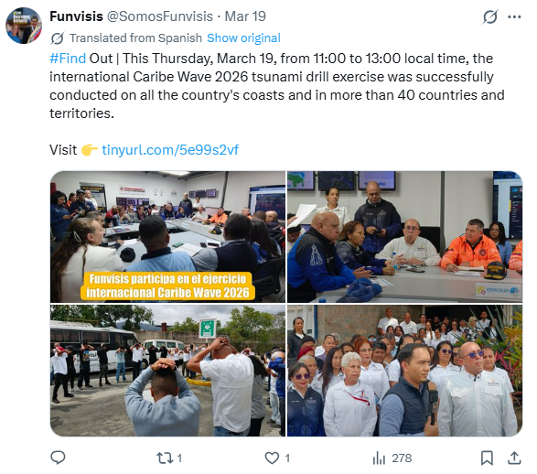
Date of publication: March 19, 2026
Retrieved from: https://x.com/SomosFunvisis/status/2034785686390215088

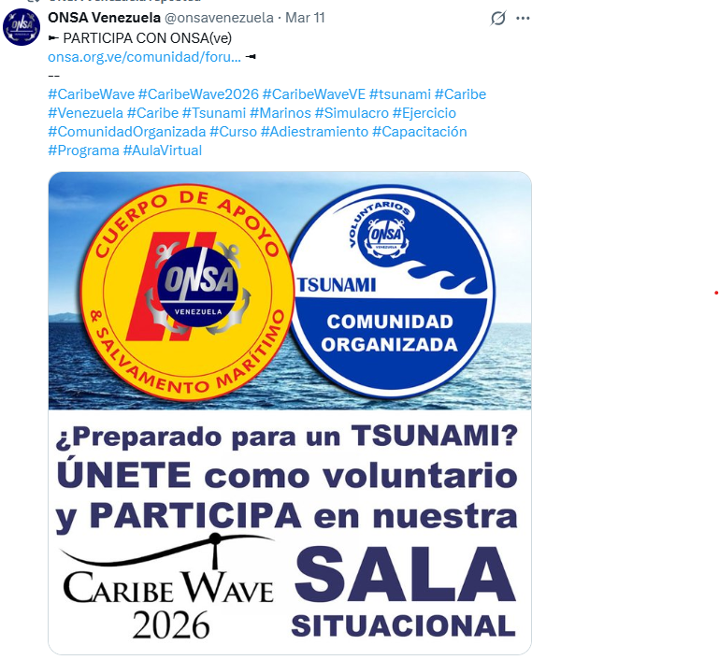
Date of publication: March 11,2026
Retrieved from: https://x.com/onsavenezuela/status/2031830735376826411

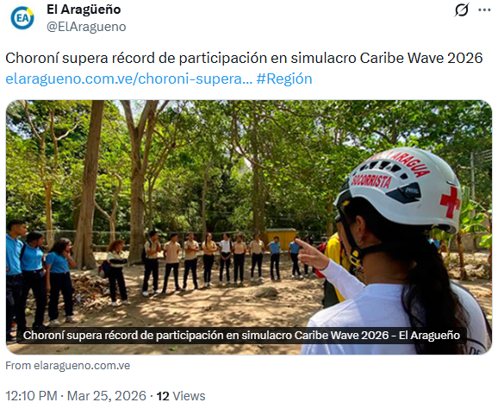
Date of publication: March 25,2026
Retrieved from: https://x.com/ElAragueno/status/2036838015700762916

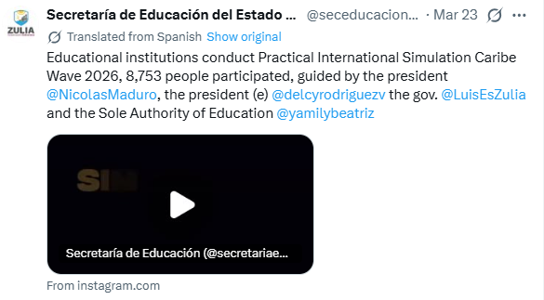
Date of publication: March 23,2026
Retrieved from: https://x.com/seceducaciongob/status/2036232618799169789

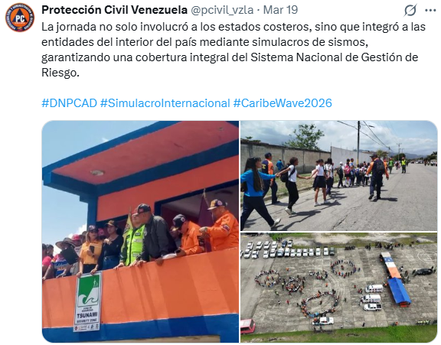
Date of publication: March 19, 2026
Retrieved from: https://x.com/pcivil_vzla/status/2034767383806496839

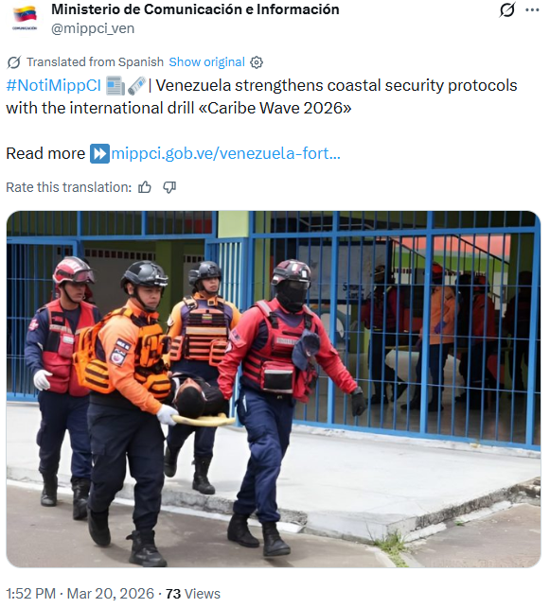
Date of publication: March 20, 2026
Retrieved from: https://x.com/mippci_ven/status/2035051745596870735

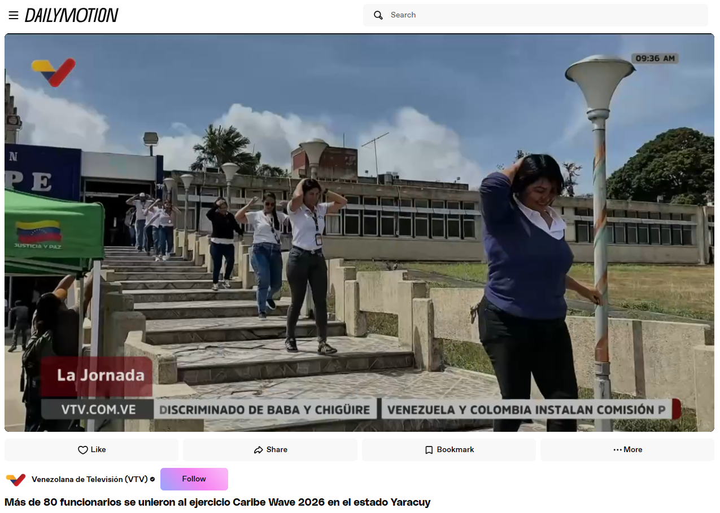
Date of publication: March 20, 2026
Retrieved from: https://www.dailymotion.com/video/xa2tdv2

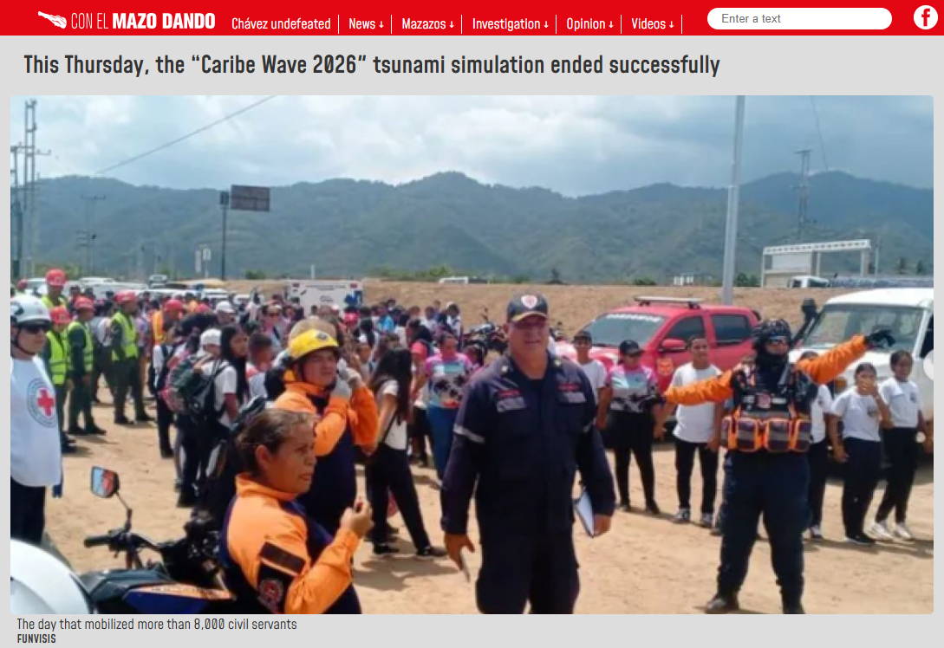
Date of publication: March 19, 2026
Retrieved from: https://mazo4f.com/en/this-thursday-the-caribe-wave-2026-tsunami-simulation-ended-successfully

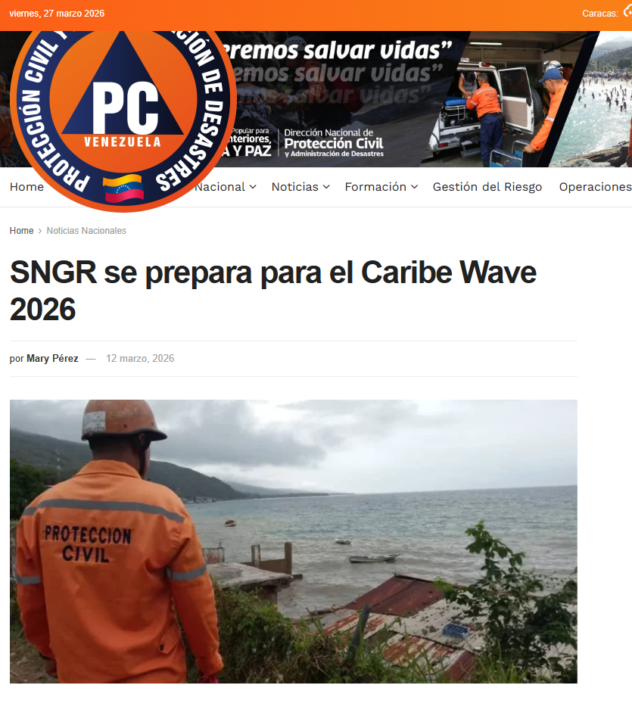
Date of publication: March 12, 2026
Retrieved from: https://www.pcivil.gob.ve/2026/03/sngr-se-prepara-para-el-caribe-wave-2026/

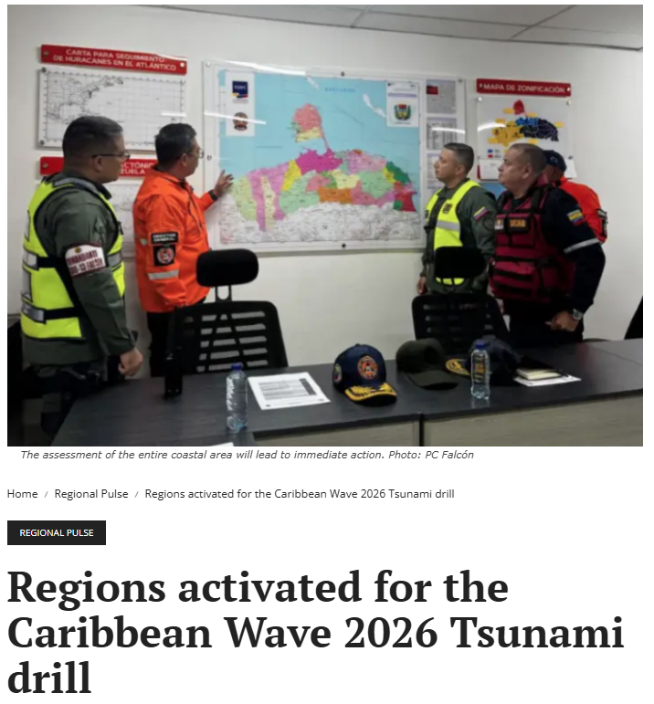
Date of publication: March 16, 2026
Retrieved from: https://en.ultimasnoticias.com.ve/present/Regions-activated-for-the-Caribbean-Wave-2026-tsunami-drill/

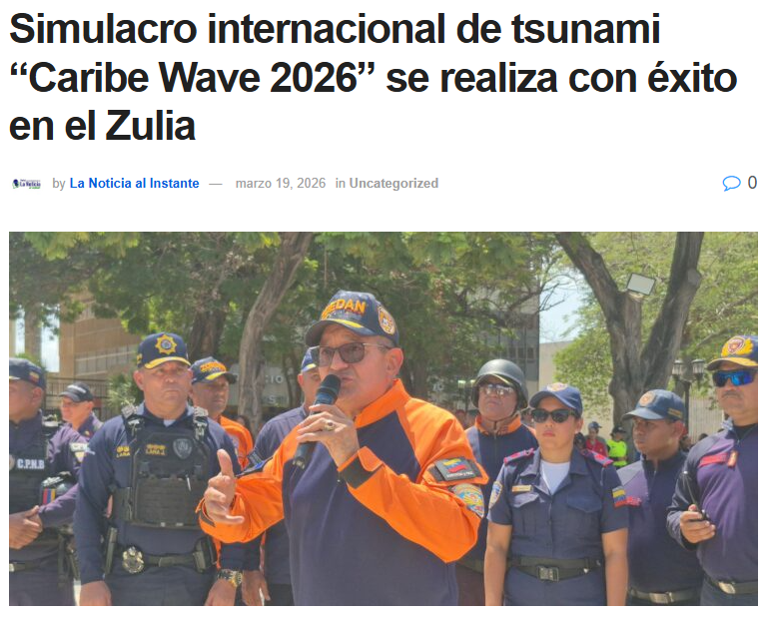
Date of publication: March 19, 2026
Retrieved from: https://lanoticiaalinstante.com/simulacro-internacional-de-tsunami-caribe-wave-2026-se-realiza-con-exito-en-el-zulia/

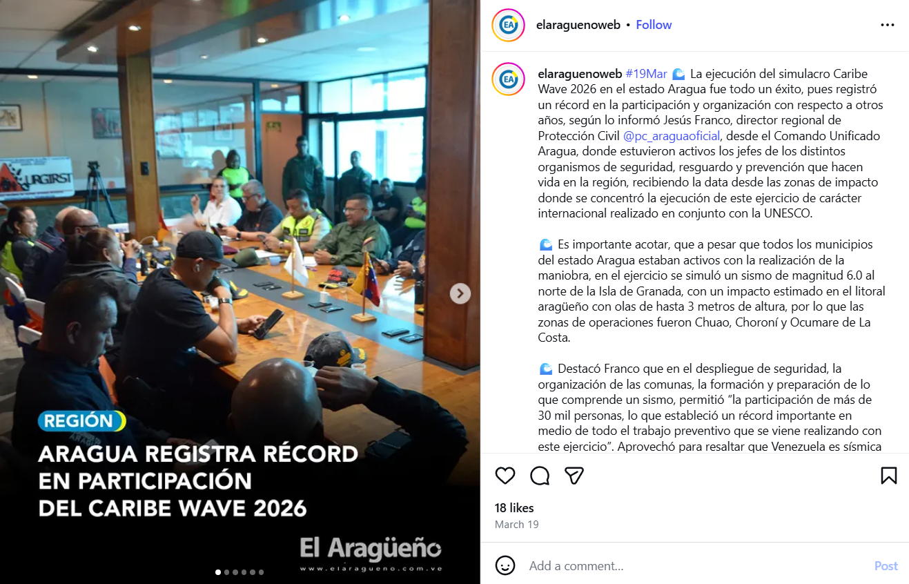
Date of publication: March 19, 2026
Retrieved from: https://www.instagram.com/p/DWFUHpnFaOo/

