Intergovernmental Oceanographic Commission
Technical Series | 151

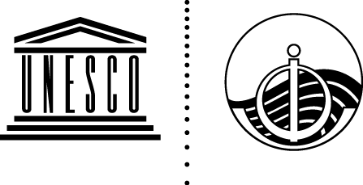

EXERCISE CARIBE WAVE 26
A Caribbean and Adjacent Regions Tsunami Warning Exercise
19 March 2026
(Cayman Islands and Kick ‘em Jenny)
Volume 2 Summary Report

UNESCO

Intergovernmental Oceanographic Commission
technical series | 151

EXERCISE CARIBE WAVE 26
A Caribbean and Adjacent Regions Tsunami Warning Exercise
19 March 2026
(Cayman Islands and Kick ‘em Jenny)
Volume 2 Summary Report

UNESCO 2026
IOC Technical Series, 151 (volume 2)
Paris, June 2022
English only

The designations employed and the presentation of the material in this publication do not imply the expression of any opinion whatsoever on the part of the Secretariats of UNESCO and IOC concerning the legal status of any country or territory, or its authorities, or concerning the delimitation of the frontiers of any country or territory.

NOTE: The United Nations Educational, Scientific and Cultural Organization (UNESCO) and the Intergovernmental Oceanographic Commission (IOC) pattern the contents of this handbook after the CARIBE WAVE 2011, 2013, 2014, 2015, 2016, 2017, 2018, 2019, 2020, 2021, 2022 and 2023 Exercises. Each of these exercises has a handbook published as IOC Technical Series. These CARIBE WAVE exercises followed the Pacific Wave exercises which commenced in 2008 with a manual published by the Intergovernmental Oceanographic Commission (Exercise Pacific Wave 08: A Pacific-wide Tsunami Warning and Communication Exercise, 28–30 October 2008, IOC Technical Series, 82, Paris, UNESCO 2008). The UNESCO How to Plan, Conduct and Evaluate Tsunami Wave Exercises, IOC Manuals and Guides, 58 rev., Paris, UNESCO 2013 (English and Spanish) is another important reference.
For bibliographic purposes, this document should be cited as follows:
UNESCO/IOC. 2026. Exercise CARIBE WAVE 2026. A Caribbean and Adjacent Region Tsunami Warning Exercise, 19 March 2026 (Cayman Islands and Kick ‘em Jenny). Volume 2: Summary Report. Paris, UNESCO, IOC Technical Series No 151, Vol. 2. (English only)
Report prepared by: Intergovernmental Coordination Group for the Tsunami and other Coastal Hazards Warning System for the Caribbean and Adjacent Regions (ICG/CARIBE-EWS)
Authors: Kimberly Maisonet González, Christa von Hillebrandt-Andrade, Gisela Báez-Sánchez, Antonio Aguilar M, and Claudia Guzmán Soto.

Published in 2026
by United Nations Educational, Scientific and Cultural Organization
7, Place de Fontenoy, 75352 Paris 07 SP
(IOC/2019/TS/151 Vol.2)
TABLE OF CONTENTS

TABLE OF CONTENTS 6
Summary 7
1. BACKGROUND 8
2. EXERCISE CONCEPT 9
2.1 PURPOSE 9
2.2 OBJECTIVES AND GOALS 9
2.3 TYPE OF EXERCISES 10
3. EXERCISE OUTLINE 12
3.1 GENERAL 12
3.2 MASTER SCHEDULE (EXERCISE SCRIPT) 13
3.3 ACTIONS IN THE CASE OF A REAL EVENT AND FALSE ALARMS 14
3.4 REGISTRATION PROCEDURE 14
3.5 STATUS OF SEA LEVEL STATIONS DURING EXERCISE 17
3.6 MEDIA ARRANGEMENTS 20
3.7 POST-EXERCISE EVALUATION 20
4. REFERENCES 28
ANNEX I. List Of Acronyms 29

Summary
The CARIBE WAVE exercise is conducted within the framework of the UNESCO Intergovernmental Coordination Group for Tsunamis and other Coastal Hazards for the Caribbean and Adjacent Regions (ICG/CARIBE-EWS). The 2026 annual tsunami exercise took place on March 19 to test Tsunami Warning Systems and promote tsunami preparedness in the Caribbean and adjacent regions. Over 600,000 people of the ICG participated in the exercise from 45 countries and territories according to Member States (MS) and Territories. The majority of the participants from across the region were from K-12 Schools and Districts, local government, as well as preparedness organizations. Social media platforms, which has become the primary source for communicating tsunami awareness, had worldwide reach. The exercise focused on communications and evaluating procedures and programs within Member States and Territories.

Both the Pacific Tsunami Warning Center (PTWC), an ICG Tsunami Service Provider (TSP) and the Central America Tsunami Advisory Center (CATAC), interim TSP, issued products to test communications. Both issued a “Dummy” message at 1500 UTC to test communications with corresponding Tsunami Warning Focal Points (TWFP) and National Tsunami Warning Centers (NTWC). PTWC used all their standard broadcasting methods of communications for a real event to test and disseminate the message: The World Meteorological Organization (WMO), Advanced Weather Interactive Processing System (AWIPS), Aeronautical Information Replacement System (AIRS), NOAA Weather Wire, GEONETCast Americas, and Email. According to feedback, the dummy message was successfully received. The Central America Tsunami Advisory Center (CATAC), issued its dummy message to its stakeholders via Email, WhatsApp, Telegram, and SMS; in particular, email had some reported issues on delivery.

PTWC and CATAC also issued via email simulated threat messages. The PTWC issued messages for each of the Cayman Islands and Kick ‘em Jenny scenarios, according to the selection of the countries. CATAC’s issued messages for just the Cayman Islands scenario. The PTWC messages were timely received while some countries reported non-deliveries delays with some of the CATAC emails.

Sea level data availability is important to forecast and confirm a real tsunami event. If a tsunami had occurred during the day of the exercise, data of 86 of the 182 sea-level stations in the region would have been available for event analysis. The only Deep Ocean Assessment and Reporting on Tsunamis (DARTs) in the Atlantic and Caribbean that was included in the simulated PTWC products was operational during the exercise.

The exercise was coordinated by the CARIBE WAVE Task Team, the NOAA International Tsunami Information Center Caribbean Office (ITIC-CAR), and supported by the Caribbean Tsunami Information Center (CTIC), PTWC and CATAC. This exercise has been conducted since 2011, on an annual basis as of 2013.

1. BACKGROUND
The UNESCO IOC Intergovernmental Coordination Group for the Tsunami and Other Coastal Hazards Warning System for the Caribbean and Adjacent Regions at its Eighth Session (ICG/CARIBE-EWS-VIII, Port of Spain, Trinidad and Tobago, 29 April – 1 May 2013), decided to conduct exercises named CARIBE WAVE on an annual basis leaving each Member State to define its level of participation. At its Eighteenth Session (ICG/CARIBE-EWS-XVIII, virtual session, 5-7 May, 2025), the ICG/CARIBE-EWS recommended that Exercise CARIBE WAVE 26 take place on 19 March 2026 at 1500 UTC, with two hypothetical tsunami scenarios. The first scenario simulates a tsunami generated by a magnitude 7.6 earthquake located southwest of the Cayman Islands and the second scenario is generated by a flank collapse of the Kick ‘em Jenny submarine volcano.
Historical tsunami records from sources such as the NOAA National Centers for Environmental Information (NCEI) show that from the years 1530 to 2023 tsunamis from earthquake, landslide, and volcanic sources have all impacted the Caribbean and adjacent regions (Figure 1). Since the devastating tsunami of 1946, there has been an explosive population growth and influx of tourists along the Caribbean and Western Atlantic coasts increasing the tsunami vulnerability of the region (von Hillebrandt-Andrade, 2013).
Recognizing the need for an early warning system, especially after the lessons learned from the 2004 Indian Ocean Tsunami, the Intergovernmental Coordination Group for the Tsunami and other Coastal Hazards Warning System for the Caribbean and Adjacent Regions (ICG/CARIBE-EWS) was established in 2005 as a subsidiary body of the IOC/UNESCO with the purpose of providing assistance to all Member States of the region to establish their own early tsunami warning system. The main objective of the CARIBE-EWS is to identify and mitigate the hazards posed by local, regional and distant tsunamis. The ultimate goal is to create a fully integrated end-to-end warning system comprising four key components: monitoring and detection systems, hazard assessment, tsunami related services (dissemination), and community preparedness, readiness and resilience.
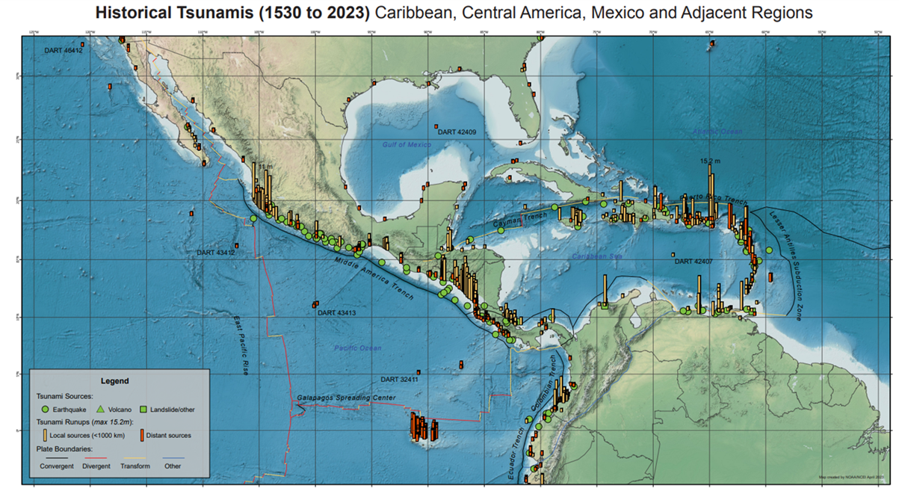
Figure 1. Map of historical tsunamis (1530 to 2023) in the Caribbean, Central America, Mexico and adjacent regions (National Centers for Environmental Information, https://www.ncei.noaa.gov/products/natural-hazards/tsunamis-earthquakes-volcanoes/tsunamis/posters)
2. EXERCISE CONCEPT
2.1 PURPOSE
The purpose of the exercise was to improve Tsunami Warning System effectiveness in the Caribbean and adjacent regions. The exercise provided an opportunity for emergency management organizations throughout the region to exercise their operational lines of communications, review their tsunami response procedures, and promote tsunami preparedness. Regular exercising of response plans is critical to maintain readiness in case of an emergency. This is particularly true for the Caribbean and adjacent regions, where tsunamis are infrequent but can be of very high impact. Every emergency management organization (EMO) was encouraged to participate.
2.2 OBJECTIVES AND GOALS

Each organization developed its objectives for the exercise depending on its level of involvement in the scenario. There were three principal overarching objectives for the exercise:
- Exercise and evaluate communications between Regional Tsunami Service Providers (TSP) and Member States/Territories:
  - Validate the issuance of tsunami products from the PTWC.
  - Validate receipts of tsunami products by CARIBE-EWS Tsunami Warning Focal Points (TWFPs) and/or National Tsunami Warning Centers (NTWCs).
- Evaluate the tsunami procedures and programs within Member States/Territories:
  - Validate readiness to respond to a tsunami.
  - Validate the operational readiness of the TWFPs/NTWCs and/or the National Disaster Management Office (NDMO).
  - Improve operational readiness. Before the exercise, ensure appropriate tools and response plan(s) have been developed, including public education materials.
  - Validate that the dissemination of warnings and information/advice by TWFPs and NTWCs, to relevant in-country agencies and the public is accurate and timely.
  - Evaluate the status of the implementation of the UNESCO/IOC Tsunami Ready Programme.
- To evaluate volcanic products:
  - Evaluate experimental PTWC CARIBE-EWS procedures and products for volcanic events.
  - Evaluate input and procedures from agencies responsible for volcano monitoring.
  - Evaluate Member States and Territories response plans for tsunamis from volcanoes.
ICG/CARIBE-EWS has established metrics to evaluate the goals of the exercise (Table 1). 91% of participating Member States and Territories submitted the Post-Exercise Survey, with 96% who answered being satisfied with the exercise.
Goals | 2016  Results | 2017  Results | 2018  Results | 2019  Results | 2020  Results | 2021  Results | 2022  Results | 2023  Results | 2024  Results | 2025  Results | 2026  Metrics | 2026  Results
TWFP receive the dummy message | 84% | 95% | 100% | 89% | 97% | 97% | 91% | 97% | 100% | 100% | 100% | 94%
Participation of Member States of the ICG - CARIBE-EWS with designated focal warning point | 100% | 100% | 97% | 100% | 92% | 98% | 100% | 94% | 96% | 93% | 100% | 94%
Community involvement (including agencies beyond TWFP) | 73% | 82% | 77% | 66% | 38% | 56% | 43% | 41% | 76% | 81% | 95% | 87%
Number of participants* | 332,812 | 679,985 | 643,403 | 793,353 | 4,622 | 333,518 | 413,281 | 422,913 | 470,423 | 510,360 | +10% | 619,340
Countries who participate submit exercise questionnaire | 100% | 100% | 91% | 82% | 92% | 95% | 100% | 93% | 80% | 91% | 100% | 91%
Members State and Territories are satisfied with exercise |  |  |  | 82% | 76% | 96% | 88% | 97% | 100% | 86% | 100% | 96%
Table 1. Goals and Metrics. *As reported by Member States and Territories or in default tsunamizone.org. The total number of registered participants on TsunamiZone.org were 606,265.
2.3 TYPE OF EXERCISES

The CARIBE WAVE 26 was planned for Caribbean countries to carry exercises at various scales of magnitude and sophistication. It was up for Member States and Territories to decide the type of exercise that would be carried out. Communication tests were carried out to validate the issuance and receipt of the messages distributed by the Pacific Tsunami Warning Center (PTWC), the Regional Tsunami Service Provider, and evaluations of the tsunami procedures and programs within Member States and Territories. The Central America Tsunami Advisory Center (CATAC) also distributed messages during the exercise. Several of the National and local Offices of Emergency Management (OEM) were able to extend the exercise down to the level of testing local notification systems such as the Emergency Alert System (EAS), sirens and loudspeakers.
According to the Member States, the number of participants in the exercise was 619,340 people throughout the Caribbean and adjacent regions. The participants in the fifteenth annual regional tsunami exercise hailed from forty-five out of the forty-eight Member States and Territories. It represented a participation rate of 94% of all the Member States of the UNESCO Intergovernmental Coordination Group for Tsunamis and other Coastal Hazards for the Caribbean and Adjacent Regions (CARIBE-EWS).
Exercises were conducted at various scales of magnitude and sophistication. Exercises simulated the development, training, testing, and evaluation of Disaster Plans and Standard Operating Procedures (SOPs). The reported exercises included a variety of activities including testing communication systems, performing tabletop exercises, conducting seminars and drills (Figure 2). After the exercise, the CARIBE WAVE 26 Task Team organized a post-exercise “hot-wash” webinar to permit Member States and Territories to discuss and provide feedback on the exercise in an open forum on March 26, 2026. Some of the feedback was on the successful completion of the exercise. It was stated that the Kick ‘em Jenny scenario was helpful for identifying gaps for volcanic events. Some expressed dissatisfaction with the low-impact scenarios, opting for a greater challenge in the future. Regarding improvements for future exercises, there are plans for enhancing the CARIBE WAVE webpage (caribewave.org). The importance of multiple, redundant, and reliable methods of communication beyond email was reiterated.
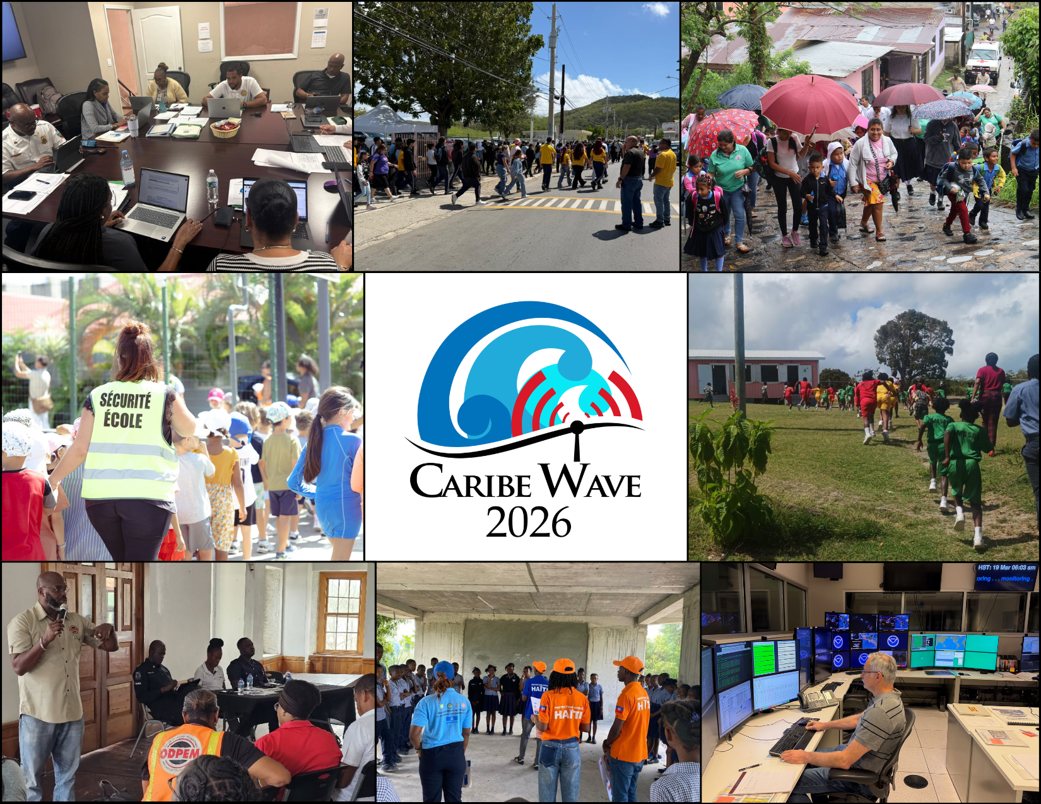
Figure 2. CARIBE WAVE 26 Exercise Photos. From Left to Right: Emergency Operations Center, St. Croix, U.S. Virgin Islands; Áurea E. Quiles Claudio High School in Guánica, Puerto Rico; Omoa Community Exercise, Honduras; Evacuation of the Gustavia School Complex, Saint Barthélemy; New Winthorpes Primary School, St. John, Antigua & Barbuda, ODPEM activity, Jamaica; Les Cayes Schools with UNESCO and Civil Protection, Haiti; and the Pacific Tsunami Warning Center in Honolulu, Hawaii.
3. EXERCISE OUTLINE
3.1 GENERAL

The tsunami messages that were issued for this exercise were based a hypothetical events with the following parameters for Cayman Islands and Kick ‘em Jenny:
Cayman Islands Earthquake Scenario Parameters:
Origin Time 15:00:00 UTC March 19, 2026
Latitude 17.646ºN
Longitude 82.6285ºW
Magnitude 7.6 – Mw
Depth 10 km

Kick ‘em Jenny Volcano Scenario Parameters:
Origin Time 15:00:00 UTC March 19, 2026
Latitude 12.30ºN
Longitude 61.63ºW
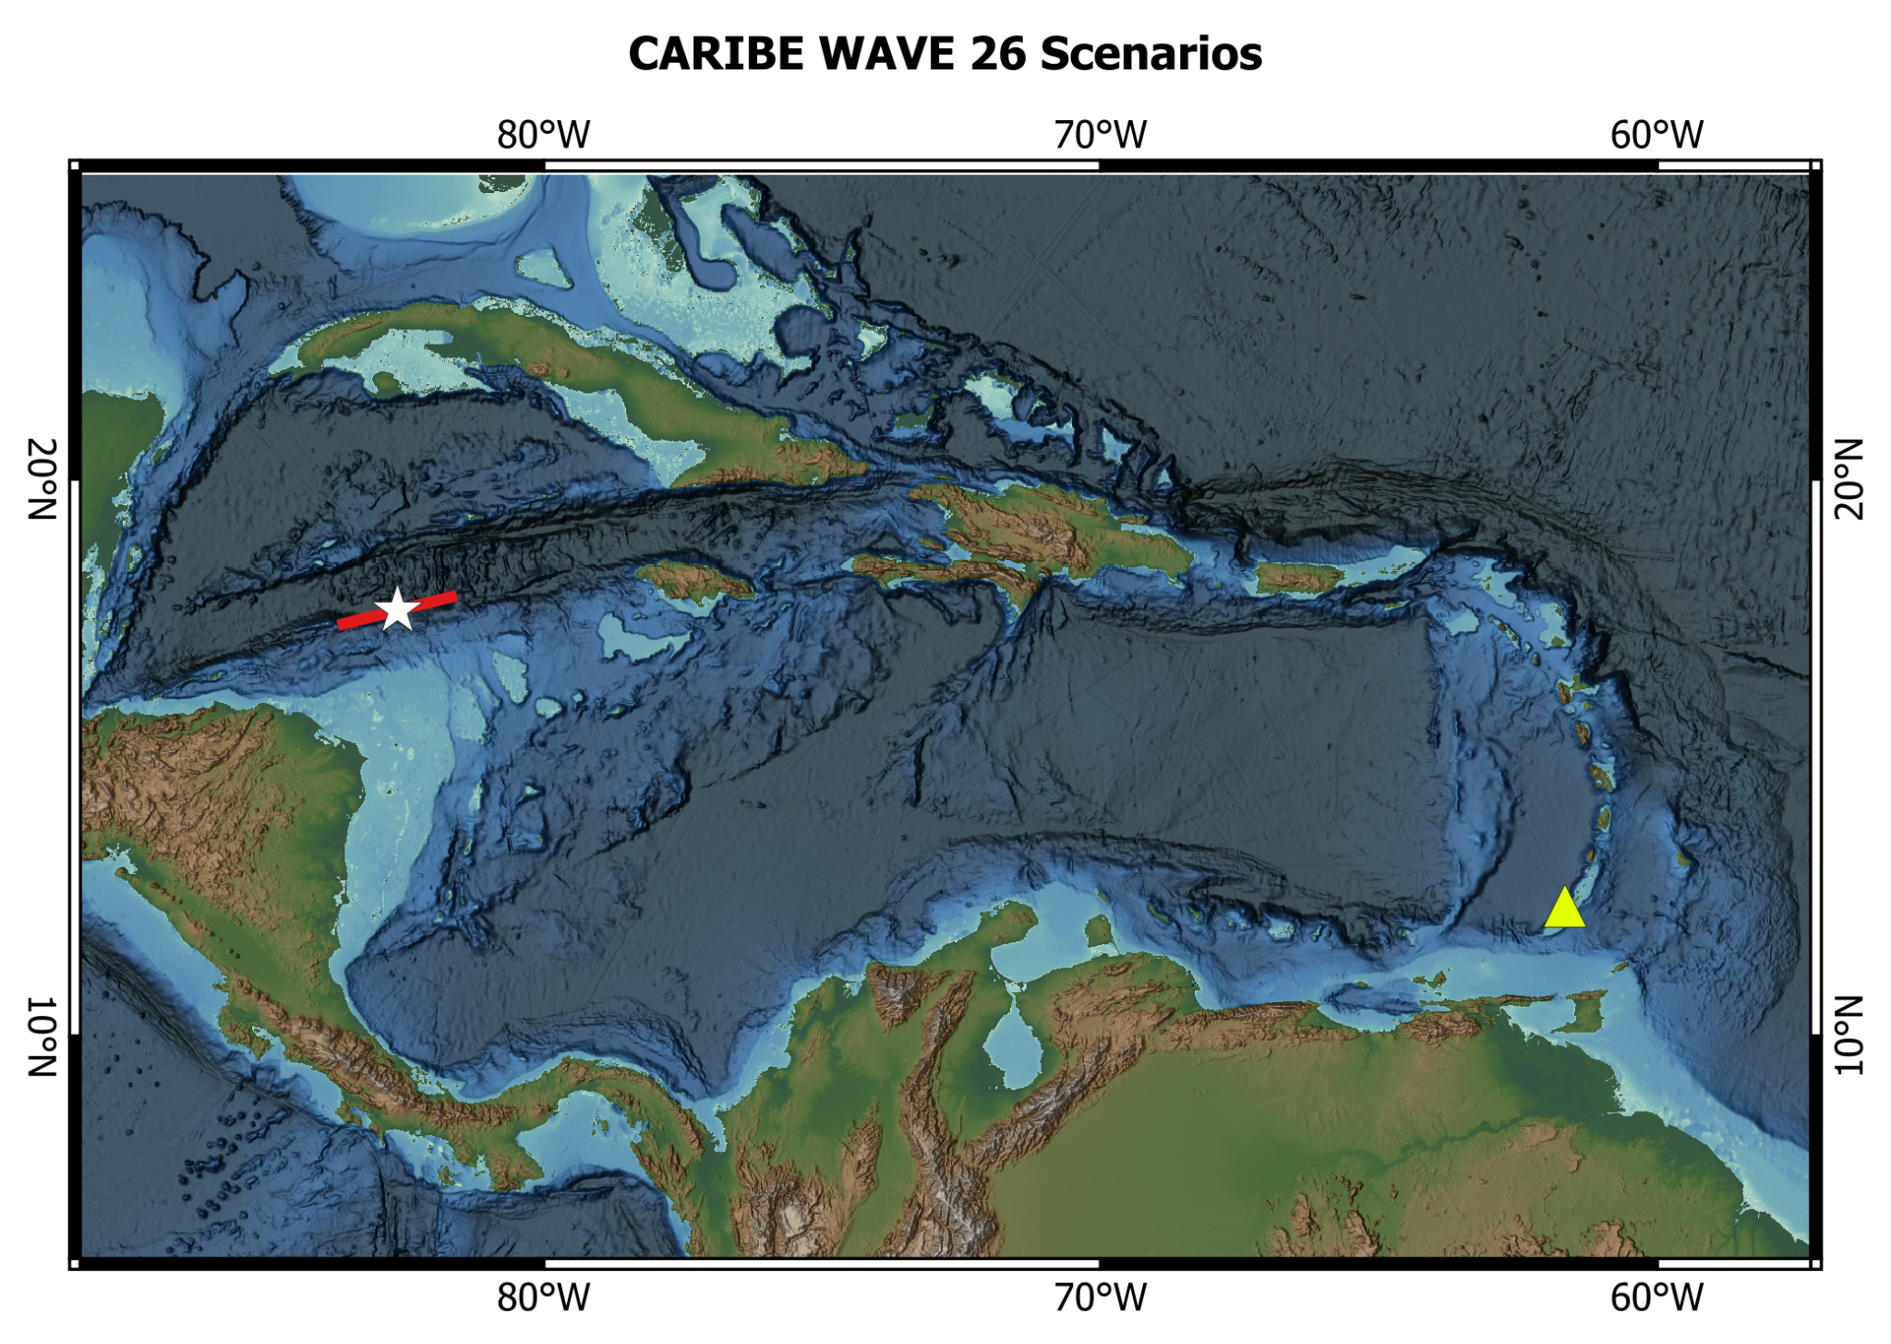
Figure 3. Map of the CARIBE WAVE 26 scenarios. White star indicates epicentral location and the red box indicates the map view of the ruptured fault segment of the Cayman Islands scenario, while the yellow triangle indicates the volcano location of the Kick ‘em Jenny scenario. The figure is underlain by ETOPO 2022 model of NOAA National Centers for Environmental Information (2022). This figure was generated using QGIS.

Messages Issued by the PTWC
The PTWC issued thirty-one (11) international simulated messages total for CARIBE WAVE 26. The first tsunami threat message for the Cayman Islands and Kick ‘em Jenny scenarios was based on the tsunami, earthquake, volcano and source event parameters, and the estimated tsunami travel times. As of the third messages were based on simulated tsunami wave forecast and other available information. Tsunami threat forecasts indicated the levels of threat that have been forecast and to which countries or places they apply. The levels are tsunami heights of 0.3-1 meters, 1-3 meters, and greater than 3 meters above the normal tide levels. The threats were updated usually within half-hour to an hour.
Member States were required to select one scenario by March 6 for the 2026 CARIBE WAVE Exercise. Those who did not select a scenario, the organizers decided for which scenario the PTWC would send the products. All simulated products (text and graphical) were disseminated through email to the corresponding TWFPs and NTWCs and were made available in the Exercise Handbook. Any further dissemination was the responsibility of the corresponding national and local authorities.
The PTWC also issued live over all standard broadcast channels (WMO/AWIPS IDs WECA41 PHEB/TSUCAX) the initial dummy message to start the exercise at 1500 UTC on 19 March 2026.
Messages Issued by CATAC
The initial dummy message was issued to start the exercise at 1500 UTC on 19 March 2026 and test communications. According to the Member States and Territories feedback, the message was successfully received by all the Member States of Central America in the CARIBE EWS.
CATAC issued five (5) simulated messages in English and Spanish for CARIBE WAVE 26, with a similar format as the PTWC products. The first tsunami threat message was based on the earthquake magnitude and location. The third message included the simulated tsunami wave forecast and graphical products with predicted amplitudes at sea gauges and coastal zones without travel time isochrons. The messages were disseminated through email, WhatsApp, Telegram and posted on their website only for the Cayman Islands Scenario to NTWC and TWFP’s of Central American countries members of the CARIBE EWS, PTWC, ITIC-CAR and CTIC. Some countries reported delays and non-deliveries which CATAC indicated may be due to an issue with the email server restrictions. They stated that another server will be explored to avoid future issues.
3.2 MASTER SCHEDULE (EXERCISE SCRIPT)

CARIBE-EWS Tsunami Service Provider (PTWC) issued the initial dummy message for the two scenarios on March 19, 2026 at 1500 UTC. This message was used to test communications with TWFPs and NTWCs, and to start the exercise. The transmission methods used to send the dummy message were GTS - WIS (WMO Information System), EMWIN, AISR, NWWS, GNC-A, Email, and AWIPS (Advanced Weather Interactive Processing System), using header IDs WECA41 PHEB/TSUCAX. All simulated products (text and graphical) were disseminated only through email to TWFPs and NTWCs. Six (6) threat messages were issued for the Cayman islands Scenario, and five (5) for the Kick ‘em Jenny Scenario. The graphical enhanced products were included in the third threat message for the Cayman Islands Scenario. For the Kick ‘em Jenny scenario, data from previous studies and observations from the Seismic Research Center of the University of West Indies (SRC-UWI) was used. This is a non-seismic scenario and no graphical products were generated. As in past years, the most common method to receive the Dummy messages was Email.
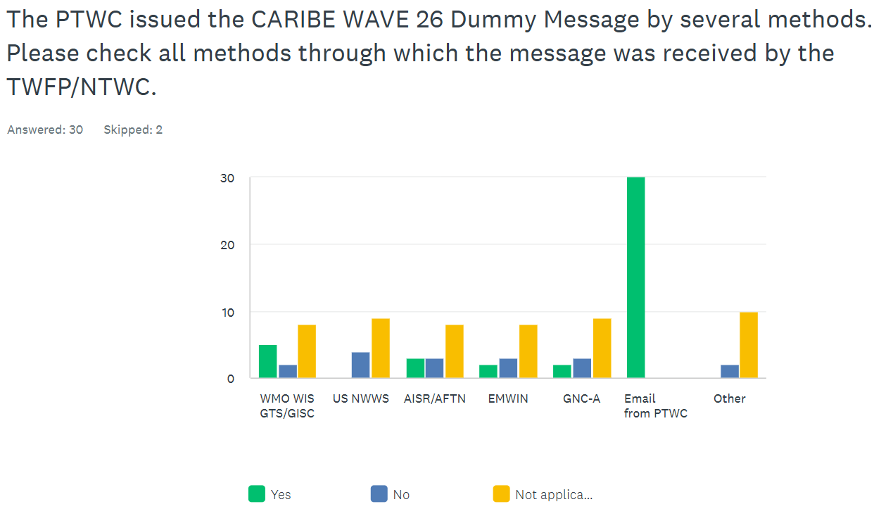
Figure 4. Methods that the CARIBE-EWS TWFPs/NTWCs used to receive the Dummy message by the PTWC.
3.3 ACTIONS IN THE CASE OF A REAL EVENT AND FALSE ALARMS
No significant real events and false alarms were reported by the Member States and Territories during the exercise. No actions were thus required.
3.4 REGISTRATION PROCEDURE
As for past exercises, the CARIBE-EWS teamed up with TsunamiZone.org for online registration (Figure 5). The link used for the registration was http://www.tsunamizone.org/register/. Under the “Register Here” Tab, participants were able to sign up and choose among the three major categories:
- Myself and/or my family,
- My school, district, college/university, or childcare center, and
- My organization, department, or agency (including TNCs, TWFPs and NTWCs). EMOs were encouraged to promote this registration system.
Most people registered directly on the TsunamiZone.org which is an open registration system available during the whole year. As of 14 April 2026, 606,265 people had registered (Table 2). There were people from every category participating. Nevertheless, according to Member States who answered the post-exercise survey the estimated number of people actually participating were approximately 619,340 (Table 3).

Category | Number of Participants
Individuals/Families | 3,207
Childcare and Pre-Schools | 10,387
K-12 Schools and Districts | 314,160
Colleges and Universities | 29,843
Local Government | 60,870
State Government | 45,355
Federal/National Government (Including Military) | 19,717
Tribes/Indigenous Peoples | 3
Businesses | 4,761
Hotels and Other Lodgings | 3,453
Healthcare | 22,205
Senior Facilities/Communities | 1,424
Disability/AFN Organizations | 152
Non-Profit Organizations | 5,264
Neighborhood Groups | 3,967
Preparedness Organizations | 56,241
Faith-based Organizations | 1,751
Museums, Libraries, Parks, etc. | 384
Volunteer/Service Clubs | 1,856
Youth Organizations | 337
Animal Shelter/Service Providers | 200
Agriculture/Livestock Sector | 110
Volunteer Radio Groups | 2,340
Science/Engineering Organizations | 396
Media Organizations | 7,973
Other | 9,909
Total | 606,265
Table 2. List of registrants and participants by Categories on TsunamiZone.org in the Caribbean (as of 04/14/2026)

Country |  | Participants according to Member States | Participants according to Tsunami Zone
Antigua and Barbuda |  | 9,163* | 9,163
Aruba |  | 32,347 | 6,299
Bahamas |  | 2* | 2
Barbados |  | 1,400 | 1,535
Belize |  | 2 | 2
Brazil |  | 14* | 14
Colombia |  | 30 | 394
Costa Rica |  | 4 | 22
Cuba |  | 0* | 0
Curacao |  | 5* | 5
Dominica |  | 250* | 250
Dominican Republic |  | 431 | 431
France |  | 104,263 | 104,263
Grenada |  | 200 | 7,682
Guatemala |  | 25 | 32
Guyana |  | 10 | 10
Haiti |  | 28,000 | 27,947
Honduras |  | 2,219 | 2,219
Jamaica |  | 15,000 | 6,743
Mexico |  | 8,100 | 1,191
Netherlands  (Bonaire, Saba, Sint Eustatius, other) |  | 55 | 55
Nicaragua |  | 50 | 95
Panama |  | 6,054 | 6,054
Saint Kitts and Nevis |  | 7,501* | 7,501
Saint Lucia |  | 750 | 205
Saint Vincent and the Grenadines |  | 20 | 150
Sint Maarten |  | 15* | 15
Suriname |  | 0* | 0
Trinidad and Tobago |  | 252* | 252
United Kingdom | Anguilla | 65 | 7
United Kingdom | Bermuda | 325* | 325
United Kingdom | British Virgin Islands | 6,032 | 6,089
United Kingdom | Cayman Islands | 10,961 | 9,582
United Kingdom | Montserrat | 0* | 0
United Kingdom | Turks and Caicos | 425* | 425
United States | Puerto Rico | 220,428 | 220,428
United States | US Virgin Island | 21,526 | 21,526
Venezuela |  | 161,368 | 165,352
TOTAL |  | 619,340 | 606,265
Table 3. List of participants by Country/Territory (as of 04/14/2026). *Number taken from TsunamiZone.org for cases where countries did not report the number of participants in the survey.

3.5 STATUS OF SEA LEVEL STATIONS DURING EXERCISE
An analysis of sea level stations status was carried out by the International Tsunami Information Center Caribbean Office (ITIC-CAR) as part of the CARIBE WAVE 26 Regional Tsunami Exercise. This allowed ITIC-CAR to analyze the availability of sea level data. The PTWC provided simulated forecasted maximum wave heights for 3 and 60 CARIBE-EWS stations for the Cayman Islands and Kick ‘em Jenny scenarios, respectively. Only about 76% of these sea level stations were online on the IOC Sea Level facility during the exercise period (Figures 6 and 7). The reported DART station for Kick ‘em Jenny was streaming data during the day of the exercise (Figure 10).
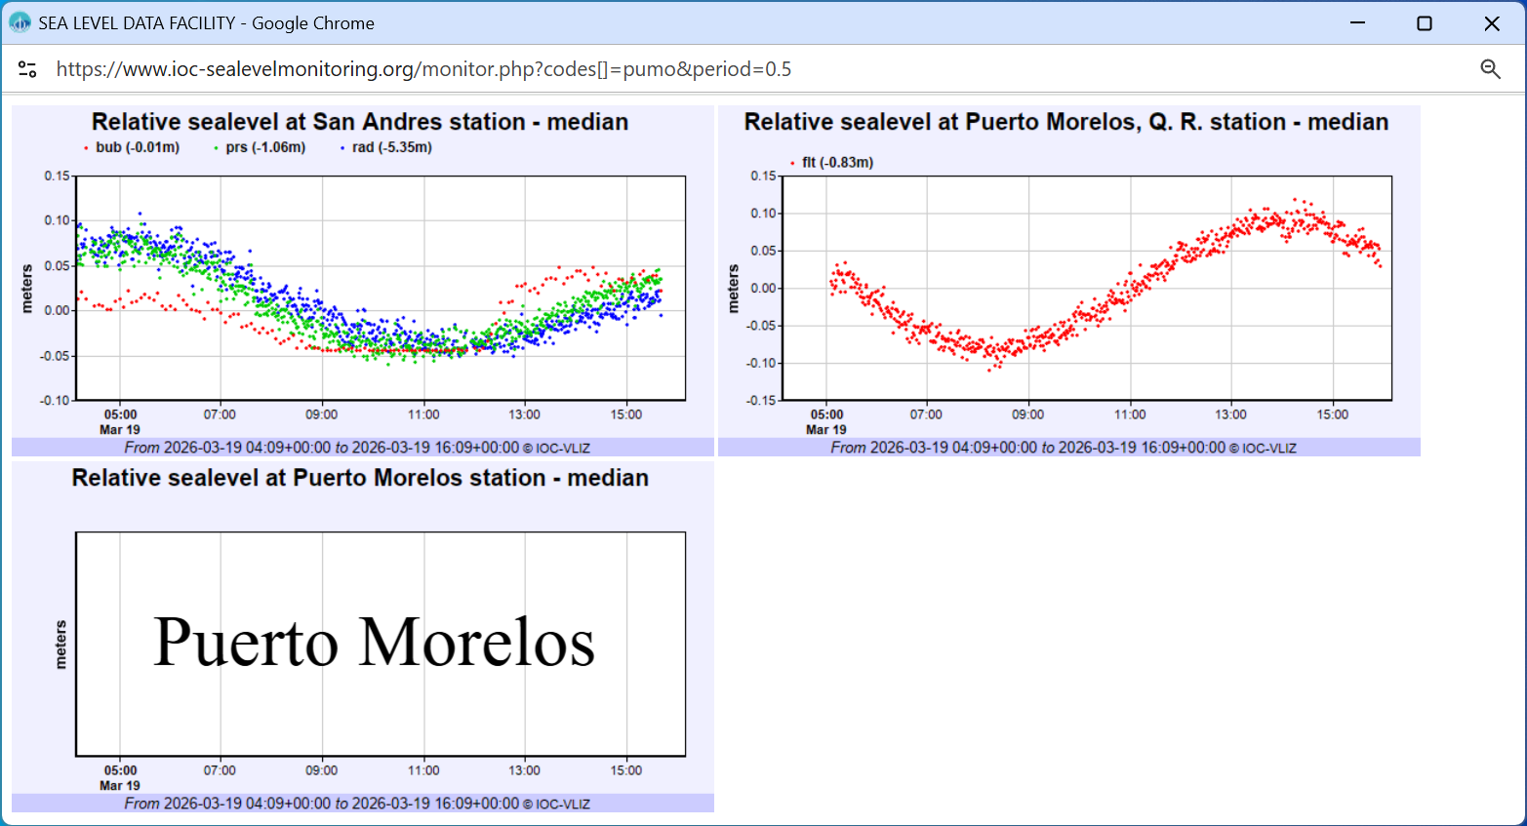

Figure 6. Two (2) of the 3 stations for which PTWC include sea level observations for the Cayman Islands Scenario in its simulated product. Stations for which the name of the station is provided and not the waveform, are stations that had no data on the IOC Sea Level Monitoring Facility.

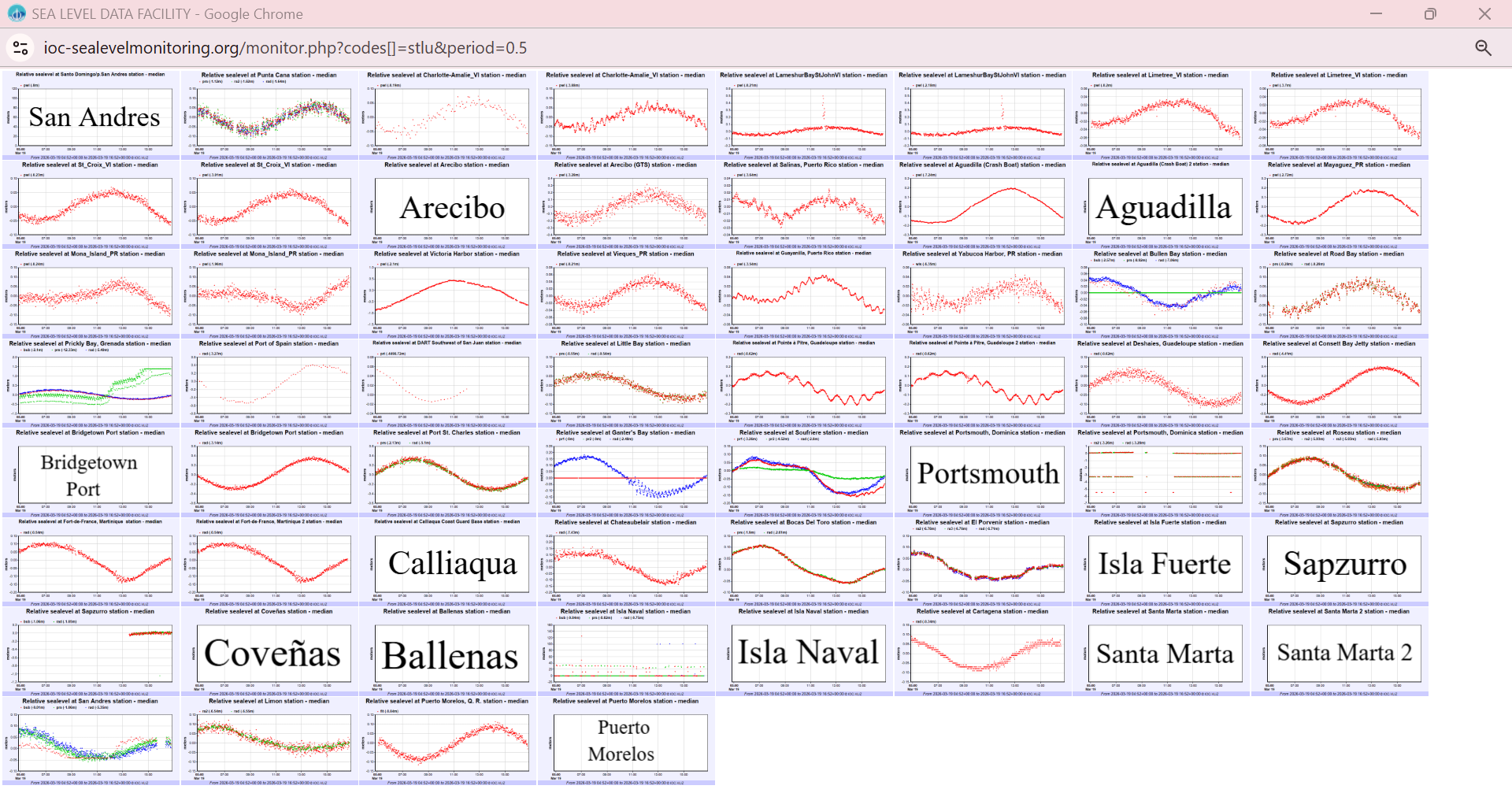

Figure 7. Forty Six (46) of the 60 stations for which PTWC include sea level observations for the Kick ‘em Jenny Scenario in its simulated product. Stations for which the name of the station is provided, and not the waveform, are stations with no data on the IOC Sea Level Monitoring Facility.

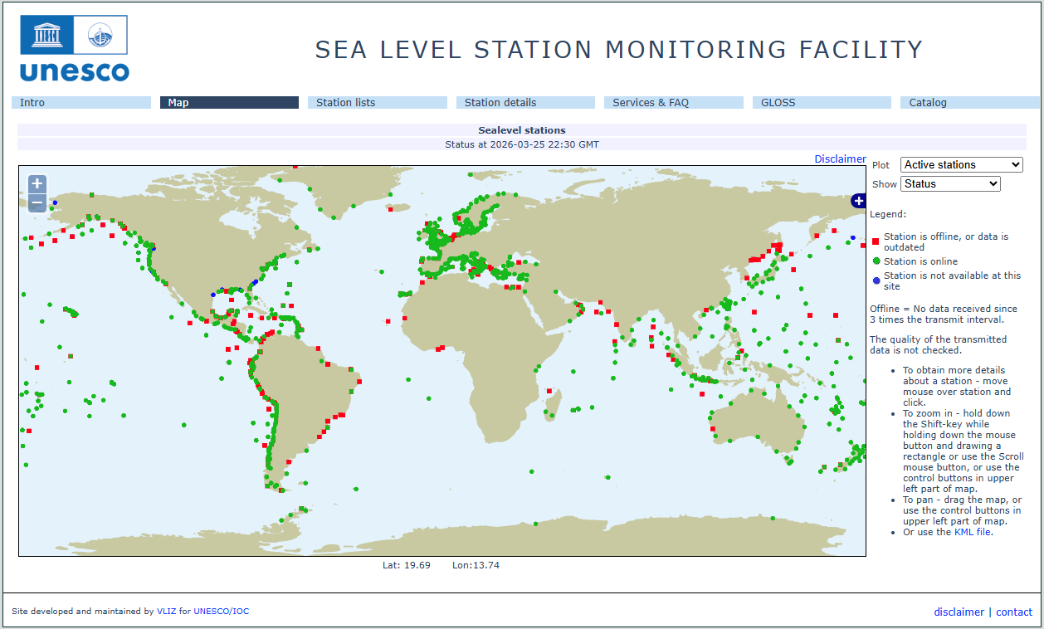
Figure 8. Screenshot showing IOC Sea Level facilities operating during the CARIBE WAVE 26 Exercise. In green are stations for which data were available, red dots are for stations for which there were no data available.

A)
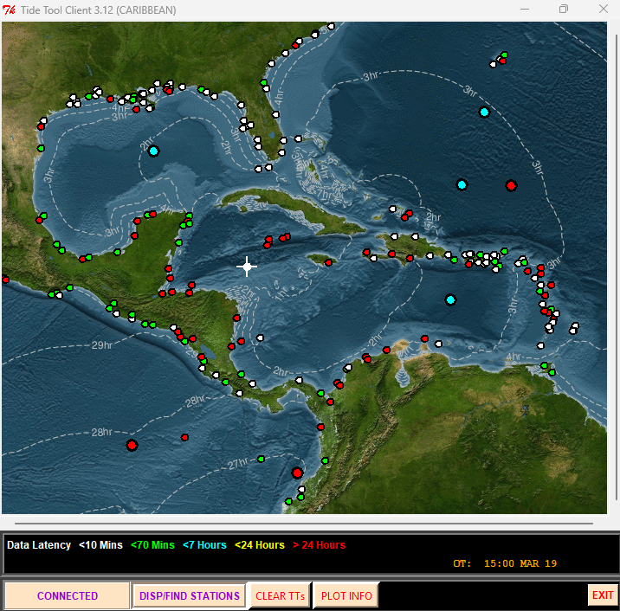
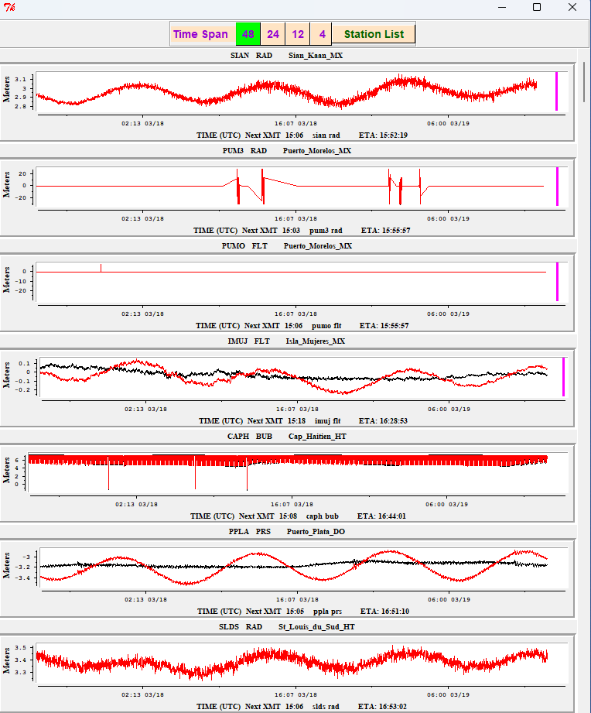

B)
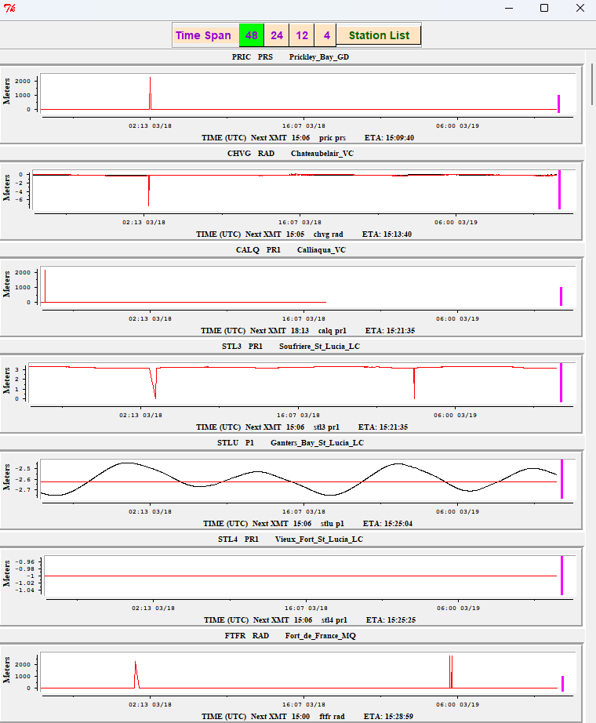
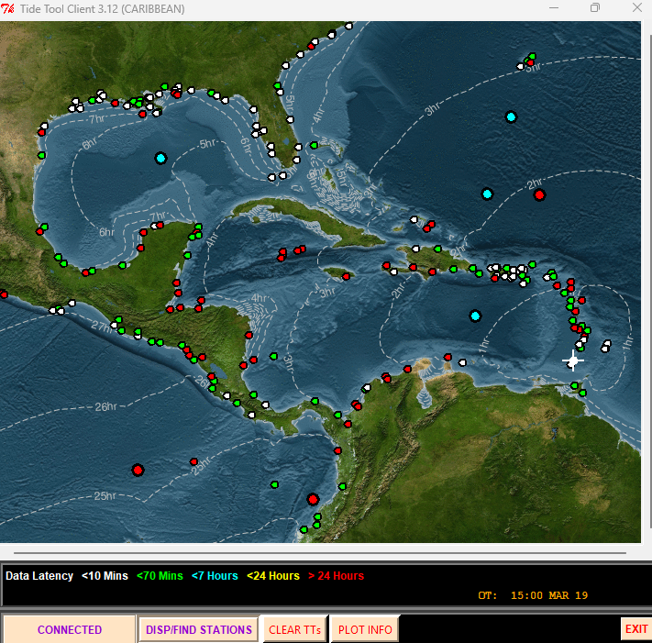

Figure 9. Screenshot from Tide Tool for the CARIBE WAVE 26 Cayman Islands (A) and Kick ‘em Jenny (B) Scenario. Tide Tool includes both coastal gauges and DARTs. In white and green are operational stations, in red are stations with no data over the past 24 hours (non-operational). The isochrons represent the travel time from the source of the simulated tsunami. The Strip Chart to the left includes the mareograms from the closest 7 stations. The magenta stripe marks the estimated time of arrival.
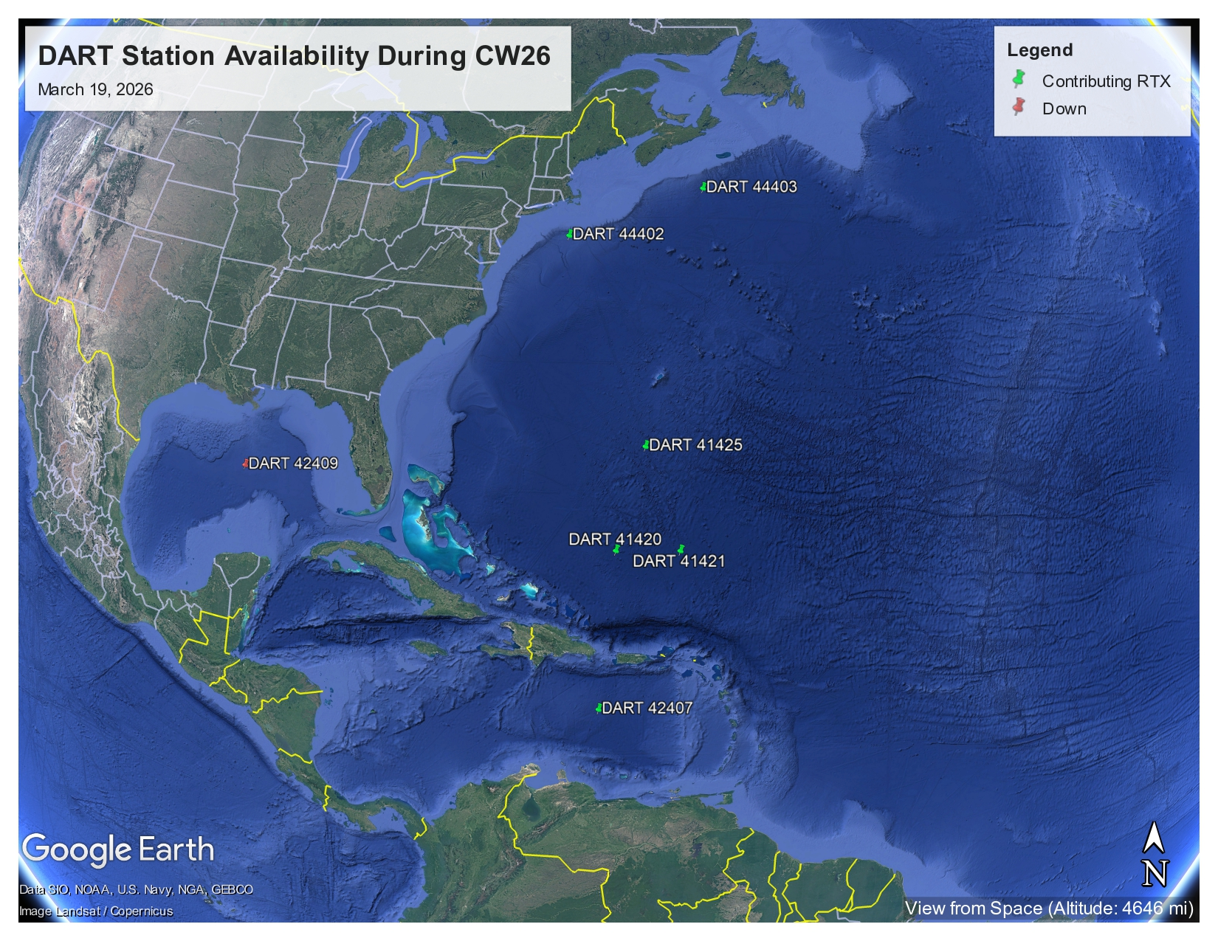
Figure 10. Map of operational DARTs on March 19, 2026.

3.6 MEDIA ARRANGEMENTS
One advantage of conducting exercises is that it provides a venue to promote tsunami awareness. The exercise offers an opportunity to collaborate with the media and disseminate more broadly information on the warning system. The CARIBE-EWS Member States and Territories indicated that about 48% of the news media participated and covered the exercise. Most countries and territories publicized the exercise through social media to encourage the participation of the community using the hashtag #CARIBEWAVE to track their activities on March 19th, resulting in worldwide reach. Several Emergency Management agencies from countries informed citizens through online article publications and social media posts that their country would participate in the exercise. The International Tsunami Information Center Caribbean Office (ITIC-CAR), as well as the Puerto Rico Seismic Network (PRSN), also published informative posts related to tsunami awareness in preparation for CARIBE WAVE.
3.7 POST-EXERCISE EVALUATION
All participating countries were requested to provide feedback on the exercise through an online questionnaire. This feedback assists the ICG/CARIBE-EWS and UNESCO-IOC Tsunami Resilience Section in the evaluation of CARIBE WAVE 26 and the development of subsequent exercises, to identify strengths and challenges in the warning system and the implementation of the UNESCO/IOC Tsunami Ready Programme. It also helps response agencies document lessons learned and leads to improvements in the national systems. The survey contained 50 questions and was conducted using SurveyMonkey. In total, 32 surveys were completed, representing the feedback from 91% of the Member States (MS) and Territories.*
The survey was available until April 13th, a few weeks after the day of the exercise. Overall, the results indicated that the Dummy (Start of Exercise) message from PTWC was received by 94% of the CARIBE-EWS Member States and Territories.
There was a strong dependency on email for the reception of products from the PTWC. The message was received by most countries within the first 1-5 minutes.
87% of the Member States indicated that the TWFP/NTWC issued follow up messages to relevant in-country agencies. The exercise planning went well under extenuating circumstances, resulting in 96% satisfaction of Member States and Territories, and a total participation of 619,340 people from the Caribbean, according to the survey responses of the Member States. The questions, as well as the answers and comments, are contained in the Supplement.
The results for the status of the implementation of the UNESCO/IOC Tsunami Ready Recognition Programme indicated that 76% Member States and Territories have implemented or are in the process of implementing the program, while 17% interested for those who have not yet implemented it, with 394 as the total number of target communities to be recognized as Tsunami Ready (Table 4).
In addition, the survey provided the MS an opportunity to provide statements on the exercise (Table 5). Many of the countries highlight their active participation and importance and relevance of the exercise.
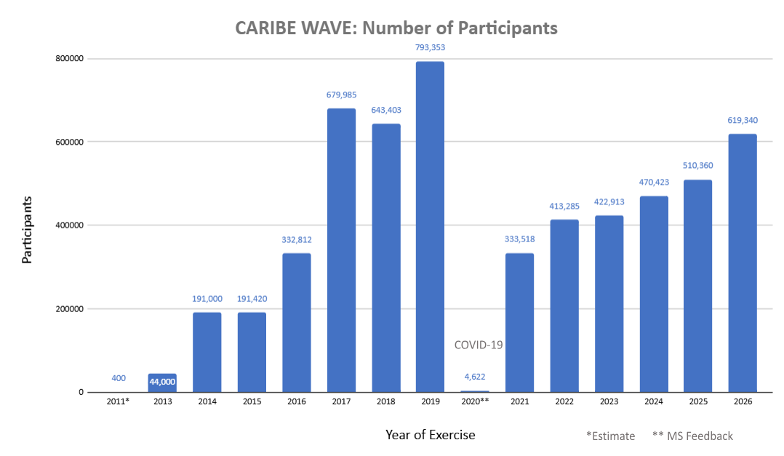
Figure 11. Number of participants for all the CARIBE WAVE exercises as reported by the Member States in the survey.

Country | Already Implementing | Interested in Implementing in case not implementing | TsunamiReady® or Tsunami Ready Communities (IOC Records For CARIBE EWS) | Target Number
Antigua and Barbuda | - | - | 1 | -
Aruba | No | Yes | 0 | 2
Bahamas | - | Yes | 0 | 75
Barbados | Yes | N/A | 3 | 4
Belize | Yes | N/A | 0 | 1
Brazil | - | - | 0 | -
Colombia | Yes | N/A | 0 | 2
Costa Rica | Yes | N/A | 11 | 18
Cuba | - | - | 0 | -
Curacao | Yes | N/A | 0 | -
Dominica | No | - | 1 | -
Dominican Republic | Yes | N/A | 0 | -
France | Yes | N/A | 1 | -
Grenada | Yes | N/A | 3 | 4
Guatemala | Yes | N/A | 2 | -
Guyana | Yes | N/A | 0 | -
Haiti | Yes | N/A | 1 | 12
Honduras | Yes | N/A | 3 | 5
Jamaica | Yes | N/A | 1 | 137
1Mexico | Yes | N/A | 0 | 44
NL- Bonaire, Saba, and Sint Eustatius | No | No | 0 | N/A
Nicaragua | Yes | N/A | 2 | -
Panama | Yes | N/A | 0 | 5
Saint Kitts and Nevis | Yes | N/A | 1 | 1
Saint Lucia | Yes | N/A | 1 | 18
Saint Vincent and the Grenadines | Yes | N/A | 1 | 10
Sint Maarten | - | - | 0 | -
Suriname | - | - | 0 | -
Trinidad and Tobago | Yes | N/A | 1 | -
UK- Anguilla | Yes | N/A | 1 | 1
UK- Bermuda | - | - | 0 | -
UK- British Virgin Islands | Yes | N/A | 1 | 1
UK- Cayman Islands | Yes | N/A | 0 | 3
UK- Montserrat | - | - | 0 | -
UK- Turks and Caicos | - | - | 0 | -
USA- Puerto Rico | Yes | N/A | 47 | 47
USA- US Virgin Islands | Yes | N/A | 3 | 4
Venezuela | Yes | N/A | 0 | -
TOTAL | 26 YES | 2 INTERESTED | 85 | 394
Table 4. Status of Implementation of the CARIBE EWS Tsunami Ready Recognition Program. In the case of Puerto Rico and the USVI, the TR recognition is through the US NWS TsunamiReady Program.

Country | Exercise Caribe Wave 26  General Statements
Aruba | Keep the impact scenario above 3 meter.
Barbados | The Caribe Wave 26 exercise was good overall, as it included more processes than in previous years. The submarine source was also a great option for Barbados and the Windward Islands. Additionally, it allowed for the refinement of procedures for testing and approving plans for tsunami hazards.
France | Caribe Wave provides each territorial crisis management service with the opportunity to test its procedures and tools at least once a year, using historical or realistic scenarios. This exercise served as a reminder to the population of the need to prepare for this type of crisis.  This year, the exercise gave all the French West Indies the opportunity to test a near-field wave, reaching the coast in less than an hour. Because of the volcano scenario, the challenge this year was to make decisions before knowing the impact on the territories. The tsunami alert through NAVAREA was tested for the first time. The PTWC message was received by CROSS-AG (MRCC) and the FAA (Deputy National Coordinator).  A questionnaire was distributed to the population of St MArtin/St Barth via various channels (FR-Alert (our cell-broadcast system), WhatsApp group, Facebook), and this should allow us to identify areas for improvement in terms of public alerts. This exercise also provided the opportunity to test the WhatsApp alert system for the first time in a real-world scenario. It proved to be one of the fastest and most effective tools to implement in the event of a tsunami.
Grenada | Overall, CARIBE Wave 26 was a successful exercise that was well participated. The pilot use of drone technology for data collection and communication via the loudspeaker was a success at the muster points.
Guatemala | On March 19, all personnel from the Seismology Section of the Department of Geophysical Research and Services in Guatemala participated in the CARIBE WAVE 26 exercise. Each staff member was assigned to handle one of the alerts during the exercise. Based on these alerts, bulletins were generated with information relevant to Guatemala. All bulletins were sent by email to CONRED personnel (the national disaster coordination agency) and to INSIVUMEH’s regional offices along the country’s coasts. Confirmation responses were requested from recipients as part of an internal communication evaluation.
Haiti | This is a good exercice. This is the first time Haiti has a great number of participants although the bad socio-political situation. Hope an improvement of the situation in Haiti letting have a better exercice.
Jamaica | Caribe Wave was observed on March 19, 2026. The focus was on Port Maria in St. Mary, but several other parishes also observed an activity. The sirens were tested in Port Maria and saw the participation of schools, Port Maria Preparatory and High, Port Maria Primary and Marymount High Schools. Several agencies also participated included the Ministry of Health and Wellness, Ministry of Labour and Social Security, The Social Development Commission, the St. Mary Parish Court, Jamaica Fire Brigade, Jamaica Constabulary Force, Jamaica Public Service Company, Pagee Beach Fishing Cooperative among other actors. Special commendations to FLOW and DIGICEL for blasting tsunami messages to thousands of persons both nationally and through the parish of St. Mary and neighboring parishes such as Portland, St. Ann and Trelawny. A total of ten Municipal Corporations along with the ODPEM registered on tsunamizone.org. Other entities which registered activities included the Jamaica Energy Partners, Old Harbour Bay, Jamaica Bauxite Institute and the Maritime Authority. One community group from St. Mary also registered as well as one individual was reflected on the site. For the Port Maria Exercise there was a general unresponsiveness of the business centre. Greater sensitization is needed but it was an excellent attempt, and commendations are in order for Mr. Adrian Tate, Parish Disaster Coordinator and Mr. Marlon Brown, Regional Disaster Coordinator.  Worthy of note also, the Validation Session for the Treasure Beach Tsunami Response Plan was held on March 21. Other Tsunami Sessions were held at the New Hope Primary in Whitehouse in Westmoreland, the St. Thomas Municipal Corporation, Public Education Transect Walks in Clarendon (southeast Clarendon coastal communities)  On March 12, St. Catherine MC hosted a radio training for MDAs, Jamaica Energy Partners and the South Jamaica Power Company (LNG Plant) and community actors and the testing of the sirens in Old Harbour Bay.
Mexico | Participation in the CARIBE WAVE 26 exercise represented a valuable opportunity to strengthen community preparedness for tsunamis in the Caribbean region. Through the simulation, response protocols were activated, reaction times were evaluated, and coordination among local, national, and regional institutions was fostered.  These types of exercises not only reinforce technical capabilities but also promote a culture of resilience. In particular, the Tsunami Ready program approach has proven to be an effective tool for empowering coastal communities by integrating education, signage, evacuation routes, and early warning systems.  We reiterate our commitment to continuous improvement, the inclusion of local stakeholders, and the expansion of the Tsunami Ready program's coverage, recognizing that preparedness saves lives and strengthens the social fabric in the face of natural hazards.  We also respectfully request that, if possible, you develop, as supporting materials, animations of the tsunami wave travel time simulation along the Caribbean, naturally depending on the source.
Nicaragua | For us it was important to test for the first time in a Caribe Wave the dissemination of messages using the social networks on the regional and international scale
Panama | The CARIBE WAVE 2026 exercise on March 19,2026 covered the main objectives in terms of communications procedures (for us). In our case, we worked with the Cayman Islands scenario considered seismically and tectonically interesting, even we also wanted to work with Kick-´em-Jenny scenario to improve the volcanic experience. We are expectíng a more active CARIBE WAVE 2027 for Panama, including training in tsunami awareness (basic concepts, risks, warning systems, community preparedness, evacuation procedures) in selected communities.
Saint Kitts and Nevis | The overall experience was informative. In essence society appreciates the activity and looks forward to it. Ways and means to improve the drill should always be considered. There should also be more public awareness to bring about a change in attitude towards implementing these types of exercises. Consider using technological advancement to support the overall exercise.
Saint Lucia | Overall the Caribe Wave 26 exercise was successful in Saint Lucia, we had greater participation, notably the inclusion of banks business places and administration centers. The involvement of the police and fire service proved to be a great asset. The exercise provided an opportunity to identify gaps which we are working on filling going forward.
Saint Vincent and the Grenadines | The beginning of 2026 posed some logistical challenges that restricted our usual involvement in the annual exercise. We have discussed these challenges and shortfalls and concluded with a renewed commitment to greater and meaningful participation going forward.
Trinidad and Tobago | Good experience with testing response for tsunami generation by volcanic activity.
UK- Cayman Islands | Hazard Management Cayman Islands is grateful to UNESCO for your valuable partnership and support.  The CARIBE WAVE tsunami exercises are a great opportunity to share the focus among various hazards as the Caribbean tends to remain focused on Hurricanes.  The Cayman scenario used in the CARIBE WAVE 26 Tsunami exercise was taken from a real event of the 7.6M earthquake which occurred on 8 February 2025 on the Swan Islands Fault.  The actual event was a unique one for the Cayman Islands as it was similar in magnitude to the 7.8M 2020 Earthquake. However, the 8 February 2025 earthquake did NOT generate shaking within the Cayman Islands but did generate a tsunami threat. This tested our response as the guidance is "if an earthquake is long and strong, get gone!". This guidance was not applicable to the 2025 earthquake despite it being a considerably large magnitude earthquake. Therefore, the simulated exercise was a replay of the real event (no shaking).  Persons were caught off guard by the real tsunami threat from the 2025 and CARIBE WAVE 26 Cayman scenario allowed the people of the Cayman Islands to get a second chance and practice what their response should have been.  Feedback for PTWC:  -Messages information heavy and critical/time-sensitive information can get lost.  -Offering different measurements meters and feet could be beneficial as communities are diverse.
USA- Puerto Rico | The CARIBE WAVE 26 exercise was a great opportunity to explain to the population that a volcano can generate a tsunami that affects PR even when we don't have volcanoes on the island. It was also a good exercise to evaluate the communication with different agencies.
USA-US Virgin Islands | Our Islands of St. Thomas and St. John both had a power outage occur just after the EAS message went out. Many individuals didn't participate due to the power outage. However, the Island of St. John did stand-up its Emergency Operations Center and exercise its Continuity of Operations Plan (COOP) to a location with an operational microgrid as well as used PACE emergency communications - Starlink - to communicate to the Emergency Operation Center on the Island of St. Croix. An exercise scenario based on a significant impact to the Island of St. John ran for 2-hours with injects to Emergency Support Function Staff and ending with a mock Press Release. Additionally, the Territory exercised its Continuity of Government Plan (COG) (Legislative Branch, Executive Branch, and Judicial Branch) for accountability of senior leaders.  The EAS / IPAWS message went to and was received by mobile phone, radio stations, and television stations. Great success!  A formal after action review (AAR) conducted the following week by the Emergency Management Agency / VIGTEMA on the EOC response, COG, COOP, and EAS.
Venezuela | This year's Caribe Wave 26 exercise was very active. Contacts were re-established with top authorities, and the new authorities were successfully incorporated into the exercise. The Vice Ministry of Risk Management decided to include the entire national territory, encompassing both coastal and inland states, in coordination with scientists and communities. With great enthusiasm, state and municipal civil protection agencies, drawing on their experience in previous exercises, embraced participation, adapting their own methodologies and reporting to the main situation room located at the SSATV (Social Security and Television System) in Funvisis (National Fund for the Development of the State of Veracruz) and two secondary rooms in La Carlota and La Guaira. Coordination with the authorities in these rooms utilized the updated and adapted Kobox platform, developed by Funvisis, to collect key indicators. This allowed for an assessment of the capabilities and progress of coastal areas in their TsunamiReady preparedness. The operational order for the exercise, prepared by the Vice Ministry of Risk Management and Civil Protection and its team, entitled "Operations Order" for Caribe Wave, was also in place. The participation of amateur radio operators further strengthened communications. We must restore international communications with other warning centers in the region to obtain confirmation and exchange data, among other things.  The assessment of coastal areas that can be prepared for the TsunamiReady program continues.
Table 5. General statements on CARIBE WAVE 26 Tsunami Exercise experience from countries
that participated.

Person | Agency | Email
Gisela Báez-Sánchez  CARIBE WAVE Task Team Chair, | Puerto Rico Seismic Network, USA | gisela.baez1@upr.edu
Antonio Aguilar  CARIBE WAVE Task Team Vice Chair, | FUNVISIS, Venezuela | antoniodesastres@gmail.com
Gerard Metayer  CARIBE EWS Chair | Service Maritime et de Navigation  Haiti | gerard_metayer@yahoo.fr
Fréderic Dondin  Chair WG 1 Risk Knowledge | BGRM | fredericdondin@gmail.com
Raphaël Paris  Member WG 1 Risk Knowledge | Université Blaise Pascal et CNRS-LMV | Raphael.paris@uca.fr
Elizabeth Vanacore  Chair WG 2 Tsunami Detection, Analysis and Forecasting | Puerto Rico Seismic Network, USA | elizabeth.vanacore@upr.edu
Christa von Hillebrandt-Andrade  Chair WG 3 Tsunami Warning Dissemination and Communication | ITIC-CAR | christa.vonh@noaa.gov
Jacob Munakwa Ngumbah  Chair WG 4 Preparedness, Readiness and Resilience | NDMD, St. Kitts and Nevis | jack_dmc2011@yahoo.com
Matthieu Péroche  Chair of TsunamiReady Task Team | University of Montpellier Paul-Val | mathieu.peroche@gmail.com
Erouscilla Joseph  Scientific Expert – Kick ‘em Jenny Scenario | UWI Seismic Research Centre | Erouscilla.joseph@sta.uwi.edu
Valerie Clouard  Scientific Expert – Kick ‘em Jenny Scenario | GET/OMP, Univ. Toulouse Paul Sabatier | valerie.clouard@get.omp.eu
Lemoine Anne  Scientific Expert – Cayman Islands Scenario | BGRM | A.Lemoine@brgm.fr
Elizabeth Riley  Director CDEMA | CDEMA | elizabeth.riley@cdema.org
Adherbal de la Rosa Toulier  Executive Secretary CEPREDENAC | CEPREDENAC | cgarcia@cepredenac.org
Lt. Colonel Daniel Polinacci  Chief EMIZ Antilles | EMIZ Antilles | daniel.polinacci@martinique.pref.gouv.fr
Charles McCreery / Carolina Hincapié  PTWC, USA | PTWC, USA | charles.mccreery@noaa.gov  carolina.hincapie@noaa.gov
Wilfried Strauch  CATAC, Nicaragua | CATAC, Nicaragua | wilfried.strauch@yahoo.com
David Wald / Kristin Marano  Scientific Experts – Earthquake Impact Products | United States Geological Survey | wald@usgs.gov  kmarano@usgs.gov
Alison Brome  Director CTIC | CTIC | a.brome@unesco.org
Öcal Necmioglu  Technical Secretary CARIBE EWS | CARIBE EWS | (up to November 2025)
Patrick Tyburn  CARIBE WAVE Task Team Member | STIS,  Saint Barthélemy | patrick.tyburn@sdis972.fr
José A. Tojil Jimenez  CARIBE WAVE Task Team Member | INSIVUMEH | jatojil@insivumeh.gob.gt
Kaza Hippolyte  CARIBE WAVE Task Team Member, | STLFS, Saint Lucia | kazagr81@hotmail.com
Lucius Lake  CARIBE WAVE Task Team Member | NEOC | lucius.yl@gmail.com
Mabius Francis  CARIBE WAVE Task Team Member, | STLFS, Saint Lucia | mabiusfrancis@me.com
Malcom Job  CARIBE WAVE Task Team Member | NEMO, Saint Lucia | job@nemo.gov.lc
Table 5. Members of the CARIBE WAVE 26 Task Team

- REFERENCES

National Centers for Environmental Information/World Data Service (NCEI/WDS). (2023). Global Historical Tsunami Database National Centers for Environmental. Information, Boulder, Colo., doi:10.7289/V5PN93H7. (Accessed April 2026)
von Hillebrandt-Andrade, Christa, 2013, Minimizing Caribbean Tsunami Risk: Science, Vol. 341, p. 966-968.
ANNEX I. List Of Acronyms
AWIPS | Advanced Weather Interactive Processing System
CATAC | Central American Tsunami Advisory Centre
EAS | Emergency Alert System
EMO | Emergency Management Organization
EMWIN | Emergency Management Weather Information Network
GNC-A | GEONETCast Americas
GTS | Global Telecommunication System
ICG/CARIBE-EWS | Intergovernmental Coordination Group for the Tsunamis and Other Coastal Hazards Warning System for the Caribbean and Adjacent Regions
INETER | Instituto Nicaragüense de Estudios Territoriales
IOC | Intergovernmental Oceanographic Commission of UNESCO
ITIC-CAR | International Tsunami Information Center Caribbean Office
NCEI | National Centers for Environmental Information
NDMO | National Disaster Management Office
NOAA | National Oceanic and Atmospheric Administration
NTWC | National Tsunami Warning Centre
NWS | National Weather Service
NWWS | NOAA Weather Wire Service
PTWC | Pacific Tsunami Warning Center
RIFT | Rapid Inundation and Forecasting of Tsunamis
TWFP | Tsunami Warning Focal Points
UNESCO | United National Educational, Scientific, and Cultural Organization
WMO | World Meteorological Organization
WIS | WMO Information System

* Countries answering the post-exercise survey: Antigua and Barbuda, Aruba, Bahamas, Barbados, Belize, Colombia, Costa Rica, Curaçao, Dominica, Dominican Republic, France (Guadeloupe, Martinique, Saint Martin, Saint Barthelemy), Grenada, Guatemala, Guyana, Haiti, Honduras, Jamaica, Mexico, Netherlands (Bonaire, Saba, Sint Eustatius), Nicaragua, Panama, Saint Kitts and Nevis, Saint Lucia, Saint Vincent and the Grenadines, Trinidad and Tobago, United Kingdom (Anguilla, Bermuda, British Virgin Islands, Cayman Islands), United States (Puerto Rico, U.S. Virgin Islands), and Venezuela.

