Summary
Introduction
Part I – Revised Programme and budget 2026–2027 as presented as part of UNESCO's Draft 43 C/5 Rev. to the 224th session of the UNESCO Executive Board (224 EX/11)
Part II – Details of proposed budgetary allocations based on Member States’ guidance in IOC Resolutions A-32/4 and EC-57/2
Decision proposed is referenced Dec. IOC/EC-59/4.1 in the Provisional Action Paper IOC/EC-59/AP Prov.

Introduction
- In line with the IOC Medium-Term Strategy 2022–2029, the IOC’s chapter in the revised draft programme and budget and expenditure plan (first biennium of the 2026–2029 quadriennium (43 C/5 Revised Draft), as presented in Part I of this document is guided by the Commission’s Mission Statement, Vision and High-Level Objectives and supported by its conceptual framework of functions.
- The first Draft Programme and Budget 2026–2027 (Draft 43 C/5) was presented to the IOC Assembly at its 33rd session as document IOC/A-33/5.1.Doc(1) Rev. In its IOC Resolution A-33/3, the Assembly welcomed “the effort put in the development of the new Draft IOC Results Framework 2026–2027, aligned with the IOC Medium-Term Strategy 2022–2029” and considered that “the programmatic choices of the Secretariat […] follow Member States’ strategic guidance, in line with the priority areas of the 42 C/5 and the spirit of maintaining the achievements related to the high-level principles of the IOC Resolution A-32/4 and EC-57/2”.
- Acknowledging that “the working assumptions of the proposed budgetary scenarios for 2026–2027 may change in light of the potential loss of funding for the regular budget and voluntary contributions, adversely impacting the allocations to the IOC, while some of the Commission’s critically vulnerable areas are still understaffed and under-resourced”, the Assembly requested the IOC Executive Secretary, in consultation with IOC Intersessional Financial Advisory Group, “to explore options to maintain and optimize the 43 C/5, with the number and level of positions foreseen in the 42 C/5 as the minimal baseline, in finalizing the IOC proposal for the 43 C/5 budgetary scenario(s) to be presented to the 43rd session of the UNESCO General Conference.”
- UNESCO General Conference at its 43rd session in November 2025 adopted Appropriation resolution for 2026–2027 (43 C/Resolution 84) resolving that for the regular budget appropriations amounting to $610,045,936, Member States shall be assessed for $342,722,436 in 2026 and $267,323,500 in 2027, this decision arising from the exceptional circumstances of a reduced budget ceiling to account for the contributions that two Member States withdrawing from the Organization would have been assessed for in 2027.
- Following the recommendations of the 222nd session of the UNESCO Executive Board presented to it in document 43 C/64, the General Conference adopted 43 GC/Resolution 85 stating that “a baseline be identified agreed for IOC’s share of UNESCO’s regular budget under document 42 C/5 and future C/5 documents and that no reduction to this baseline be made in the future unless agreed by the General Conference” and recommitted “to 216 EX/Decision 44 in order to ensure that IOC receives no less than 3% of the available overall regular budget”.
- The General Conference requested the UNESCO Director-General to present to the Executive Board at its 224th session in April 2026 the complete revised 43 C/5 documentation. The Executive Board, as a one-time exception, was given delegated authority to approve at its 224th session the 2026–2027 budget by appropriation line within the overall budget ceiling approved by the General Conference.
- The Director-General was further invited to present for approval the full details of an expenditure plan for $534.6 million for the 2026–2027 regular budget to be implemented in the event of non-payment of their 2026 assessed contributions by the Member States withdrawing from the Organization.
- This document presents the revised IOC Programme and Budget for 2026–2027 (43 C/5 Rev), both under the $610M budget ceiling and the $534.6M expenditure plan for UNESCO.
- In line with the IOC Assembly decisions further endorsed by UNESCO General Conference, it contains the programmatic proposals based on the 42 C/5 prioritization by the Assembly and articulated around the relevant parts of the new IOC Results Framework and the budgetary allocations representing 3% of the total UNESCO regular budget.
- Table 1 below provides the comparison of IOC regular budget allocations in 42 C/5, Draft 43 C/5 Zero Nominal Growth scenario as considered by the IOC Assembly at its 33rd session and 43 C/5 Revised, both under the $610M budget ceiling and the $534.6M expenditure plan for UNESCO.
Table 1. Comparison of regular budget allocations (in USD’000)

- The document also presents the Secretariat’s analysis of the impact of budget reductions on the scope of activities, their impact and reach, as well as the areas of possible upscaling should additional resources become available. The guiding principles applied by the Secretariat in its preparation also benefitted from extensive consultations with Member States through the Intersessional Financial Advisory Group.
- The new results framework of collectively agreed priorities will also guide efforts to mobilize voluntary contributions ($22.3 million), so that these do not divert attention from the Commission’s core mandate, based on a new approach to resource mobilization in order to seek alignment with the Strategy and Results Framework.

Part I

REVISED PROGRAMME AND BUDGET 2026-2027
As part of UNESCO 43 C/5 Rev. – 224 EX/11

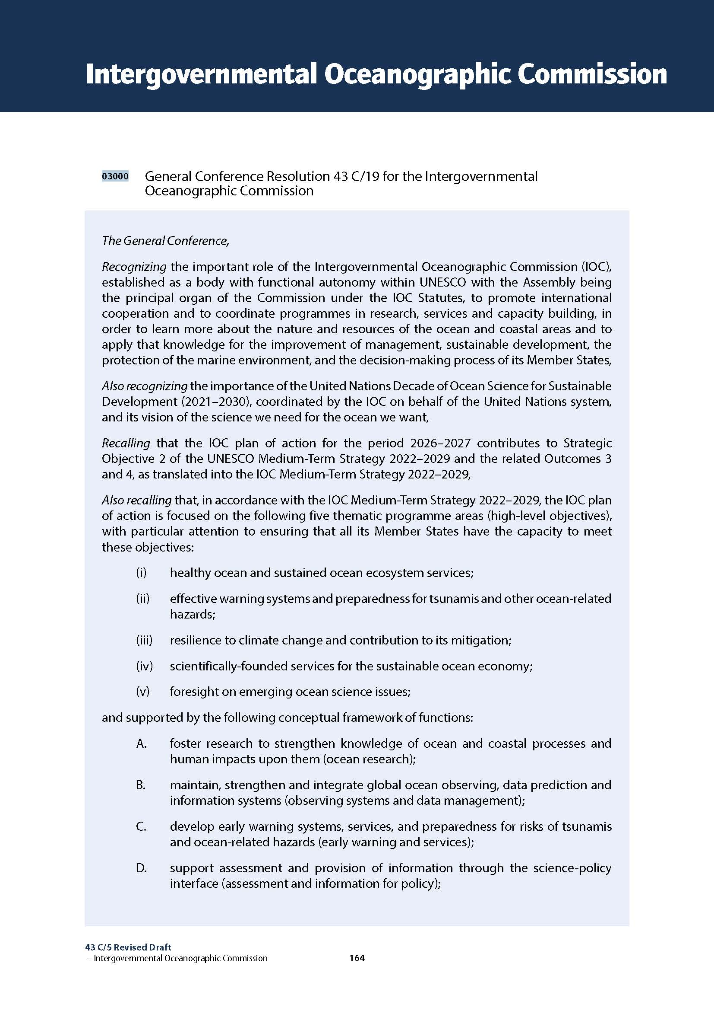
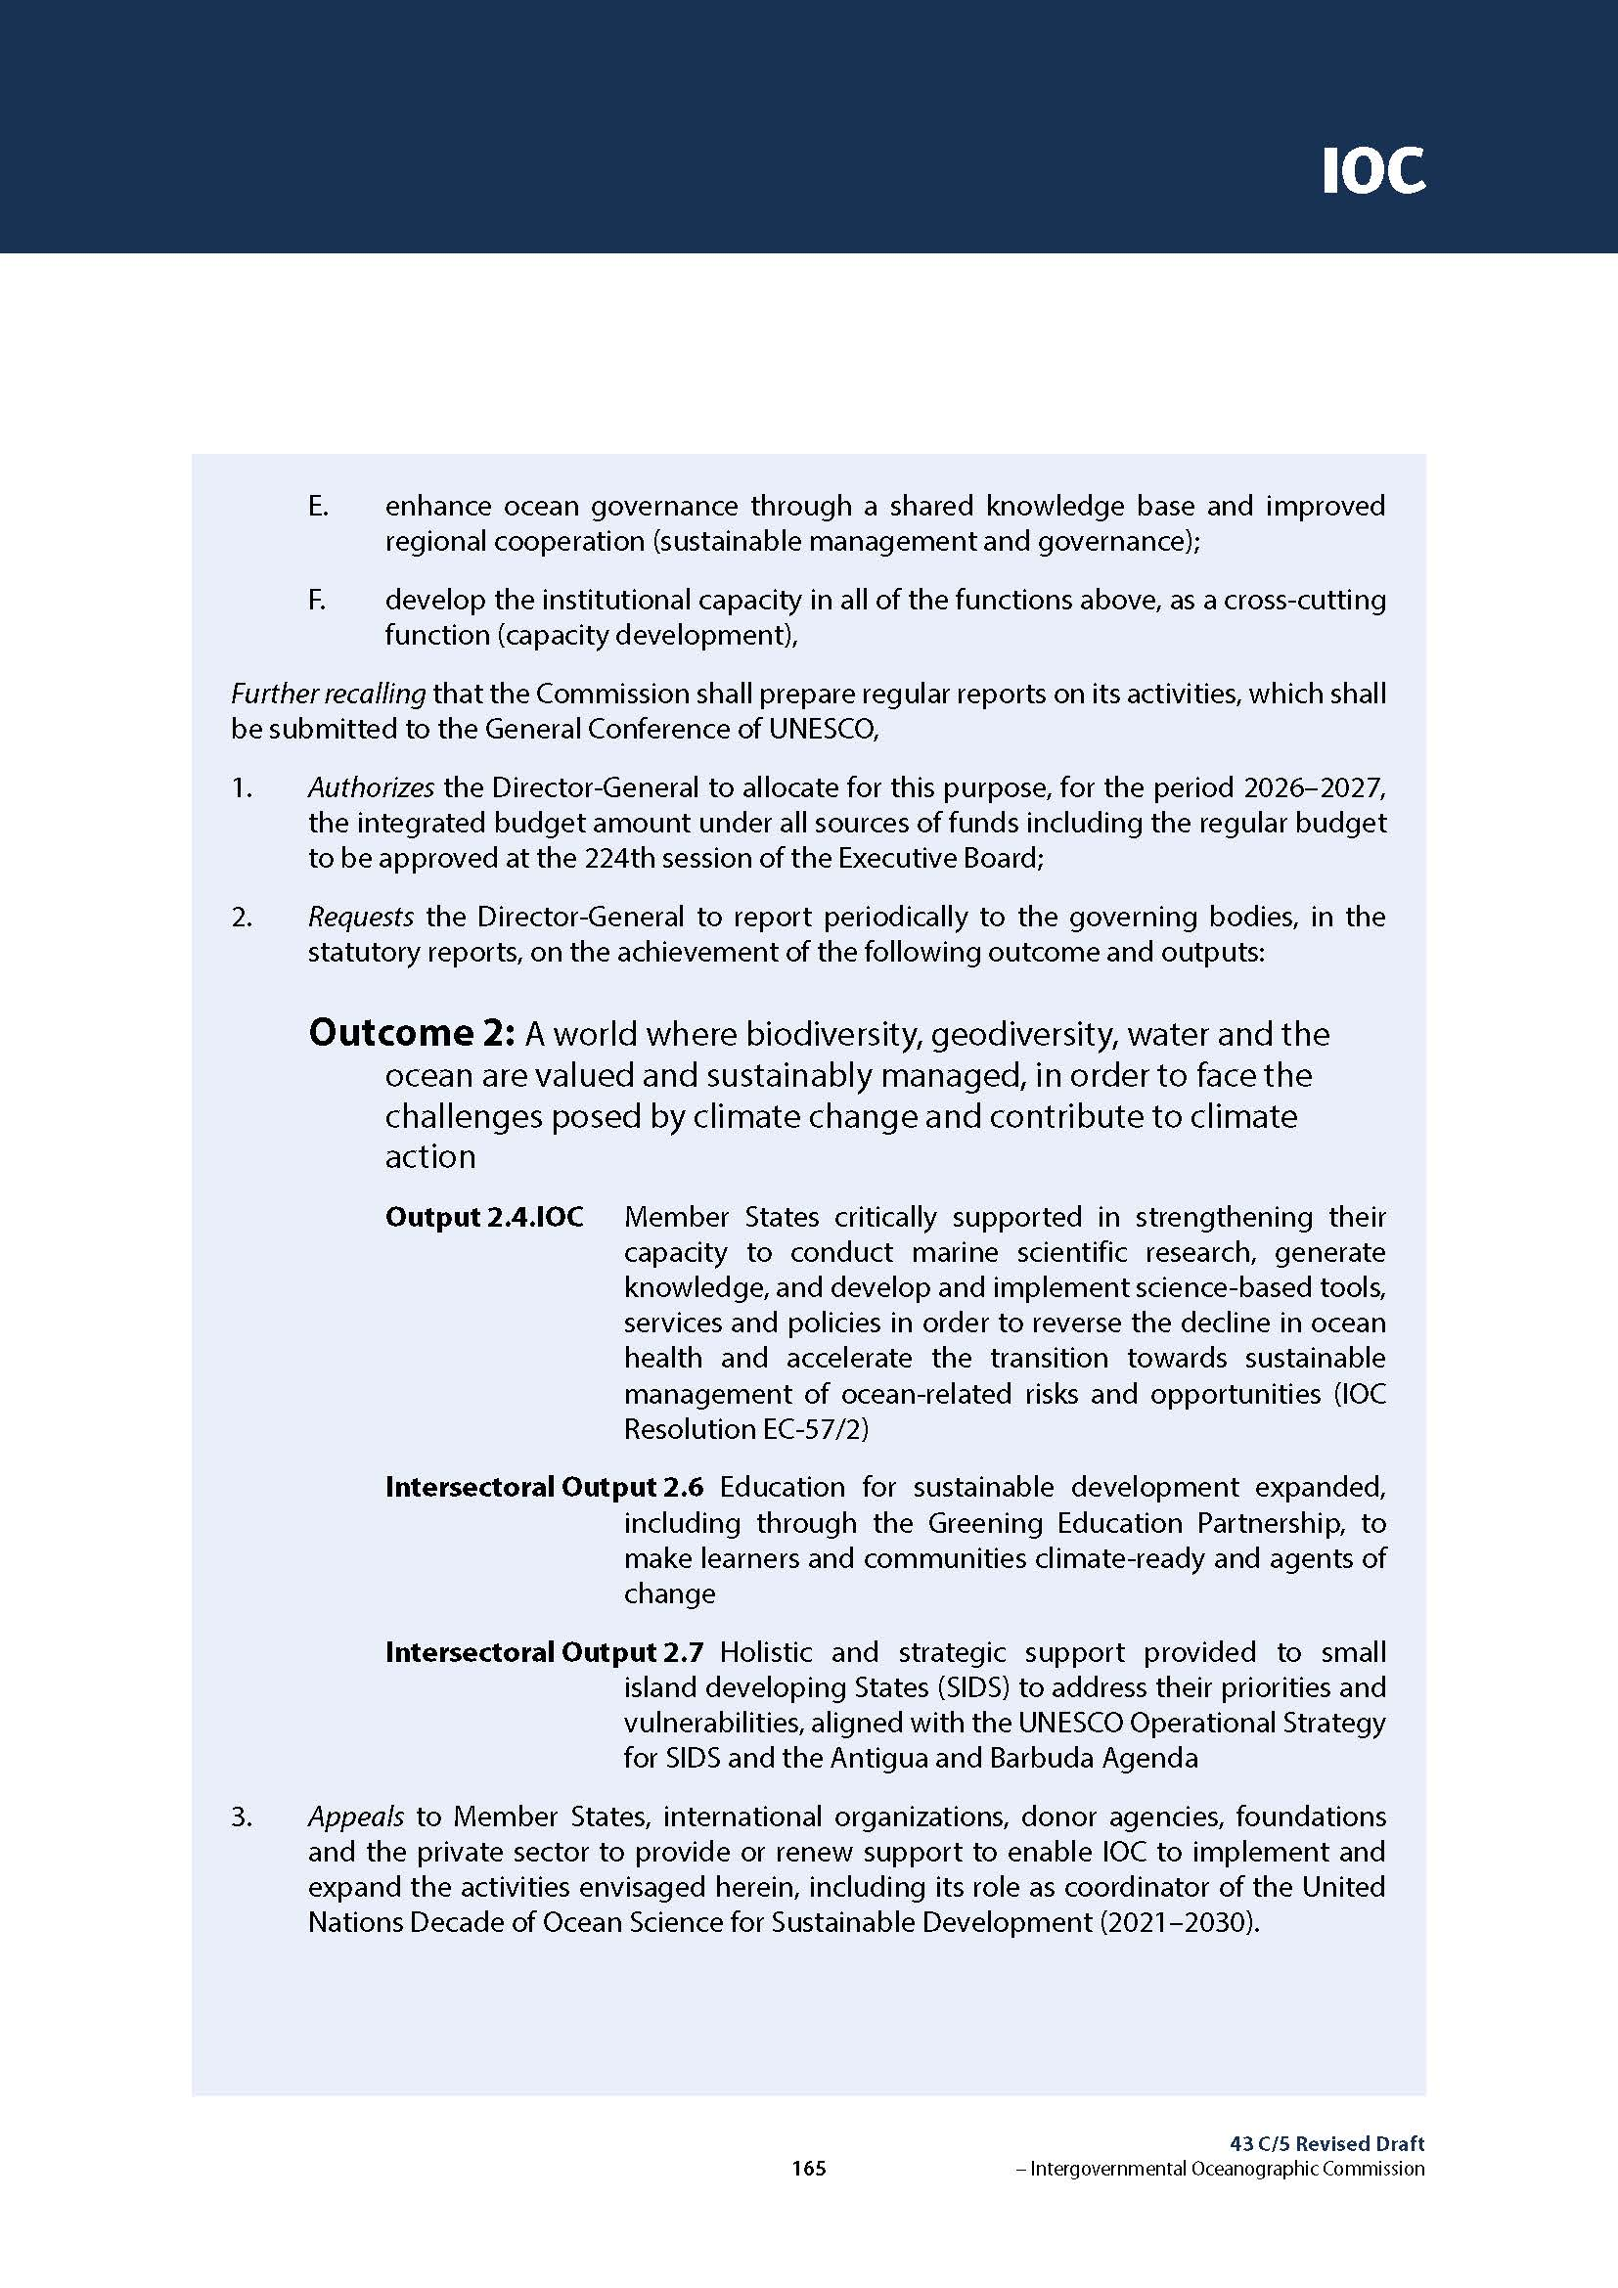
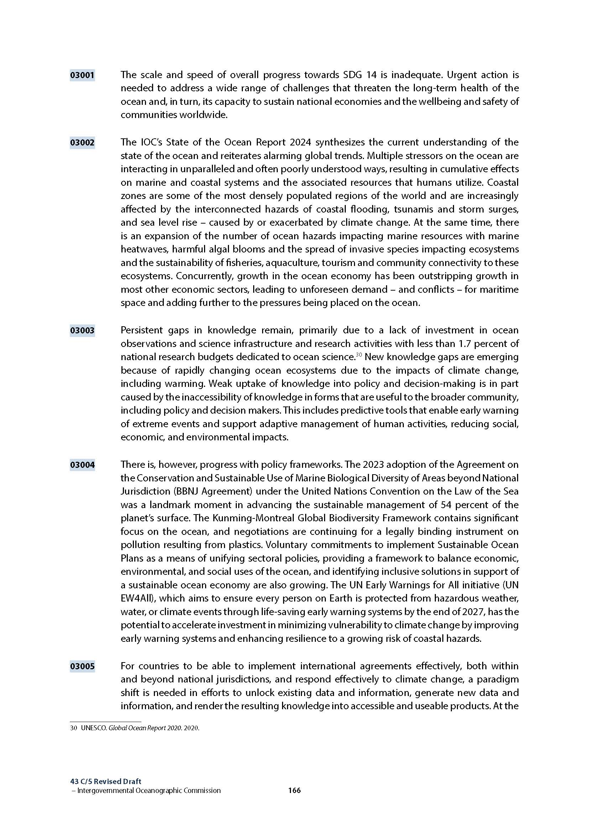
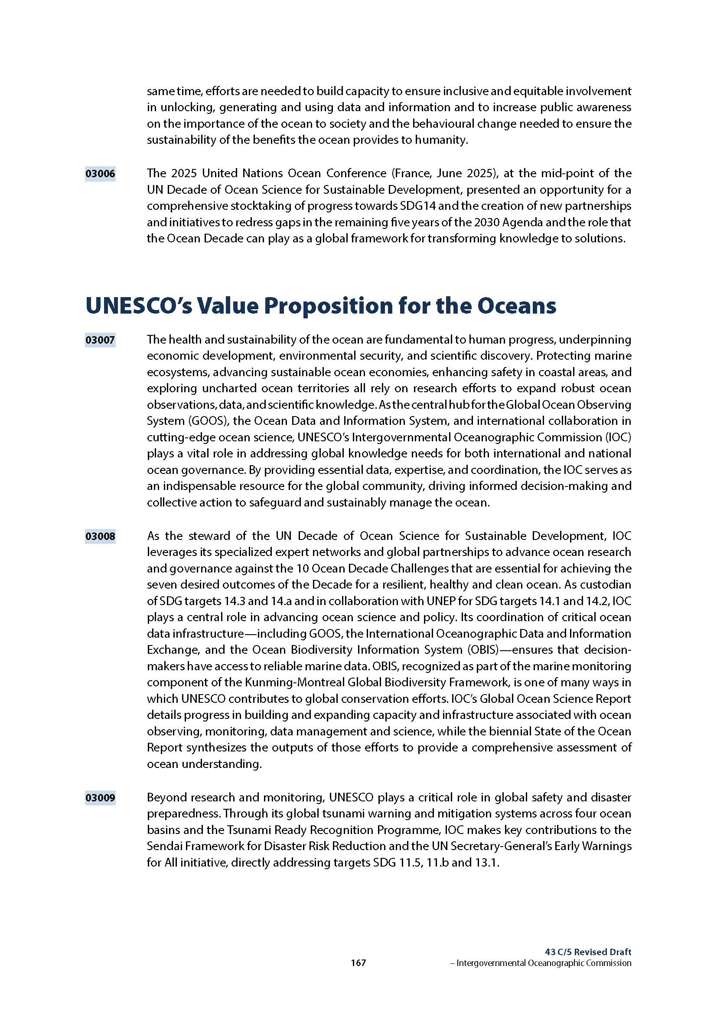
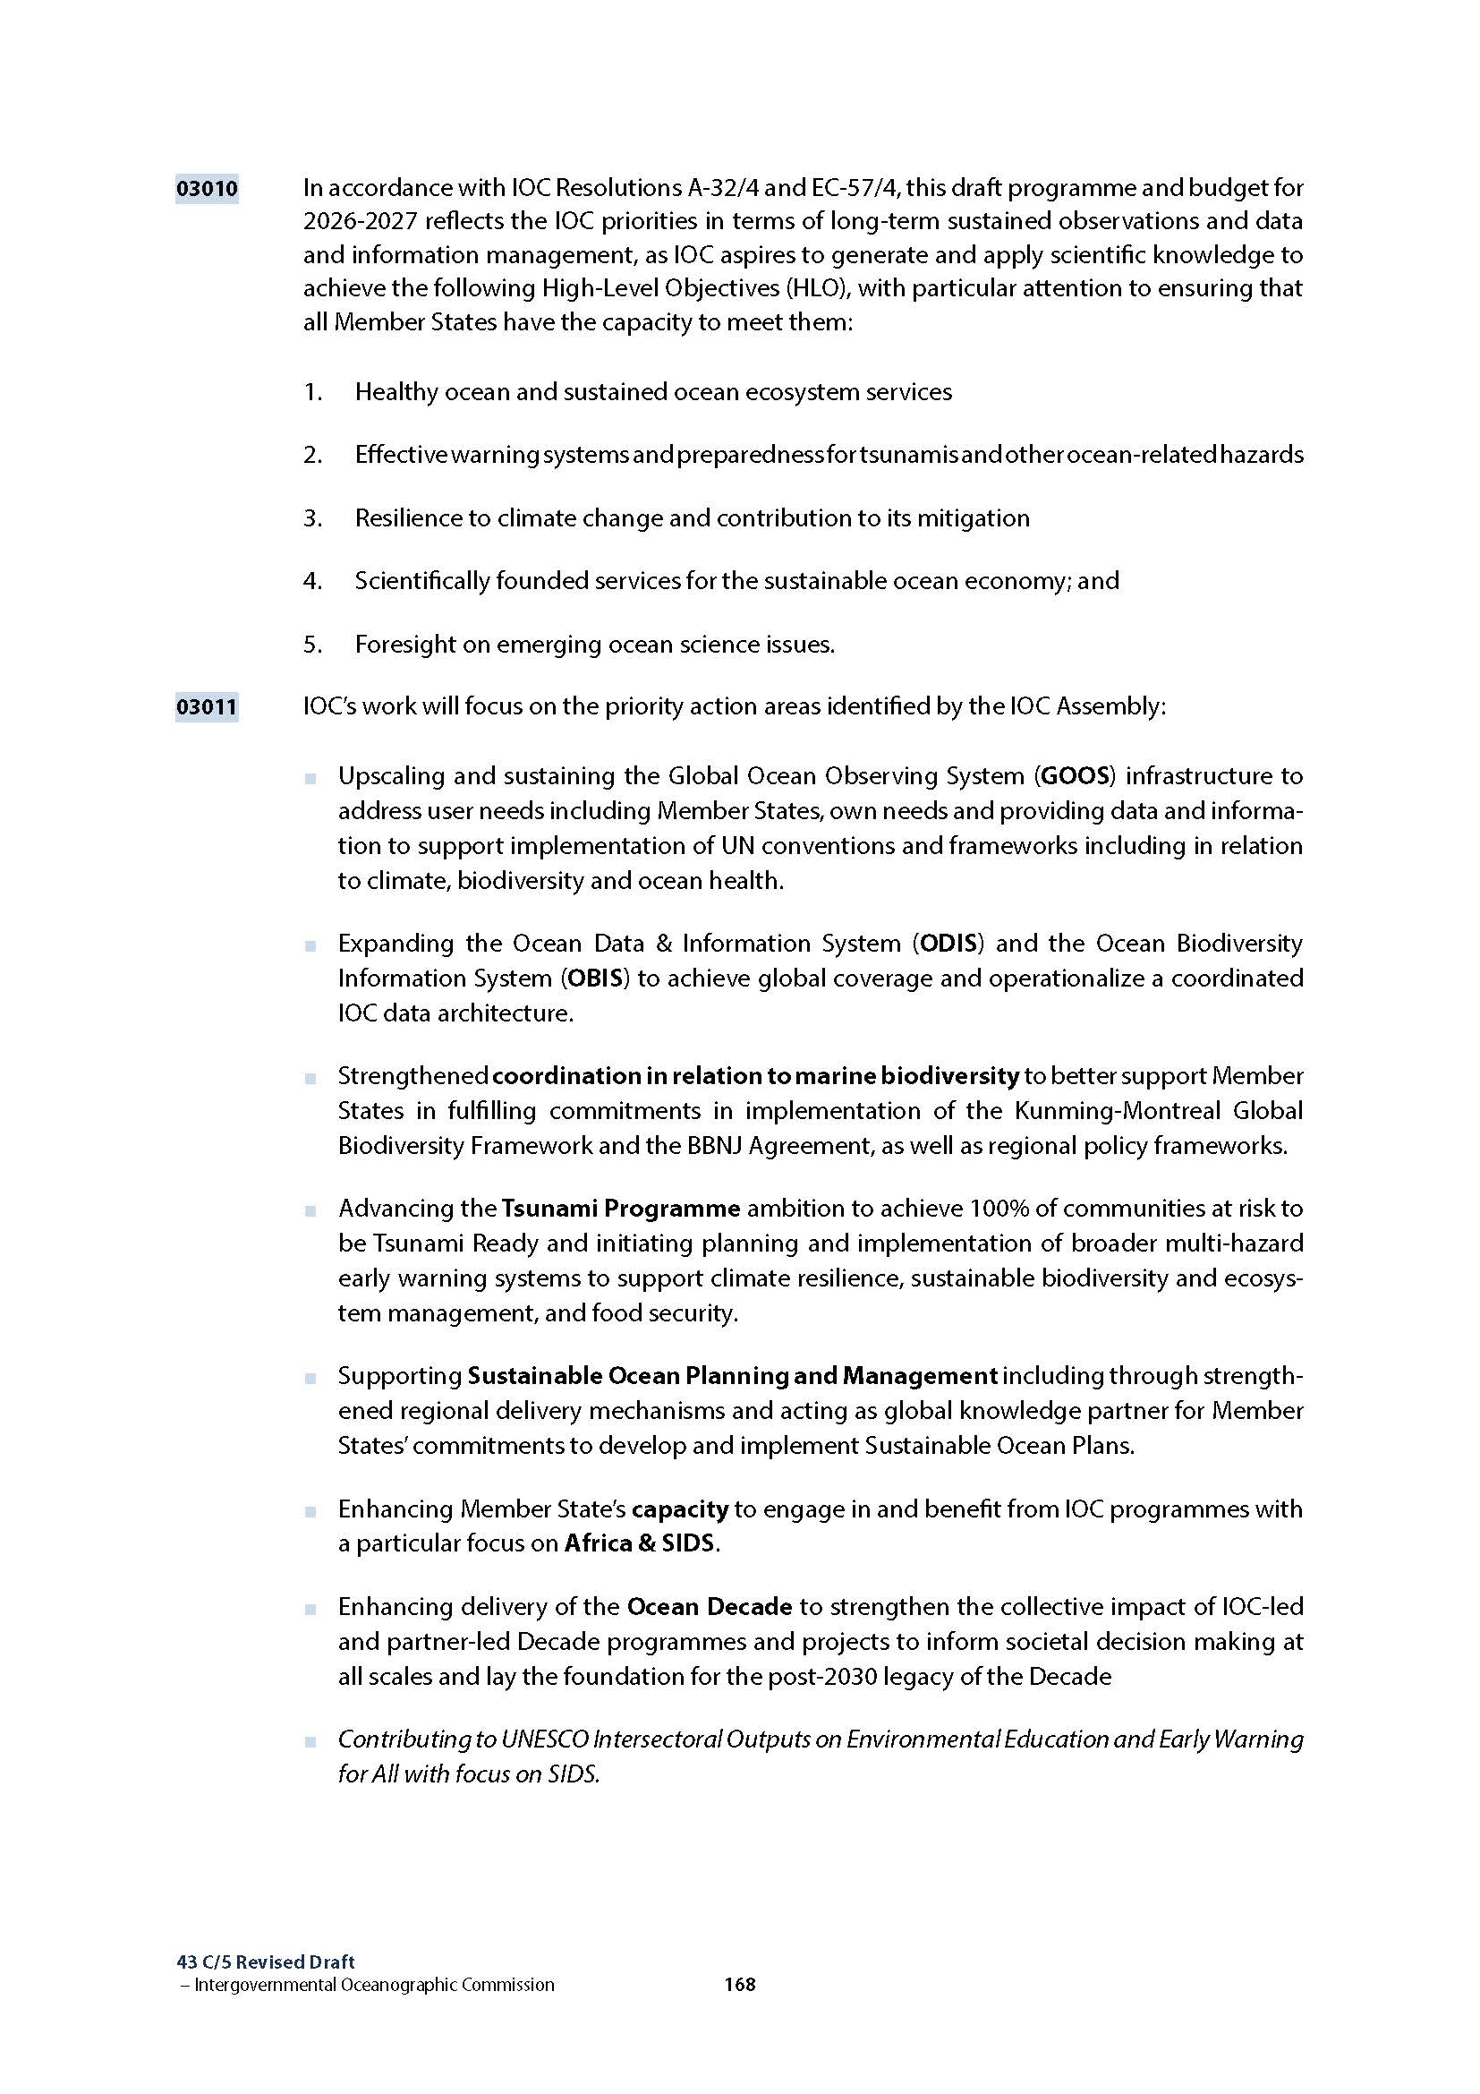
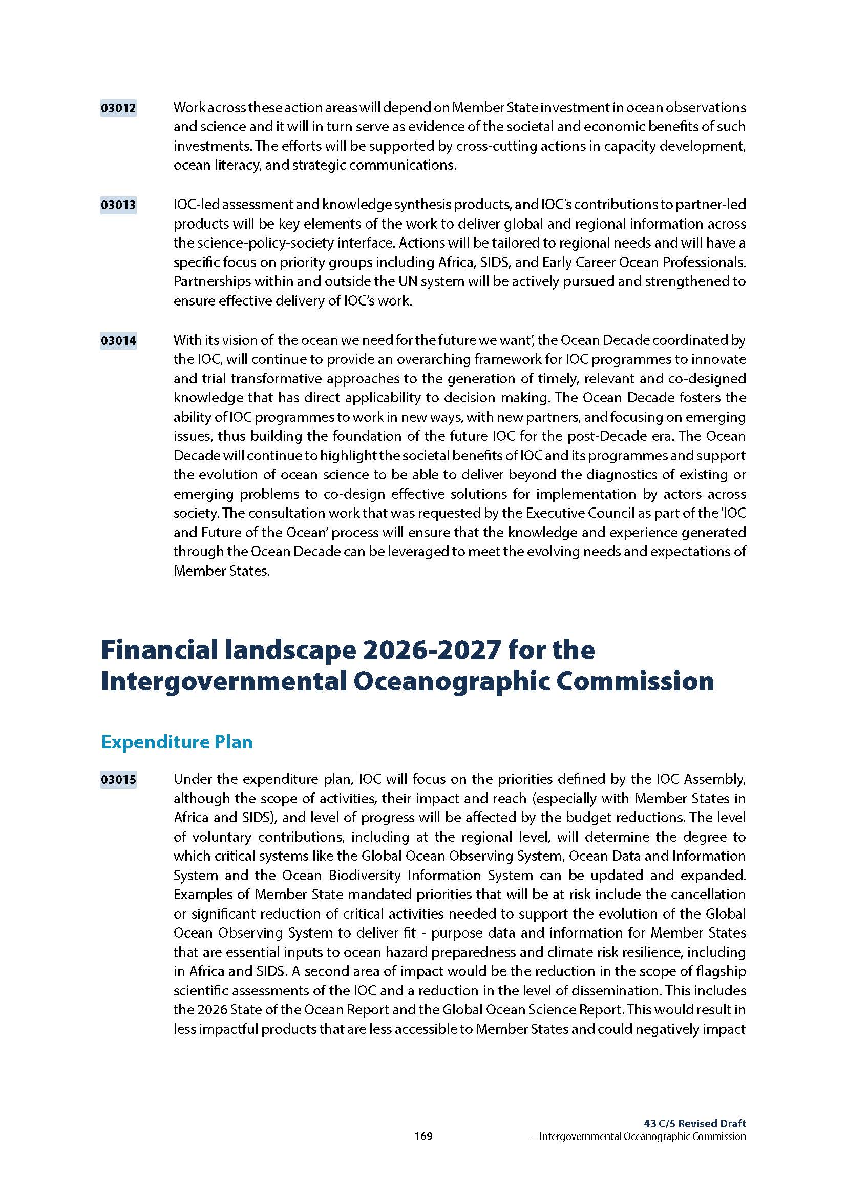
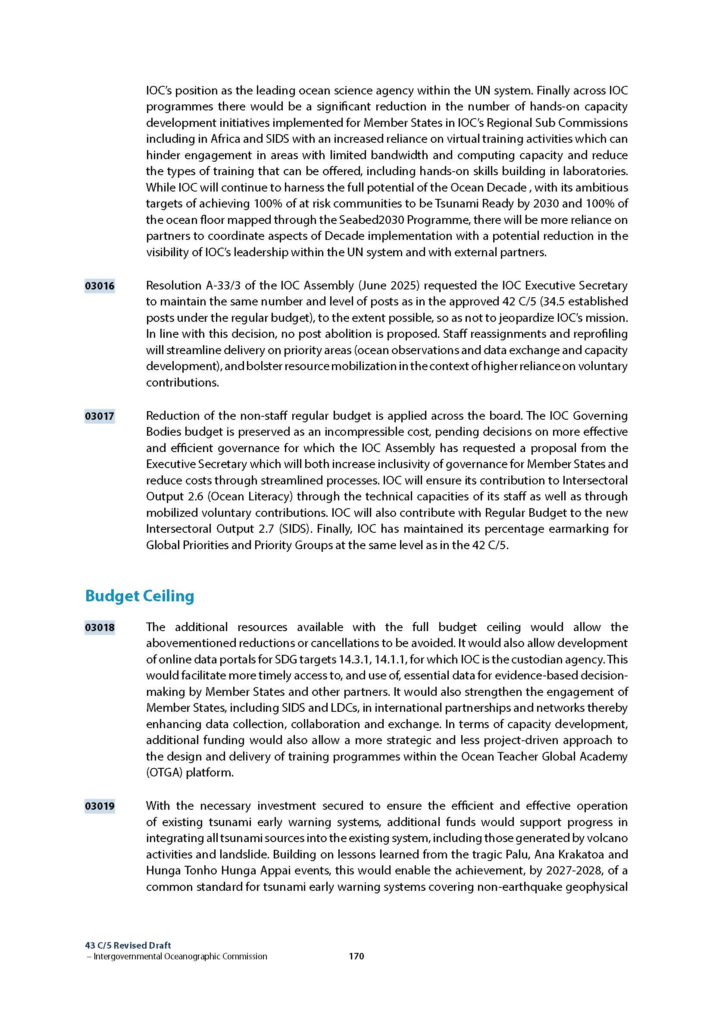

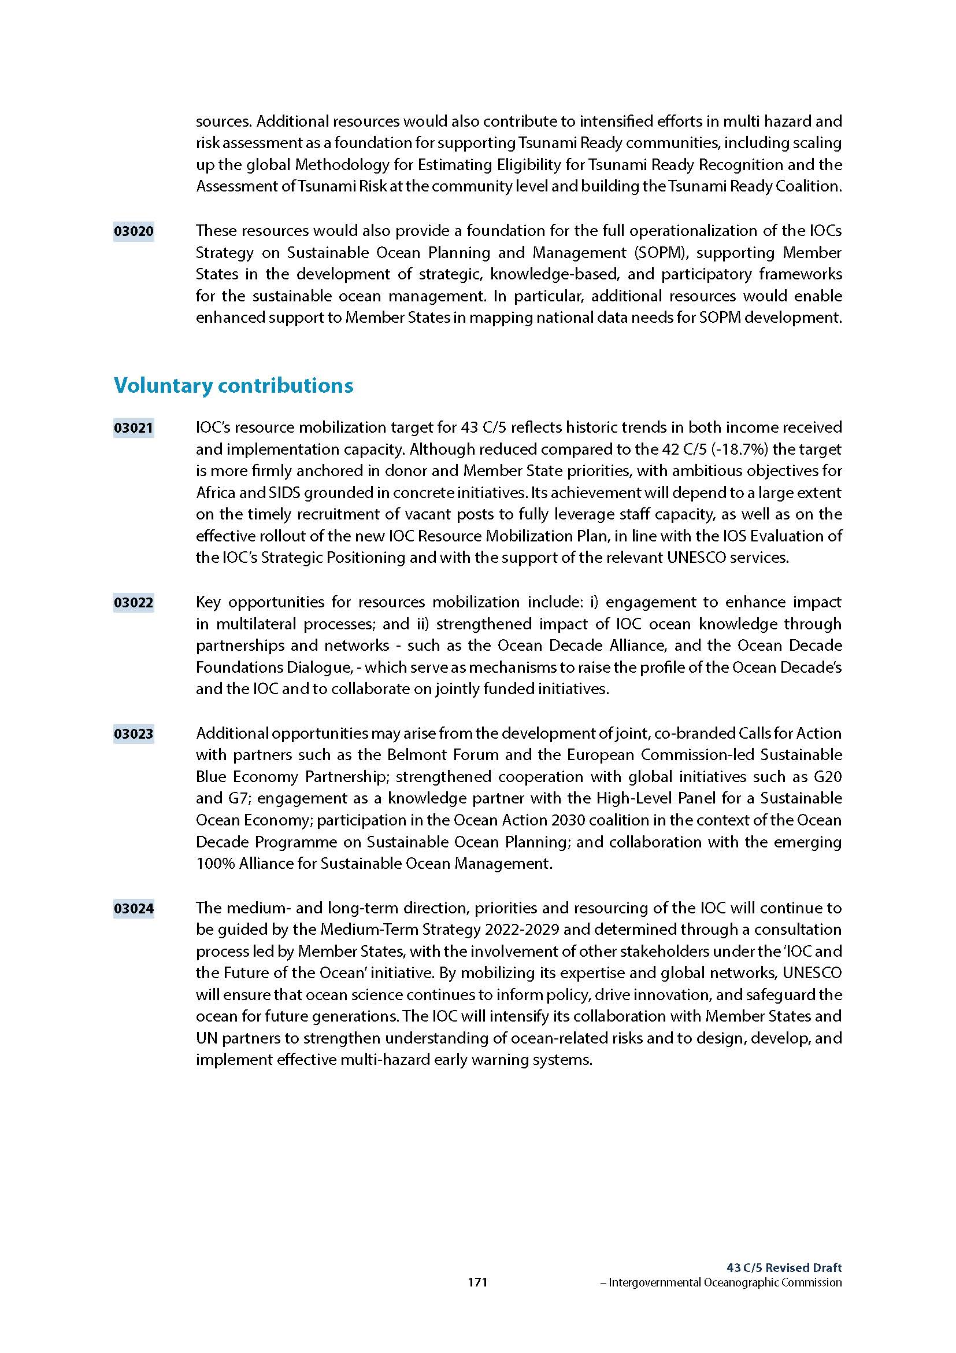
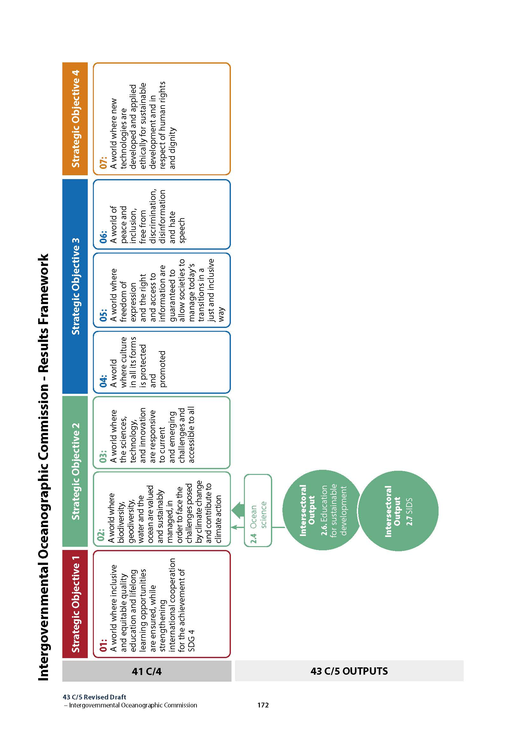
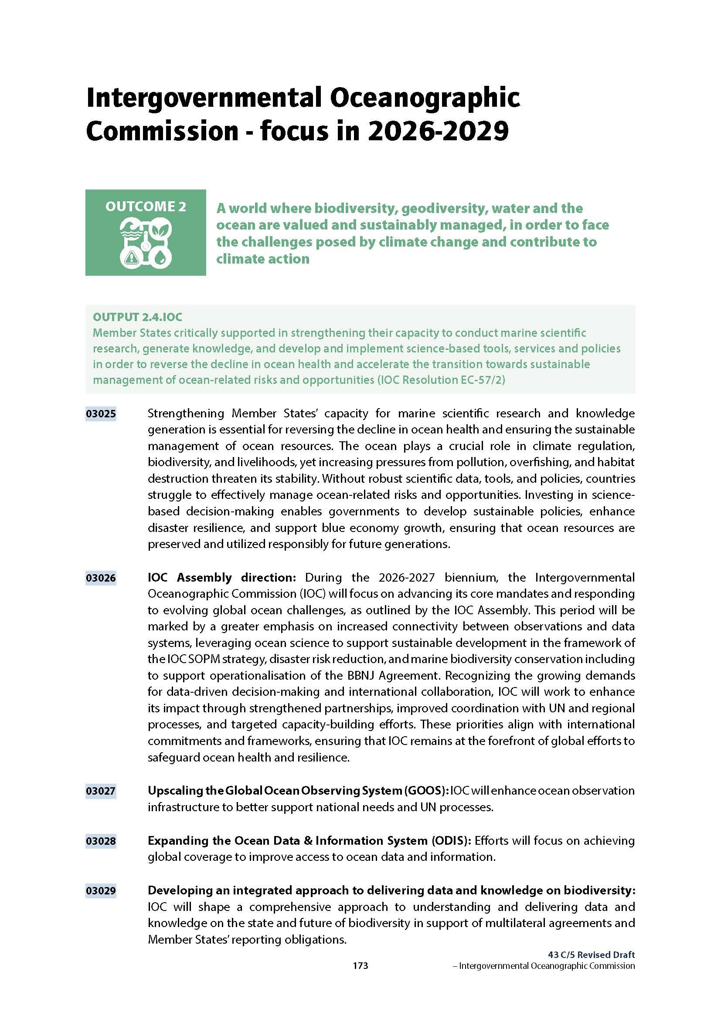
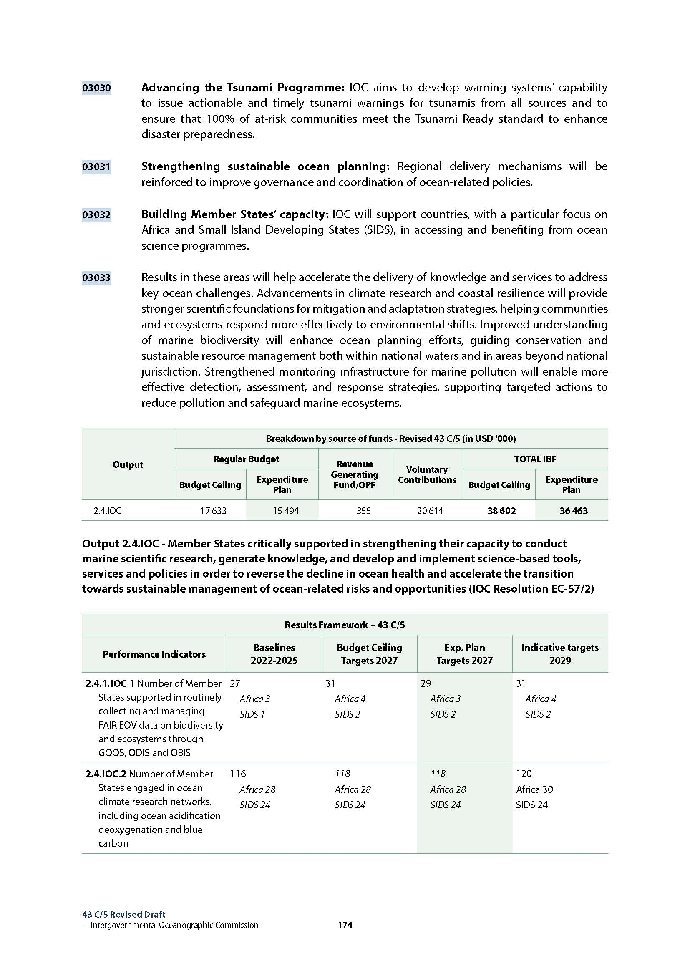
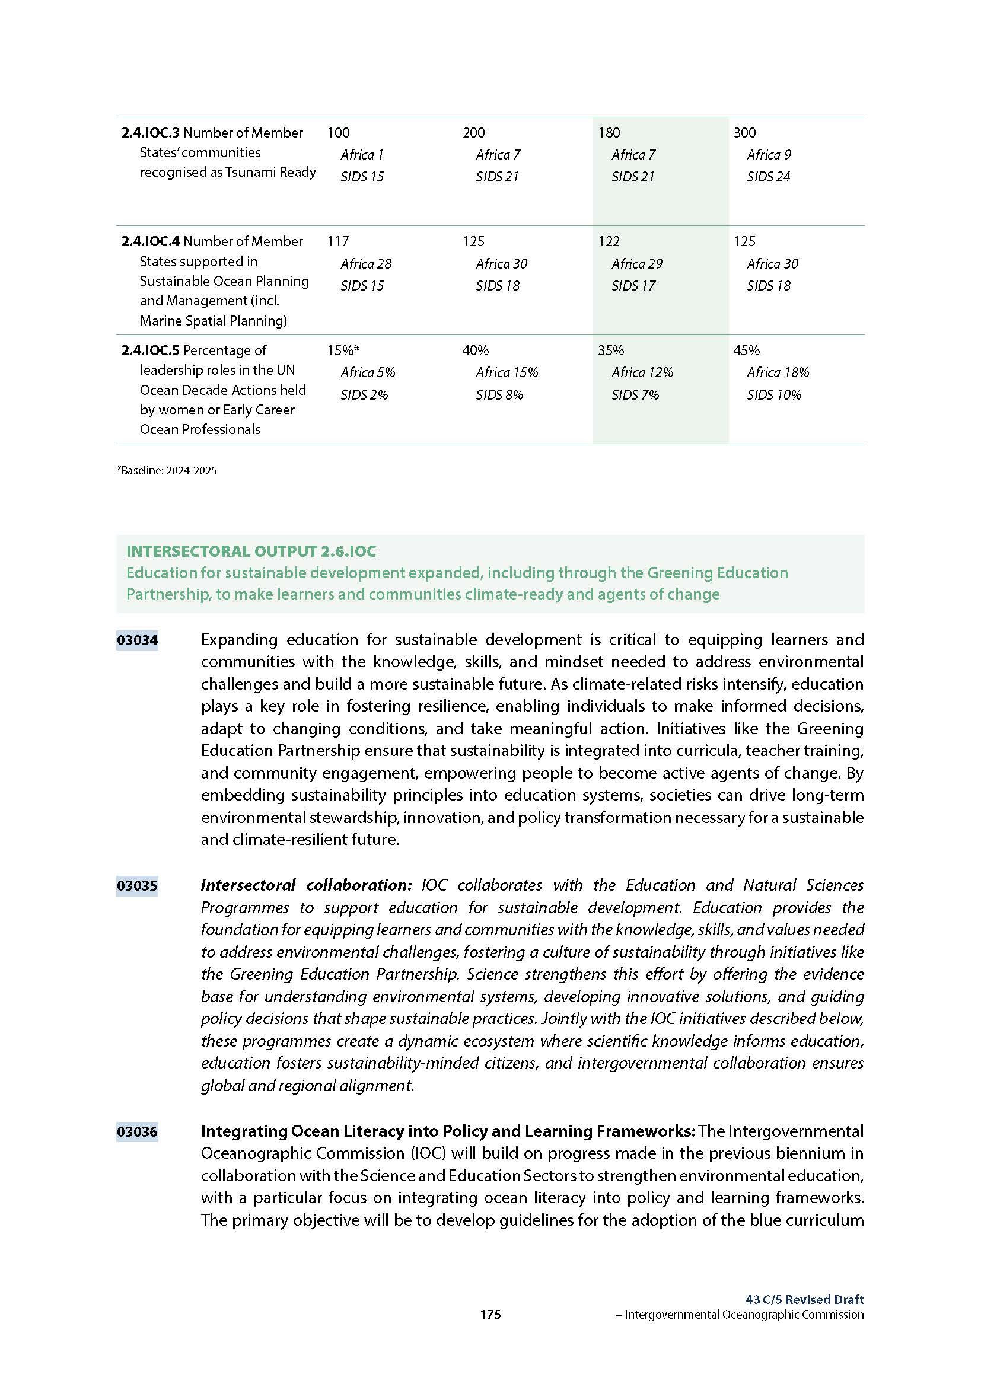
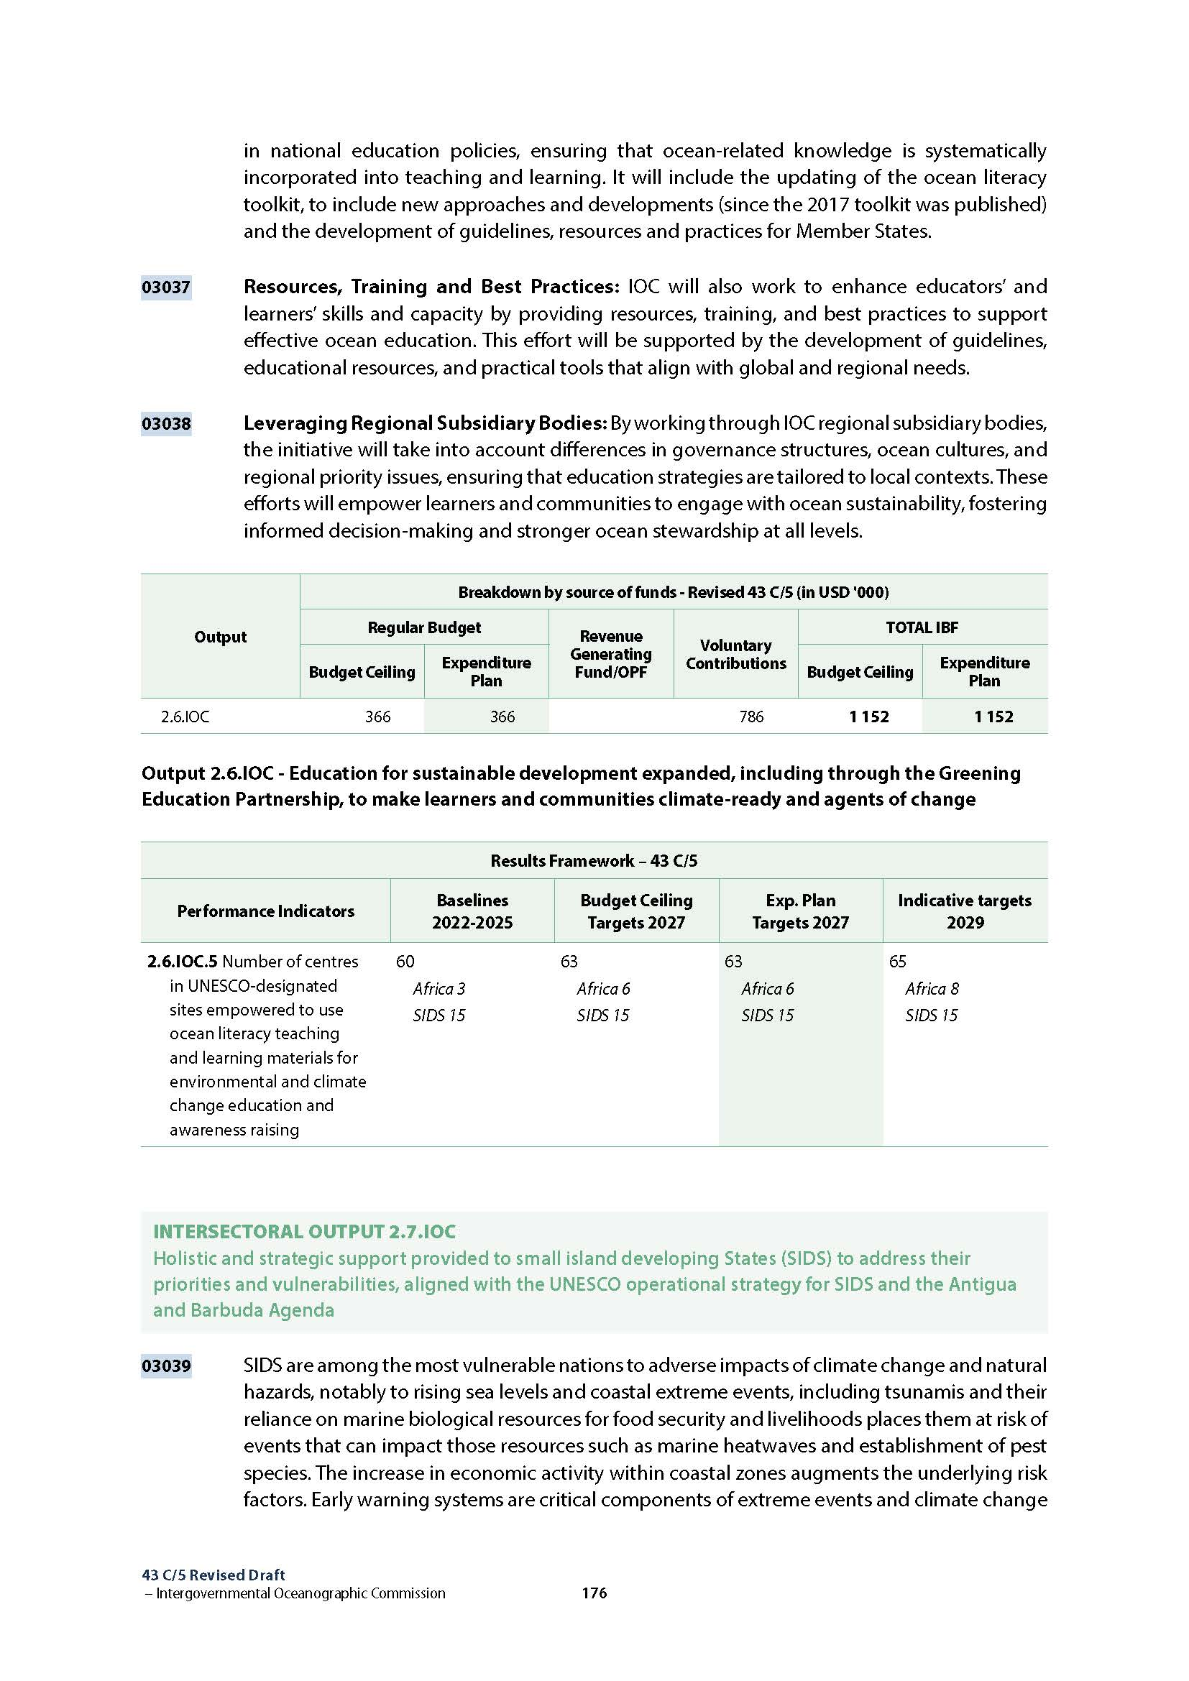
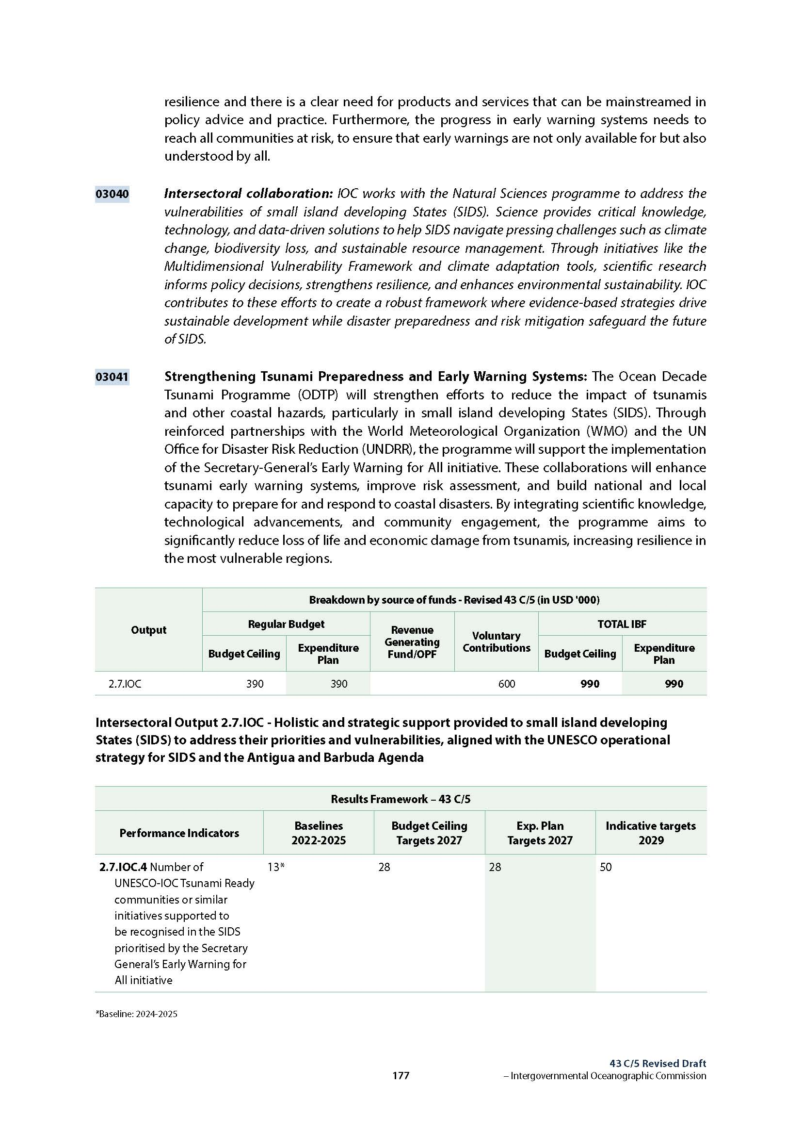
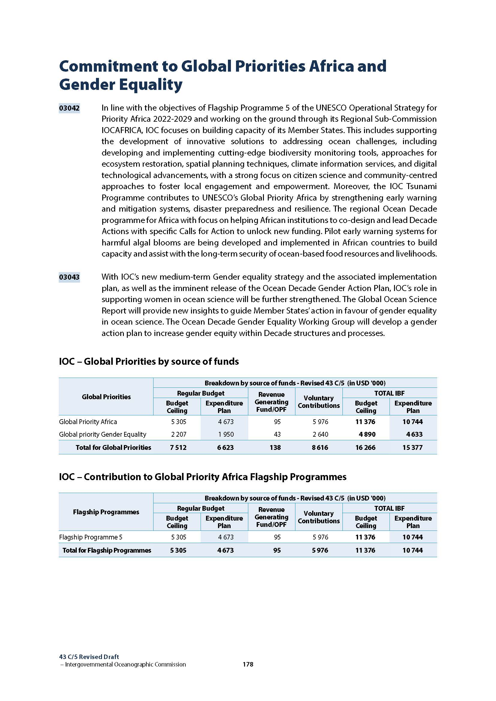
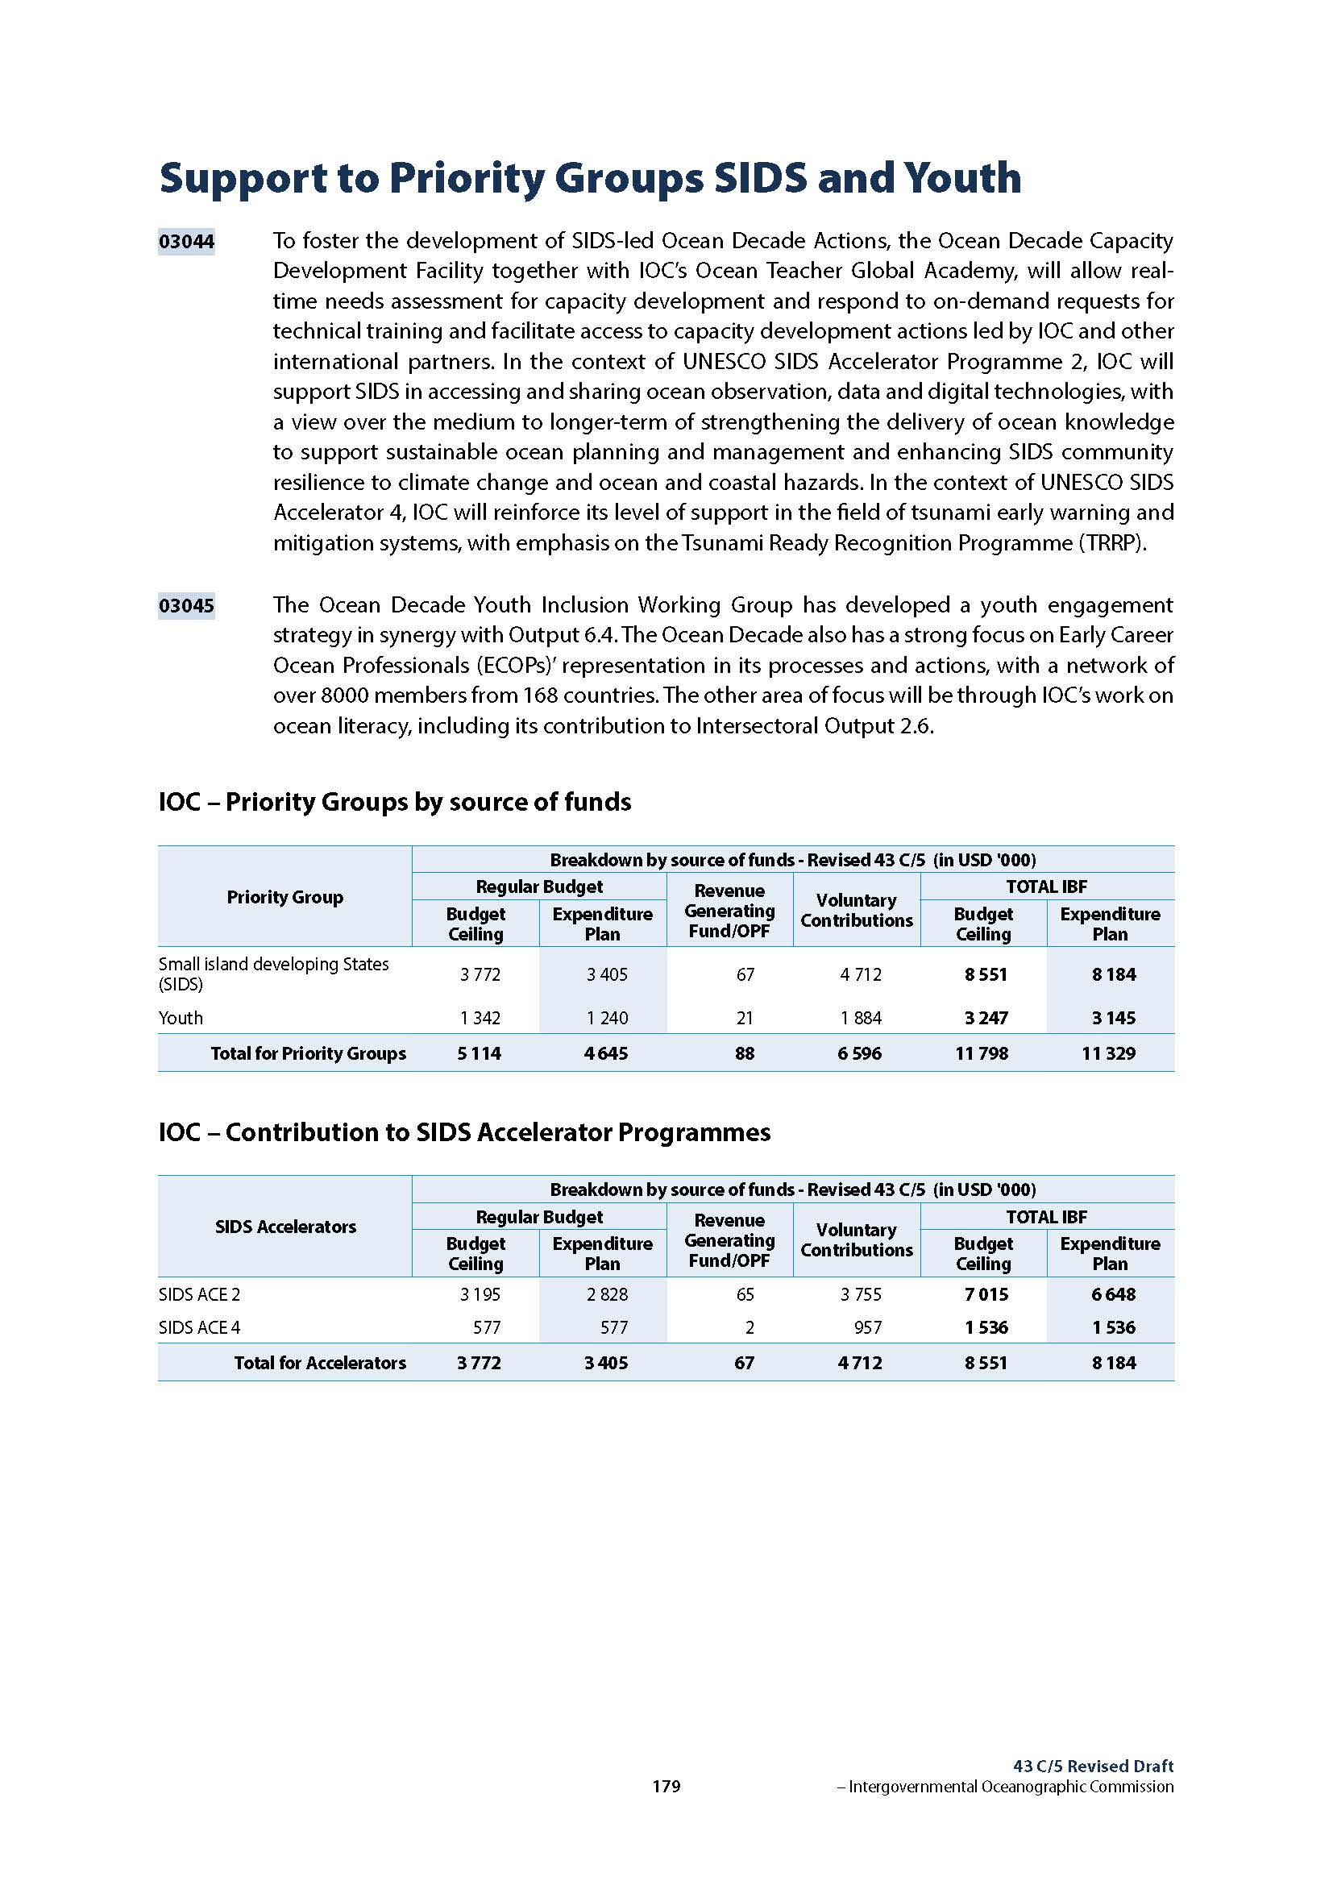
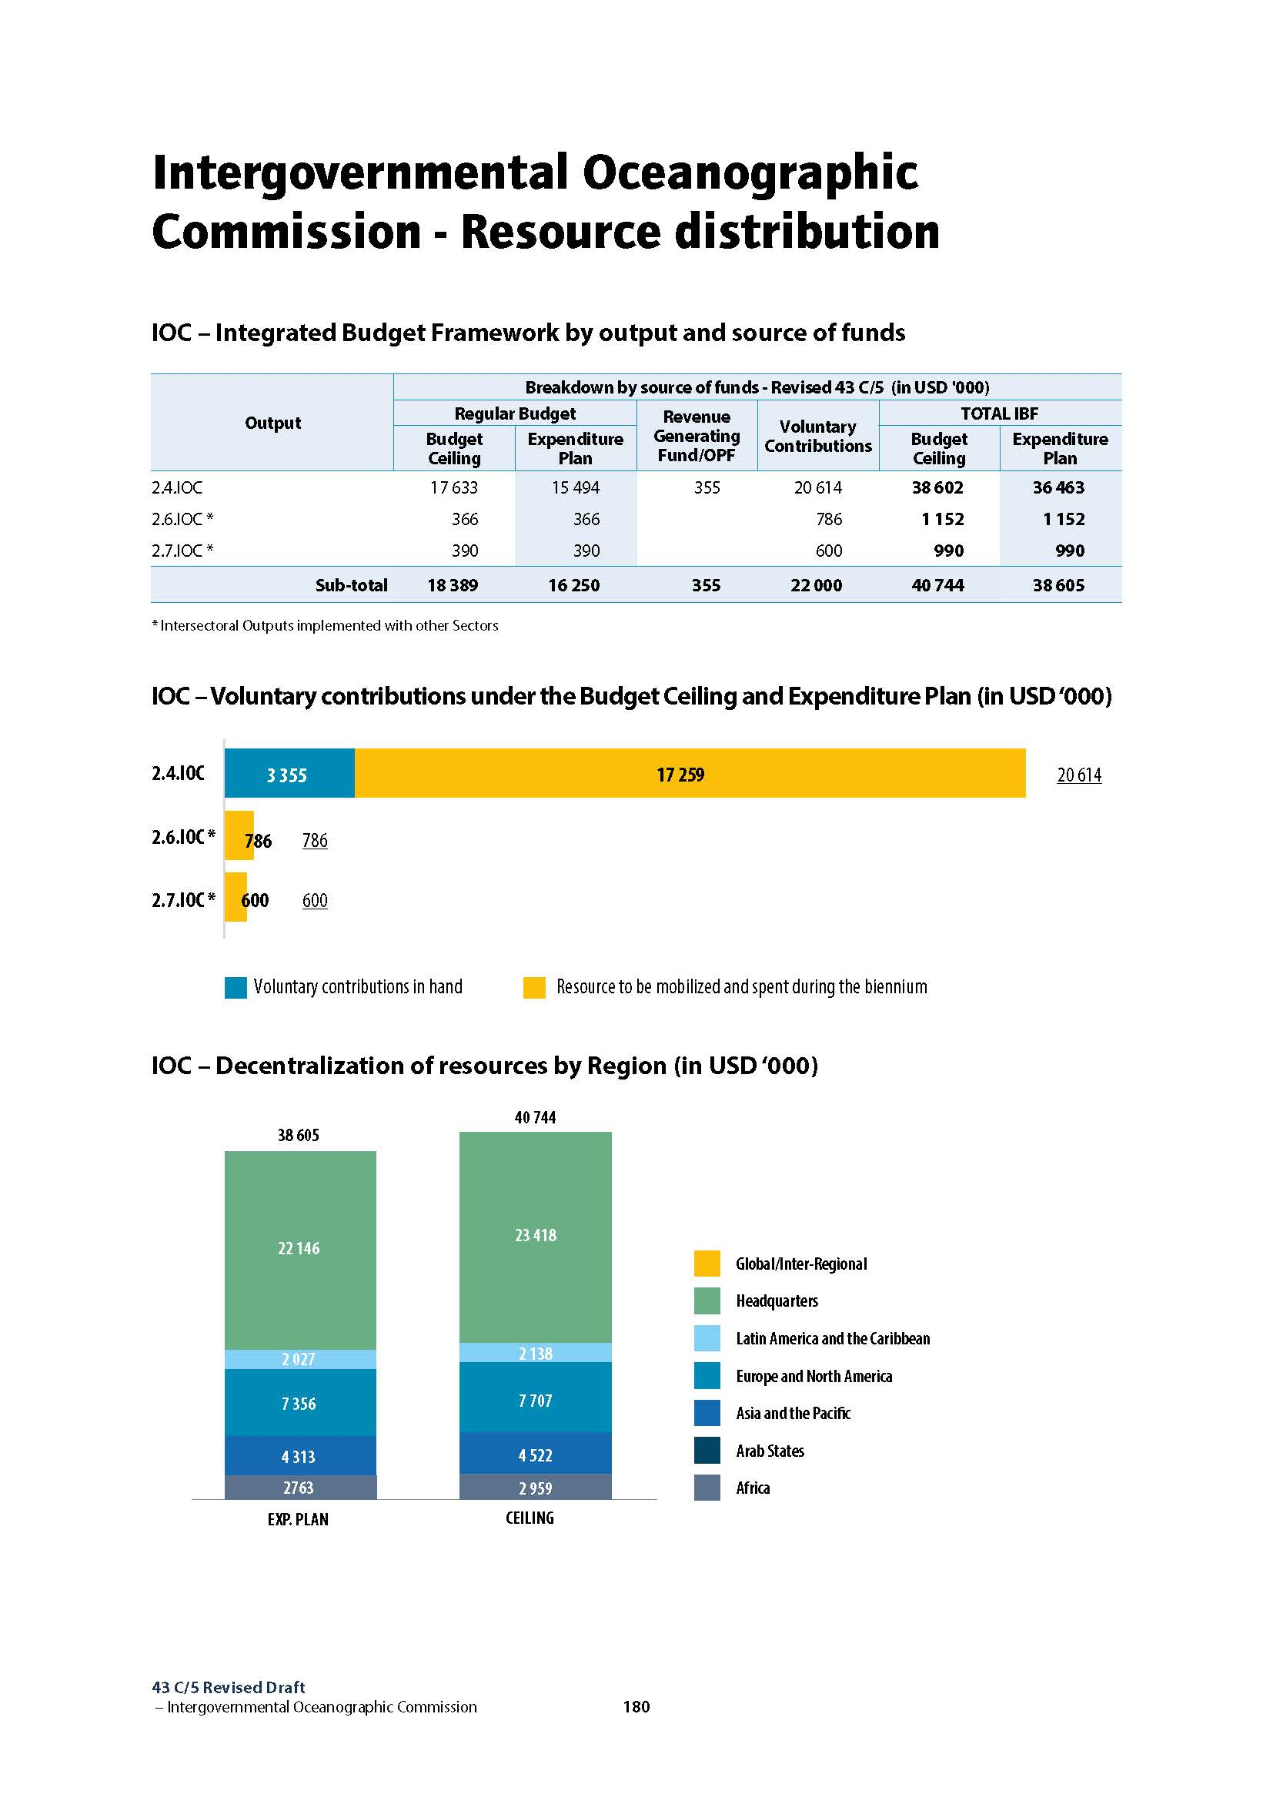

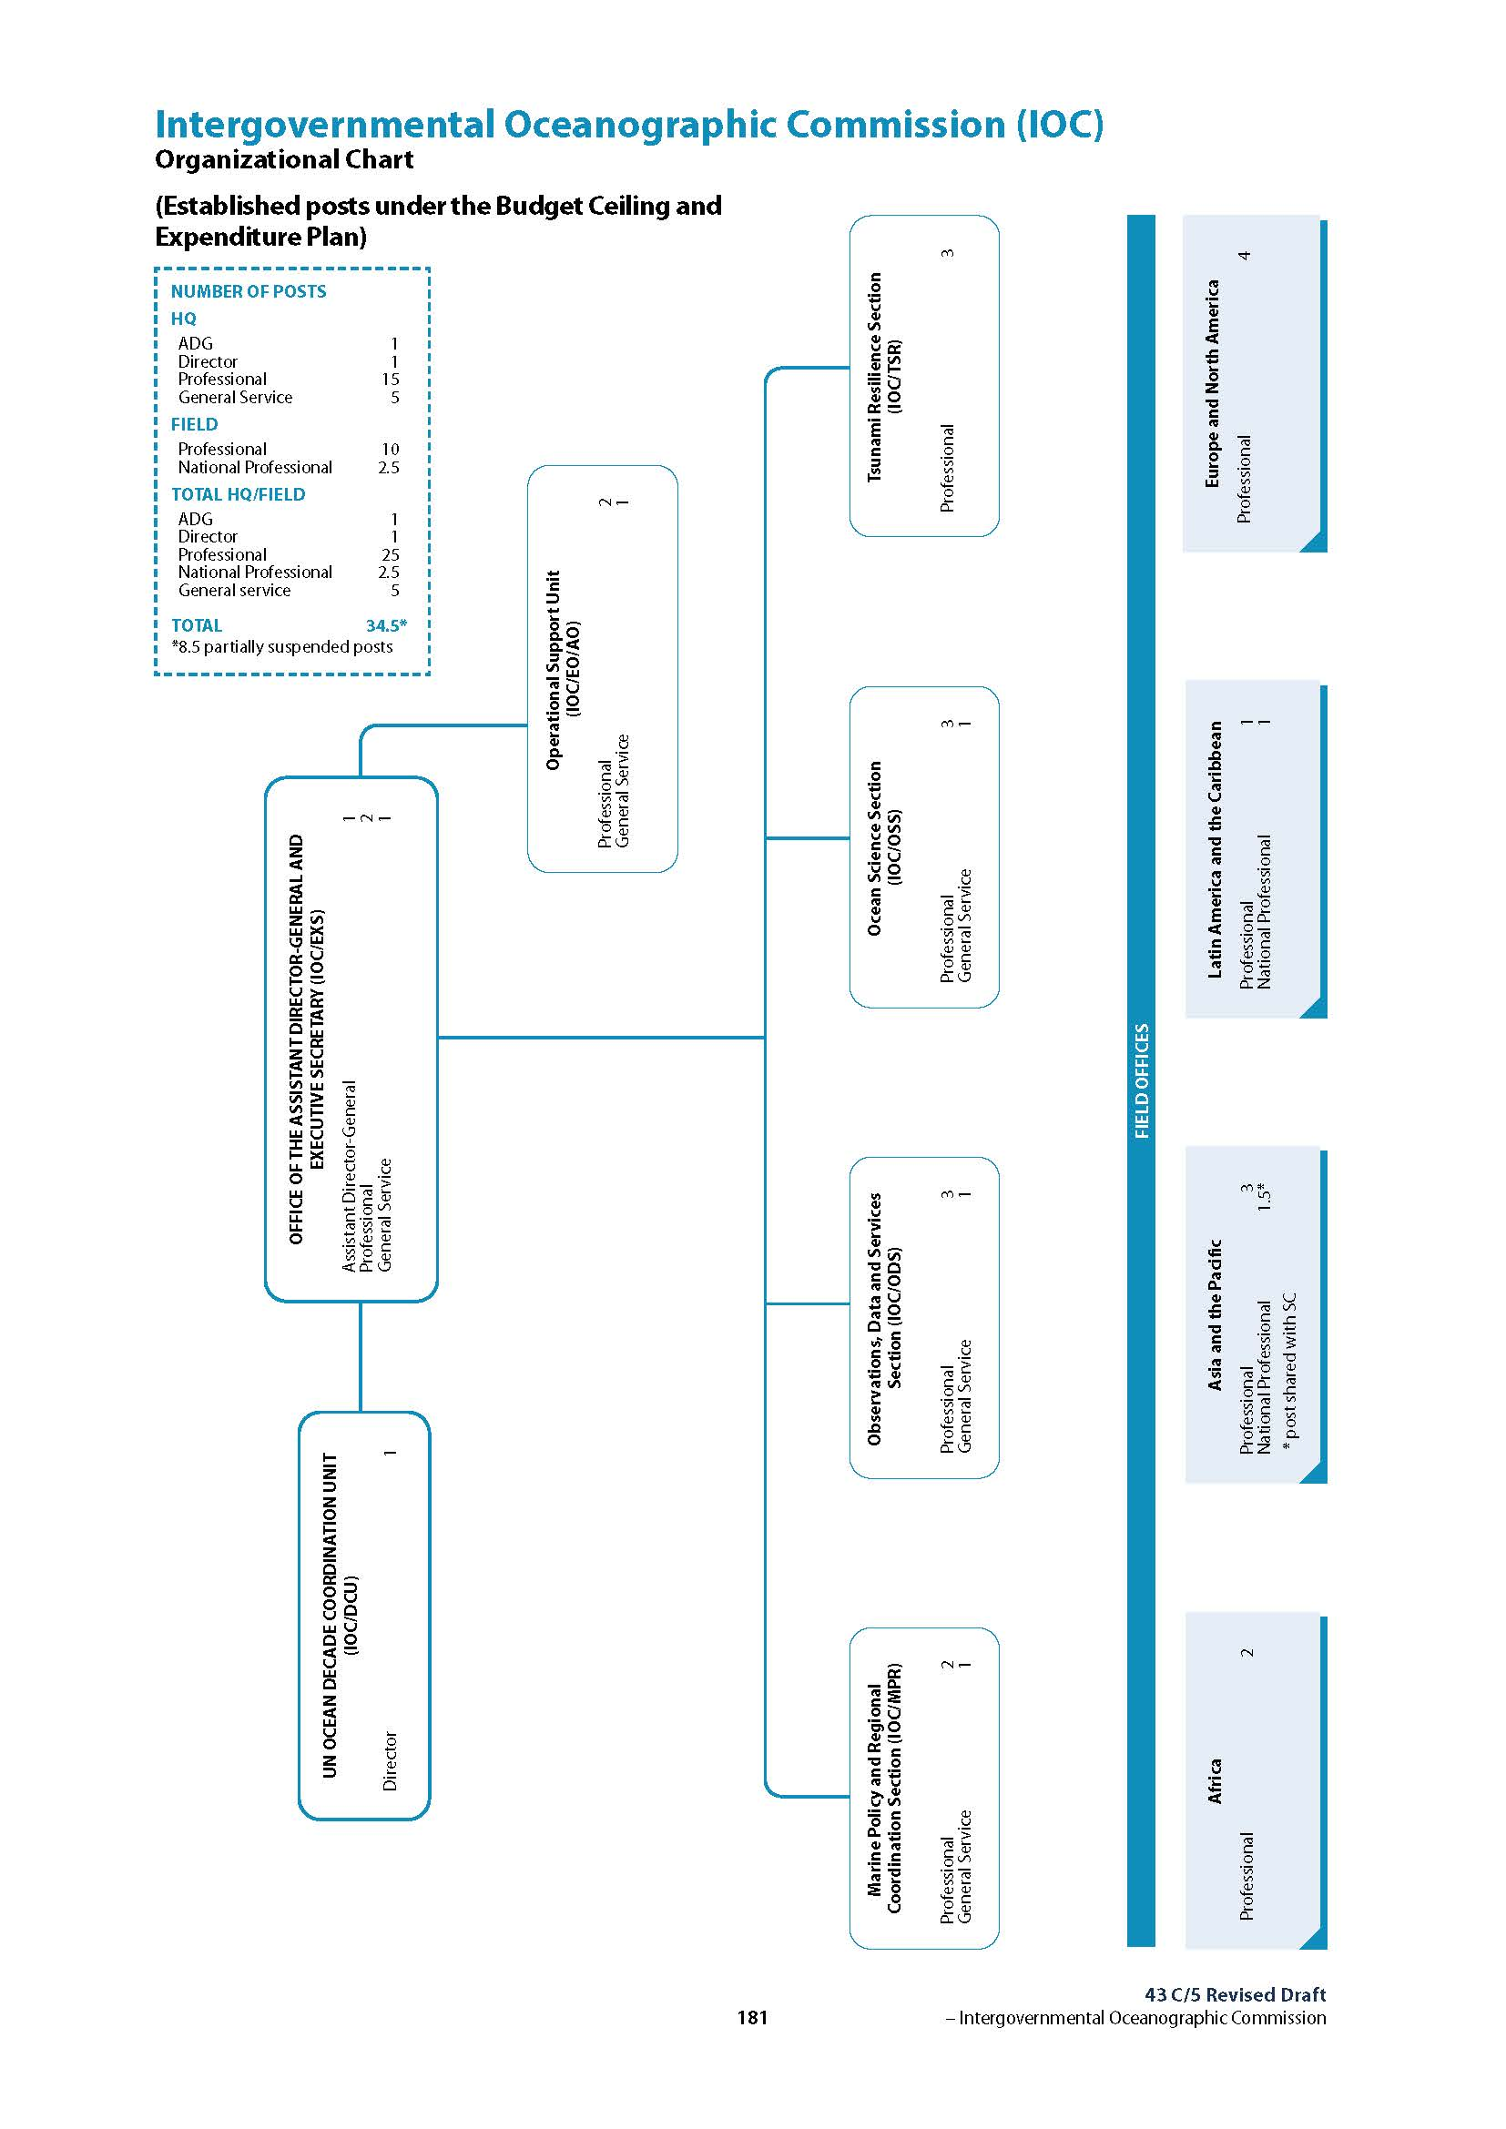
Part II

PROPOSED 2026–2027 BUDGETARY ALLOCATIONS

- In preparing the proposals for the 43 C/5 Rev. allocations, the Secretariat was guided by Member States’ definition of priorities as reflected in IOC Resolutions A-32/4, EC-57/2 and A-33/3.
- Taking the Draft 43 C/5 Zero Nominal Growth (ZNG) budget approved by the IOC Assembly at its 33rd session as a basis, the same number of posts funded by regular budget (34.5 in total) was maintained, with some adjustments to account for the freeze of recruitments pending the approval of the budget by the UNESCO Executive Board at its 224th session in April 2026 and better integrate and reinforce priority areas of work in observations and data and information management and capacity development, supported by strategic planning and enhanced and coordinated resource mobilisation. The graph below shows the staff/non-staff comparison between 42 C/5, the 43 C/5 ZNG scenario and the 43 C/5 Rev. Expenditure Plan.

- The reduction to the non-staff portion of the regular budget was applied across the board to all IOC functions and activities to:
- preserving the 42 C/5 agreed prioritization
- ensure sufficient allocations for primary Governing Bodies’ meetings
- keeping priority to IOCAFRICA and the contribution to SIDS/Early Warning for All intersectoral output, while reallocation the regular budget non-staff contribution to the intersectoral output on ocean literacy to the core capacity development budgets of the IOC Regional Sub-Commissions.

Table 2: Proposed budgetary allocations 43 C/5 Rev.

IOC Allocations under the one-off appropriation of $31M
to supplement the 43 C/5 Rev. regular budget

- At its 43rd session, the UNESCO General Conference approved a one-off appropriation of $31 million to supplement the regular budget for the 2026–2027 financial period, comprising $23 million from the residual balance of the Special Account for Management Costs (MCA) and $8 million advance of the Working Capital Fund (WCF) from the two Member States withdrawing from the Organization.
- Under the same resolution, the General Conference further requested the Director-General to present, for approval by the Executive Board at its 224th session, the proposed mechanism and allocations for the use of the supplementary funding (cf 224 EX/11.II).
- The supplementary funding provides much-needed short-term relief, but it does not resolve the structural and financial pressures the Organization (and therefore the IOC) faces with a reduced regular budget under the 43 C/5 expenditure plan.
- Additional funds will be made available under a new ‘Special Account for the Supplementary Funding of the 43 C/5 Regular Budget’. IOC’s share of this funding amounts to $500,000.
- 70% of the supplementary funds will be allocated to field implementation, notably in Cartagena, Fiji, Jakarta and Nairobi. This will enhance Member States’ observations and data infrastructure for increased scientific understanding of the ocean dimension in climate change, sea level variations at regional and global levels, early warning systems for multiple ocean-based hazards, as well as strengthening the data flow and National Oceanographic Centre support, and support African Member States and SIDS to join the Tsunami Ready Recognition programme (TRRP). This will translate into target enhancements (table 3 below), and will directly contribute to UNESCO’s Priority African Flagship Programme 5 and SIDS Accelerators 2 and 4.

Table 3: Expected changes in output targets (Table 6 of document 224 EX/11.II)

Performance Indicators | Expenditure Plan Target 2027 | Impact
Output 2.4.IOC – Member States critically supported in strengthening their capacity to conduct marine scientific research, generate knowledge, and develop and implement science-based tools, services and policies in order to reverse the decline in ocean health and accelerate the transition towards sustainable management of ocean-related risks and opportunities (IOC Resolution EC-57/2)
2.4.IOC.1 Number of Member States supported in routinely collecting and managing FAIR EOV data on biodiversity and ecosystems through GOOS, ODIS, and OBIS | 118  Africa 28  SIDS 24 | 126 (+8)  Africa 31 (+3)  SIDS 29 (+5)
2.4.IOC.3 Number of Member States’ communities recognized as Tsunami Ready | 180  Africa 7  SIDS 21 | 194 (+14)  Africa 14 (+7)  SIDS 28 (+7)

