User's Guide for the
Central American Tsunami Advisory Center (CATAC)
– English, version 2026 -

Managua, Nicaragua
March 2026

Central America Tsunami Advisory Center (CATAC)

User's Guide for the Central American Tsunami Advisory Center (CATAC) – English, version 2025

Date: March 2025

Elaborated by: Wilfried Strauch,
with input from the CATAC team, Managua, Nicaragua

NOTES

CATAC´s User´s Guide can be downloaded from
https://catac.ineter.gob.ni/doc/CATAC_Guia_de_usuario_2026.pdf
https://catac.ineter.gob.ni/doc/CATAC_users_guide_2026.pdf

Comments and corrections
Please send comments and corrections to wilfried.strauch@yahoo.com .

Earlier versions
The first version of the User´s Guide was elaborated in 1919. It was updated in 2021, 2023, and 2025.

The present version of 2026 of the User's Guide has been written with reference to the Common PTWS TSP Users’ Guide Table of Contents as prepared by the WG2 Task Team of TSPs in August, 2023; the TOWS-WG Global Services Definition Document from 2016 and the User's Guide for the Pacific Tsunami Warning Center (PTWS) Enhanced Products, IOC Technical Series No 1 05, revised edition. IOC 2014 are considered in the contents of this document.

Contents

Executive Summary

- Overview
  - Background
  - Area of Service
  - Earthquake Source Zone
  - Tsunami Hazard

- Operations
  - CATAC´s Capacities and Facilities
2.2.1 Staff
2.2.2 Central Facilities
2.2.3 CATAC Monitoring Networks
2.2.4 Virtual networks used by CATAC
  - Operational Tools and Procedures
    - Seismological and Geophysical Tsunami Source Detection and Characterization
    - Tsunami Wave Observations
    - Tsunami Forecasting
    - Decision Support
    - Product Creation and Dissemination
    - Timeline

- Products
  - Product Types and Criteria
    - Informational
    - Threat
  - Product Content
    - Text Products
    - Graphical Products

- Dissemination
  - Methodologies
    - Products
    - Customer Decision Support
  - Communication Testing
  - Capacitation

ANNEXES
- Example Products
- Forecast Points
- Observation Sites
- NTWC and TWFP in Central America
- Recognized Tsunami Service Providers
- References
- Acronyms

Executive Summary – CATAC User’s Guide 2026

Since 2019, the Central American Tsunami Advisory Center (CATAC), established at the Nicaraguan Institute for Territorial Studies (INETER), has served as an interim sub-regional Tsunami Service Provider (TSP) for both the Pacific and Caribbean Tsunami Warning and Mitigation Systems (PTWS, Caribe EWS). During this period, CATAC has provided guidance to National Tsunami Warning Centers (NTWCs) and Tsunami Warning Focal Points (TWFPs) across Central America, steadily strengthening its own capacity and expertise.

1. Background and Establishment
- Following the destructive 1992 tsunami on its Pacific coast, Nicaragua was the only country in Central America developing early tsunami warning capacities.
- The huge 2004 tsunami in the Indian Ocean provoked intense discussions in the CEPREDENAC regional framework which led to proposals for a dedicated tsunami advisory service for Central America.
- In 2015, CATAC was created in 2015 by the Nicaraguan government under INETER, responding to regional requests. Within the IOC framework, the Pacific and Caribbean Tsunami Warning systems (PTWS, CARIBE EWS) and the IOC General Assembly accepted the Nicaraguan proposal to establish CATAC as a Tsunami Service Provider for Central America.
- INETER developed the capacities of CATAC during 2016-2019 within a cooperation project with JICA and Japanese Meteorological Agency (JMA) and Hokkaido University.
- In December 2024, CATAC became a General Directorate of INETER, consolidating seismic monitoring and early warning, tsunami forecasting, and national and regional early warning responsibilities.
- CATAC operates within IOC frameworks:
  - Pacific Tsunami Warning and Mitigation System (PTWS)
  - Caribbean Tsunami Warning and Mitigation System (CARIBE-EWS)
  - TOWS-WG Global Services
- Mission: Provide continuous, timely technical information on potentially destructive tsunamis to National Tsunami Warning Centers (NTWCs) and Civil Protection agencies in Central America.
2. Area of Service and Hazards
- Coverage: Pacific and Caribbean coasts of Central America (Guatemala, El Salvador, Honduras, Nicaragua, Costa Rica, Panama).
- Earthquake Source Zones:
  - Central American Subduction Zone (Guatemala–Costa Rica) – capable of M 8.6 events.
  - Northern Colombia–Ecuador subduction zone.
  - Subduction zone North of Panama and fault system extending towards Costa Rica
  - North America-Caribbean plate borders and Caribbean large faults
- Tsunami Hazards:
  - Historical record: ~54 tsunamis in 500 years; most destructive was 1992 Nicaragua tsunami (10 m run-up).
  - Special risks: Gulf of Fonseca (volcanic tsunamis), Lake Nicaragua (seiches/tsunamis), Caribbean meteorological tsunamis.
  - Some coastal areas have <10 minutes warning time, requiring ultra-rapid alerts.
3. Operations and Facilities
- Staff: 24 professionals, trained via JICA, IOC/UNESCO, Swiss cooperation, CATAC internal training. 24/7 duty shifts.
- Facilities:
  - Monitoring and Warning Center (250 m²) with seismic bunker, IT servers, meeting rooms, and labs.
  - Backup centers planned in Boaco (Nicaragua) and El Salvador (MARN).
- Networks:
  - Seismic: 250+ stations in Nicaragua; 350+ across Central America. ~500+worldwide
  - GNSS/GPS: 33 national stations, expecting to add regional data streams.
  - CATAC operates tide gauges on the Nicaraguan Pacific and Caribbean coasts; Additional international tide gauges are received via TOAST from the VLIZ data center.
  - Volcano monitoring: with CATAC seismic network, data of other sensors and camaras via collaboration with INETER volcanology unit. Collaboration with MARN and Honduras for volcanoes in the Gulf of Fonseca
- Software Tools:
  - SeisComP PRO with TOAST using EasyWave for fast real-time tsunami simulations and estimate of arrival times and wave amplitudes at the coasts
  - HySEA experimentally for real time numerical tsunami modelling for inundation maps and videos
  - Earthquake Early Warning (EEW) methods for SeisComP established at CATAC with Swiss Seismological Service.
  - ShakeMaps (SeisComP) for rapid earthquake impact scenarios.
4. Products and Dissemination
- Text Bulletins: Earthquake parameters, tsunami potential, arrival times, recommended actions.
- Graphical Products:
  - Tsunami energy maps
  - Travel time contours
  - Coastal forecast maps with amplitude categories (<0.3 m, 0.3–1 m, 1–3 m, >3 m).
  - Coastal forecast map and videos of tsunami inundation for nearest population center.
- Dissemination Channels: Email, Whatsapp, Telegram, SMS, CATAC website.
- Languages: Spanish (primary), English (for certain IOC partners).
- Testing: participation in Caribe Wave and Pacific Wave exercises, in 4 national exercises per year in Nicaragua, unannounced communication tests with NTWCs and focal points.
5. Regional Impact and Capacity Building
- CATAC supports all six Central American countries, tailoring forecasts to national protocols.
- Training initiatives (2019–2025):
  - 17 webinars and courses with JICA and CEPREDENAC.
  - Visits to NTWCs and Civil Protection agencies to update Standard Operating Procedures (SOPs).
- Findings: Many countries still rely on outdated SOPs (1917 UNESCO project), lacking integration of PTWC and CATAC.
- Important projects:
  - ATTAC/EWARNICA (Swiss cooperation) – Earthquake Early Warning, seismic network densification.
  - Coastal hazards (JICA/Japan) – together with meteorology and Hydrology units at INETER
  - SINAREM (China / SINAPRED) – new seismic instruments and communications system for SINAPRED.
  - Third Country Course (JICA) – regional training in Nicaragua.
6. Conclusion
CATAC has matured into a robust, still in an interim mode, regionally integrated tsunami service provider, combining:
- Dense monitoring networks
- Advanced real-time modeling
- Strong international cooperation
- Continuous training and SOP modernization
Its role is pivotal in safeguarding Central America’s coastal populations against earthquake and tsunami hazards.

- Overview

  - Background

Historical Origin. Following the devastating 1992 tsunami on Nicaragua’s Pacific coast, national institutions prioritized prevention and mitigation. In 1993, Nicaragua joined UNESCO’s Intergovernmental Coordination Group of the Pacific Tsunami Warning System (ICG/PTWS), designating INETER as the National Tsunami Warning Focal Point. By 1996, INETER’s seismology section had become the National Tsunami Warning Center (NTWC), operating in coordination with Civil Defense to issue warnings and organize evacuations. Early warnings, however, were limited by insufficient predictive capacity, leading to occasional false alarms. In 1999, Nicaragua established SINAPRED, a nationwide disaster prevention network, further strengthening institutional coordination. Over subsequent years, Nicaragua became increasingly active within UNESCO’s tsunami warning structures. The Intergovernmental Oceanographic Commission (IOC) of UNESCO adopted Resolution EC-XLI.6, for Member States around the regional seas, as appropriate, to actively promote the development, establishment and sustained operation of National and Sub-regional Tsunami Warning and Mitigation Systems.

The preparation of CATAC. The ICG/PTWS in its XIX Session in 2003 decided to assist the Central American countries in the process to develop a regional tsunami warning system and established for this purpose the Regional Working Group on the Tsunami Warning and Mitigation System for the Pacific Coast of Central America (WG-CA). ICG/PTWS-XXV.1 recommended to determine whether El Salvador or Nicaragua (or both countries in cooperation) could establish an Interim Tsunami Warning Center to disseminate warnings to all Central American countries and the implementation of a Technical Committee for the Development of a Regional Tsunami Warning and Mitigation System. The following four ICG/PTWS-WG-CA meetings have developed the ideas for the Central American Regional Tsunami Advisory Center (CATAC): 1) Managua, Nicaragua, 04-06/11/2009; 2) San Salvador, El Salvador, 28-30/09/2011; 3) Managua, Nicaragua, 29/11/2014; 4) Managua, Nicaragua, 11/02/2019. The efforts for the establishment of a Central American Regional Seismic Network are documented in the materials of the Third Meeting of the ICG/PTWS-WG-CA.

The Center for the Coordination of Natural Disaster Prevention in Central America (CEPREDENAC) is the corresponding agency for disaster prevention within the Central American Integration System (SICA).
The Council of Representatives of CEPREDENAC at its meeting of February 6, 2015, decided to "recognize within CEPREDENAC's priorities the development of the Central American Tsunami Warning Center (CATAC) and the creation of a Regional Seismic Network to be established in the Republic of Nicaragua and to elevate it to SICA". Also, the scientific or seismological institutions of all central American countries related to tsunami warning expressed their support for this proposal in letters sent to INETER.

It was important that, in 2011-2012, the SeisComP software system (GFZ-Potsdam, Germany) was adopted in all Central American seismological observatories for online seismic waveform sharing, seismic data processing and dissemination. CATAC could benefit greatly from the long-standing and intense cooperation of Central American countries in seismology and seismic data exchange. To support the strengthening of tsunami warning and mitigation capacity in Central America, CATAC also would focus on regional collaboration and training by organizing training workshops on tsunami modeling and risk assessment and standard operating procedures.

The proposal for CATAC. At PTWS‑XXVI in 2015, Nicaragua formalized its proposal to establish the Central American Tsunami Advisory Center (CATAC) at INETER in Managua, with coverage for both Pacific and Caribbean coasts under PTWS and CARIBE‑EWS. Recognizing Nicaragua’s progress in tsunami warning and mitigation, the ICG/PTWS accepted the offer through Recommendation XXVI.2, which also created a subregional task team (TT‑CATAC) to assist in its establishment and strengthen regional coordination.
That same year, ICG/CARIBE‑EWS and the UNESCO/IOC General Assembly endorsed Nicaragua’s proposal, confirming CATAC as a subregional tsunami service within the frameworks of PTWS, CARIBE‑EWS, and TOWS‑WG. The Nicaraguan government assigned INETER responsibility for CATAC’s creation and operation. INETER, founded in 1982 and subordinated to the Presidency of Nicaragua, is the largest geoscience institution in Central America, with about 400 staff. Based in Managua, it comprises directorates for CATAC, Geology and Geophysics, Meteorology, Water Resources, Geodesy and Cartography, Land Use Planning, Physical Cadaster, and Geoinformatics.

Assignment of CATAC as a General Directorate at INETER. In December 2024, the Nicaraguan government restructured INETER, establishing CATAC as a General Directorate and merging the former Seismology Directorate into it. The detailed structure will be defined in 2026, but preliminarily CATAC includes Seismology, the Early Warning Center, Monitoring Networks, and Earthquake and Tsunami Engineering. CATAC is responsible for seismic and tsunami hazard studies, risk mitigation, early warning systems, and management of the Nicaraguan Seismic Network. It also serves as a Tsunami Service Provider (TSP) for Central America within UNESCO/IOC frameworks (PTWS, CARIBE‑EWS, TOWS‑WG). CATAC reports directly to INETER’s Director, with its General Director advising both INETER and the Nicaraguan government. Operations are funded through INETER’s budget and integrated into its annual and long‑term planning.

CATAC’s effectiveness depends on active regional participation. Its advisory products support Guatemala, El Salvador, Honduras, Nicaragua, Costa Rica, and Panama in responding to local and regional hazards, complementing PTWC services. Developing region‑specific products tailored to member states is essential, requiring strong collaboration during the design phase.

CATAC employs advanced forecasting, including real‑time numerical modeling based on rapid CMT solutions. Benchmarking and validation ensure reliability. These advisory products have formed the operational basis of CATAC since 2019.

Mission and duties of CATAC. CATAC’s mission is to provide continuous, timely technical information on potentially destructive tsunamis to National Tsunami Warning Centers (NTWCs) and Focal Points of WG‑CA member states. It operates 24/7, processing seismic and sea‑level data from regional and global sources to assess threats for Central America.
CATAC´s Core Duties are
1. Acquire real‑time seismic records from multiple sources.
2. Detect, locate, and determine magnitudes of regional earthquakes.
3. Characterize earthquake source parameters through automated and interactive analysis.
4. Assess tsunami potential based on seismological and geophysical data.
5. Estimate arrival times and amplitudes for forecast points designated by member states.
6. Disseminate seismic and tsunami bulletins to NTWCs and Focal Points.
7. Integrate real‑time sea‑level data to confirm tsunami generation and severity.
8. Conduct routine and unannounced communication tests with NTWCs and Focal Points.
9. Support education, outreach, and training activities in the region.
10. Issue summary reports after destructive tsunamis, prepare annual activity reports, publish in INETER bulletins, and maintain the CATAC website.

  - Area of Service

CATAC’s objective is to support Central American countries in preventing and mitigating tsunami disasters. Its service area includes the Pacific and Caribbean coasts, as well as the islands of member states, as shown in Figure 1.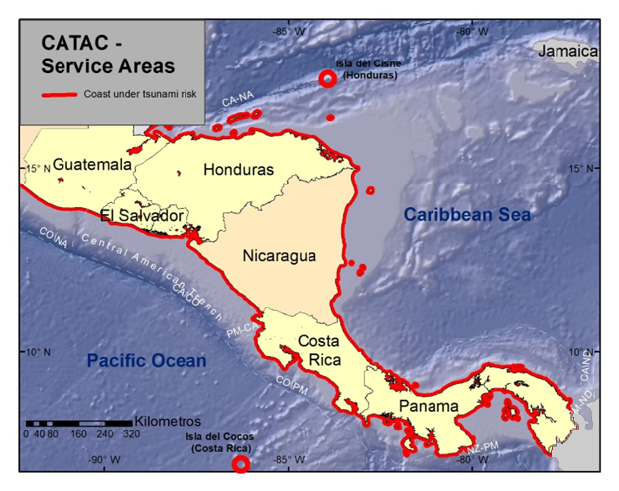
Figure 1. CATAC´s Service Areas on the Central American coasts
of the Pacific Ocean and the Caribbean Sea

CATAC issues advisory information when earthquakes of magnitude 6.5 or greater are detected within its Monitoring Areas (see Figure 2). These areas include both nearby and more distant zones capable of generating tsunamis that could reach Central American coasts within approximately one hour.
Monitoring Areas
• Pacific Zone: Extends from the Guerrero–Oaxaca border along the coasts of Oaxaca, Central America, Colombia, and Ecuador; from the Ecuador–Peru border to the southern tip of the Galápagos Islands; and back to Mexico.
• Caribbean Zone: Extends from Cancún along the coasts of Mexico, Belize, Central America, Colombia, and Venezuela to Coro; then through Santo Domingo, Inagua Islands, Trinidad (Cuba), and back to Cancún.
In the SeisComP processing system, these zones are defined numerically by polygon coordinates.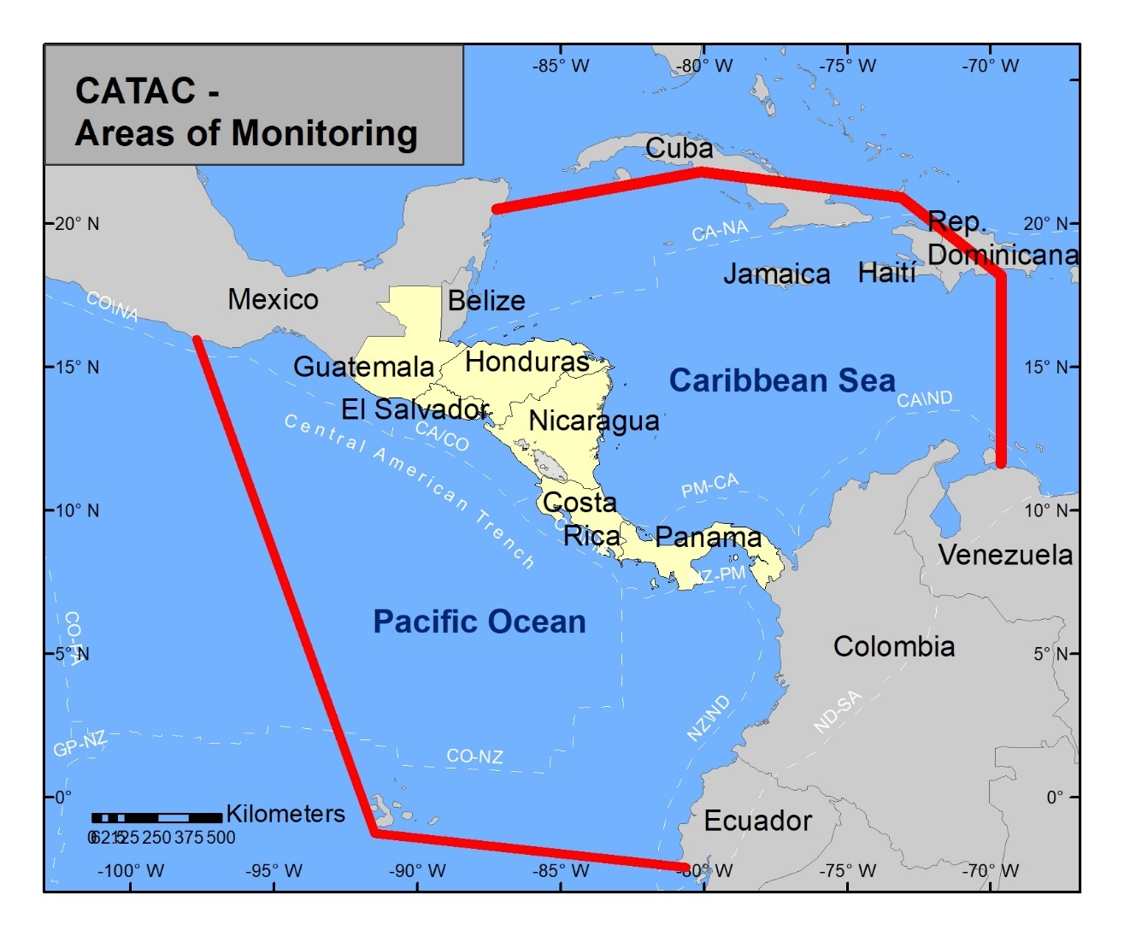
Figure 2. CATAC´s Area of Monitoring

If there are strong earthquakes just outside the Monitoring Zones which might affect Central America CATAC will process them and send out seismological and tsunami products.

As there are only few earthquakes strong enough to generate tsunamis in Central America,
CATAC also processes strong events on a global scale for internal discussion and training of the personnel.

  - Earthquake Source Zones

Seismicity in the Pacific Subduction Zones of Central America and Northern South America. The main tsunami hazard in Central America arises from local earthquakes along the Central American Subduction Zone, stretching from southern Mexico to northwestern Panama. This zone can produce earthquakes up to magnitude 8.6. Numeric simulations have shown that M8.6 earthquakes could produce tsunamis with runups of more than 20 meters on the Pacific coasts of Central America. The risk is heightened not only by the strength of these events but also by the very short interval between detection and tsunami impact on the coast. Another important source area in the Pacific Ocean is the subduction zone along the Pacific coast from Northern Colombia to Ecuador though the travel time to Central America is somewhat longer.

Subduction process North of Panamá and the faults extending to the border to Costa Rica. Strong earthquakes above magnitude 8 have created earthquakes and tsunamis which affected both countries and are also able to impact in other Central American coasts.

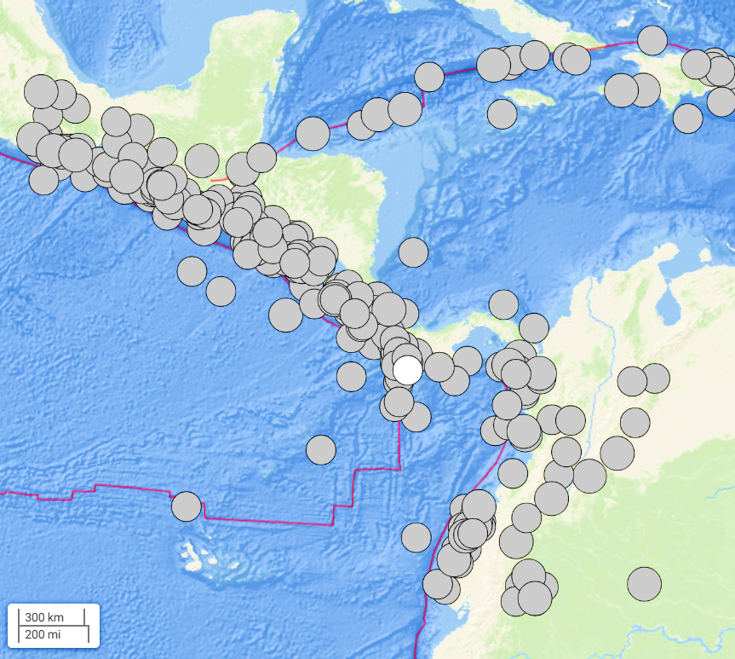

Figure 3. Earthquakes 1904-2025 with magnitudes above 6.5 in and around Central America. according to NEIC/USA. Large earthquakes occur mainly in the Central American subduction zone from Guatemala to Southern Costa Rica

Earthquakes in the fault zone between North American and the Caribbean plate

Volcanoes in Central America. The volcanic hazard is high in Guatemala, El Salvador, Nicaragua and Costa Rica but much smaller in Honduras and Panama. Evidence exists that volcanic explosions, pyroclastic and mass movements have caused tsunamis in the big Nicaraguan lakes. Volcanoes in El Salvador,

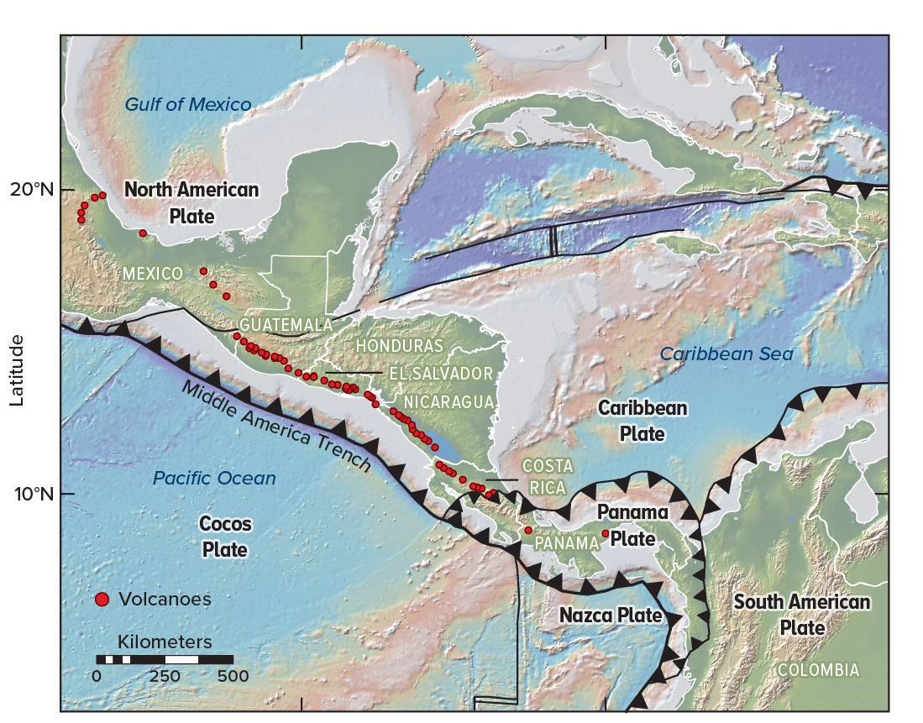
Figure 4. Central American Volcanic Arc
Volcanoes can cause tsunamis the Fonseca Gulf (Pacific coast, red big circle) and in the big lakes of Nicaragua (red rectangle) Taken from https://knowablemagazine.org/content/article/physical-world/202/central-american-volcanoes-clues-earth-geological-evolution

  - Tsunami Hazard

General tsunami hazard. The Pacific Coast of Central America is prone to tsunamis due to the high seismicity at the margins of the Cocos and Caribbean tectonic plates; while the Caribbean Sea Coast of this region has a considerably lower tsunami threat (Molina, 1996; Fernández et al., 2001; IOC 2018). IN around 500 years of about 54 tsunamis are known to have affected Central America. The largest known tsunami impact in history was caused by the 1992 disastrous event on the Pacific coast of Nicaragua with a runup of up to 10 meters.
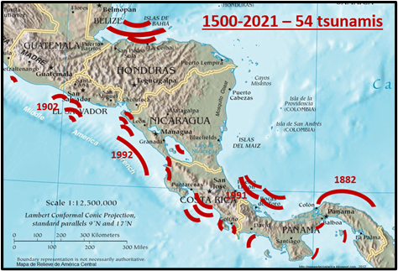

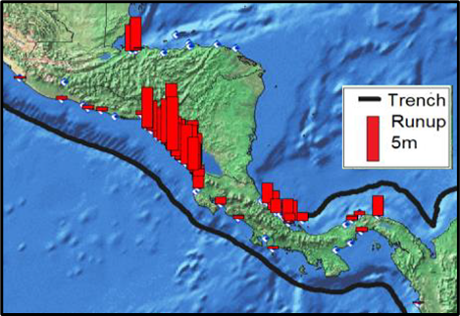
Figure 5. Location of tsunamis (obove) and runup (below) in Central America since 1500. Source: Molina, 1996; Fernández et al.,2000); NGDC/WDS, 2015; modified.
Figure 6. Major earthquake sources contributing to the tsunami hazard for Central America
(red rectangles). According to IOC (2018), IOC (2020).

Coastal areas with reduced tsunami first impact time. In the Pacific Ocean, Guatemala, El Salvador and Nicaragua have a very broad continental shelf with shallow sea depth, which reduces wave speed and increases the time tsunamis need to reach the coast. On these coasts, tsunamis would enter within 30 to 60 minutes after the local earthquake. However, in some coastal areas, the minimum time of impact of local tsunamis is much shorter, which forces CATAC to send warning messages within a few minutes.

But there exist coastal zones with reduced time to tsunami impact exist, due to:
1) The source area is very close to the coast: e.g. Swan Islands in Honduras, Nicoya and Osa in Costa Rica; Chiriqui Gulf, Azuero and Darien in Panama).
2) The source fault enters the coast: e.g. Northern Guatemala, San Juan del Norte in Nicaragua, El Limon in Costa Rica).
3) Between the coast and the source zone there are very deep waters (e.g. Gulf of Chiriqui in Panama).
4) There is a deeper sea channel that connects the source zone with the coast (e.g. Southern Guatemala, Gulf of Chiriquí in Panama).

These conditions exist also combined in some areas.

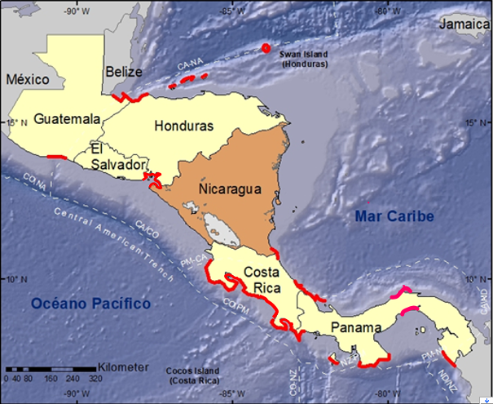

Figure 7. Areas where the tsunami impact time can be less than 10 minutes (red lines)

Volcanic tsunami hazard in the Gulf of Fonseca, Pacific coast. The Gulf of Fonseca, shared by Nicaragua, El Salvador and Honduras, seems to be the only place along the Pacific Coast of the Americas - besides Alaska and Southern Chile - where volcanoes are situated at the very coast and thus with the possibility to generate tsunamis due to flank collapses, landslides, lahars, pyroclastic flows and volcanic explosions. (Not to count volcanoes Barcena and Evermann on the Revillagigedo Archipelago more than 600 km west of the Mexican Pacific coast (Puerto Vallarta) or other Volcano islands far from the main land) The huge eruption in 1835 of Cosiguina volcano, Gulf of Fonseca, Nicaragua, possibly caused tsunamis, but there are no direct evidences. In this time the population density in this area was very low. Besides Cosiguina there is Conchagua, a large inactive volcano on the coast of El Salvador. Both, Cosiguina and Conchagua, could cause tsunamis due to flank collapse or lahars. In the Gulf there are several volcanic islands and earthquakes with magnitudes up to 6 have occurred, also seismic swarm activity is frequent.

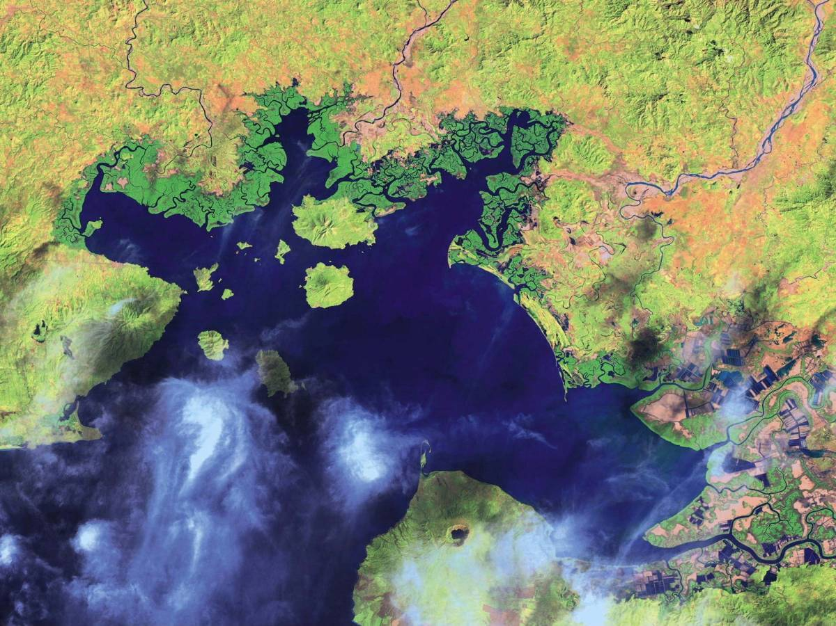
El Salvador
Honduras
Nicaragua

Figure 8. Gulf of Fonseca. Satellite photo. Wikipedia

The Gulf of Fonseca is included in CATAC´s area of monitoring and area of responsibility. CATAC/INETER is in discussion with the seismic networks of El Salvador and Honduras to improve the seismic monitoring for the Gulf and to develop also the capacity for tsunami warning in the case of volcanic sources.

Tsunami hazard in the big lakes of Nicaragua. There exist geological and historical information on the occurrence of tsunamis or seiches in the big lakes in Nicaragua caused by earthquakes or volcanic processes. The tsunami catalogue of Central America (Molina, 1997) mentions that in May, 1844 an earthquake with a magnitude between 7 and 7.8 with epicenter in the southernmost part of Lake Nicaragua of Nicaragua caused a tsunami o seiches in the Lake. CATAC has carried out tsunami simulations of large earthquakes in the area between Nicaragua and Costa Rica and for earthquakes in the Pacific Ocean which confirmed that tsunamis or seiches with amplitudes of several meters can occur in Lake Nicaragua due to these events.
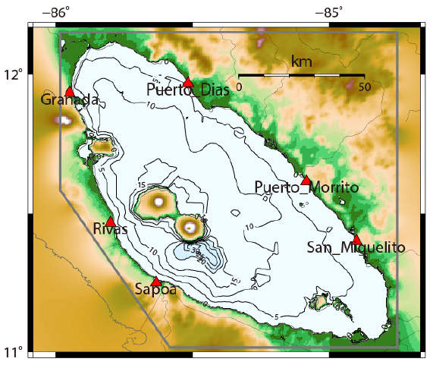
Concepcion
volcano
Mombacho
volcano

Figure 9. Map of Lake Nicaragua. Red triangles indicate coastal sites used for tsunami modelling.
Bathymetry in meters.

For Mombacho, a steep volcano located at the coast of Lake Nicaragua very near the city of Granada, there exist geological and topographic evidence for a large collapse of its Eastern flank. The landslide entered directly into lake Nicaragua and created a peninsula and hundreds of small islands. Certainly, this event caused a tsunami in the lake. At this volcano another collapse is known which also might have entered the lake

Concepción, a steep active volcano on Ometepe Island in Lake Nicaragua, could also be the origin tsunamis caused by landslides, pyroclastic flows or volcanic explosions. Perez (2019) has carried out numeric simulation of tsunamis caused by a debris avalanches at Concepción and Mombacho. It was shown that destructive tsunamis could not only affect the vicinity of these volcanoes but also at other densely populated coasts.

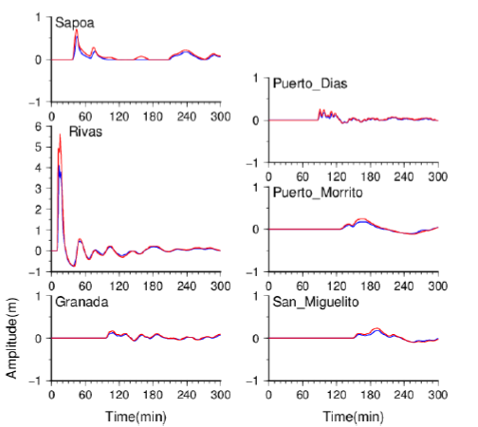
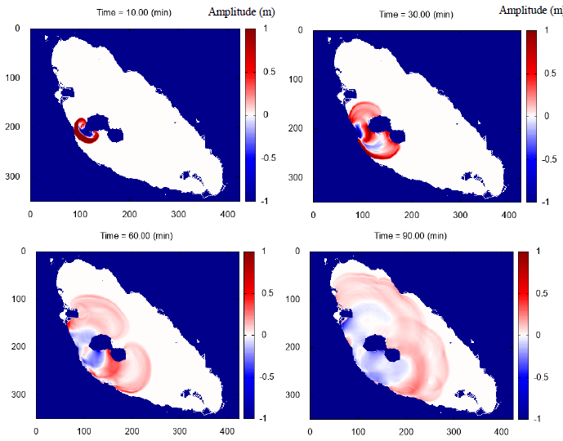
Figure 10. Tsunami simulation for Lake Nicaragua.
Left: Snapshots of simulated tsunami propagation from a debris avalanche at Concepcion volcano;
Right: Simulation of the tsunami impact at coastal place of Lake Nicaragua. From Perez (2019)

Freundt et al (2006ª, 2006^{b}), documented geologic evidence about a tsunami generated by a volcanic explosion near Apoyeque volcano located at the shore of Lake Managua, only 8 km from the Nicaraguan capital, Managua. Freundt et al (2007) discuss the possibilities of tsunamis generated by volcanoes. The Momotombo, another active volcano in Lake Managua, could also cause tsunamis due to pyroclastic flows or flank collapses.

Meteorological tsunamis. The Caribbean coast of Central America is affected by hurricanes and other meteorological phenomena which can swell the surface of the sea which then propagate to the coast similar as tsunamis and can reach several meters height on the beach. Also, the big lakes in Nicaragua can be affected by these meteorological tsunamis, when strong air pressure disturbances travel over the lakes with velocities similar as the tsunami propagation speed corresponding to the shallow water depths in these lakes, mainly 10 to 20 meters, in smaller areas up to 40 meters.

In the moment CATAC has no capacities to monitor and process these phenomena but related discussions are going on with the INETER Meterological Department. In 2025, a project with JICA/Japan was started with the aim on to study coastal hazards and to create capacity at INETER to monitor and predict Storm Swells/meteorological Tsun

Not to be confused with the tsunamis are the strong surfs which affect frequently certain places on the Pacific coasts of Central America (e.g. Cedeño/Honduras, Corinto/Nicaragua) and which are caused by distant storms or hurricanes in the Ocean from where the generated waves travel to the coasts. The monitoring of theses waves and predictions of possible impact are done by the for oceanographic groups in some countries of Central America as for instance at MARN in El Salvador.

- Operations

  - CATAC´s Capacities and Facilities
.
2.1.1 CATAC´s staff
CATAC operates with a dedicated team of 24 professionals (see list below) to ensure continuous 24/7 monitoring and warning services for various phenomena. The team works in two 12-hour shifts per day, maintaining seamless operational coverage. Since November 2019, CATAC has been mandated to always have a minimum of two personnel on duty.

The staff has undergone extensive training, initially through the JICA project (2017–2019) and subsequently in ongoing capacity-building initiatives. Both watch standers remain stationed within CATAC's facilities, with additional emergency support available from INETER during office hours.

To strengthen its operational framework, CATAC has designated five key leadership positions:
-General Director of CATAC
-Director of Seismology
-IT Manager of the CATAC Monitoring and Warning Center
-Manager of CATAC's field stations in Nicaragua.

For sustained operations, INETER's Computer and Network Division provides technical assistance in computing, local networking, and internet connectivity whenever CATAC's internal capacity requires additional support.

To foster regional collaboration, CATAC Member States are strongly encouraged to nominate seismologists or tsunami specialists for temporary assignments at CATAC. These assignments would facilitate bilateral cooperation, promoting the exchange of expertise and personnel. In 2024, one seismologist from the University of Honduras has made use of this possibility in a one week visit to CATAC.

List of CATAC staff, as of March 2026
D - serves as a 24x7 on-duty seismologist
(D) – capacitation ongoing for 24x7 on-duty seismologist
DG – serves as 24x7 on-duty for immediate advice to government
P – assignment pending

# | First and last name | 24x7 | Function / experience
1 | Dr. Wilfried Strauch | - | General Director CATAC; Advisor to INETER and Government of Nicaragua; Seismology, Tsunami, volcanology, SeiscomP; programming
2 | MSc Emilio Talavera | D | Director of Seismology; seismology, tsunami; scripting
3 | Eng. Miguel Flores | D | IT Manager of the Central Monitoring Center, seismology, tsunami, SeisComP, scripting
P | NN, to be assigned | D | Director of seismic and geophysical network; /seismology, tsunami, electronics, communications
4 | MSc Greyving Argüello | D | Seismology, Geophysics, Tsunami; Scripting
5 | MSc Amilcar Cabrera | D | Seismology, Mathematics, Tsunami, programming
6 | MSc Petronila Flores | D | Seismology, Geology, Tsunami;  Publication of CATAC monthly and yearly bulletins
7 | MSc Martha Herrera | D | Seismology, Electronics, Tsunami; Field Maintenance;  Digital Communication, Seismometry, Sea gauges
8 | MSc Domingo J. Ñamendi | D | Seismology, Electronics, Tsunami; Field Maintenance;  Digital Communication, Seismometry, Sea gauges; scripting
9 | MSc Ulbert Grillo | D | Seismology, Tsunami, Electronics, Seismometry, Field Maintenance; Programmer
10 | MSc Ana Rodriguez | D | Seismology, Tsunami, GIS
11 | MSc Milton Espinoza | D | Seismology, Tsunami, GIS
12 | MSc Wesly Rodríguez | D | Geophysics, Seismology, Tsunami
13 | Eng. Norwin Acosta | D | Tsunami Hazard, Tsunami Modelling, GIS
14 | Eng. Jaqueline Sanchez | D | Seismology, Tsunami, IT, Contacts with Users
15 | Eng. Elvis Mendoza | D | Seismology, Field Maintenance; Electronics, Seismic and GPS equipments,
16 | Tec. Allan Morales | D | Seismometry, Tsunami, Electronics, Field Maintenance seismic, GPS equipments
17 | Tec. Antonio Acosta | D | Seismology, Seismometry, Tsunami, Electronics, Field Maintenance seismic, GPS equipments
18 | Tec Leonel García | - | Driver, Electronics, Field assistant
19 | Michael José Malespin | DG | Informatics, immediate advice to government
20 | Carlos José Pérez | DG | Civil Eng, immediate advice to government
21 | Geovanny Rivas | DG | Informatics, immediate advice to government
22 | Juan Carlos Reyes | DG | Economist, immediate advice to government
23 | Ileana Boza | - | Administrative Assistant
P | N.N. free position | - | Programmer

2.1.2 CATAC´s Facilities

Monitoring and warning center CATAC´s Monitoring and Warning Center for earthquakes, tsunamis, seismological evaluation of volcanic phenomena and landslides occupies an area of 250 square meters divided in a monitoring and warning room, a meeting room, an underground bunker for seismographs, computational servers bunker and battery backup, the electronics/seismometry lab for maintenance of the data center and Nicaraguan seismic network , an IT room, and 6 offices for CATACs personnel.

Computing facilities CATAC is equipped with high performance servers, workstations, communication hardware, as well as decision support systems, facilities for the development and maintenance of equipment at the central and monitoring stations throughout Nicaragua. Critical equipment and facilities have multiple safety redundancies for the case of fatal failure.

Most of the servers are located in a concrete bunker of about 40 square meters in the basement of the building where there are also the seismometers, accelerometers for routine and instrument tests. There is also a battery backup unit with a capacity of 20kWh. The bottom of the bunker is about 3 m depth below surface.

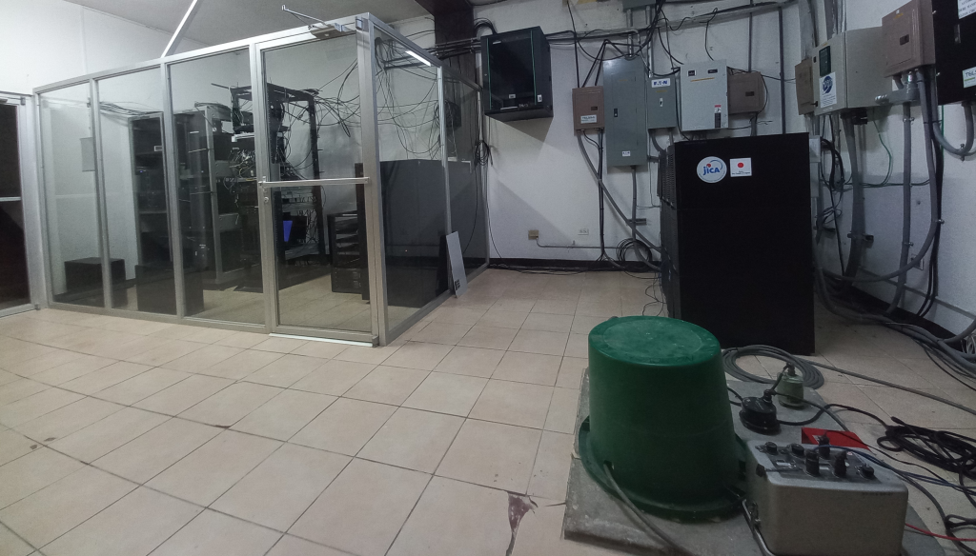
Photo 1. Server and Seismometer bunker at CATAC.
Around the processing facilities the is ample room for meetings, capacitation and emergency work (situation room). That way the watch standers - to some extent - can participate in meetings or capacitation measures, while there are no important events occurring.

Part of CATAC is also a laboratory for maintenance of seismic, electronic, communications devices and for testing seismic equipment.
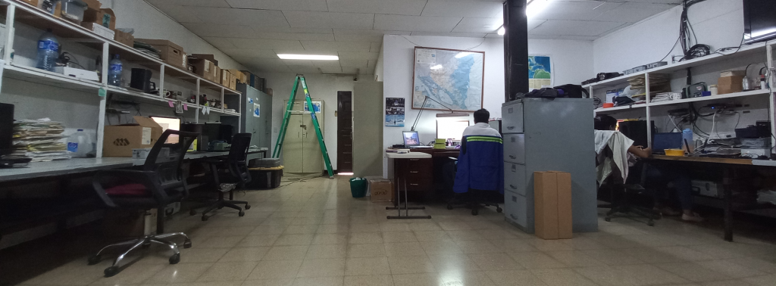
Photo 2. Seismometric and electronic laboratory
Computing facilities The main workstation for automatic and manual seismological and tsunami processing was since 2017 a machine which has an Intel Processor Xeon (LGA2011-3 2.60G 35M Proc E5-2697V3 14C DDR4 Up to 2133 MHZ ) and a GPU Nvidia TESLA M40 GPU 12GB GDDR5. Additionally, there are now 2 more modern workstations installed with NVIDIA RTX 4090 GPU which reduced considerably the computing time for tsunami simulations.

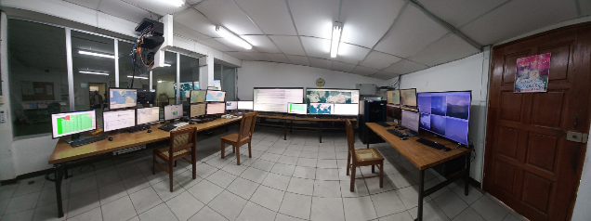
Photo 3. CATAC, Processing and Alerting Room
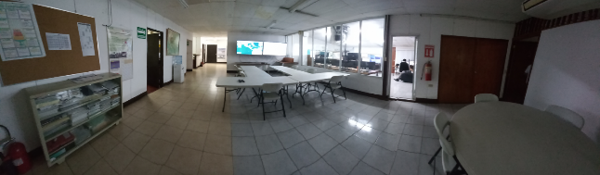
Photo 4. CATAC, Situation and Meeting Room
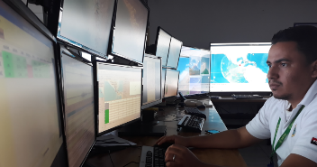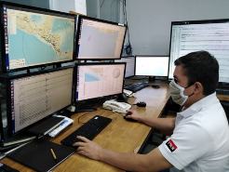
Photo 5. Seismologists of the 24x7 service. They revise the automatic results, perform the manual processing and must publish the first manual results within 2 minutes after the detection of the earthquake.

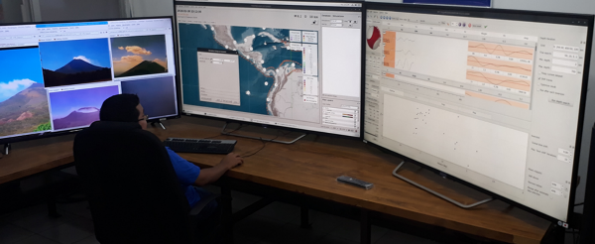
Photo 6. Moment Tensor calculation and numerical tsunami simulation are important tasks of the CATAC seismologist on duty.

Backup facilities of CATAC The most important parts of CATAC's operating system - as the workstation for earthquake and tsunami processing and the terminals for manual processing and the electric power backup systems - are duplicated in case of partial malfunction. However, the possibility of catastrophic failure cannot be eliminated; a giant distant earthquake or a local earthquake in Managua might affect CATAC facilities. If CATAC products cannot be issued in an emergency, CATAC user countries/organizations should take appropriate measures with reference to PTWC products and/or use their own or alternate means to estimate the effects of a strong earthquake possibly generating tsunami advisory services for both coasts of Central America are currently provided by the Pacific Tsunami Warning Center (PTWC).

Backup center for CATAC, in Nicaragua. CATAC has a plan for the implementation for a backup center in Nicaragua. The site under consideration is located in a facility of the Nicaraguan Electric Power Transmission Company ENATREL near the town of Boaco, about 100 km N of Managua. This place is distant to the volcanic chain of Nicaragua, has much lower seismic hazard, would not be seriously affected by earthquakes in Managua or in the Nicaraguan subduction zone. ENATREL provides access to their optical fiber network which transports large part of the data of the Nicaraguan seismic network. ENATREL is also an INTERNET provider and would facilitate access to the regional and international seismological data centers.

Backup center for CATAC, in El Salvador. Another backup plan is under discussion with the Seismological Center at the Ministry of Environment in El Salvador (MARN). INETER and MARN are cooperating closely and MARN is the NTWC of El Salvador. They dispose to similar facilities and software system as CATAC and their organization of earthquake and Tsunami processing is similar. MARN does not use the complete suite of SeisComP, as CATAC does, but has elaborated own solutions for the most important functions. In talks between CATAC and MARN a closer integration of both centers was agreed, including direct exchange of the products of both centers using the corresponding modules of SeisComP.

  - Seismological and Geophysical Monitoring Networks

2.2.1 Seismic stations

CATAC´s Seismic Network in Nicaragua CATAC, besides working as a TSP within the IOC/UNESCO system, on a national level is responsible to develop and to maintain the Nicaraguan seismic network which currently (2026) has around 140 accelerometric, short period and broad band seismic sensors The data are received by direct streaming with the seedlink protocol and is fed into several SeisComP systems for archiving and for real time automatic and manual processing. About 70 % of these stations were installed since 2016 that means with the direct consideration to be used for the reinforcement of CATAC and the development of the earthquake early warning system in Nicaragua. The network uses a large numbers of high quality equipment of but also many low-cost instruments (for example Raspberry Shake) according to the limited budget of INETER. Especially, there are sufficient broadband sensors suited for some tsunami specific processing methods.
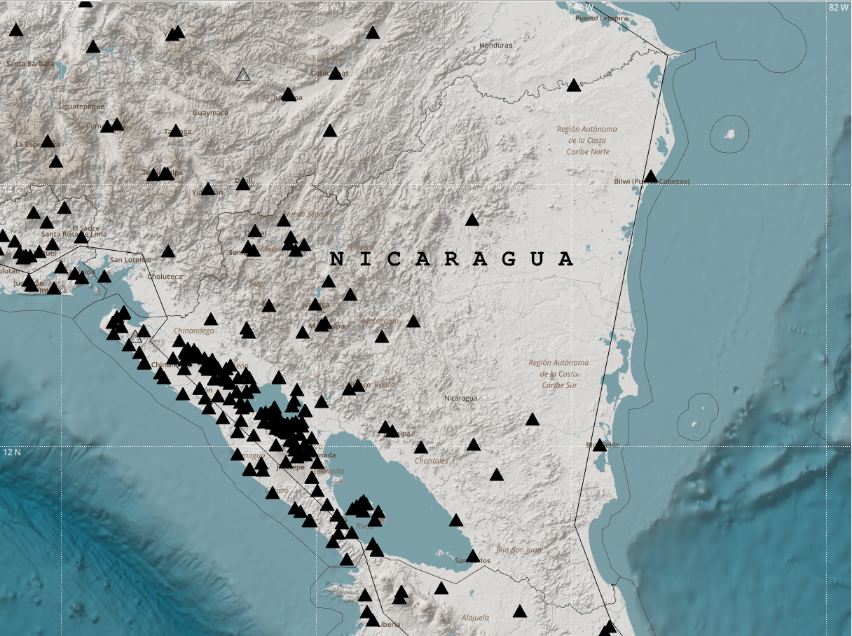
Figure 11. CATAC´s seismic network in March, 2026
In 2025-26 CATAC´s seismic network was significantly expanded. SINAPRED and INETER are executing with support from China the project SINAREM on the improvement of the Disaster Prevention in the country. CATAC installed in December 2025 - February 2026 the number 50 accelerographs, 10 broad band sensors, 36 Raspberry Shake sensors and 7 infrasound instruments. Twenty more broadband stations will be installed in 2026.

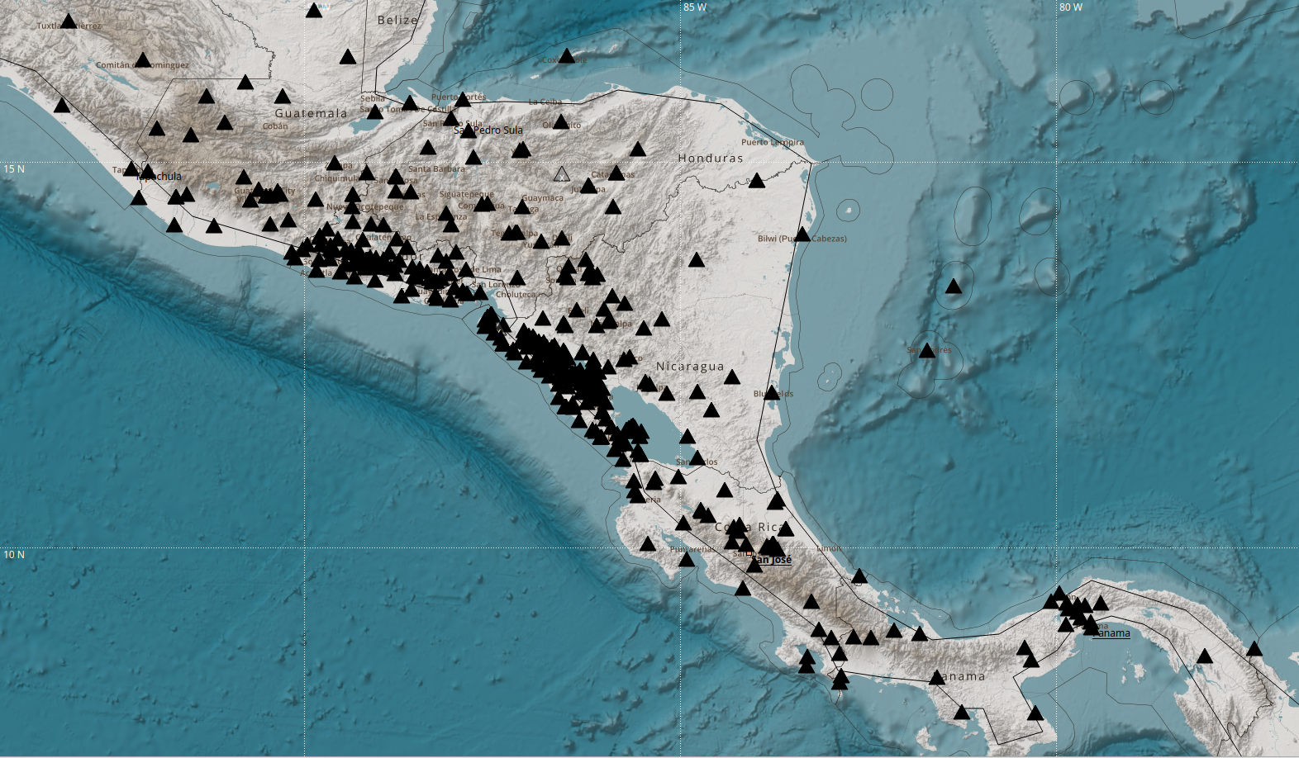
Figure 12. Seismic stations in Central America monitored by CATAC, March, 2026

Seismic networks in other Central American countries CATAC receives real time data from nearly all seismological data centers in the countries of the Central America. These data are obtained via direct transmission via seedlink from the corresponding network centers and are characterized by a low data transmission delay from the station to CATAC, normally less than a five seconds. Obviously, it is the responsibility of the countries interested in receiving CATAC's tsunami advisory to provide the necessary data. If a country does not provide sufficient data, it will not be able to receive the products quickly and in good quality, especially for local events near its coasts.

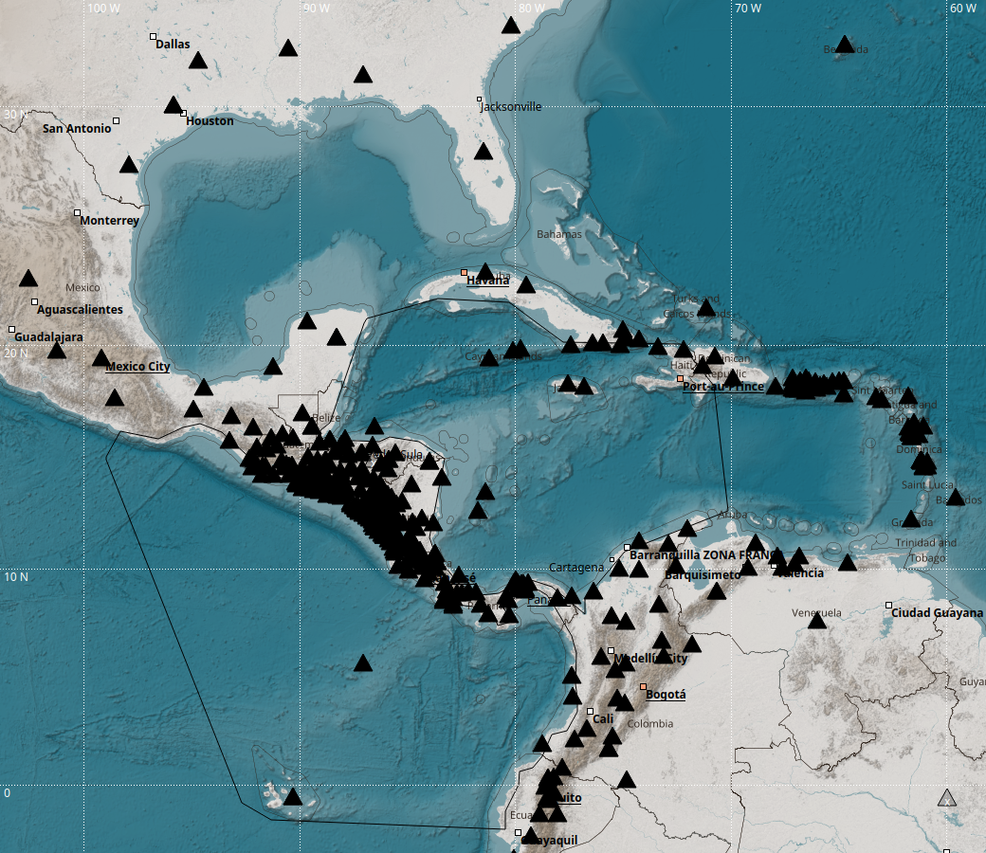
Figure 13. Seismic stations in the greater Central America-Caribbean region monitored by CATAC
Table 1. Direct streaming from Central America, low delay (several seconds)
Country | Institution | Type of  sensors | Number of seismic stations/sensors
Nicaragua* | CATAC/INETER*, Governmental | ac, sp, bb | 250 / 310
El Salvador* | MARN*, Governmental | ac, sp, bb | 70
Guatemala | INSIVUMEH*, Governmental | ac, sp, bb | 60
Honduras* | COPECO*, Governmental | sp, 1 bb | 15
Honduras* | UNAH*, University | sp | 16
Costa Rica | OVSICORI, University | ac, sp, bb | 10
Costa Rica | UCR, University | sp, bb | 22
Panama* | Panama Canal*, Governmental | ac, sp, bb | 10
Panama* | Baru Network, Private | sp | 8
Panama* | IG-UPA*, University | ac, sp, bb | 6
*) All existing networks in the country participate | *) Facilitates complete network  Gob-Government, Univ.-University, Priv.-Private |  | Total 453 (03/2026)
CATAC receives also data from other countries located in its Region of Monitoring as listed in the following table:

Table 2. Direct streaming from countries in the greater region,
Country | Institution | Type of  sensors | Number of Seismic stations
Mexico (Southern part) | UNAM, University | bb | 14
Venezuela | FUNVISIS, Government. | bb | 11
Colombia | Colombian Geological Service (SGC), Governmental | bb | 21
Ecuador | Geophysical Institute, IGN, University | bb | 20

Other broad band seismic data from South America, North America, the Caribbean and the World come in through EarthScope (previously IRIS)/USA or GEOFON (GFZ, Potsdam, Germany).

The density of seismic stations in Central America is very high, which in general could facilitate the rapid and accurate elaboration of CATAC products for local earthquakes occurring in the region. The governmental seismological institutions in Nicaragua, El Salvador, Guatemala and Honduras facilitate the data of near 100% of their networks. However, in Honduras and Panama there due to administrative restrictions is still insufficient coverage for high quality products. Especially there is in some areas a lack of broad band sensors and for instance there is currently only one station near the plate border North of Honduras where the major seismic hazard for the country is produced. As for Panama, CATAC is in the process of establishing an agreement with the University of Panama (UPA) to receive more seismic data from its Geosciences Institute.

A high density of seismic stations and the small delays of the data from the very region entering CATAC permit the use of alternative methods for the rapid evaluation of the seismic magnitude as the module FINDER from the Earthquake Early Warning software package provided by the Swiss Seismological Service to the countries of Central America. This method uses the high frequency spectrum of the recordings contrary to the very long period signals which are preferred normally for the evaluation of seismological parameters relevant for tsunami evaluation.

Improvement of regional seismic networks. The seismic networks in Nicaragua, El Salvador, and Guatemala were greatly densified in 2021 through the EWARNICA project with Switzerland, while improving the accuracy of earthquake locations. With the CATAC earthquake early warning methods, CATAC obtains an initial location and the magnitude of the earthquakes occurring in Central America within a few seconds after the start of the event. Also, the calculations of the Moment Tensor and the Mw magnitude are accelerated.

Influence of station density to Initial Tsunami Product. CATAC issues its first product for a potentially tsunamigenic earthquake once location, depth, focal mechanism, and magnitude are determined with sufficient accuracy to assess tsunami potential through numerical modeling.

The speed of this process depends mainly on the density of real-time seismic stations near the epicenter. In CATAC’s Monitoring Area, this density varies: an earthquake in the Pacific off Nicaragua or El Salvador may allow products within 20 seconds, while one in the Caribbean can take several minutes.
Rapid issuance is critical for nearby coasts, where a tsunami could arrive within minutes. In Central America, Nicaragua, El Salvador, Guatemala, and Honduras provide CATAC with dense seismic data, whereas Costa Rica and Panama contribute fewer stations.

CATAC´s global seismic monitoring. CATAC maintains a special SeisComP system for global earthquake monitoring. This system provides locations and magnitudes of earthquakes with magnitudes above 5.5 worldwide. This system is useful when seismic waves emitted by these earthquakes are recorded in Central America. It also facilitates a awareness global of seismicity and zones close to the CATAC monitoring areas, such as South America and Eastern Caribbean. For big global earthquakes the CATAC SeisComP system also performs the calculation of the moment tensor and tsunami simulations.

Huge earthquakes are seldom in CATAC´s Area of Monitoring. CATAC is using its golbal monitoring facility to test its tsunami evaluation system and for the training of its personnel on the processing of strong earthquakes and tsunamis.

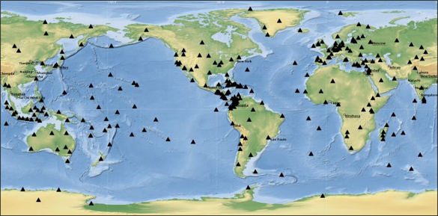
Figure 14. Seismic stations used by the CATAC global locator.

2.2.2 GPS/GNSS networks

In the last years methods were developed internationally to use displacement data obtained from GPS/GNSS for the characterization of large earthquakes. Magnitudes, moment tensors or event slip distributions can be obtained much faster than with the data from seismographs.

CATAC maintains in Nicaragua a total of 33 GPS/GNSS stations. Additionally there are available data from the stations of the Geodesy Department of INETER and the Cadaster Department. The data with a sampling frequency of 1 Hz from all stations are streamed with the BKG Caster software to CATAC to be converted into displacement and fed to the SeisComP system. CATAC is recently working to develop the capacity for the use of these real-time data for tsunami advisory. In the near future CATAC expects to receive also GPS/GNSS data streams from other Central American Geophysical Institutions.
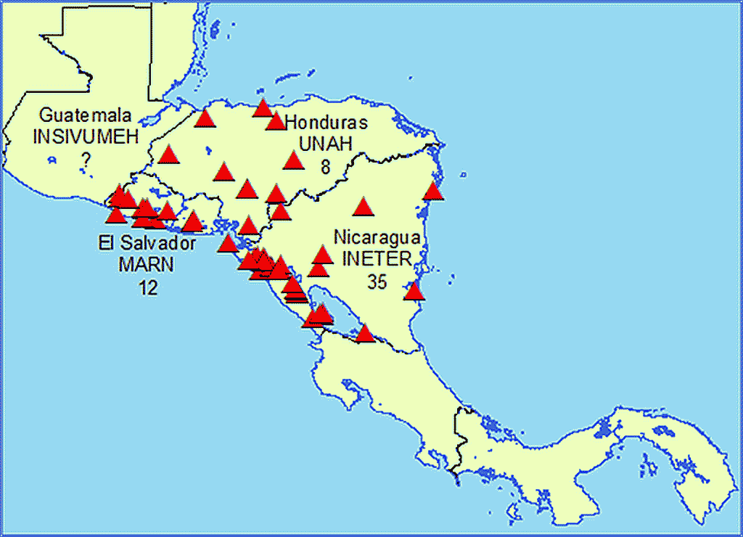

Figure 15. GPS/GNSS stations of CATAC and other geophysical institutions
of Northern Central America

In Central America and the Caribbean there are many GPS/GNSS stations installed the data of which were exchanged freely during the project COCONET (with UNAVCO, now EarthScope Consortium). INETER maintains since 2015 a regional mirror system of UNAVCO GPS stations in Central America and the Caribbean and expects to convert this system in a real time acquisition system for CATAC. maintained a server as a regional mirror for GPS/GNSS data from Central America and the Caribbean. CATAC pretends to make use of this experience and establish a real time download from these stations and use them (or several of them) for tsunami warning.

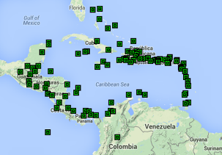

Figure 16. GPS/GNSS stations received at the Coconet mirror at INETER

    - Mareographic facilities

In case a tsunami is caused by an earthquake or any other event, its occurrence can be verified or measured using sea gauges located along the coast, deep water tsunami buoys, GPS/GNSS installed on large ships, GPS/GNSS or ocean radars located on the coast, or other appropriate methods.

CATAC´s SeisComP system receives data directly from INETER´s own sea gauges, or from foreign sea gauges via the COI/UNESCO sea level site (https://www.ioc-sealevelmonitoring.org/) operated by VLIZ. SeisComP´s TOAST module is used to visualize and process the data. Mareographic data are also received and visualized with TideTool (PTWC).

In general, the density mareographic is much too low in Central America to use them efficiently for the tsunami warning. The reason is that

Mareographic stations in Nicaragua. INETER (both CATAC and Water Resources Department) has installed 6 mareographic stations on the Pacific Ocean coast of Nicaragua and 4 on the Caribbean coast. In some sites 2 stations are operating in parallel. In the last years the network has experienced strong impacts by hurricanes and ship accidents, instruments were lost and the network is in a process of restructuring.

A list and access to data of sea gauges in Nicaragua and the other countries of Central America can be obtained from http://catac.ineter.gob.ni/mareo.html. From the VLIZ via www.ioc-sealevelmonitoring.org/map.php, CATAC can receive data in real time of about 700 stations from all parts of the Pacific Ocean 13 from the Pacific coast of Nicaragua and and 60 from all the Caribbean Sea.

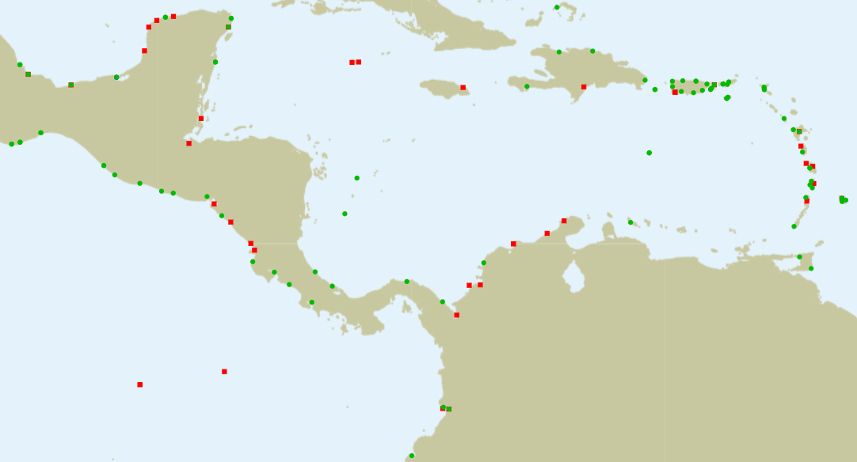
Figure 17. Sea level stations available to CATAC
Green squares - functioning stations;
red squares - not operating stations now accessing the website.
(Copied from www.ioc-sealevelmonitoring.org/map.php. Page accessed on 30/03/2023)

New experimental buoys with GPS in the Pacific Ocean of Nicaragua. In March 2025, three buoys were installed in front of the Pacific coast of Nicaragua by the US Research vessel Atlantis in a project of CATAC with the University of Tampa, USA, OVSICORI (COSTA Rica) and other international scientific institutions. Another buoy was installed in front of Nicoya peninsula, Costa Rica.
These 4 buoys record locally GPS data which are downloaded in certain periods visiting the sites by ship or automatic wavegliders. There are possibilities to increase the number of these instrument and to establish real time data transmissions. These data will permit to increase drastically the lead time of earthquake and tsunami warning for Nicaragua. 4 buoys transmit in real time estimates of both waves at ocean´s surface waves or tsunamis and the ocean bottom.

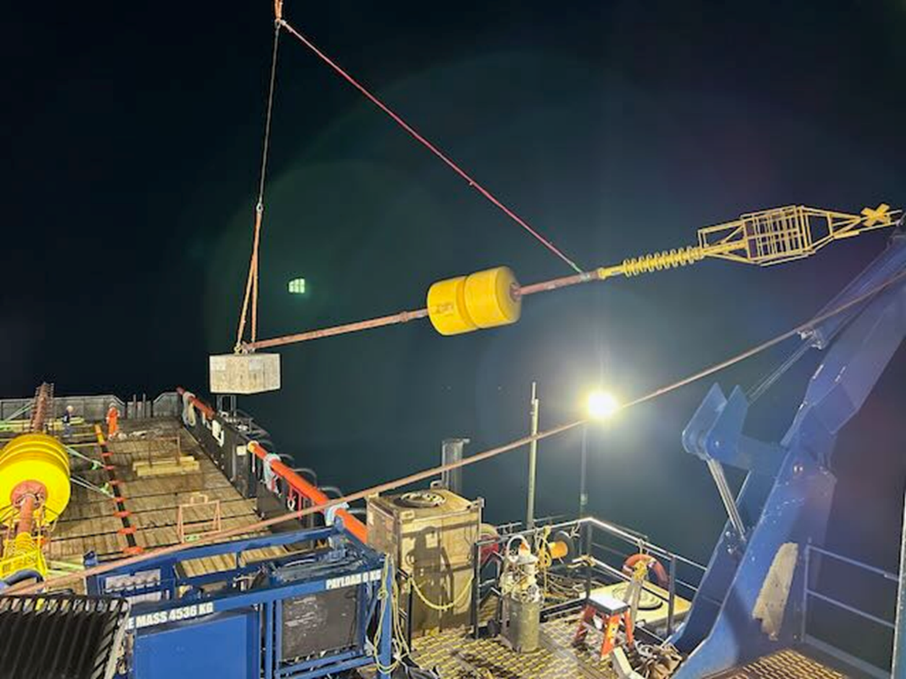

Photo 7. Installation of a Buoy from the Research vessel Atlantis

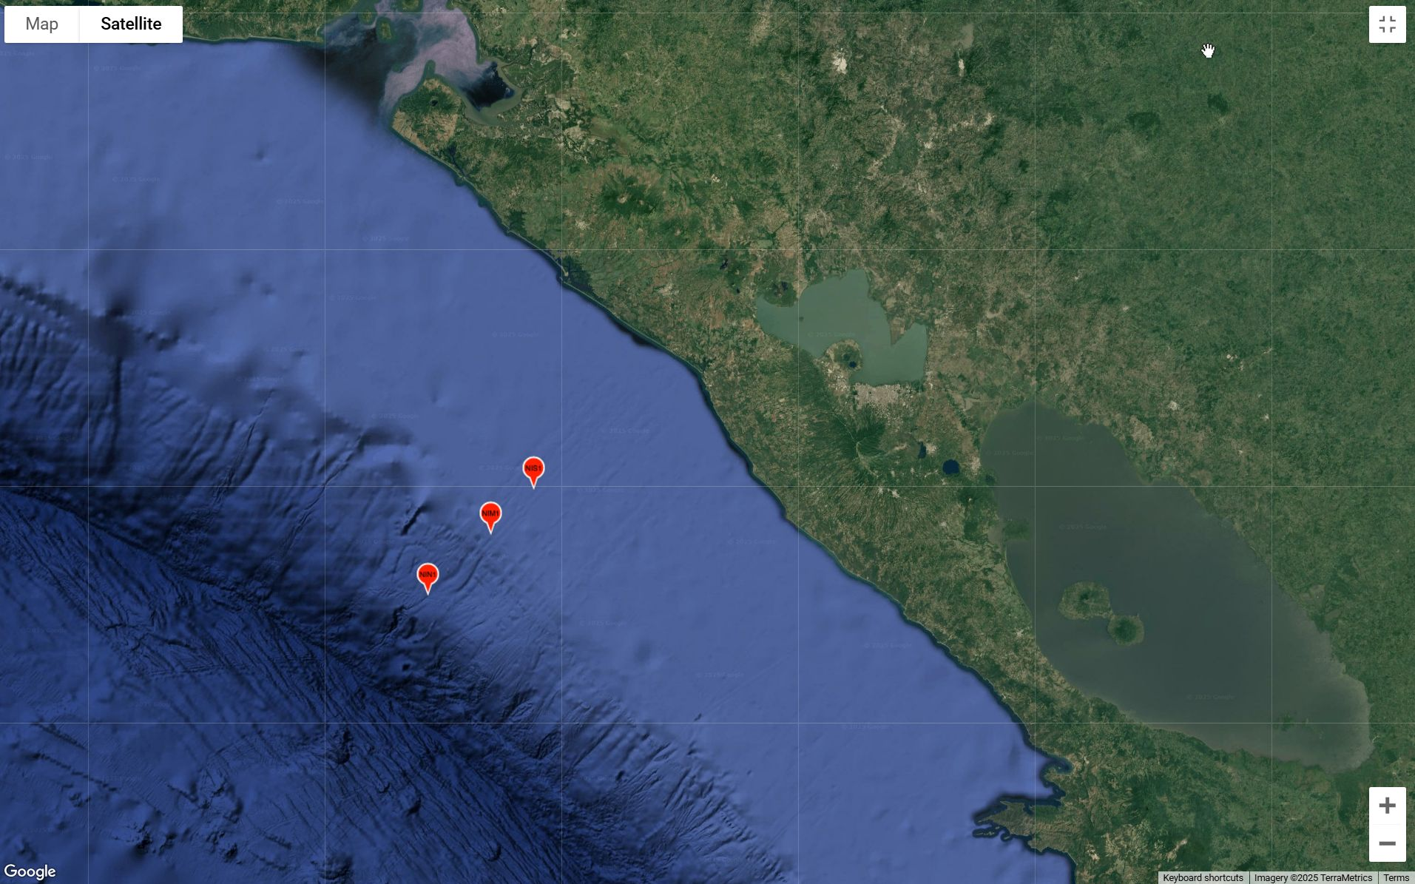

Figure 18. Location of the buoys in the economic maritime zone of Nicaragua

    - Volcano monitoring capacities for possible tsunami warning

CATAC uses its seismic and GPS stations for volcano monitoring in Nicaragua and cooperates with INETER´s Volcanology and Geology directorates which maintain other sensors as in the volcanic chain of Nicaragua for volcano and landslide monitoring and early warning.

  - Operational Tools and Procedures

CATAC uses the SeisComP software package (GFZ/Potsdam, GEMPA) with the PRO Extension for both automatic real-time and manual post-processing of seismic data and tsunami analysis. SeisComP was designed as a real-time data processing and fully automatic data acquisition tool, including quality control, event and location detection, as well as event alert dissemination. Also, additional functionalities were implemented to meet the requirements of 24/7 early warning centers. SeisComP is currently being developed by the Company GEMPA based in Potsdam, Germany.

2.3.1 Seismological Tsunami Source Characterization

Automatic and Interactive Moment Tensor Calculation. The Moment Tensor is a physical description of the process of fault rupture that generates the displacement of the blocks under the seafloor that cause the tsunami and that emit the seismic waves that are recorded remotely and that allow the detection of the earthquake and the prediction of the tsunami before it reaches the coast. The determination of the Moment Tensor also makes it possible to determine the magnitude of the earthquake Mw with a higher precision than that allowed by simple methods that use the amplitude value of certain seismic waves to estimate the magnitude ML, Mb with certain formulas.

Automatic Moment Tensor Calculation. After detecting and locating the earthquakes automatically the SCAUTOMT Module evaluates the seismic waveforms recorded at the different stations and compares them with the numerically simulated shapes with a certain model of the earthquake focal mechanism. By testing a large number of possibilities for hypocenter depth and varying the location and parameters of the fault it arrives at a result where the recorded data optimally matches the model. The SCAUTOMT module is configured to include near and far stations in the processing. Distant stations have the advantage that their records are not saturated, which would make the determination of the Moment Tensor impossible.

Interactive Moment Tensor Calculation. The SCMTV module is used for the interactive calculation of the Moment Tensor. The operator can adapt the program to the specific situation of the event. By limiting the distance of the stations involved in the processing, the work can be accelerated.

The SCAUTOMT and SCMTV modules of SeisComP PRO use P-wave, S-wave, surface waveforms and W-waves to determine the Moment Tensor. CATAC previously used only broadband seismic station records for this process. However, broadband records located near the epicenter are often saturated by the high amplitudes of seismic waves and cannot be used for magnitude and Moment Tensor calculations. That is why CATAC also uses on a large scale the high quality accelerographic stations located in Central America for these purposes.

The W phase is a long-period phase that arrives before the S wave. Because of the fast group velocity of the W phase, most of the energy of the W phase is contained within a short time window after the arrival of the P wave. The amplitude of the long-period waves best represents the tsunami potential of an earthquake. By extracting the W phase from the vertical component of seismic waves, the Mw magnitude and source mechanism can be deduced for large earthquakes using the linear inversion algorithm. Previous studies (e.g. Argüello, 2016; Argüello et al, 2018)) show that W-phase inversion produces reliable and consistent CMT solutions that are necessary for numerical tsunami modeling. With the current CATAC-initiated enhanced seismic networks in Central America, the initial solution can be produced within 5-8 min after the occurrence of earthquakes of magnitude greater than 5.5 including data from stations up to 1000 km epicentral distance. Central America is a very narrow region and sometimes solution stability problems can occur due to insufficient azimuthal coverage. In this case it is possible to increase the distance of stations up to 1500 or 2000 km and repeat the calculation (Cabrera et al., 2021).

Exploitation of Earthquake Early Warning Results. Since 2016, CATAC/Seismology has been developing together with the Swiss Seismological Service (SED) at the ETH Zurich University an Earthquake Early Warning (EEW) system for Nicaragua. After promising results in Nicaragua this project was extended from 2020 also to other Central American countries and was largely supportive in the development of CATAC Strauch et al, (2018), (Massin et al, 2018).

A primary objective for EEW is the immediate estimation of the location and magnitude of the seismic event within seconds after or even during the rupture of the earthquake fault. The main difference to the standard processing is that the magnitude is calculated from the seismic wave which arrives the station, the so called P-wave (P-wave) and not from the S(econdary)-waves or which arrive minutes later. The fast magnitude estimation algorithms created for EEW can be useful for Tsunami Warning. The fast location of the seismic event provided by EEW is important for the tsunami warning, especially in those coastal regions where tsunamis may arrive a few minutes after the crustal rupture process ends.

Tsunami mitigation efforts can be seriously affected by the seismic impact of the earthquake that generated the waves. NTWC and Civil Protection institutions should have an estimate of the level of impact or destruction as soon as possible to adapt mitigation measures (e.g., evacuation) accordingly. The EEW requires very rapid methods to alert large numbers of people of the impending impact by an earthquake and the same methods serve the tsunami warning.

CATAC was requested in 2024 by the ICG/Caribe EWS to make use of these capacities. EEW methods for these countries in Central America for which a high density of seismic stations is available, i.e. Nicaragua, El Salvador, Costa Rica , and Honduras. Location, depth and magnitude are computed within 10 seconds after detecting the earthquake. Immediately a numerical tsunami simulation is carried out using both methods CATAC has implemented: TOAST with

Earthquake Impact Scenarios, Shakemaps. In tsunami response planning, it is crucial to consider the seismic impact near the source, as these effects can hinder evacuation, contribute to wave-borne debris, and amplify tsunami impacts. To assess earthquake impact, the USGS developed ShakeMap and PAGER (Prompt Assessment of Global Earthquakes for Response). ShakeMap provides visualizations of ground shaking levels, analyzing earthquake magnitude, distance from the epicenter, regional geology, and seismic wave propagation. PAGER then estimates the population exposed, potential fatalities, and economic losses based on ShakeMap data.

The initial experience of CATAC with Shakemaps in near real-time for Nicaragua and Central America were implemented in March 2017 (Cauzzi et al., 2018) within the Earthquake Early Warning project with SED/ETH 2016-2025 for the internal use in Nicaragua.

Recently, CATAC acquired the licenses for the use of the SIGMA module to generate Shakemap in a version implemented In the SeisComP package. This permits earthquake impact scenario modeling and Shakemap calculations within minutes of an earthquake. CATAC is testing this module and pretends to make the near reao time results results for strong earthquakes available to the NTWC and TWFP in Central America via its tsunami products and its website.

    - Tsunami Forecasting
.

Tsunami Forecast Models CATAC uses for quantitative tsunami warnings a real-time numerical simulation technique which is implemented in the SeisComP PRO Module TOAST elaborated by GEMPA.

Real-time tsunami forecast model SEISCOMP PRO, the seismological software package used at CATAC for earthquake detection, location and magnitude determination has a real-time tsunami forecast model based on the TOAST module (Tsunami Observation and Simulation Terminal; GEMPA, https://www.gempa.de/products/toast/). TOAST is a tsunami simulation and verification software for rapid hazard assessment. The results can be verified by oceanographic sensors such as tide gauges or buoys. TOAST is the complement to SeisComP3 for the implementation of a fully functional tsunami warning system. In addition to this in-flight simulation the TOAST interface for flexible simulation also allows the integration of existing pre-calculated scenario databases.

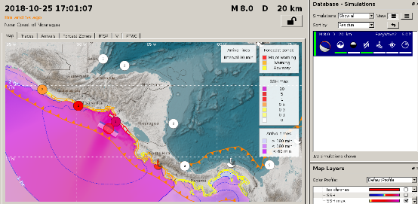
Figure 19. TOAST simulation of tsunami propagation of a magnitude 8.0 event off the Pacific coast of Nicaragua

TOAST module workflow. TOAST connects to the SeisComP3 system and waits for internal system messages with parameters of an incoming earthquake. In case a hypocenter and magnitude arrive, TOAST uses a formula from Wells & Coppersmith (1984) to generate the rupture size based on the magnitude. By default, the rupture area is centered around the epicenter, and strike and dip information are derived from preconfigured fault information. Once the rupture area is generated, the simulation plug-ins are activated.

EasyWave application for tsunami simulation. By default, TOAST uses the EasyWave (Babeyko, 2012) program (https://gitext.gfz-potsdam.de/id2/geoperil/easyWave ) an application used to numerically simulate tsunami generation and propagation in the context of early warning. It makes use of Graphics Processing Units (GPU) to considerably speed up the calculations. In the new versions of TOAST other applications can be used for the numerical simulation can be used as for instance HySEA (University of Malaga)

The rupture area can be placed at several preconfigured positions with respect to the hypocenter and simulations for several positions can be computed on the fly in parallel. As the earthquake information is changing over time, with each relevant update new simulations are automatically triggered. But, rupture areas can also be generated manually and simulations can be started using these.

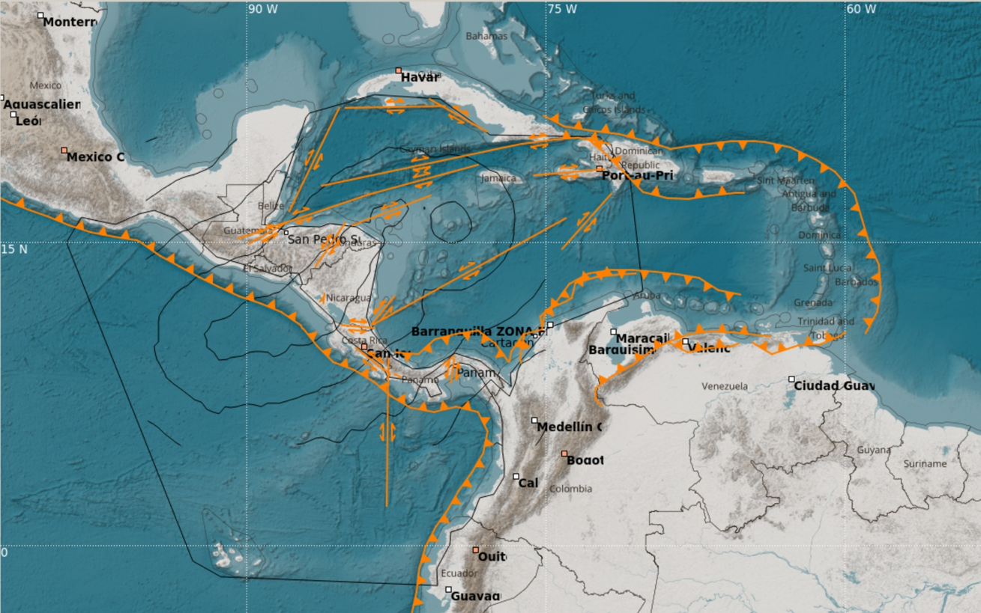

Figure 20. Plate boundaries with subduction process (yellow line with triangles) and other main faults (yellow line) in the CATAC monitoring area. When CMT is not yet known, TOAST uses a database of parameters of these faults as input for initial tsunami simulation

TOAST provides different perspectives showing the simulation results. The following features are shown:
- Simulated as a function of time Sea Surface Height
- Simulated sea surface height
- Simulated isochrones
- Simulated tsunami travel times
- Estimated tsunami arrivals
- Tsunami coastal wave height estimation.
- Observations of tsunami arrival through manual picking
- Observations of tsunami wave heights/periods by manual picking
- Points of interest and oceanographic sensors
- Failure information
- Rupture area
- Seismic parameters
- Simulation progress
- Simulation quality
- Newsletter

To verify the simulation results, TOAST provides a manual tsunami onset selector, which allows selection of arrivals, amplitudes and periods based on real-time sea gauge observations. The observed information is then used to calculate the quality of a scenario that represents the agreement between the simulated and observed values.

For example, the quality of oceanographic sensors is indicated by the color of the tide gauge symbol in the simulation widget. The simulation widget displays these quality parameters not only for tide gauge data, but also for epicenter location, depth, magnitude, comparison with preconfigured rupture mechanisms, and existing moment tensors. The quality information may change over time as it compares the simulation information with the actual information.

Use of HySEA. CATAC has routinely employed several computational programs, such as TUNAMI (Japan) and HySEA (Málaga, Spain), for numerical tsunami simulations, particularly in hazard assessment studies. Unlike EasyWave, which only estimates tsunami heights at offshore points near the coast—requiring extrapolation to approximate run‑up—HySEA can directly compute coastal inundation caused by tsunamis. Given HySEA’s advantages, CATAC has developed a script to couple it with TOAST, enabling the automatic generation of products such as inundation maps and videos for cities and larger settlements located closest to the earthquake’s epicenter.

Comparation Table between HySEA and EasyWave
Aspect | HySEA (Tsunami-HySEA) | EasyWave
Main function | Comprehensive numerical model for tsunamis generated by earthquakes | Fast simulator for tsunami generation and propagation
Stages covered | Generation (Okada model), oceanic propagation, and coastal inundation in a single code | Generation and propagation; does not include detailed coastal inundation
Speed | GPU “faster than real time” | GPU-accelerated, capable of simulating hours of propagation in seconds
Accuracy | High robustness and reliability; supports multiple fault planes and sequential ruptures | Good for initial forecasts, but less detailed in complex processes
Typical use | Warning centers requiring technical products (maps, videos, bulletins) with coastal detail | Quick “on the fly” forecasts within TOAST for initial evaluations
Key advantage | Comprehensive, scientifically validated simulation | Extreme speed for multiple scenarios and rapid re-evaluations

In new versions of TOAST, HySEA can be used directly without additional scripts (see TOAST HySEA documentation). In this way, CATAC will in the future employ HySEA in parallel with EasyWave, taking advantage of the strengths of both programs.

It is also noted that there are versions of HySEA capable of simulating tsunamis generated by sources other than earthquakes, such as landslides. which could be used by CATAC for the tsunami warning due to volcano induced landslides in Central America.

Interpretation of model results. The uncertainties associated with the tsunami propagation scenario database and numerical models come from the CMT solution, interpolation between neighboring scenarios, numerical modeling of the propagation, as well as Green's law extrapolation. Each uncertainty can result in large errors. For example, numerical forecasts can easily vary by a factor of two due to uncertainties in earthquake magnitude, depth and assumed mechanism; Green's Law is very sensitive to local topography and bathymetry, and the coastal amplitude could be over or underestimated by a factor of 2-3 depending on coastal features; the effect of wave dispersion is significant for distant tsunami propagation.

Therefore, to understand the numerical forecasts is very important for national receivers to correctly recognize tsunami hazards. Basically, CATAC interprets the numerical results by classifying them into several categories. In CATAC's Tsunami Advisory Products, the coastal amplitude forecast at each forecast point is classified into four threat levels of <0.3 m; 0.3-1 m, 1-3 m and above 3 m, which are illustrated with different colors along the coasts. The practice is the same as that of the PTWC New Enhanced Products.

    - Decision Support
.
The TOAST module of SeisComP provides ample graphical, tabular and text information for the decision support to be used by the 24x7 watch standers.

    - Product Creation and Dissemination

CATAC tsunami advisory products are issued when an earthquake with moment magnitude 6.5 or greater is detected in one of the CATAC Monitoring Areas.

Text bulletin. The Text bulletin is available to the public and NTWCs/TWFPs. Typically, the CATAC text product contains earthquake parameters, tsunami genic potential, tsunami amplitude and ETA forecasts for Coastal Forecast Points, tsunami observations and recommended actions. As the CATAC products are destinated for the Central American countries the messages are in Spanish language. English versions are sent only to the PTWC, NWPTAC, and other interested parties in the IOC/UNESCO domain. In most Central American countries local time is UT-6. Only n Panamá it is UT-5. CATAC uses three recipients lists, for the Central American countries the local times and UT are used. For the messages in English only UT is used.

Coastal Forecast Points. The estimated tsunami amplitudes and estimated times of arrival (ETA) are provided for coastal forecast points in the CATAC region. These coastal forecast points are points chosen by CATAC Member States. They correspond to coastal cities and tide gauge station sites. In the tsunami threat message, all forecast points with maximum amplitude greater than 0.3 meters are listed in groups according to Member States. Tsunami amplitude estimates are grouped into four clusters of <0.3 m; 0.3 to less than 1 m; 1 to 3 m; and greater than 3 m.

Tsunami Energy Map. The tsunami energy map gives the distribution of the maximum tsunami amplitude in the CATAC region color coded. The direction of the tsunami energy beam and the threatened areas can be easily identified by the different color. The tsunami travel time (TTT) contours are shown in light gray lines and are superimposed on the tsunami energy map.

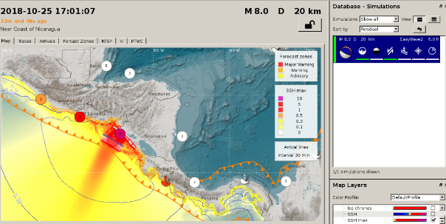
Figure 21. Tsunami energy radiance of a simulated event of magnitude 8.0
off the Coast of Nicaragua, created with TOAST.

Coastal Prediction Map The coastal forecast map provides a detailed view of the tsunami threat along the coasts of the CATAC region. It divides the CATAC coastlines into a series of modeling output sites. Each site is colored according to the tsunami amplitude corresponding to the model grid points closest to the site. The tsunami energy map is also overlaid in gray shading style with illuminated effect and in addition there are TTT contour lines placed.

2.2.5 Dissemination and Services

Computer Base. Messages are generated with GDS, QuakeLink and GIS, which are SeisComP modules that collect event information and disseminate template-based messages through various communication channels such as SMS, email, fax and web. Using plug-in technology, they import and filter seismic information from different sources before dissemination. GDS, QuakeLink and GIS complement SeisComP and TOAST functionalities in the area of notification and alert dissemination.
- Text messages are sent vía and graphic products including tsunami energy maps, coastal forecast maps are sent to NTWC/TWFPs in Central America via email, Whatsapp, Telegram, SMS (only text, in a short version), and are available on the password protected CATAC website.
- In Nicaragua short text messages are disseminated through the EWBS system of digital TV to many institutions and the general public, starting December 2021. In the other countries of the region with the EWBS system implemented, NTWC/TWFPs could follow this example.
- The earthquake Early Warning Messages are disseminated also with an Android app.
- The text messages are posted on CATAC's website for the general public, together with graphic material on the earthquake which generated the tsunami.

    - Timeline

The timeline of the combined automatic and manual processing is displayed in the following table. The times are only estimates:
(Abbreviations : SeisComP = SC, EEWS= Earthquake Early WarningSystem, ASS= AlertSeismicScript, TOAST= Tsunami Observation and Simulation Terminal, SCMT-SeisComP Moment Tensor Module, GDS= Gempa Dissemination Server, Graphical products: Maps of tsunami Energy Emission max SSH and Map of Coastal stripes Max SSH)

Table 3. Timeline

Time/ minutes | Occurrence / Actions
00 | An earthquake rupture initiated in the CATAC Monitoring Areas. P-and S-waves are leaving constantly from the rupture. (The rupture might take up to 3 minutes in total. So, first seismic and tsunami products might be sent out before the rupture finishes).
0-0.3 | SeisComP (SC) detects P waves with a minimum 4 seismic stations, computes a reliable location within 4 seconds and the initial magnitude only from P-waves
0-0.3 | EEW generates an EEW message and sends it automatically to recipients in Nicaragua - only if the magnitude is bigger than 4 and the epicenter lies in Central America. The smartphones emit a strong acoustic and visual warning only if the predicted seismic intensity at the location of the phone is bigger than V, or only a Notification is provided.
0.1-0.3 | TOAST detects the EEW message adds rupture parameters according SC fault data base and starts tsunami simulation. If on any coastal stripe in Central America the tsunami amplitude is estimated to exceed 0.3m a preliminary threat message is sent automatically to the recipients including the tsunami arrival time and amplitude. In the opposite a preliminary “No tsunami” information message is sent out.
0.5-2 | SC detects P and S waves at 15 or more stations, the hypocenter is located and computes a more reliable magnitude from S waves –  EEW sends automatically an info with only seismic parameters to the recipients, if magnitude is 5 or bigger. For magnitudes below 6.5 saying “no tsunami is possible”.
0.5-2 | TOAST automatically does tsunami simulations based on initial earthquake parameters adding rupture parameters according SC fault data base. Propagation is limited to 3h to reduce GPU processing to less than 10s.
2 | Operators revise automatic location and magnitude and confirm or produce a corrected manual solution.
3 | TOAST proposes the first CATAC tsunami text product based on information from real-time simulation along with updated preliminary earthquake parameters.  -The CATAC Watchstanders revise predicted impact hazard maps for coastal stripes  -accept the text - or – selects another (newer) or “higher hazard” estimate, judging from hazard map of coastal stripes
 | Another CATAC text product may be issued this way if the earthquake parameters change considerably in the first minutes.
5 | Operators divide work: one dedicates to SCMT, the other works with TOAST
8 | TOAST presents automatic or manual CMT solutions of SCMT which is to be revised by operator with TOAST maps and lists; The simulation in real time is recalculated again using CMT results and 3 hours propagation time. In this moment the watchstanders revise whether the earthquake has characteristics of a slow earthquake so that preliminary results might be completely wrong in terms of magnitude and tsunami amplitude parameters. This will be mentioned in the second message and the correct magnitude and the new simulation based on the Magnitude from CMT will be used.
10 | TOAST produces the second CATAC text product and graphical products based on real-time numerical simulation using CMT.
10 | An initial text product from PTWC might arrive at CATAC and is compared with CATAC´s products. Eventual corrections are made. Possible interaction CATAC-PTWC.
15 | Operator does other real time tsunami simulation with 4 hours tsunami propagation time; text and graphical products are sent to the recipients with the third message.
20 | A real time tsunami simulation is carried out again with 8 hours tsunami propagation time and the text and graphical products are sent to the recipients with the fourth message
30 | First tsunami arrivals are detected at sea gauges and informed to the recipients with a text message. Possibly a reinterpretation has to be carried out and a new product is to be sent to the recipients with the fifth message.
60 | More tsunami arrivals are detected at sea gauges and informed to the recipients.  Possibly a reinterpretation has to be carried out and product to be sent to the recipients
120 or more | Final product with text and graphical products with a possible cancellation of the tsunami threat with the final message

3. Products

  - Product Types and Criteria

    - Informational

CATAC issues seismological products for earthquakes above magnitude 5 that have occurred in the Area of Monitoring. In this case only a short tsunami note is given that this earthquake is too small to generate a tsunami. About 50 earthquakes with these characteristics occur within one year with these characteristics. These messages have beside the information also the function to test the messaging facilities of CATAC and to remember the existence of CATAC in between the occurrence of strong earthquakes.

CATAC issues products for moderate earthquakes with magnitudes between magnitude 6.5 and 7.0 that have occurred in the Area of Monitoring but that present no tsunami threat to the Area of Service. The reasons for excluding the possibility of a tsunami are given. For these earthquakes a numerical tsunami simulation is carried out and an estimate of the maximum wave heights at the Central American coasts are obtained but remain below 30 centimeters for all coastal areas. The values might be discussed with the NTWC´s by telephone or chat. These events might occur three times per year in the Area of Monitoring.

In some situations, an informational statement is sent out – for example in the case of a very distant source or when the tsunami threat to the Area of Service is still under evaluation. The latter may occur in the case of the occurrence of a slow earthquake where the initial magnitude determination is below 6 but later shows an increasing tendency.
.

    - Threat .

At the Twenty-fifth session of the ICG/PTWS (ICG/PTWS-XXV/3 rev.) held from 11 to 13 September 2013, all Member States agreed on a changeover to the PTWC New enhanced Products suite since 1 October 2014. As each Member State is sovereign and thus responsible for taking actions to ensure the safety of its own population, the PTWC New Enhanced Products no longer use levels of alert (i.e., watch and warning) to define the tsunami bulletins, and instead provide levels of threat based on numerical modelling. The levels of threat now are provided as expected maximum tsunami wave amplitudes relative to the tide within four categories which are: (i) less than 0.3 metre, (ii) 0.3 to less than 1 metre, (iii) 1 m to 3 metres, and (iv) greater than 3 metres.
The CATAC Tsunami Advisory Products stick to practice of PTWC, NWPTAC and SCSTAC to provide quantitative tsunami threat to recipients, rather than warning levels that are more meaningful for domestic warnings. According to numerical studies in the CATAC region, tsunamis may hit within few minutes, thus there are not much time left for emergency response. Basically, CATAC will send out the initial bulletin as soon as possible mainly based on the automatic estimate of preliminary earthquake parameters like location, magnitude and focal depth. Whether a Member State will be put into ‘threat area’ depends on the relatively conservative output of initial numerical simulations based on the initial earthquake parameters.
CATAC uses W-phase Centroid Moment Tensor analysis SCMT of SeisComP, which is typically available about 5-10 minutes after the earthquake, to trigger the numerical modelling. It´s important that the SCMT can yield a more accurate initial condition which is critical to tsunami modelling result. While SCMT analysis is appropriate for more distant or regional tsunami sources, for local tsunamis in Central America it might take too much time to provide the quantitative forecasts using this technique. Therefore, tsunami automatic simulation based on the preliminary earthquake parameters and assumption of the fault parameters from SeisComP fault data base, in combination with rapid tsunami models, will be adopted to evaluate coastal threat levels quantitatively in the subsequent bulletin that comes up 3-5 minutes after the first one. After that, the supplementary bulletins may be issued if a major earthquake magnitude revision occurs especially to avoid completely wrong results in case of the so-called slow earthquakes. Slow earthquakes have occurred twice in Central America and which produce very small seismic amplitudes in the higher frequencies which are recorded by accelerometers and short period sensors and are also the frequencies which are strongly felt by people and are causing destructions in buildings. CATAC will also run the high-resolution regional models when SCMT analysis is available, however the main purpose is to update and validate the preceding forecasting results.
New criteria adopted by CATAC. The time needed for tsunami simulation has been reduced enormously in the last years due to the use of new Graphical Processor Units (GPU) for the numerical simulation of the tsunami generation and propagation. A typical simulation for an earthquake near the coasts of Central America takes now only a few seconds. Therefore, CATAC was able to adopt new criteria for the number and the character of the bulletins emitted in their text messages. CATAC defines a simulated Tsunami Amplitude criteria which is the maximum amplitude at any costal forecast point in the area of responsibility of CATAC that means at the coast of Central America.
New Criteria Adopted by CATAC. In recent years, the time required for tsunami simulations has been drastically reduced thanks to the implementation of advanced Graphical Processing Units (GPUs). These GPUs accelerate the numerical modelling of tsunami generation and propagation, allowing simulations that once took minutes to be completed in just a few seconds. For example, a typical simulation of an earthquake occurring near the coasts of Central America can now be executed almost instantaneously. This technological advancement has enabled CATAC to adopt new criteria regarding both the number and the character of the bulletins issued in its official text messages. CATAC now applies a Simulated Tsunami Amplitude Criterion, defined as the maximum wave amplitude calculated at any coastal forecast point within its area of responsibility — namely, the coasts of Central America. This criterion ensures that bulletins are more precise, timely, and directly relevant to the populations at risk.

Bulletin type |  | Original simple Magnitude Criteria | Simulated Tsunami Amplitude  Criteria | Content | Timeline
Tsunami Information | Only one bulletin | Magnitude of 6.0-6.4;  or on land;  or depth≥100km | 0.3 m at any coastal forecast point in Central America | EQ parameters and statement of ‘No tsunami threat’ | 3-5 min
Tsunami Information | Only one bulletin unless costal forecast  Tsunami amplitude larger than 0.3m or  minor waves observed and should be reported | Magnitude of 6.5-7.0 | 0.3 m at any coastal forecast point in Central America | EQ parameters and statement of ‘No tsunami threat’ | 4-7 min
Tsunami Threat Message | Bulletin with quantitative forecast | ≥7.0 and shallow under water earthquake | 1 m at any coastal forecast point in Central America | EQ parameters and quantitative forecasts on threat level and Estimated Time of Arrival (ETA) | 8-15 min
Tsunami Threat Message | Supplementary with observations | ≥7.0 and shallow under water earthquake |  | EQ parameters, quantitative forecast and tidal gauge observations | If revision on EQ & tsunami forecasts, or observation available
Tsunami Threat Message | Final bulletin | ≥7.0 and shallow under water earthquake |  | Statement of ‘No tsunami confirmed or threat passed’ | hazardous waves have passed or no significant tsunami observations
Table 4. Criteria adopted by CATAC
In Tsunami Information or Tsunami Threat Message, the tsunamigenic potential is provided based on preliminary earthquake parameters as follows:
Magnitude (Mw)/  forecast amplitude FA | Tsunami Potential Description
6.0 ≤ M_{w} ≤ 7.0/  FA≤0.3m | There is no tsunami threat from this earthquake
7.1 ≤ M_{w} ≤ 7.5  FA≤1m | Possibility of a destructive local tsunami confined to 100-300 km of the epicentre
M_{w}≥7.6  FA≤1m | Possibility of a destructive basin-wide tsunami
Table 5. Tsunamigenic potential adopted by CATAC
As the numerical tsunami simulation with the new Graphical Processing Units GPU are now so much faster than in the initial phase of CATAC it is now possible to repeat the simulation with different duration of the tsunami propagation and estimate the wave height in the coastal areas after more than 8 hours. Experience has shown that in case of very large earthquakes in Southern Mexico the maximum tsunami reached the Pacific coasts of Central America around 10 hours after the earthquake.

  - Product Content

    - Text Products
.
Basic considerations. The messages from PTWC are sent in English and use wording which seem to have some legal background to be considered in the United States. Original discussions in Central America about CATAC products highlighted the interest to receive shorter and concise messages in Spanish language without much technical and legal wordings. This is especially important for users in the civil protection agencies as their personnel frequently lacks sufficient knowledge of the English language or of scientific terms. Thus, the text messages of CATAC are short and concentrate on the presentation of the general threat estimate or on the threat levels for the different coastal stripes of the countries.

Interpretation of the model results. Uncertainties associated with the tsunami propagation scenario database and numerical models come from the SCMT solution, the interpolation among neighboring scenarios, numerical modelling of propagation, as well as Green’s Law Scaling. Each uncertainty could result in large errors. For example, numerical forecast results can vary easily by a factor of two because of uncertainties in the earthquake magnitude, depth and assumed mechanism; Green’s Law is very sensitive to local topography and bathymetry, coastal amplitude could be over- or under-estimated by a factor of 2-3 depending on coastal features; wave dispersion effect is non-negligible for distant propagation of tsunami wave.

  - Graphical Products

To properly comprehend numerical forecasts, it is essential for national recipients to correctly recognize tsunami threats. In practice, tsunami service providers across the Pacific—such as PTWC, NWPTAC, SCSTACC and CATAC—interpret numerical outputs by classifying them into distinct categories. For example, the PTWC’s New Enhanced Products present coastal amplitude forecasts at each forecast point using four threat levels:
- less than 0.3 m,
- between 0.3 and 1 m,
- between 1 and 3 m, and
- more than 3 m

These categories are visually represented with different colors along the coastlines, making the threat levels easier to interpret and communicate.

- Dissemination

  - Methodologies

    - Dissemination of Products

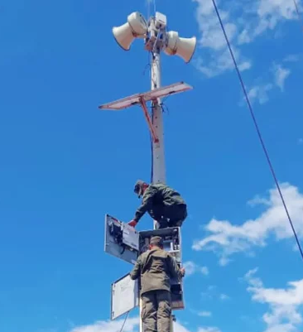
Nicaragua. In Nicaragua, sirens are the main system to disseminate the warnings of CATAC to the coastal population. Since 1915, there are 60 sirens installed in the communities at the Pacific coast. Twenty additional sirens were installed, in 2022, in communities along the Caribbean coast that means there are now in total 80 sirens installed on both coasts. Most of the coastal population is in reach of the acoustic signals emitted from this system as typical siren sound or speech “Alerta de tsunami!”. Thus, the vast majority of the entire population under tsunami danger can receive CATAC warnings by this means. The sirens are controlled by the Civil Defense organization of the Nicaraguan Army via a digital VHF radio system. After receiving a warning message, they activate by pressing a single switch or using a computer all sirens of a coast or part of them. While the system was installed for tsunamis warning the sirens can also be used for other emergencies. Each siren can also be activated locally if necessary. The sirens a completely independent from commercial electrical power as each device has a solar panel and a battery. The siren system is maintained by the Civil Defense of Nicaragua.
Photo 8. Maintenance of a tsunami siren
Taken from https://www.canal4.com.ni/defensa-civil-da-mantenimiento-a-sistema-de-sirenas-de-alerta-temprana/

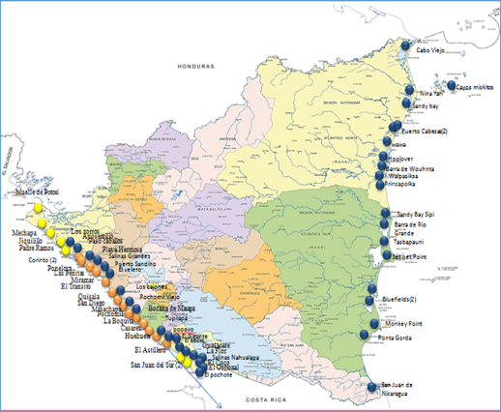
Figure 22. Location of sirens on the Pacific and Caribbean coasts of Nicaragua.

Sirens in other Central American countries. The installation of sirens has also begun in the other Central American countries but up to the moment no other country has reached the completeness of the siren system as in Nicaragua.

Development and test of a cellphoneapp for tsunami warning. CATAC has developed for Android cellphones a real-time application for tsunami warning and evacuation route information in the Pacific coastal areas of Nicaragua. The message of CATAC is transmitted to cellphones and the application presents the position of the user according its GPS in a map where the coastal strip is coded according the tsunami hazard, together with routes to safe places. The app is not yet in regular use.

Early Warning Broadcasting System of the digital TV. CATAC participates in a massive experiment on the use Early Warning Broadcasting System of the digital TV for the transmission of warning messages to the public which is going on in Nicaragua, El Salvador, Costa Rica and Guatemala since 2022.

Direct Computer-Computer messaging. CATAC uses software modules of SeisComP to communicate its products to institutional users in Nicaragua. A SeisComP SCESV module is run on small computers (eg. Raspberry Pi) to present real time graphs of the earthquake processing. That way Nicaragua for many years in the Monitoring and Situation rooms of SINAPRED and Civil Defense.

Delivery of products to the costumers in other Central American countries
Email - CATAC´s texts and graphical products are sent to its regional customers using email. The messages are sent out using INETER´s mailserver. If there is found a problem with this server, the sending out is switched to the use of the Google mailserver GMAIL.

Whatsapp – CATAC sends out messages manually to existing Whatsapp groups. The message is send automatically using an API to a limited number of recipients, the official contact list from COI/UNESCO plus some additional contacts.

Telegram –Telegram is used, since 2021, for sending out CATACs messages automatically to users in Nicaragua. Since 2025, CATAC has also the capacity to send these messages to regional users in Central America.

SMS – shortened text messages are also sent via SMS to the recipients with reference to CATACs website and the messages by email, Whatsapp and Telegram.

Website - The seismic and tsunami products are published in CATAC´s website http://catac.ineter.gob.ni.

Direct Computer-Computer messaging.. CATAC uses software modules of SeisComP to communicate its products to institutional users in Central America as described above for Nicaragua. To the seismic observatories in Central America, often the NTWC´s, CATAC offered to import the CATAC numerical solutions (that means earthquake locations, magnitudes, phase pickings, time residuals, etc.) directly via Internet in their own SeisComP system. That way they can check them or merge the results immediately with their own results or even adopt CATAC´s results and use them for their needs. With the same method CATAC can also import their solutions. This is completely automatic and an extremely fast way to exchange results. The comparison of the results of other observatories may diminish the possibility of gross interpretation errors. As the PTWC started recently to use SeisComP CATAC can also use these modules can also to be used for the direct exchange of products and data.

Any other TSP/NTWC/TWFP could use SeisComP to receive CATAC products using the gratis version of SeisComP with a simple and extremely cheap computer, as for instance Raspberry PI. CATAC can provide Memory cards for these computers with the Linux operating system and a small version of SeisComP preinstalled which will present the texts and graphical products as maps and videos as well acoustic warnings or voice messages on a computer screen or a TV using an HDMI cable.

    - Customer Decision Support

CATAC staff reaches out to customers, i.e. seismological or tsunami observatories and civil protection agencies, during events to ensure they are aware of a tsunami situation and check whether they have received the TSP products issued. CATAC also provides additional information to help with customer decision-making Voice Calls using ordinary or cell phone calls or Whatsapp calls and Whatapp chats.

CATAC maintains a contact list of their customers which can be used to call them in case of an emergency.

Non routine phone calls and chats were in the past ad-hoc and voluntary depending on staff availability, mainly from CATAC´s director but CATAC has started to transmit its threat messages via Whatsapp.

Voice Calls. In case of necessity CATAC makes calls using ordinary or cell phones or Whatsapp with official contacts of the IOC/UNESCO list These calls are done normally by one of the leaders of CATAC but any 24x7 operator is qualified to make these calls. For

Chats via Whatsapp The most common social network for chatting in Central America is Whatsapp. CATAC started using it in 2025 with official contacts or relevant individuals well known by the CATAC. As CATAC has a close cooperation with the institutions in Central America there is also the possibility to communicate with key persons who are not on the official lists.

Whatsapp Chats with groups of users. CATAC text messages and graphical products are sent to regional or national Whatasapp user groups, as for instance “Tsunami Centroamérica”, “Tsunamis Centroamericanos”, which comprise personal of NTWCs in the region and “Comité de Tsunami Panama” integrating personal related to tsunami warning and mitigation in Panama.

Whatsapp, Telegram and SMS chats to NTWC and NTFP and other TSP. Since 2026 CATAC is able to send out its tsunami text and graphical products routinely with these media. The first ample application was the use in the exercise CARIBE WAVE2026.

  - Communication Testing

As of April 2026, CATAC is sending out once per month a short test message which has not to be answered by the recipient.

Supervision of seismic data streams. CATAC is receiving continuously data streams from most of the NTWC´s in Central America, the exception is only SINAMOT in Costa Rica which does no has own seismic processing. If CATAC observed that data streams might have suffered it will take measures with the corresponding institution to solve the problem.

Supervision of seismic information messages. CATAC interchanges, several times per day, email messages about small earthquakes with the NTWC´s as seismological observatories. As soon as CATAC receives notes from the email client that certain messages could not be delivered, the institution is contacted by other means to investigate and solve the problem.

4.3 Conducting Regional Tsunami Exercises

In the experimental phase, CATAC co..nducted two exercises for Central American countries:

- Mega earthquake in the subduction zone between Guatemala, El Salvador and Nicaragua.
Date of exercise 1: 08/19/2019
Earthquake parameters:
Magnitude 8.6, with a complex source that would generate a maximum possible tsunami in Central America of more than 20 m in height.

The modeling was done with SeisComP TOAST, in "real time".

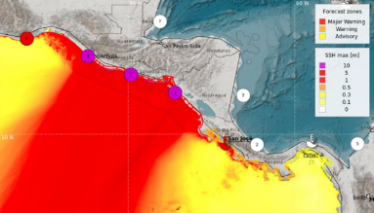
Figure 23. Tsunami map of exercise with M8.6 EQ.

- Slow earthquake of magnitude 7.6 off the Gulf of Fonseca
Exercise date 2: 11/11/2020
Earthquake parameters: M 7.6, slow earthquake and tsunami impacting El Salvador, Honduras and Nicaragua, Honduras, Nicaragua)
Modeling with: SeisComP TOAST
This exercise was conducted under COVID-2019 conditions.

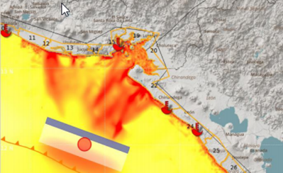
Figure 24. Tsunami map of exercise 2.

Other planned exercises were cancelled due to the Covid 2019 crisis.

In Nicaragua, CATAC participates 4 times per year in the multihazard exercises of the National System for the Disaster Prevention (SINAPRED).

Furthermore CATAC participates in the CARIBEWAVE and PACIFICWAVE exercises.

  - Capacitation

4.3.1 Capacitation of CATAC personnel

During the development of CATAC the following capacitation measures were carried out:

One-year Seismology Course at UNAN University. In 2015-2016 CATAC´s personnel who previously had no degree in Earth sciences (but in other fields as engineering, IT, Computer science, etc.) were trained on seismology at the UNAN university in Managua.

Master´s degrees on Earthquake and Tsunami and disaster prevention. Seven CATAC personnel have obtained their master´s degree on Earthquake and Tsunami sciences at GRIPS in Japan in Japan. Three of CATAC´s personnel have obtained a Master´s degree on Disaster prevention, including seismology, at University UNAN in Managua.

Courses about SeisComP. All CATAC personnel received several courses on the processing of Earthquakes and Tsunami with the SeisComP software system within the CATAC project 2016-2019 with JICA on the enforcement of CATAC. Also, the Project with the Swiss technical cooperation on Earthquake Early Warning 2015-2025 carried out capacitation measures on SeisComP.

Capacitation for the 24x7 duty. New CATAC personnel who is pretended to work as watch standers in the 24x7 shifts must undergo personal training which is run by already experienced watch standers. They participate around half a year in the daytime shifts to acquire experience in the routine procedures of CATAC.

CATAC supports SINAPRED which integrates all relevant institutions in Nicaragua in the capacitation of its personnel on earthquake and tsunamis disaster prevention

4.3.2 Capacitation of personnel from Central América institutions
Between 2016–2019, CATAC supported training for scientific institutions (NTWC) and civil protection agencies (TWFP) through UNESCO projects on Standard Operating Procedures (SOPs). As CATAC was not yet an official provider, only PTWC was included in the SOPs.
The process was interrupted by COVID-19, which restricted institutional activities and visits.
From March–June 2023, CATAC, with JICA and CEPREDENAC, organized 17 webinars across Central America, Belize, and the Dominican Republic to present procedures, products, and national protocols.
CATAC assisted by JICA/Japan started a new training project (2023–2026). JICA launched the “Third Country Course” in September 2023, held virtually and in person in Nicaragua, to train key personnel and promote regional exchange. The course was repeated in 2024 and 2025 and will run again in 2026.
CATAC staff also visited institutions in Guatemala, El Salvador, Honduras, Costa Rica, Panama, Belize, and the Dominican Republic in 2023–2025 to strengthen use of CATAC products and ensure inclusion in regional SOPs.
ANNEXES

- Example Products

I.1 Example of Text products

Notre: These examples were generated in English for the Exercise CARIBEWAVE 25 and are used here in the Report to be published in this language. The messages transmitted in real events to the users in Central America are formulated in Spanish. The Spanish version of the present report contains these examples in this language.

CATAC Message #1:
********************************************************************************

Central America Tsunami Advisory Center - CATAC

NOTICE : This message is published for information purposes only in support of Central American countries. National authorities are responsible for determining the level of alert and for taking appropriate measures for their country.

Tsunami Bulletin N° 01

Issued: 2025-03-20 09:03 Central American Time
2025-03-20 10:03 Panama Time
2025-03-20 15:03 UTC Time

An earthquake has occurred with the following these preliminary parameters:

Magnitude : 8.0
Date : 20/03/2025
Time : 09:00 Central American Time,
: 10:00 Panama Time, 15:00 UTC Time
Latitude : 18.20 N
Longitude : 75.37 W
Depth : 25 Km
Location : Jamaica Region

Assessment:
There is a high possibility of tsunami considering the magnitude, depth of the hypocenter, and the location of the earthquake.

Recommended Actions:

Immediate actions are urgently needed for the protection of the population on the Caribbean coasts of Central America.
More information will be provided in the next few minutes.

*************************************************************************************
CATAC Message #2:
*************************************************************************************

Central America Tsunami Advisory Center - CATAC

NOTICE : This message is published for information purposes only in support of Central American
countries. National authorities are responsible for determining the level of
alert and for taking appropriate measures for their country.

Tsunami Bulletin N° 02

Issued: 2025-03-21 09:09 Central American Time
2025-03-21 10:09 Panama Time
2025-03-21 15:09 UTC Time

An earthquake has occurred with the following parameters:

Magnitude : 8.0
Date : 20/03/2025
Time : 09:00 Central American Time,
: 10:00 Panama Time, 15:00 UTC Time
Latitude : 18.20 N
Longitude : 75.37 W
Depth : 25 Km
Location : Jamaica Region

Evaluation:

According to the analysis of the Moment Tensor of the earthquake there is a major possibility that a tsunami may have been produced which would affect with greater intensity the nearest coasts, about 100 km from the epicenter of the earthquake.
Authorities should take actions corresponding to their response plans

Tsunami simulation results:

Estimated Time of Arrival (ETA) in local time, Status and Maximum Height (AM) of tsunami waves, at different forecast points:

Site Country ETA (Local Time= Status AM(m)
ISLA GRANDE PANAMA 2025-03-20 11:45:30 Threat 1.45
TURTLE ISLAND PANAMA 2025-03-20 11:45:00 Threat 1.28
COLON PANAMA 2025-03-20 11:53:00 Threat 1.22
SAN BLAS PANAMA 2025-03-20 11:50:30 Threat 1.11
LIMON COSTA RICA 2025-03-20 11:13:00 Threat 0.93
VERAGUAS PANAMA 2025-03-20 12:13:30 Threat 0.92

Graphical result:

Review in the attachment to this message, the color-coded forecast zones according to hazard,for the Caribbean Sea coastal areas of Central America according to our numerical tsunami simulations.

Updates:

More information will be provided in the next few minutes.

Countries may additionally receive messages from the Pacific Tsunami Warning Center (PTWC). In case of differences between 2024 and PTWC results, we recommend conservatively,the estimates that correspond to a higher hazard.

Additional information:

Detailed earthquake and tsunami information can be found at the website.
www.catac.ineter.gob.ni

*************************************************************************************
CATAC Message #3
*************************************************************************************
Central America Tsunami Advisory Center - CATAC

NOTICE : This message is published for information purposes only in
support of Central American countries. National authorities
are responsible for determining the level of alert and for
taking appropriate measures for their country.

Tsunami Bulletin N° 03

Issued: 2025-03-20 09:30 Central American Time
2025-03-20 10:30 Panama Time
2025-03-20 15:30 UTC Time

A tsunami warning is in effect for the coastal areas of Central American countries.

An earthquake has occurred with the following parameters:

Magnitude : 8.0
Date : 20/03/2025
Time : 09:00 Central American Time,
: 10:00 Panama Time, 15:00 UTC Time
Latitude : 18.20 N
Longitude : 75.37 W
Depth : 25 Km
Location : Jamaica Region

Evaluation:
Due to magnitude, depth and location of the earthquake there is a possibility that a tsunami may have been produced which would affect with greater intensity the closest coasts, about 100 km from the epicenter of the earthquake.
Authorities should take actions corresponding to their response plans.

Tsunami simulation results:
Estimated Time of Arrival (ETA) in local time, Status and Maximum Height (AM) of tsunami waves, at different forecast points:

Site Country ETA (Local Time) Status AM(m)
ISLA GRANDE PANAMA 2025-03-20 11:45:30 Threat 1.45
TURTLE ISLAND PANAMA 2025-03-20 11:45:00 Threat 1.28
COLON PANAMA 2025-03-20 11:53:00 Threat 1.22
SAN BLAS PANAMA 2025-03-20 11:50:30 Threat 1.11
LIMON COSTA RICA 2025-03-20 11:13:00 Threat 0.93
VERAGUAS-CARIBE PANAMA 2025-03-20 12:13:30 Threat 0.92

Graphical result:

Review in the attachment to this message, the color-coded forecast zones according to hazard,and wave heights, for the Caribbean Sea coastal areas of Central America estimated with numerical tsunami simulations.

Sea level station measurements:

Code Coordinates Country ETA (Local Time) AM(m)
VZ..ELPO 09.56°N 78.95°O Panamá 2025-03-20 09:21 1.50
VZ..BDTO 09.35°N 82.26°O Panamá 2025-03-20 09:56 1.30
VZ..LIMON 09.99°N 83.02°0 Costa Rica 2025-03-20 10:21 0.80

Updates:
More information will be provided in the next few minutes.

Countries may additionally receive messages from the Pacific Tsunami Warning Center (PTWC).
In case of differences between CATAC and PTWC results, we recommend conservatively, the estimates that correspond to a higher hazard.

Additional information:
Detailed earthquake and tsunami information can be found at the website.
http://catac.ineter.gob.ni/

*************************************************************************************
CATAC Message #4:
*************************************************************************************

Central America Tsunami Advisory Center - CATAC

NOTICE: This message is published for information purposes only in
support of Central American countries. National authorities
are responsible for determining the level of alert and for
taking appropriate measures for their country.

Tsunami Bulletin N° 04

Issued: 2025-03-20 10:00 Central American Time
2025-03-20 11:00 Panama Time
2025-03-20 16:00 UTC Time

A tsunami warning is in effect for the coastal areas of Central American countries.

An earthquake has occurred with the following parameters:

Magnitude : 8.0
Date : 20/03/2025
Time : 09:00 Central American Time,
: 10:00 Panama Time, 15:00 UTC Time
Latitude : 18.20 N
Longitude : 75.37 W
Depth : 25 Km
Location : Jamaica Region

Evaluation:

A tsunami was produced which affects or will affect the Caribbean coasts of Panama and Costa Rica.
Authorities should take actions corresponding to their response plans.

Tsunami simulation results:

Estimated Time of Arrival (ETA) in local time, Status and Maximum Height (AM) of tsunami waves, at different forecast points:

Site Country ETA (Local Time) STATUS AM(m)
ISLA GRANDE PANAMA 2025-03-20 11:45:30 Threat 1.45
TURTLE ISLAND PANAMA 2025-03-20 11:45:00 Threat 1.28
COLON PANAMA 2025-03-20 11:53:00 Threat 1.22
SAN BLAS PANAMA 2025-03-20 11:50:30 Threat 1.11
LIMON COSTA RICA 2025-03-20 11:13:00 Threat 0.93
VERAGUAS-CARIBE PANAMA 2025-03-20 12:13:30 Threat 0.92

Sea level station measurements obtained:

Code Coordinates Country ETA (Local Time) AM(m)
VZ..ELPO 09.56°N 78.95°O PANAMA 2025-03-20 09:21 1.50
VZ..BDTO 09.35°N 82.26°O PANAMA 2025-03-20 09:56 1.30
VZ..LIMON 09.99°N 83.02°0 COSTA RICA 2025-03-20 10:21 0.80

Updates:

More information will be provided in the next few minutes.

Countries may additionally receive messages from the Pacific Tsunami Warning Center (PTWC).
In case of differences between CATAC and PTWC results, we recommend conservatively,the estimates that correspond to a higher hazard.

Additional information:

Detailed earthquake and tsunami information can be found on the website.
http://catac.ineter.gob.ni/

*************************************************************************************
CATAC Message #5:
*************************************************************************************

Central America Tsunami Advisory Center - CATAC

NOTICE: This message is published for information purposes only in
support of Central American countries. National authorities
are responsible for determining the level of alert and for
taking appropriate measures for their country.

Tsunami Bulletin N° 05

Issued : 2025-03-20 11:00 Central American Time
2025-03-20 12:00 Panama Time
2025-03-20 17:00 UTC Time

An earthquake has occurred with the following parameters:

Magnitude : 8.0
Date : 20/03/2025
Time : 09:00 Central American Time,
: 10:00 Panama Time, 15:00 UTC Time
Latitude : 18.20 N
Longitude : 75.37 W
Depth : 25 Km
Location : Jamaica Region

Evaluation: A tsunami was generated which affects the Caribbean coasts of Panama and Costa Rica.
Observed Time of Arrival (ETA) in local time and Maximum Height (AM) of tsunami waves observed.

Code Coordinates Country ETA (Local Time) AM(m)
VZ..ELPO 09.56°N 78.95°O PANAMA 2025-03-20 09:21 1.50
VZ..BDTO 09.35°N 82.26°O PANAMA 2025-03-20 09:56 1.30
VZ..LIMON 09.99°N 83.02°0 COSTA RICA 2025-03-20 10:21 0.80
VZ..COIS 12.33°N 83.02°O NICARAGUA 2025-03-20 10:42 0.30

Assessment:
According to our simulations, higher amplitudes could occur in the next few hours.
The national authorities of the different countries should make the appropriate decisions,according to their response plans.

PTWC messages:
Countries may additionally receive messages from the Pacific Tsunami Warning Center (PTWC).
In case of differences between CATAC and PTWC results, we recommend preferring conservatively,the estimates that correspond to a higher hazard.

I.2. Examples of CATAC graphic products

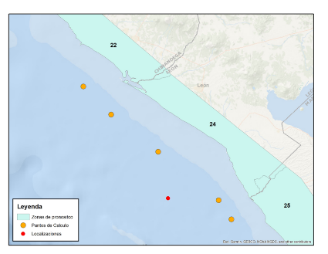
Figure 25. Coastal blocks and forecast points on the coast. Forecast points at 50 m depth. Definition of forecast zones at departmental level. Maximum values obtained for 70 forecast zones. For 130 forecast points on the Pacific and Caribbean coast.

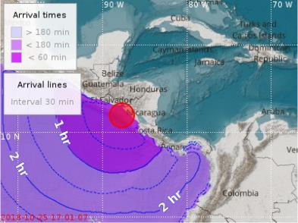

Figure 26. CATAC Tsunami arrival time forecast.

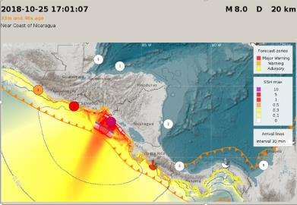
Figure 27. CATAC Tsunami coastal amplitude forecast.

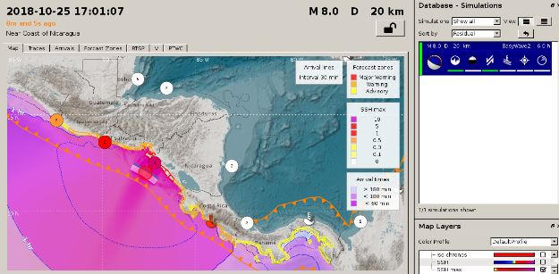

Figure 28. CATAC Deep-sea tsunami amplitude forecast.

Example of Text Message generated by TOAST at CATAC

Magnitude : 8.0 Mw
Date : 10/25/2018
Time : 17:01:07 UTC
Latitude : 11.98 N
Length : 87.69 W
Depth : 20 Km
Event ID toast2018vamnlx M
Location : Near Coast of Nicaragua
Evaluation:
There is a Tsunami Possibility in the Following Areas:
-----------------------------------------------------------------------------------
T2 T1 T3 T4 Status Height COUNTRY
------------------------------------------------------------------------------------
2018-10-25 17:46:37 2018-10-25 17:01:07 2018-10-25 17:54:07 2018-10-25 23:01:07 Tsunami 5.08m NICARAGUA LEON
2018-10-25 17:47:37 2018-10-25 17:01:07 2018-10-25 21:44:37 2018-10-25 23:01:07 Tsunami 3.49m NICARAGUA CARAZO
2018-10-25 17:50:37 2018-10-25 17:01:07 2018-10-25 20:28:37 2018-10-25 23:01:07 Tsunami 3.03m NICARAGUA MANAGUA
2018-10-25 17:52:07 2018-10-25 17:01:07 2018-10-25 18:06:07 2018-10-25 23:01:07 Tsunami 3.03m NICARAGUA CHINANDEGA
2018-10-25 17:55:07 2018-10-25 17:01:07 2018-10-25 20:05:07 2018-10-25 23:01:07 Tsunami 2.51m NICARAGUA RIVAS
2018-10-25 18:55:07 2018-10-25 17:01:07 2018-10-25 22:53:07 2018-10-25 23:01:07 Tsunami 2.24m HONDURAS TIGER ISLAND
2018-10-25 18:19:37 2018-10-25 17:01:07 2018-10-25 18:46:07 2018-10-25 23:01:07 Tsunami 2.13m EL SALVADORCONCHAGUITA
2018-10-25 18:32:37 2018-10-25 17:01:07 2018-10-25 19:19:37 2018-10-25 23:01:07 Tsunami 2.11m EL SALVADORLA UNION
2018-10-25 17:42:37 2018-10-25 17:20:29 2018-10-25 21:16:07 2018-10-25 23:01:07 Tsunami 2.08m COSTA RICA GUANACASTE
2018-10-25 19:22:37 2018-10-25 17:08:23 2018-10-25 19:54:07 2018-10-25 23:01:07 Tsunami 2.01m HONDURAS VALLEY
2018-10-25 18:04:07 2018-10-25 17:01:07 2018-10-25 19:53:37 2018-10-25 22:37:07 Tsunami 1.97m EL SALVADORUSULUTLAN
2018-10-25 18:20:37 2018-10-25 17:01:07 2018-10-25 18:50:07 2018-10-25 22:45:37 Tsunami 1.95m EL SALVADORMEANGUERA DEL GOLFO
2018-10-25 17:53:37 2018-10-25 17:01:07 2018-10-25 21:43:37 2018-10-25 22:52:37 Tsunami 1.92m EL SALVADORSAN MIGUEL
2018-10-25 18:08:07 2018-10-25 17:04:07 2018-10-25 18:15:07 2018-10-25 22:57:37 Tsunami 1.90m EL SALVADORSAN VICENTE
2018-10-25 18:11:07 2018-10-25 17:12:35 2018-10-25 22:41:07 2018-10-25 23:01:07 Tsunami 1.90m EL SALVADORLA PAZ
2018-10-25 19:24:37 2018-10-25 17:01:07 2018-10-25 22:27:07 2018-10-25 23:01:07 Tsunami 1.87m HONDURAS CHOLUTECA
2018-10-25 18:34:07 2018-10-25 17:01:07 2018-10-25 18:39:37 2018-10-25 23:01:07 Tsunami 1.62m EL SALVADORISLA PUNTA ZACATE
2018-10-25 18:12:07 2018-10-25 17:01:07 2018-10-25 18:57:37 2018-10-25 22:54:07 Tsunami 1.48m NICARAGUA FARALLONES OF COSIGUINA
2018-10-25 18:00:37 2018-10-25 17:35:43 2018-10-25 22:08:37 2018-10-25 22:51:07 Tsunami 1.45m EL SALVADORLA LIBERTAD
2018-10-25 19:46:07 2018-10-25 17:48:29 2018-10-25 21:32:07 2018-10-25 23:01:07 Tsunami 1.25m GUATEMALA SANTA ROSA
2018-10-25 18:10:37 2018-10-25 17:59:35 2018-10-25 18:17:37 2018-10-25 22:48:37 Tsunami 1.16m GUATEMALA JUTIAPA
2018-10-25 18:11:37 2018-10-25 17:57:59 2018-10-25 18:15:07 2018-10-25 22:03:07 Tsunami 1.04m EL SALVADORAHUACHAPAN
2018-10-25 20:25:37 2018-10-25 18:13:05 2018-10-25 20:17:07 2018-10-25 23:01:07 Tsunami 1.03m GUATEMALA SUCHITEPEQUEZ
2018-10-25 18:00:07 2018-10-25 17:48:44 2018-10-25 22:46:37 2018-10-25 23:01:07 Tsunami 1.00m EL SALVADORSONSONATE
2018-10-25 18:20:07 2018-10-25 17:48:13 2018-10-25 22:56:37 2018-10-25 23:01:07 Tsunami 0.71m GUATEMALA ESCUINTLA
2018-10-25 18:12:37 2018-10-25 17:58:53 2018-10-25 18:43:37 2018-10-25 21:18:07 Tsunami 0.64m COSTA RICA COCOS ISLAND
2018-10-25 17:44:37 2018-10-25 17:35:17 2018-10-25 20:37:07 2018-10-25 23:01:07 Tsunami 0.64m COSTA RICA PUNTARENAS
2018-10-25 22:49:37 2018-10-25 18:15:35 2018-10-25 22:57:37 2018-10-25 22:54:37 Tsunami 0.58m GUATEMALA SAN MARCOS
2018-10-25 22:22:07 2018-10-25 17:47:29 2018-10-25 22:51:07 2018-10-25 23:01:07 Tsunami 0.56m COSTA RICA PUNTARENAS

- NTWC and TWFP in Central America

- NTWC and other institutions responsible for scientific monitoring to which CATAC sends tsunami products from and from which CATAC receives seismic and geophysical data

1.1 Nicaragua. The Nicaraguan Institute for Territorial Studies (INETER) is the geophysical institution in Nicaragua to which CATAC belongs. CATAC cooperates closely with the Geophysical, Meteorological and Water Resources Departments of INETER on dangerous volcanic, coastal and weather phenomena. For Nicaragua, CATAC itself acts as NTWC issuing messages to the Government of Nicaragua, the Emergency Operations Centers (CODE) of the National System for Disaster Prevention, Mitigation and Response (SINAPRED) and to the Civil Defense of the Nicaraguan Army according to the national SOPs of Nicaragua. CATAC directly sends Earthquake and Tsunami messages to the population.

1.2 El Salvador: Ministry of Environment and Natural Resources (MARN), General Directorate of the Environmental Observatory (MARN-DGOA). CATAC is interchanging seismic data with MARN-DGOA.

1.3 Guatemala: National Institute of Seismology, Volcanology, Meteorology and Hydrology (INSIVUMEH). CATAC is interchanging seismic data with INSIVUMEH.

1.4 Honduras: a) Permanent Contingency Commission (COPECO). In Honduras there is no large scientific institution with the capacity to evaluate the tsunami threat. COPECO has a scientific branch which maintains the national seismic network. b) Geophysical Institute, University of Honduras. Maintains the seismic network of UNAH which cooperates closely with the seismic network of COPECO. CATAC interchanges seismic data with both networks

1.5 Costa Rica: National System for Tsunami Monitoring (SINAMOT) at the National University (UNA). SINAMOT receives seismological products from the Volcano and Earthquake Observatory of Costa Rica ( (OVSICORI, at UNA) and the National Seismic Network (RSN, Universidad de Costa Rica). CATAC is interchanging seismic data with OVSICORI and RSN.

1.6 Panama: a) Institute of Geosciences of the University of Panama (IGC-UPA) which is de facto the NTWC of the country; CATAC is interchanging seismic waveform with IGC.
b) Authority of the Panama Canal (ACP) CATAC is interchanging sea gauge data with ACP
c) Baru Seismic Network (private institution) interchanges seismic data mainly from Western Panamá with CATAC.

- TWFP or Organizations in charge of issuing Tsunami Warnings to the population and to organize the tsunami hazard mitigation measures, to which CATAC sends seismic and tsunami products.

2.1 Nicaragua: a) CATAC/INETER itself directly sends Earthquake and Tsunami messages to the population.
b) National System for Disaster Prevention, Mitigation and Response (SINAPRED). CATAC is integrated in the SINAPRED and sends seismic and tsunami messages to the Secretariate and the Centers of Operation CODE of SINAPRED. c) Civil Defense of the Nicaraguan Army,

2.2 El Salvador: Ministry of the Interior, General Directorate of Civil Protection and Disaster Prevention and Mitigation (DGPC).

2.3 Guatemala: National Coordinator for Disaster Reduction (CONRED).

2.4 Honduras: Permanent Contingency Commission (COPECO)

2.5 Costa Rica: National Commission for Risk Prevention and Emergency Attention (CNE).

  - Panama: National Civil Protection System (SINAPROC).

- Regional institution related to disaster prevention including tsunamis
CEPREDENAC (Center for Disaster Prevention in Central America y República Dominicana)
Coordination of disaster prevention measures and the establishment of a common politics on disaster prevention and mitigation in Central America
Receives CATAC messages, it is planned to integrate CATAC products in their Website.

- Observation Sites

A table of the observation sites used by CATAC can be obtained from its webpage http://catac.ineter.gob.ni .

- IOC Recognized Tsunami Service Providers

Center (Acronym) | Full Name | Host Institution | Location | Countries / Regions Served
PTWC | Pacific Tsunami Warning Center | NOAA | Honolulu, Hawaii, USA | Hawaii; Guam; American Samoa; Northern Mariana Islands; Puerto Rico; U.S. Virgin Islands; British Virgin Islands; advisory services to 46 Pacific nations and territories.
PTWC  TSP function covered by PTWS | Caribbean Tsunami Warning and Mitigation System (regional TSP network) | Multiple national agencies under IOC/CARIBE-EWS | Honolulu, Hawaii, USA | All CARIBE-EWS Member States and territories in the Caribbean basin (32+ countries/territories, and dependent territories).
NTWC  Serves also as backup for PTWC | National Tsunami Warning Center | NOAA | Palmer, Alaska, USA | Continental United States (West Coast), Alaska, and Canada.
NWPTAC | Northwest Pacific Tsunami Advisory Center | Japan Meteorological Agency (JMA) | JMA, Tokyo, Japan | Japan; People’s Republic of China; Republic of Korea; Russian Federation (Far East Pacific coast).
SCSTAC | South China Sea Tsunami Advisory Center | National Marine Environmental Forecasting Center (NMEFC), Ministry of Natural Resources | Beijing, China | Brunei; Cambodia; China; Indonesia; Malaysia; Philippines; Singapore; Thailand; Vietnam.
CATAC  (Full recognition pending) | Central American Tsunami Advisory Center | INETER (Central American host) | Managua, Nicaragua | The 6 countries of Central America: Guatemala; El Salvador; Honduras; Nicaragua; Costa Rica; Panama (Pacific and Caribbean coasts).
JATWC | Joint Australian Tsunami Warning Centre | Bureau of Meteorology / Geoscience Australia (joint) | Australia | Australia and Indian Ocean partner countries for Indian Ocean tsunami advisories (regional coverage under IOTWMS arrangements).
ITEWC | Indian Tsunami Early Warning Centre | Indian National Centre for Ocean Information Services (INCOIS) | India | India and Indian Ocean regional partners (Indian Ocean Tsunami Warning and Mitigation System coverage).
InaTEWS | Indonesian Tsunami Early Warning System | BMKG (Meteorology, Climatology and Geophysical Agency of Indonesia) | Indonesia | Indonesia and adjacent Indian Ocean/ASEAN partners as defined under IOTWMS/IOC arrangements.
NEAMTWS TSPs | NE Atlantic, Mediterranean and connected seas TSPs (e.g., CENAL/CENALT variants) | Regional national agencies under IOC NEAMTWS | Europe /  NE Atlantic / Mediterranean | NEAMTWS member states across Europe, North Africa and adjacent seas (national coverage varies by host center).

  - Forecast Areas and Forecast Points

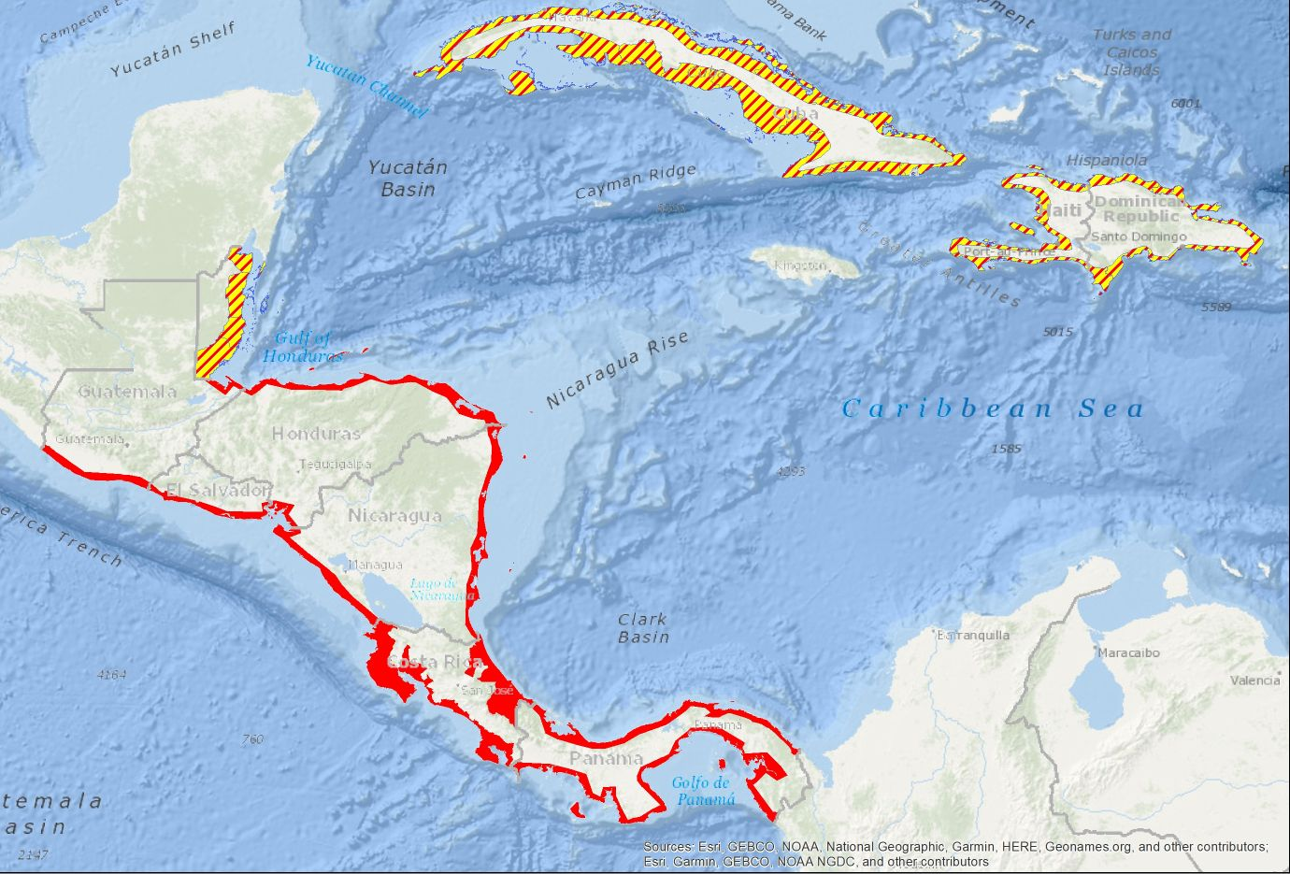

Figure 29. Map of Forecast zones.
Red: Zones used by CATAC for official tsunami products for Central America; Red/Yellow: For these zones CATAC has the capacity to generate tsunami forecast products to be used for training or studies

List of Forecast Points
Sitename; Sea; Latitud; Longitude

Country: Bel-Belize, Cos-Costa Rica, Cub- Cuba, Dom-Dominican Republic, Gua-Guatemala, Hai-Haití, Hon-Honduras, Nic-Nicaragua, Pan-Panama, Sal-El Salvador
Sea: C-Caribbean, P-Pacific Ocean

Country;Sea;Lat;Lon;Name
?;C;-71.66;19.86;San Fernando d.M.Cris
?;C;-71.22;19.85;Punta Rucia Damaris
?;C;-71.09;19.88;La Isabela
Bel;C;-88.40;16.53;Malacate Beach
Bel;C;-88.79;16.11;Della Creek
Bel;C;-88.79;16.09;Punta Gorda
Bel;C;-88.78;16.11;Hopeville
Bel;C;-88.73;16.17;Pork and Doughboy Pt
Bel;C;-88.48;16.36;Monkey River
Bel;C;-88.40;16.50;Big Creek
Bel;C;-88.85;16.03;Mother Point
Bel;C;-88.91;16.00;Barranco
Bel;C;-88.38;16.51;Placencia Point
Bel;C;-88.37;16.52;Placencia
Bel;C;-88.35;16.54;Rum Point
Bel;C;-88.36;16.57;Seine Bight
Bel;C;-88.35;16.61;Maya Beach
Bel;C;-88.31;16.69;Riversdale
Bel;C;-88.25;16.81;Sittee Point
Bel;C;-88.25;16.81;Sittee Point
Bel;C;-88.26;16.84;False Sittee Pt
Bel;C;-88.21;16.97;Dangringa
Bel;C;-88.23;17.02;Blunt Point
Bel;C;-88.25;17.07;Colson Point
Bel;C;-88.28;17.56;Ladyville
Bel;C;-88.26;17.55;Vista del Mar
Bel;C;-88.17;17.49;Bel City
Bel;C;-88.10;18.38;Rocky Point
Bel;C;-88.15;18.36;Sarteneja
Bel;C;-88.23;18.35;Warree Point
Bel;C;-88.33;18.33;Ochid Bay
Bel;C;-88.34;18.33;Cooper Bank
Bel;C;-88.34;18.36;Cerros Beach Resort
Bel;C;-88.40;18.36;La Horizon Landing
Bel;C;-88.38;18.39;Corozal
Bel;C;-88.30;18.45;Consejo Shores
Bel;C;-88.29;18.46;Consejo
Bel;C;-88.30;18.46;Mayan Seaside
Bel;C;-87.83;18.12;Reef Point
Bel;C;-87.85;18.10;Robles Point
Bel;C;-87.91;18.01;Kate Subdivision
Bel;C;-87.94;17.94;Caribeville
Bel;C;-87.95;17.94;Tres Cocos
Bel;C;-87.95;17.93;Mara Laguna Comm.
Bel;C;-87.96;17.92;San Pedro
Bel;C;-87.98;17.89;Mosquito Coast
Bel;C;-87.99;17.88;Boca Ciega
Bel;C;-88.00;17.88;San Pedro Town
Bel;C;-88.00;17.89;Hol Chan Vista
Bel;C;-87.97;17.92;San Pedrito
Bel;C;-87.96;17.93;San Mateo
Bel;C;-87.92;18.09;Punta Lemon
Cos;C;-83.50;10.54;Tortuguero
Cos;C;-83.02;10.00;Limon
Cos;C;-82.84;9.74;Cahuita
Cos;C;-82.75;9.66;Puerto V. de Talam
Cos;C;-83.58;10.80;Barra del Colorado
Cub;C;-74.73;20.58;Yamaniguey
Cub;C;-74.70;20.54;Jaragua
Cub;C;-74.56;20.43;Cayo Guin
Cub;C;-74.52;20.39;Playa Toa
Cub;C;-74.49;20.35;Baracoa
Cub;C;-74.34;20.30;Barigua
Cub;C;-74.30;20.30;Boca de Yumuri
Cub;C;-74.14;20.25;Maisi
Cub;C;-74.48;20.06;Punta salto del Toro
Cub;C;-74.49;20.06;Playitas
Cub;C;-74.50;20.06;Punta Tintorera
Cub;C;-74.61;20.05;Playa Imias
Cub;C;-74.80;20.03;San Antonio del Sur
Cub;C;-74.85;20.02;Baitiquiri
Cub;C;-74.95;19.97;Playa Yateritas
Cub;C;-75.00;19.92;Punta Mal
Cub;C;-75.10;19.90;Guantánamo
Cub;C;-75.17;19.89;Windward Pt Light
Cub;C;-75.13;19.93;Marine Hill
Cub;C;-75.09;20.04;Glorieta
Cub;C;-75.15;19.99;Caimanera
Gua;C;-88.60;15.75;Puerto Barrios
Hai;C;-72.07;18.23;Belle-Anse
Hai;C;-72.33;18.23;Marigot
Hai;C;-72.39;18.23;Cayes-Jacmel
Hai;C;-72.44;18.22;Carrefour Raymond
Hai;C;-72.53;18.22;Lan Mandou
Hai;C;-72.54;18.22;Jacmel
Hai;C;-72.55;18.20;Baguette
Hai;C;-72.54;18.18;Menan
Hai;C;-72.75;18.18;Bainet
Hai;C;-72.91;18.15;Pointe Ravine Bl.
Hai;C;-73.00;18.18;Coste-de-Fer
Hai;C;-73.55;18.26;Saint Louis du-Sud
Hai;C;-73.74;18.19;Les Cayes
Hai;C;-73.84;18.11;Duverni
Hai;C;-73.81;18.09;Saint-Jean du-Sud
Hai;C;-73.89;18.02;Moulin
Hai;C;-73.93;18.08;Port Salut
Hai;C;-73.94;18.08;Dupin
Hai;C;-73.94;18.09;Trouillac
Hai;C;-73.95;18.11;Pointe Sable
Hai;C;-73.96;18.13;Carpentier
Hai;C;-74.01;18.18;Roche-à-BateauR.
Hai;C;-74.04;18.20;Tamarin
Hai;C;-74.05;18.20;Côteaux
Hai;C;-74.07;18.22;Damassins
Hai;C;-74.10;18.25;Port-à-Piment
Hai;C;-74.14;18.26;Bousquet
Hai;C;-74.15;18.26;Calapa
Hai;C;-74.17;18.27;Chardonnières
Hai;C;-74.23;18.30;Les Anglais
Hai;C;-74.26;18.31;La Cahouane
Hai;C;-74.41;18.33;Tiburon
Hai;C;-74.41;18.33;Nan Sable
Hai;C;-73.65;18.09;Madame Bernard
Hai;C;-73.70;18.10;Kaykok
Hai;C;-73.57;18.08;Grande Barriere
Hai;C;-74.45;18.37;Carcasse
Hai;C;-74.45;18.39;Petite Cahouane
Hai;C;-74.46;18.40;Les Irois
Hai;C;-74.46;18.47;Malette
Hai;C;-74.46;18.48;Anse-d'Hainault
Hai;C;-74.45;18.52;Bariadelle
Hai;C;-74.44;18.55;Rousselin
Hai;C;-74.43;18.56;Dame-Marie
Hai;C;-74.43;18.59;Petite-Rivière
Hai;C;-74.39;18.64;Le Seringue
Hai;C;-74.31;18.65;Abricots
Hai;C;-74.28;18.65;Anse du Clerc
Hai;C;-74.25;18.67;Trou Bonbon
Hai;C;-74.11;18.65;Jérémie
Hai;C;-74.02;18.60;Roseaux
Hai;C;-73.89;18.57;Corail
Hai;C;-73.79;18.55;Pestel
Hai;C;-73.72;18.59;Anse-a-Macon
Hai;C;-73.78;18.59;Herbe Guinée
Hai;C;-73.80;18.60;Pointe Sable
Hai;C;-73.78;18.63;Anse du Nord
Hai;C;-73.71;18.58;Les Basses
Hai;C;-73.59;18.55;Grand Boucan
Hai;C;-73.51;18.53;Petit Trou-de-Nipp
Hai;C;-73.34;18.51;Anse-a-Veau
Hai;C;-73.24;18.48;Petite-Riviere-de-Ni
Hai;C;-73.21;18.49;Madian
Hai;C;-73.18;18.49;Charlier
Hai;C;-73.09;18.45;Miragoâne
Hai;C;-72.87;18.43;Petit-Goâve
Hai;C;-72.77;18.44;Grand-Goâve
Hai;C;-72.70;18.44;Bellevue
Hai;C;-72.65;18.52;Port Léogâne
Hai;C;-72.59;18.57;Goree
Hai;C;-72.52;18.55;Gressier
Hai;C;-72.46;18.55;Notre D d.Lim.C.
Hai;C;-72.41;18.56;Lamentin
Hai;C;-72.35;18.55;Port-au-Prince
Hai;C;-72.36;18.56;Portail Saint Joseph
Hai;C;-72.35;18.58;Cité Soleil
Hai;C;-72.33;18.68;Grace de Dieu
Hai;C;-72.45;18.71;Balleye
Hai;C;-72.47;18.75;Gareche
Hai;C;-72.49;18.76;Thomas
Hai;C;-72.51;18.76;Arcahaie
Hai;C;-72.65;18.91;Trou Baguette
Hai;C;-72.66;18.92;Trouforban
Hai;C;-72.71;18.94;Montrouis
Hai;C;-72.93;18.73;Trou Jacques
Hai;C;-72.85;18.71;Au Parc
Hai;C;-72.80;18.76;Petite Anse
Hai;C;-72.81;18.80;Trou d'Eau
Hai;C;-72.86;18.84;Anse-à-Galets
Hai;C;-72.95;18.87;Etroits
Hai;C;-73.11;18.93;Gros Mangle
Hai;C;-73.16;18.96;La Source
Hai;C;-73.24;18.97;Pointe des Lataniers
Hai;C;-73.26;18.87;Grande Vide
Hai;C;-73.21;18.83;Pointe a Pierrot
Hai;C;-73.16;18.82;Deheaune
Hai;C;-73.14;18.82;Trou Cochon
Hai;C;-73.13;18.81;Source Philippe
Hai;C;-73.08;18.79;Mahotierre
Hai;C;-73.07;18.78;Pointe-à-Raquette
Hai;C;-72.74;18.97;Deluge
Hai;C;-72.71;19.10;Saint- Marc
Hai;C;-72.70;19.12;Artibonite
Hai;C;-72.78;19.25;Grande Saline
Hai;C;-72.71;19.44;Decahos
Hai;C;-72.91;19.55;Coridón
Hai;C;-73.06;19.62;Anse-Rouge
Hai;C;-73.21;19.66;Baie-de-Henne
Hai;C;-73.38;19.81;Môle-Saint-Nicolas
Hai;C;-73.37;19.82;Carrenage
Hai;C;-73.20;19.91;Bord-De-MarJeanRa
Hai;C;-72.96;19.91;Ti Charles
Hai;C;-72.83;19.95;Port-de-Paix
Hai;C;-72.82;19.96;Desroulin
Hai;C;-72.78;19.95;Beraca
Hai;C;-72.72;19.94;Saint-Louis-du-Nord
Hai;C;-72.62;19.90;Anse-a-Foleur
Hai;C;-72.64;19.99;Point d.Portu.T.Lili
Hai;C;-72.94;20.05;Gros Raisinier
Hai;C;-72.93;20.05;Creace
Hai;C;-72.93;20.04;Mancenilier
Hai;C;-72.87;20.03;Trou Basseux
Hai;C;-72.81;20.03;Terre Cassee
Hai;C;-72.79;20.02;Corrosse Sechee
Hai;C;-72.79;20.02;Grand Mane
Hai;C;-72.77;20.01;Mare Gauthier
Hai;C;-72.76;20.01;Pointe Aux Oiseaux
Hai;C;-72.74;20.00;Port Vincent
Hai;C;-72.72;20.00;Basse Terre
Hai;C;-72.71;20.00;Grand Sable
Hai;C;-72.52;19.85;La Borgne
Hai;C;-72.34;19.74;Quartier d Camp Lou
Hai;C;-72.32;19.73;Balan
Hai;C;-72.31;19.74;Plaine-du-Nord
Hai;C;-72.25;19.78;Labadie
Hai;C;-72.24;19.79;Pointe Labadie
Hai;C;-72.23;19.79;Cormier
Hai;C;-72.19;19.76;Cap-Haien
Hai;C;-72.19;19.75;Fort Saint-Michel
Hai;C;-72.18;19.75;Petite-Anse
Hai;C;-72.12;19.74;Bord d Mer Lim
Hai;C;-72.02;19.70;Caracol
Hai;C;-71.89;19.67;Phaeton
Hai;C;-71.83;19.67;Fort-Liberté
Hai;C;-71.82;19.66;Dérac
Hon;C;-86.57;16.33;Inst. Ciencia Marina
Hon;C;-86.44;16.34;French Harbor
Hon;C;-85.87;16.51;Mangrove Bight
Hon;C;-85.89;16.44;Guanaja
Hon;C;-86.90;16.08;Utila
Hon;C;-86.89;16.13;Utila Norte
Hon;C;-83.94;17.40;Isla del Cisne
Hon;C;-86.47;15.98;Cayo Cochino Gran
Hon;C;-88.05;15.77;Omoa
Hon;C;-88.14;15.69;Nuevo Omoa
Hon;C;-87.94;15.83;Puerto Cortes
Hon;C;-87.45;15.79;Tela
Hon;C;-87.41;15.82;El Triunfo d la Cruz
Hon;C;-86.81;15.79;La Ceiba
Hon;C;-86.63;15.80;Sambo Creek
Hon;C;-86.29;15.81;Rio Esteban
Hon;C;-85.96;15.93;Trujillo
Hon;C;-84.29;15.81;Barra del Patuca
Hon;C;-82.65;15.28;Cayos de Hon
Hon;C;-87.66;13.25;Playa Negra
Hon;C;-85.84;16.47;Savannah
Nic;C;-83.07;12.14;Corn Island
Nic;C;-83.68;11.98;El Bluff
Nic;C;-83.51;12.96;Sandy Bay
Nic;C;-83.55;13.41;Prinzapolka
Nic;C;-83.52;13.55;Wounta
Nic;C;-83.51;13.69;Haulover
Nic;C;-83.45;13.88;Huahua
Nic;C;-83.37;14.03;Bilwi
Nic;C;-83.64;11.59;Monkey Point
Nic;C;-83.71;10.96;San Juan del Norte
Nic;C;-82.72;14.35;Cayos Miskitos
Nic;C;-82.99;12.32;Little Corn Island
Nic;C;-83.75;12.01;Blufields
Nic;C;-83.67;12.35;Laguna de Perlas
Nic;C;-83.14;15.00;Cabo Gracias a Dios
Pan;C;-79.90;9.41;Ciudad de Colon
Pan;C;-79.57;9.64;Isla Grande
Pan;C;-78.95;9.56;El Porvenir
Pan;C;-78.01;9.24;Aligandi
Pan;C;-78.59;9.46;Nargana
Pan;C;-82.34;9.42;Boca del Drago
Pan;C;-80.58;9.09;Coscte del Norte
Pan;C;-78.69;9.60;Turtle Island
Pan;C;-77.36;8.69;Capurgana
Dom;C;-68.85;18.37;Bayahibe
Dom;C;-68.60;18.84;Punta Sabaneta
Dom;C;-68.57;18.81;Uvero Alto
Dom;C;-68.42;18.72;Punta L Ranchitos
Dom;C;-68.40;18.70;Bávaro
Dom;C;-68.33;18.55;Punta Cana
Dom;C;-68.37;18.49;Cap Cana
Dom;C;-68.60;18.37;Boca de Yuma
Dom;C;-68.84;18.35;Dominicus
Dom;C;-68.96;18.41;La Romana
Dom;C;-69.00;18.39;Caleta
Dom;C;-69.21;18.44;Playa Nuev Roma
Dom;C;-69.31;18.43;Sn Pedro d Macoris
Dom;C;-69.43;18.41;Mar del Sol
Dom;C;-69.46;18.41;Guayacanes
Dom;C;-69.61;18.44;Boca Chica
Dom;C;-69.62;18.43;Andrés
Dom;C;-69.83;18.45;Santo Domingo E
Dom;C;-69.88;18.46;Santo Domingo
Dom;C;-70.04;18.38;Sn Greg. de Nigua
Dom;C;-70.05;18.37;Boca de Nigua
Dom;C;-70.21;18.22;Las Mercedes
Dom;C;-70.56;18.23;Las Salinas
Dom;C;-70.60;18.30;Palmar de Ocoa
Dom;C;-70.84;18.34;Puerto Viejo d Azu
Dom;C;-70.95;18.25;PlayRancho AbajodeAz
Dom;C;-71.07;18.22;Santa Cruz de Bar
Dom;C;-71.06;18.12;Juan Esteban
Dom;C;-71.07;18.10;El Arcoyo
Dom;C;-71.09;18.07;Baoruco
Dom;C;-71.10;18.06;La Cienega
Dom;C;-71.13;18.02;San Rafael
Dom;C;-71.16;17.98;Paraiso
Dom;C;-71.17;17.97;Ojeda
Dom;C;-71.18;17.95;Los Patos
Dom;C;-71.23;17.89;Enriquillo
Dom;C;-71.24;17.88;Las 4 Bocas
Dom;C;-71.26;17.86;L Cocos Abajo de Pedern
Dom;C;-71.44;17.60;Cabo Esperanza
Dom;C;-71.54;17.74;Trudillé
Dom;C;-71.57;17.76;Bucapan
Dom;C;-71.59;17.76;Oviedo
Dom;C;-71.60;17.76;Mddin
Dom;C;-71.67;17.75;Norberge
Dom;C;-71.67;17.79;Dijili
Dom;C;-71.66;17.87;La Cueva
Dom;C;-71.69;17.91;Cabo Rojo
Dom;C;-71.76;18.02;Pedernales
Dom;C;-71.55;17.59;Punta Lanza
Dom;C;-71.54;17.60;Trojanye
Dom;C;-71.53;17.62;El Palmar
Dom;C;-71.48;17.60;Ocrique
Dom;C;-71.75;19.71;Pepillo Salcedo
Dom;C;-70.94;19.91;Luperton
Dom;C;-70.73;19.83;Cofresi
Dom;C;-70.70;19.82;Costambar
Dom;C;-70.52;19.77;Sosúa
Dom;C;-70.41;19.76;Cabarete
Dom;C;-70.09;19.65;Rio San Juan
Dom;C;-69.90;19.65;Cabrera
Dom;C;-69.89;19.55;La Entrada
Dom;C;-69.84;19.38;Nagua
Dom;C;-69.82;19.36;Matancitas
Dom;C;-69.54;19.33;Las Terrenas
Dom;C;-69.19;19.30;Las Galeras
Dom;C;-69.33;19.20;Samaná
Dom;C;-69.61;19.22;Sánchez
Dom;C;-69.26;19.02;Elup. Cordero Cañ
Dom;C;-69.05;18.99;Miches
Cos;P;-85.68;11.05;Bahia de Salinas
Cos;P;-84.67;9.70;Punta Leona
Cos;P;-82.90;8.04;Frontera Cos-Pan
Cos;P;-85.78;10.45;Potrero
Cos;P;-85.71;9.99;Bahia de Salinas
Cos;P;-85.17;9.64;Santa Teresa
Cos;P;-84.64;9.61;Jaco
Cos;P;-85.11;9.56;Cabo Blanco
Cos;P;-83.60;8.47;Playa Sirena
Cos;P;-82.97;8.23;Playa La Palma
Cos;P;-84.89;9.76;Isla Tortuga
Cos;P;-84.17;9.43;Quepos
Cos;P;-83.39;8.40;Agua Buena
Cos;P;-83.13;8.35;Punta Banco
Cos;P;-85.71;10.94;Cuajiniquil
Cos;P;-85.95;10.89;Punta Santa Elena
Cos;P;-85.70;10.55;Playa Hermosa
Cos;P;-85.85;10.30;Tamarindo
Cos;P;-85.52;9.88;Samara
Cos;P;-85.31;9.81;Playa San Miguel
Cos;P;-84.99;9.73;Bahia Ballena
Cos;P;-84.50;9.52;Esterillos
Cos;P;-83.74;9.15;Playa Uvita
Cos;P;-83.87;9.25;Dominical
Cos;P;-83.89;8.70;Isla del Cano
Cos;P;-87.09;5.50;Isla del Coco
Cos;P;-84.86;9.97;Puntarenas
Cos;P;-84.97;9.94;Playa Naranjo
Cos;P;-85.09;10.10;Isla de Chira
Cos;P;-83.19;8.62;Golfito
Sal;P;-89.07;13.36;Playa El Pimental
Sal;P;-89.85;13.57;Acajutla
Sal;P;-89.60;13.50;Mizata
Sal;P;-89.33;13.47;La Libertad
Sal;P;-88.56;13.18;Bahia de Jiquilisco
Sal;P;-88.11;13.16;El Cuco
Sal;P;-90.09;13.71;Garita Palmera
Sal;P;-87.96;13.15;Playas Negras
Sal;P;-88.92;13.29;Playa El Zapote
Sal;P;-87.84;13.34;La Union
Sal;P;-87.78;13.27;Playitas
Sal;P;-87.70;13.20;Playa el Zamb.
Sal;P;-87.70;13.16;Isla Meang. Sur
Sal;P;-87.75;13.24;Conchaguita
Sal;P;-87.76;13.32;Las Playitas
Sal;P;-87.74;13.32;Playa La Pesa
Sal;P;-87.75;13.31;Playa Las Pilas
Gua;P;-91.38;13.97;Tecojate
Gua;P;-92.19;14.49;Tilapa
Gua;P;-91.93;14.29;Champerico
Gua;P;-91.66;14.11;Chiquistepegue
Gua;P;-91.15;13.91;Sipacate
Gua;P;-90.78;13.91;Puerto Quetzal
Gua;P;-90.35;13.83;Buena vista
Hon;P;-87.64;13.24;Isla del Tigre Sur
Hon;P;-87.52;13.28;Punta Raton
Hon;P;-87.63;13.31;Coyolito
Hon;P;-87.43;13.40;Puerto San Lorenzo
Hon;P;-87.44;13.17;Cedeño
Hon;P;-87.66;13.30;Amapala
Nic;P;-87.45;12.73;Jiquilillo
Nic;P;-87.38;12.65;Playa Sn Maria Mar
Nic;P;-87.20;12.50;Corinto
Nic;P;-87.04;12.36;Poneloya
Nic;P;-86.78;12.17;Puerto Sandino
Nic;P;-86.52;11.78;Masachapa
Nic;P;-86.17;11.51;El Astillero
Nic;P;-85.88;11.25;San Juan del Sur
Nic;P;-87.59;12.83;Mechapa
Nic;P;-85.76;11.10;Playa El Ostional
Nic;P;-86.36;11.64;Casares
Nic;P;-87.68;13.08;Farallones
Nic;P;-87.67;12.97;Playa Papayal-Cosig
Nic;P;-87.57;13.09;Pnta San Jose-Cosig
Nic;P;-87.50;13.01;Potosi-Cosguina
Nic;P;-87.38;12.92;Estero Real
Pan;P;-82.85;8.27;Puerto Armuelles
Pan;P;-80.31;7.40;Isla Cañas
Pan;P;-80.10;8.37;Playa Santa Clara
Pan;P;-79.95;8.46;El Palmar
Pan;P;-79.51;8.95;Ciudad de Pan
Pan;P;-80.19;7.42;Las Escobas d Ven
Pan;P;-80.17;7.77;El Uverito
Pan;P;-80.33;7.97;El Rompio
Pan;P;-79.87;8.53;Coronado
Pan;P;-79.61;8.88;Veracruz
Pan;P;-78.18;7.58;Bahia Pi
Pan;P;-78.17;7.50;Jaque
Pan;P;-81.64;7.45;Isla de Coiba
Pan;P;-80.00;7.46;Punta Mala
Pan;P;-80.92;7.24;El Cacao
Pan;P;-82.44;8.36;David
Pan;P;-81.87;8.16;Las Lajas
Pan;P;-81.25;7.62;Santa Catalina
Pan;P;-78.90;8.22;Isla del Rey Sur
Pan;P;-78.93;8.48;San Miguel
Pan;P;-78.29;8.21;Punta Patio
Pan;P;-79.52;8.81;Isla Tobagu

Annex V References
Acosta, N.; Strauch, W.; Castellón, A.; Larreynaga, A.; Funes, G. (2009). GIS based Tsunami Hazard Mapping in Nicaragua, El Salvador and Honduras and Application to Disaster Prevention Measures, Lateinamerika-Kolloquium, Göttingen, Germany, 07–09 April 2009.
Argüello, G.J. (2016). W Phase Inversion Analysis and Tsunami Simulation for Tsunami Warning for Large Earthquake [Mw>7.0] in Nicaragua, Master Thesis, GRIPS/IISEE/BRI, Tsukuba/Tokyo, Japan.
Argüello, G.J.; Tanioka, Y.; Strauch, W. (2018). Reliability of the W-Phase Inversion for earthquakes with MW > 6.0 to be used by CATAC. Abstract, Joint Conference LACSC–SSA, Miami, Florida.
Cabrera, A.G.R. (2017). Tsunami Characteristics of Outer-Rise Earthquakes Along the Pacific Coast of Nicaragua – Case Study for the 2016 Event, Master Thesis, GRIPS/IISEE/BRI, Tsukuba/Tokyo, Japan.
Cauzzi, C.; Clinton, J.; Massin, F.; Strauch, W.; Ramirez, J. (2018). Shake Maps for Nicaragua and Central America based on SeisComP3 at INETER. Joint Conference LACSC–SSA, Miami, Florida.
Flores, P. (2013). Moment Tensor Analysis of Middle and Large Earthquakes in Nicaragua, Master Thesis, NGIPS/BRI, Tsukuba/Tokyo, Japan.
Freundt, A.; Kutterolf, S.; Wehrmann, H.; Schmincke, H.-U.; Strauch, W. (2004). Tsunami in Lake Managua, Nicaragua, triggered by a compositionally zoned plinian eruption. Talk, IAVCEI General Assembly, Pucon, Chile.
Freundt, A.; Strauch, W.; Kutterolf, S.; Schmincke, H.-U. (2007). Volcanogenic Tsunamis in Lakes: Examples from Nicaragua and General Implications. Pure Appl. Geophys. 164, 527–545.
Furukawa, N.; Kumagai, Y.; Strauch, W.; Talavera, E.; Tenorio, V.; Ramirez, J.; Argüello, G.; Herrera, M.; Acosta, N.; Morales, A. (2018). Project for Strengthening the Capacity of CATAC. Abstract, IOC/UNESCO Symposium, Paris.
Gonzalez, G.; Acosta, N.; Strauch, W. (2021). A real-time application for tsunami warning and evacuation route information in the Pacific coastal areas of Nicaragua. INETER and Taiwan Technical Cooperation, Managua.
González-Vida, J. M., Castro, M. J., Macías, J., de la Asunción, M., Ortega, S., & Parés, C. (2020). Tsunami-HySEA: A Numerical Model Developed for Tsunami Early Warning Systems (TEWS). In Progress in Industrial Mathematics: Success Stories (pp. 209–226). Springer, SEMA SIMAI Springer Series
Herrera, M.V.J. (2016). Tsunami modeling of the 2012 El Salvador earthquake along the Pacific Coast of El Salvador and Nicaragua, Master Thesis, GRIPS/IISEE/BRI, Tsukuba/Tokyo, Japan.
Intergovernmental Oceanographic Commission (2018). Tsunami Hazard in Central America: Historical Events and Potential Sources. Paris, UNESCO.
JICA (2015). Data Collection Survey on the Observation Capacity of Earthquakes and Tsunami in Central America, Final Report.
Lindholm, C.; Strauch, W.; Fernández, M. (2017). Tsunami hazard in Central America: history and future. Geological Society, London, Special Publications, 456.
Massin, F.; Clinton, J.; Strauch, W. (2017). Project proposal to COSUDE: Earthquake Early Warning in Nicaragua and Central America (EWARNICA) Phase II.
Massin, F.; Clinton, J.; Behr, Y.; Strauch, W.; Cauzzi, C.; Boese, M.; Talavera, E.; Tenorio, V.; Ramirez, J. (2016). Assessing the Applicability of Earthquake Early Warning in Nicaragua. AGU Fall Meeting Abstracts.
Massin, F.; Strauch, W.; Clinton, J.F.; Ramirez, J. (2018). Building EEW in Nicaragua: Performance and Perspectives. Joint Conference LACSC–SSA, Miami, Florida.
Massin, Frédérick; Clinton, J.; Yani-Quiyuch, R.; Marroquin, G.; Protti, M.; Strauch, W.; et al. (2026). Earthquake Early Warning in Central America from 2016 to 2024. Submitted to Seismological Research Letters.
Namendi, D. (2017). Rapid Magnitude Determination for Tsunami Warning Using Local Data in and Around Nicaragua, Master Thesis, GRIPS/IISEE/BRI, Tsukuba/Tokyo, Japan.
Ramirez, J.; Strauch, W. (2018). COCONet mirror data center at INETER, Nicaragua, and Early Warning in Central America. Joint Conference LACSC–SSA, Miami, Florida.
Satake, K. (2002). Tsunamis. International Handbook of Earthquake Seismology and Engineering, Part A, III-28. Academic Press.
Siebert, L., L, Alvarado, G. E.; Vallance, James W.; van Wyk de Vries, Benjamin (2006) Large-volume volcanic edifice failures in Central America, in Ed. Rose, W.Volcanic Hazards in Central America, Doi:https://doi.org/10.1130/2006.2412(01), January 01, 2006
Shea, Thomas ; van Wyk de Vries, Benjamin ; Pilato, Martín (2008) Emplacement mechanisms of contrasting debris avalanches at Volcán Mombacho (Nicaragua), provided by structural and facies analysis, Bulletin of Volcanology, Volume 70, Issue 8, pp.899-921, DOI: 10.1007/s00445-007-0177-7
Strauch, W. (2010). Analysis of the Chilean Tsunami Early Warning System during the 2010 earthquake and tsunami. ONEMI/IDB, Santiago de Chile.
Strauch, W. (2010). Geo-Hazards in Central America. Manual for Risk Exposure Evaluation, BGR, Hannover/Managua.
Strauch, W.; Acosta, N. (2010). Tsunami hazard maps for the Gulf of Fonseca. BGR Project of Geo-risks in Central America, Internal Report, BGR-INETER, Managua, Nicaragua.
Strauch, W. (2012). Guide for the implementation of Early Warning Systems for Landslides in Central America, UNESCO San José Office.
Strauch, W. (2013). Phase 1 – Automated Risk Management Systems for Panama. OSOP/SENACYT, Volcán, Panama.
Strauch, W. (2014). Automatic Seismic Datacenters and Tsunami Warning in Central America. GOAL Newsletter No. 1.
Strauch, W. (2017). Progress in CATAC establishment. ICG/CARIBE EWS-XII, Costa Rica.
Strauch, W. (2017). Report on CATAC development. ICG/PTWS-XXVII, Tahiti.
Strauch, W.; Weber, B. (2018). New SeisComP3 installation for tsunami early warning at CATAC. IOC/UNESCO Symposium, Paris.
Strauch, W.; Weber, B.; Moeller, M.; Blanco, F.; Ramirez, J.; Talavera, E. (2018). First experience with SeisComP3 tsunami software at CATAC. Joint Conference LACSC–SSA, Miami.
Strauch, W.; Clinton, J.; Massin, F.; Ramirez, J. (2018). Towards Earthquake Early Warning in Central America. Joint Conference LACSC–SSA, Miami.
Strauch, W. (2019). Exercise TSUNAMI-CA 19. IOC/UNESCO Technical Series #148, CATAC-INETER.
Strauch, W. (2020). Exercise TSUNAMI-CA 20. IOC/UNESCO Technical Series, CATAC-INETER.
Talavera, E. (2015). Tsunami Simulation for the 1992 Nicaragua Earthquake, Master Thesis, GRIPS/IISEE/BRI, Tsukuba/Tokyo, Japan.
Tanioka, Y.; Argüello, G.J.; Gusman, A.R.; Fujii, Y. (2017). Method to Determine Appropriate Source Models of Large Earthquakes Including Tsunami Earthquakes for Tsunami Early Warning in Central America. Pure Appl. Geophys. 174(8), 3237–3248.
Tenorio, V.; Strauch, W. (2012). Evaluation of the earthquake of August 26, 2012, in the Pacific Ocean between El Salvador and Nicaragua. Boletín Mensual Sismos y Volcanes de Nicaragua. INETER
UNESCO-IOC (2009). Operational Users’ Guide for the Pacific Tsunami Warning and Mitigation System (PTWS), Technical Series No. 87.
UNESCO-IOC (2014). User’s Guide for the Pacific Tsunami Warning Center (PTWS) Enhanced Products, Technical Series No. 105.
UNESCO-IOC (2019). User’s Guide for the South China Sea Tsunami Advisory Center (SCSTAC) products for the South China Sea Tsunami Warning and Mitigation System, Intergovernmental Oceanographic Commission, IOC. Technical series, 149, IOC/2019/TS/149

Annex VI Acronyms in CATAC User’s Guide 2026

ACP – Autoridad del Canal de Panamá (Panama Canal Authority).
ATTAC –Alerta Temprana de Terremotos in América Central, Earthquake Early Warning in Central America, see also EWARNICA, below
CARIBE-EWS – Caribbean Tsunami Warning and Mitigation System
CATAC – Centro de Asesoramiento de Tsunamis para América Central, Central American Tsunami Advisory Center
CEPREDENAC – Centro de Coordinación para la Prevención de los Desastres Naturales en América Central, Center for the Coordination of Natural Disaster Prevention in Central America
CMT – Centroid Moment Tensor
CNE – Comisión Nacional de Emergencias (Costa Rica), National Emergency Commission, coordinating disaster risk management and emergency response.
COPECO – Comisión Permanente de Contingencias (Permanent Commission for Contingencies, Honduras)
EarthScope - large, U.S.-based geoscience program funded by the National Science Foundation that deploys and manages dense networks of seismic, geodetic (GNSS), and other geophysical instruments
EEW – Earthquake Early Warning
ENATREL – Empresa Nacional de Transmisión Eléctrica (Nicaraguan Electric Power Transmission Company)
ETH/SED – Swiss Seismological Service at ETH Zurich
EWARNICA – Earthquake Warning in Nicaragua and Central America (Swiss cooperation project with Nicaragua and Central American Countries, 2016-2025)
GEMPA – Global Earthquake Monitoring Processing Analysis. GEMPA (Potsdam, Germany) provides professional support, training, and development for SeisComP and related seismic monitoring solutions. Their focus is on real-time earthquake monitoring, data processing, and analysis systems used worldwide, including at CATAC.
GFZ – GeoForschungsZentrum Potsdam (German Research Centre for Geosciences)
GNSS – Global Navigation Satellite System
GOAL - Geo‑Network of Latin American–German Alumni, established in 2002 under the auspices of the German Academic Exchange Service (DAAD)
HySEA – Hybrid Shallow Water Equations. Numerical simulation tool from University of Málaga (Spain) for tsunami propagation and inundation modeling.
ICG/PTWS – Intergovernmental Coordination Group for the Pacific Tsunami Warning System
ICG/CARIBE-EWS – Intergovernmental Coordination Group for the Caribbean Tsunami Warning and Mitigation System
IOC – Intergovernmental Oceanographic Commission (of UNESCO)
INETER – Instituto Nicaragüense de Estudios Territoriales (Nicaraguan Institute of Territorial Studies)
INSIVUMEH – Instituto Nacional de Sismología, Vulcanología, Meteorología e Hidrología (Guatemala)
JMA - Japan Meteorological Agency
JICA – Japan International Cooperation Agency
MARN – Ministerio de Medio Ambiente y Recursos Naturales (El Salvador)
MARN-DGOA - Ministry of Environment and Natural Resources (MARN), General Directorate of the Environmental Observatory del MARN
NEIC – National Earthquake Information Center (USA)
NOAA – National Oceanic and Atmospheric Administration. A U.S. federal agency focused on oceans, atmosphere, and climate. NOAA operates two official tsunami warning centers: the National Tsunami Warning Center (NTWC) in Palmer, Alaska, and the Pacific Tsunami Warning Center (PTWC) in Honolulu, Hawaii.
NTWC – National Tsunami Warning Center
NWPTC – Northwest Pacific Tsunami Advisory Center. Established at JMA, Japan.
OSOP - Observatorio Sismológico del Occidente de Panamá
OVSICORI – Observatorio Vulcanológico y Sismológico de Costa Rica
PAGER – Prompt Assessment of Global Earthquakes for Response (USGS)
PTWC – Pacific Tsunami Warning Center
PTWS – Pacific Tsunami Warning and Mitigation System. Provides Tsunami Services to the countries and territories of the Pacific Ocean and the Caribbean sea.
SCSTAC – South China Sea Tsunami Advisory Center. Implemented at the National Marine Environmental Forecasting Center (NMEFC) in Beijing. Belonging to the Ministry of Natural Resources of China. Provides tsunami advisory services for nine South China Sea countries: Brunei, Cambodia, China, Indonesia, Malaysia, the Philippines, Singapore, Thailand, and Vietnam.
Established
ShakeMap – Seismic Hazard Mapping Project. U.S. Geological Survey (USGS), automatically generates maps of ground shaking
SCMTV – SeisComP Moment Tensor Viewer (interactive module)
SCAUTOMT – SeisComP Automatic Moment Tensor (automatic module)
SED – Swiss Seismological Service (ETH Zurich)
SeisComP – Seismological Communication Processor. Seismological software system developed at GFZ
SENACYT – Secretaria Nacional De Ciencia Tecnología e Innovación, National Science and Technology Secretariat (Panama)
SINAPRED – Sistema Nacional para la Prevención, Mitigación y Atención de Desastres (Nicaragua)
SINAPROC – Sistema Nacional de Protección Civil (Panama). National Civil Protection System, responsible for disaster prevention, preparedness, and response.
SINAREM – Sistema Nacional de Respuesta a Emergencias de Nicaragua (China-supported project)
SOP – Standard Operating Procedure
TSP – Tsunami Service Provider
TT-CATAC – Task Team for CATAC (subregional task team under PTWS)
TOAST – Tsunami Observation and Simulation Terminal (SeisComP PRO module)
TTT – Tsunami Travel Time
UNAM – Universidad Nacional Autónoma de México
USGS – United States Geological Survey.
UNESCO – United Nations Educational, Scientific and Cultural Organization
UNAH - Universidad Nacional Autónoma de Honduras
UNAVCO/COCONet – Consortium of GPS/GNSS stations in Central America and the Caribbean
VLIZ – Flanders Marine Institute (IOC sea level monitoring site)
WG-CA – Working Group of the PTWS formed by the Central American countries
W-phase – Long-period seismic phase used for rapid CMT solutions

