
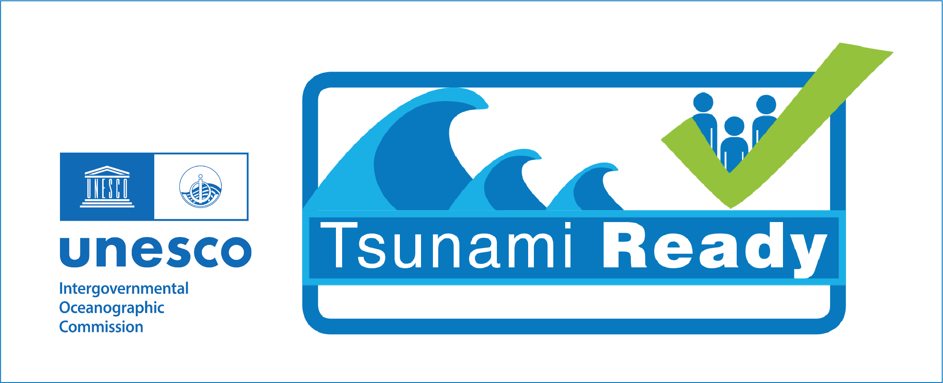



PALAU TSUNAMI WARNING AND PREPAREDNESS

PALAU TSUNAMI READY

PROVISIONAL AGENDA - 19-23 January 2026
Making 100% of communities at risk from tsunamis prepared and resilient to tsunamis

Jan 19 - Monday, 10 am - 3 pm: Coordination and Planning, Tsunami Warning Tools
Morning, 10-12 noon - WSO and NDMO - Location WSO?
- Review and confirm Agenda and Invitations
  - Tsunami Ready Recognition Ceremony (Jan 20 morning) - Marie
  - Tsunami School Evacuation Drill (Jan 20 afternoon) - Waymine
  - Tsunami Operations Strengthening Workshop (3-day, Jan 21-23) - Laura, Chip, Landon
- Other needs and preparations for the week
Afternoon, 1:30 - 3:30 pm - WSO
- Review and confirm TW Tools working (CISN, Tide Tool, TTT) - Laura
- Tsunami Coastal Assessment Tool (TsuCAT) - training on use and limitations

Jan 20 - Tuesday
- Tsunami Ready Recognition Ceremony for Palau - Location TBD?
  - Morning:
  - 10-11 am: Recognition Ceremony. (Registration 9:30-10 am)
  - 11 am -12 pm: Media interaction
  - 12 noon - Lunch
- Tsunami School Evacuation Drill - organized by Ministry of Education, NEMO

Jan 21- Wednesday, 9 am - 3:30 pm: Tsunami Operations Strengthening - 1 - Location TBD?
Morning, 9 am - 12 noon, with break
- Review recent events and Palau response - Palau NEMO / WSO, PTWC, WFO Guam - Waymine, Maria, Laura, Chip, Landon, all
- Japan NWPTAC products - Chip
- Review current Palau National Tsunami Support Plan (2015, 2024?) - Alert Criteria, Messages, Flow Chart - all
- Strengthening recommendations - all
Afternoon, 1:30 - 3:30 pm
- Tsunami Advisory Alert Level Recommendation - Laura
Based on 2 Dec 2023 and 9 Oct 2025 Philippines, and 29 Jul 2025 Kamchatka and other events, where an evacuation was not required but there was still a danger, it is recommended to establish an Advisory level (lower level of warning) to stay out of the water due to potentially strong currents or unusual waves.
- Updates to SOPs, National Tsunami Support Plan - Laura, all
  - Criteria Table, SOPs, Templates
  - Timeline-driven SOPs - local, regional and distant

Jan 22 - Thursday, 9 am - 3:30 pm: Tsunami Operations Strengthening - 2 - Location TBD?
Morning, 9 am - 12 noon, with break
- Updates to SOPs, Tsunami Support Plan (continued) - Laura, all
- Updates to States Tsunami Support Plan - Palau
- Sustaining Readiness through Regular Tsunami Communication Exercises - Landon
Afternoon, 1:30 - 3:30 pm
- Tabletop tsunami exercises - local - all
- Tabletop tsunami exercises - regional - all

Jan 23 - Friday, 9 am - 1 pm: Tsunami Operations Strengthening - 3 - Location TBD?
WSO, NEMO, ITIC, PTWC, WFO Guam
- Tabletop tsunami exercises - distant - all
- Sustaining Tsunami Ready - Marie
  - Tsunami Ready Renewal requirements
  - Tsunami Ready Indicator activities support - Preparedness, Response
- Wrap-up, Next Steps: Actions, Timelines, Milestones - all

