
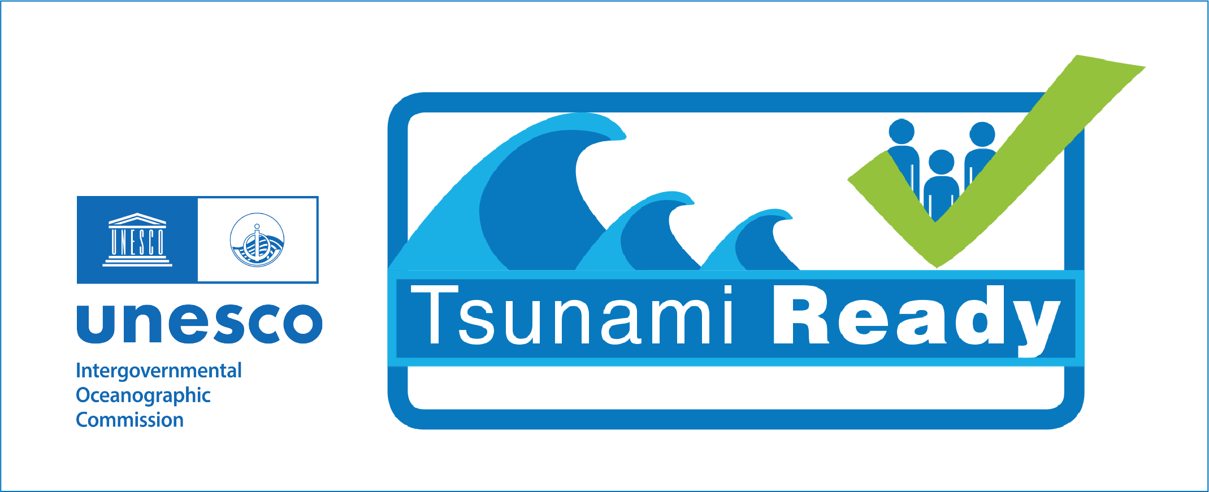
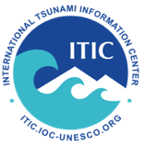


MARSHALL ISLANDS TSUNAMI WARNING AND PREPAREDNESS

MAJURO TSUNAMI READY

PROVISIONAL AGENDA - 12-15 January 2026
Making 100% of communities at risk from tsunamis prepared and resilient to tsunamis
(version 7 January 2026)

Jan 12 - Monday, 10 am - 3 pm: Coordination, Tsunami Warning Tools
Morning, 10 am - 12 noon - WSO and NDMO - Location NDMO Conference Room
- Review and confirm Agenda and Invitations
  - Tsunami Operations Strengthening (2-day, Jan 13-14) - Laura
  - Tsunami Ready Recognition Ceremony (Jan 15) - Marie
- Other needs and actions
Afternoon, 1 - 3 pm - WSO
- Review and confirm TW Tools working (CISN, Tide Tool, TTT) - Laura
- Tsunami Coastal Assessment Tool (TsuCAT) - training on use and limitations

Jan 13 - Tuesday, 9 am - 3 pm: Tsunami Operations Strengthening - Day 1
Location NDMO Conference Room
Morning, 9 am - 12 noon, with break
- Review recent events and RMI response - Laura, Landon, Marie, all
- Review current RMI Tsunami Documents - all
  - Hazard Mitigation Plan (1997, revised) - Marie
  - Homeowner's Handbook to prepare for Natural Hazards, RMI (2015) - Landon
  - RMI Tsunami Support Plan (2024) - Alert Criteria, Messages, Flow Chart - Laura
- Strengthening recommendations - all
Afternoon, 1:30 - 3 pm
- Tsunami Advisory Alert Level Recommendation - Laura
Based on 29 Jul 2025 Kamchatka and earlier events, where an evacuation was not required but there was still a danger, it is recommended to establish an Advisory level (lower level of warning) to stay out of the water due to potentially strong currents or unusual waves.
- Updates to SOPs, Tsunami Support Plan - Laura
  - Criteria Table, SOPs, Templates
  - Timeline-driven SOPs - regional and distant tsunami scenarios

Jan 14 - Wednesday, 9 am - 3 pm: Tsunami Operations Strengthening - Day 2
Location NDMO Conference Room
Morning, 9 am - 12 noon, with break
- Sustaining Readiness through Regular Tsunami Communication Exercises - Landon
- Tabletop tsunami exercises - regional and distant tsunami scenarios - all
Afternoon, 1:30 - 3 pm
- Sustaining Tsunami Ready - Marie
  - Tsunami Ready Renewal requirements
  - Tsunami Ready Plan for RMI to each 100% prepared and resilient
  - Tsunami Ready Indicator activities support - Preparedness, Response

Jan 15 - Thursday
Morning: Tsunami Ready Recognition Ceremony for Majuro, RMI, 10 am - 1 pm
Marshall Islands Resort, Melele Room
- 10-11 am: Recognition Ceremony (Registration 9:30-10 am)
- 11 am -12 pm: Media interaction
- 12 noon - Lunch

Afternoon: Wrap-up, Next Steps, 2 - 3 pm
- Actions, Timelines, Milestones - NDMO, WSO, ITIC, WFO Guam

