Summary
Introduction
Part I – Draft Programme and budget 2026–2027 as presented as part of UNESCO's draft 43 C/5 to the 221st session of the UNESCO Executive Board (221 EX/20)
Part II – Detailed IOC workplan proposal based on Member States’ guidance in IOC Resolutions A-32/4 and EC-57/2
Decision proposed is referenced Dec. A-33/5.1 in the Provisional Action Paper IOC/A-33/AP Prov.

Introduction
- UNESCO’s Programme and Budget proposal for the first biennium of the 2026–2029 quadrennium is designed to drive progress towards the four strategic objectives of its Medium-Term Strategy 2022–2029.
- IOC’s chapter in the draft UNESCO 43 C/5 Programme and Budget, as presented in Part I of this document, is intended to contribute to the achievement of UNESCO’s Strategic Objective 2:
“Reconciling humanity with nature” and its Outcome 2: “A world where biodiversity, water and the ocean are valued and sustainably managed, in order to face the challenges posed by climate change and contribute to climate action.”
- Regarding the regular budget proposal (Member States’ assessed contributions), the 43 C/5 regular budget will need to accommodate additional fixed costs stemming from specific decisions by the UNESCO Executive Board and the General Conference, as well as inflationary adjustments, including staff cost increases. The details on the nature of these costs can be found in the Executive Summary included in document 221 EX/20. Considering these fixed costs and the UNESCO Executive Board’s request for budget options, UNESCO presented three scenarios for its regular budget ceiling:
- Scenario 1: Zero Real Growth (ZRG), maintaining a cautious fiscal approach, allowing for partial adjustment for inflation while upholding overall budgetary restraint – overall UNESCO ceiling of $719.7million, IOC appropriation $21,874,400.
- Scenario 2: Zero Nominal Growth (ZNG1), preserving the nominal level of the 42 C/5 regular budget with all fixed costs and the additional financing decisions absorbed – overall UNESCO ceiling of $685.4 million, IOC appropriation $20,707,320.
- Scenario 3: Zero Nominal Growth (ZNG2), preserving the nominal level of the 42 C/5 regular budget with partial deferral of some costs – overall UNESCO ceiling of $685.4 million, IOC appropriation $20,983.999.

- With all three scenarios foreseeing no new regular budget-funded positions for IOC, simply covering the statutory staff costs increase for the same number of posts as in the 42 C/5, many critical areas of the Commission’s work remain understaffed, ultimately affecting its ability to deliver on Member States’ expectations.
- The impact of statutory staff increases will imply the activity budget decrease compared to 42 C/5 of 4.5% under the ZRG scenario, 17.4% under the ZNG 1 and 14.3% under ZNG 2.
- For the 2026–2027 biennium, the IOC is projecting $22.3 million in voluntary contributions, or 18.7% less that in the previous biennium. This projection reflets a realistic assessment of available resources and the Secretariat’s implementation capacities.
Table 1. Comparison of IOC budgets in 42 C/5 and Draft 43 C/5 (in ‘000 USD)
Regular budget | 42 C/5 |  | Draft 43 C/5
Regular budget |  |  | ZNG 1 |  | ZNG 2 |  | ZRG
Regular budget | $ | % | $ | % | $ | % | $ | %
Non-Staff/Activity | 9 032 | 43% | 7 463 | 36% | 7 740 | 37% | 8 630 | 39%
Staff | 12 102 | 57% | 13 244 | 64% | 13 244 | 63% | 13 244 | 61%
Total | 21 134 |  | 20 707 |  | 20 984 |  | 21 874
Voluntary Contributions - Target | 27 156 |  | 22 355 |  | 22 355 |  | 22 355
Integrated Budgetary Framework | 48 290 |  | 43 062 |  | 43 339 |  | 44 229
Part I
Draft 43 C/5 IOC Programme and Budget for 2026–2027

As presented to the UNESCO Executive Board at its 221st session (221 EX/20)

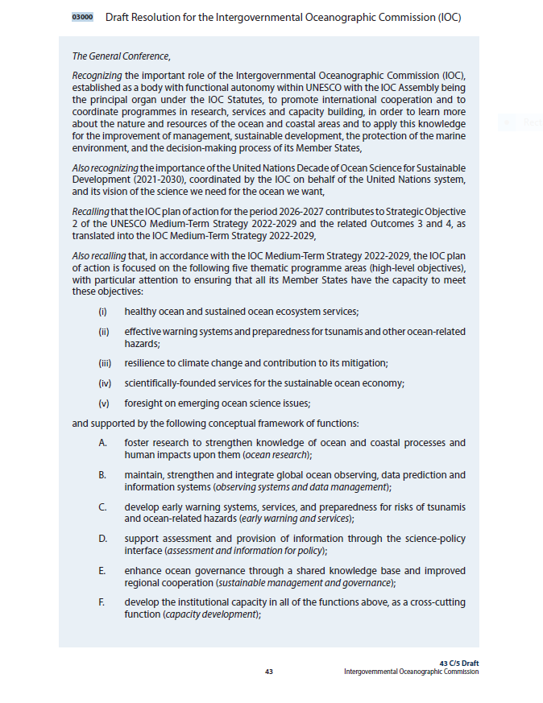
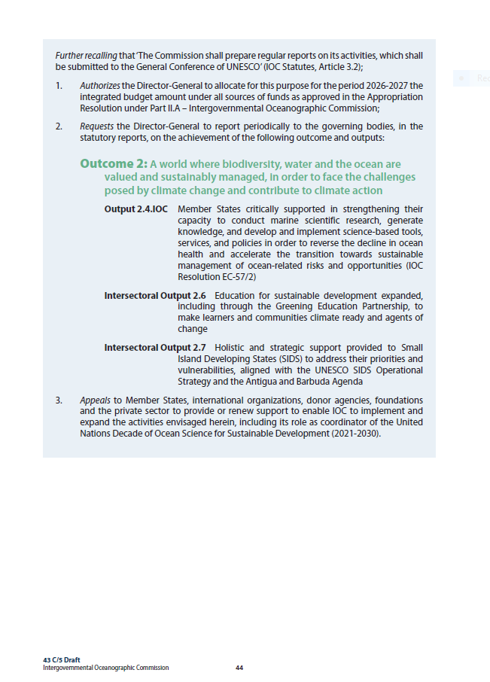

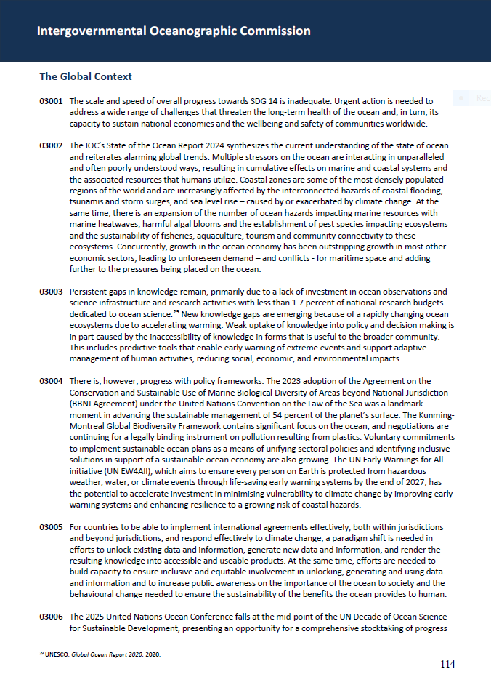

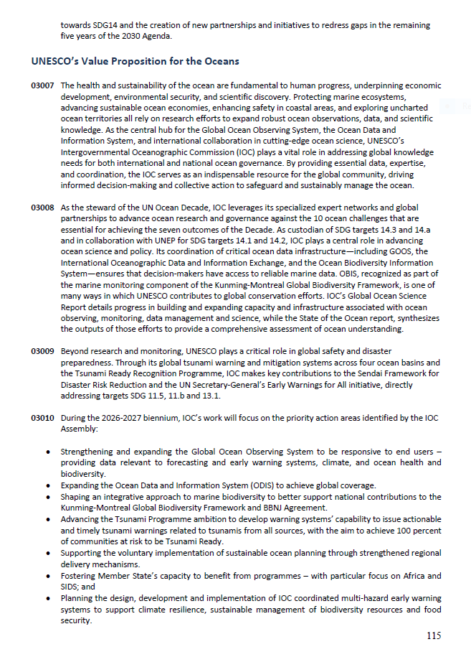
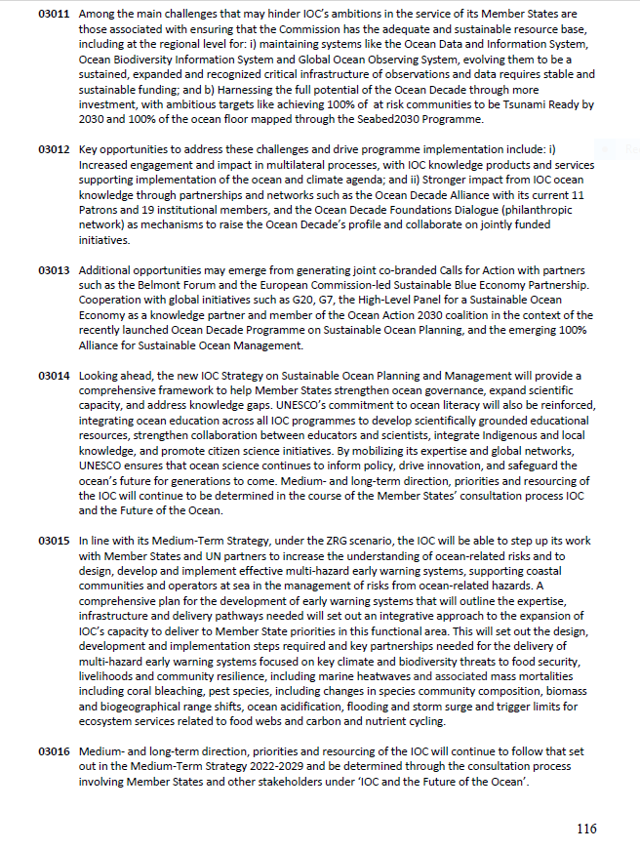
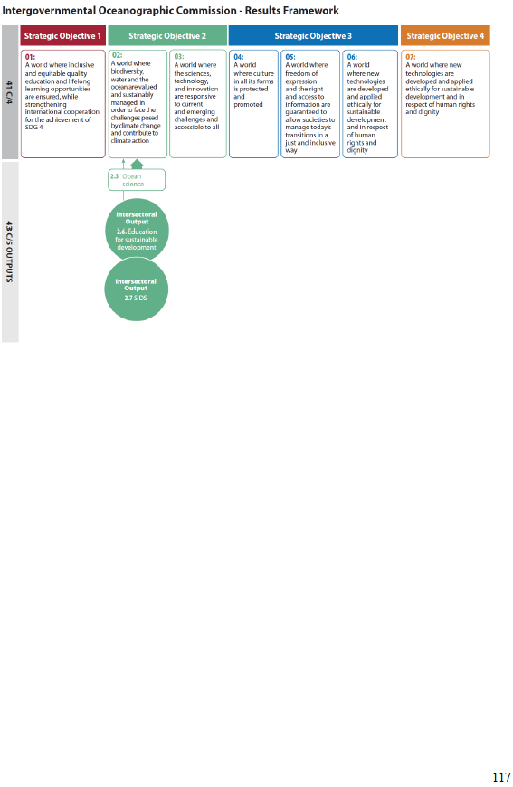

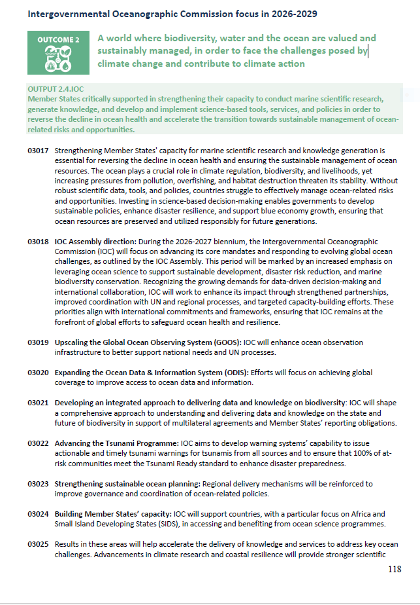

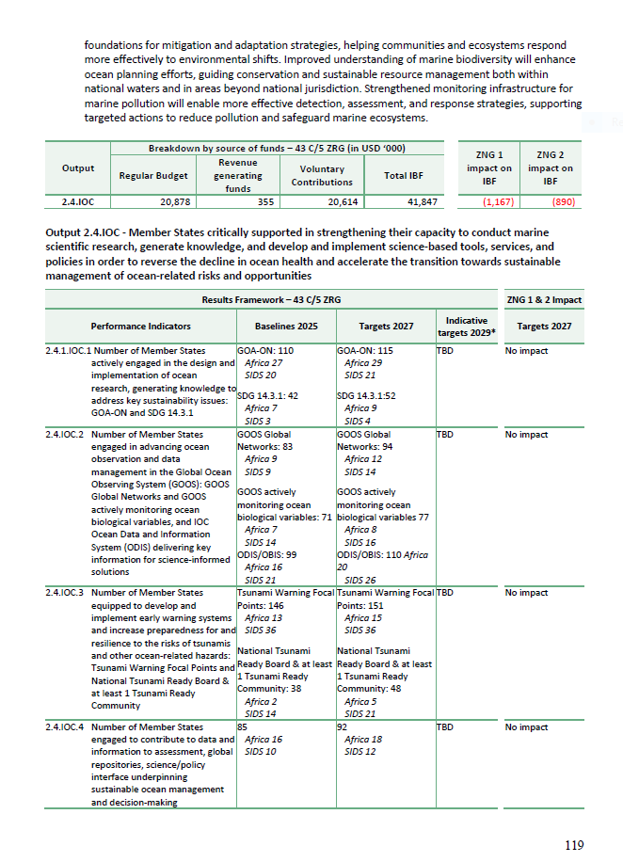

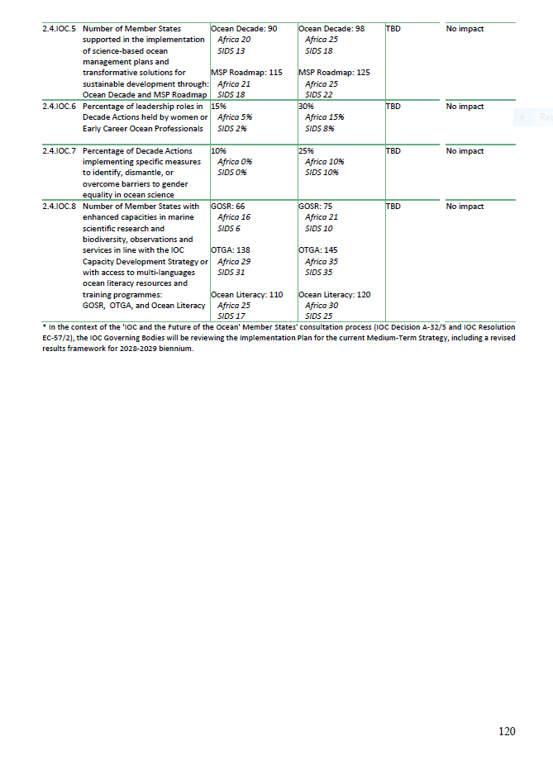

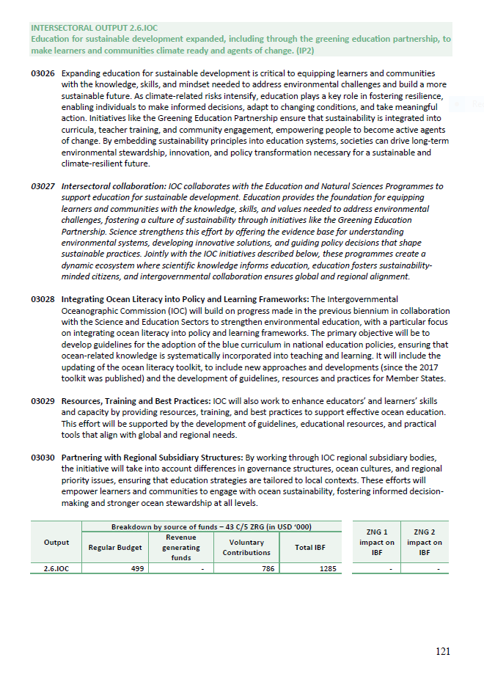

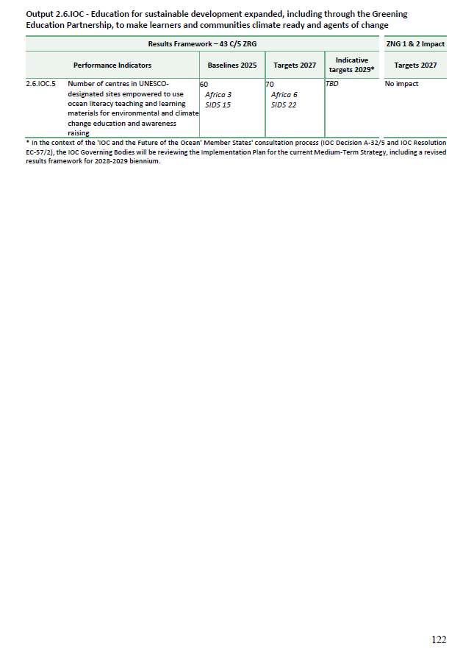

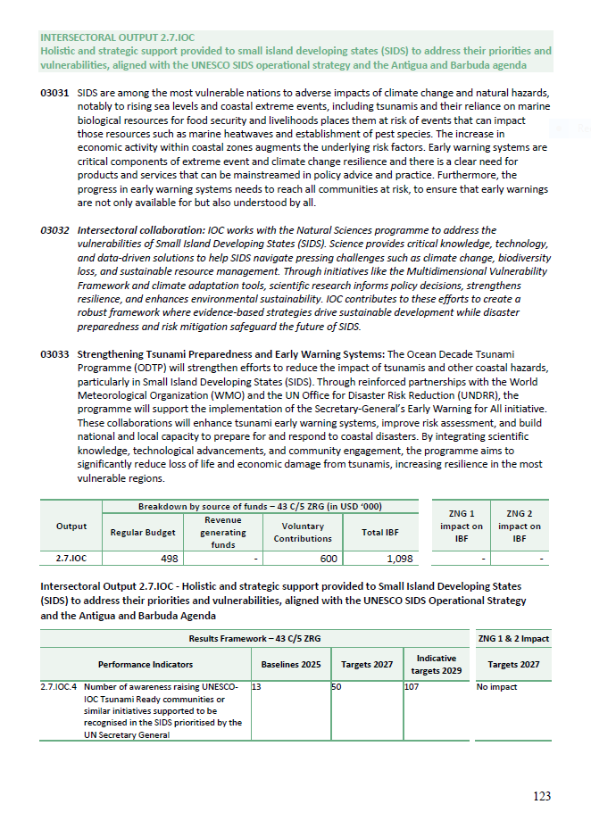
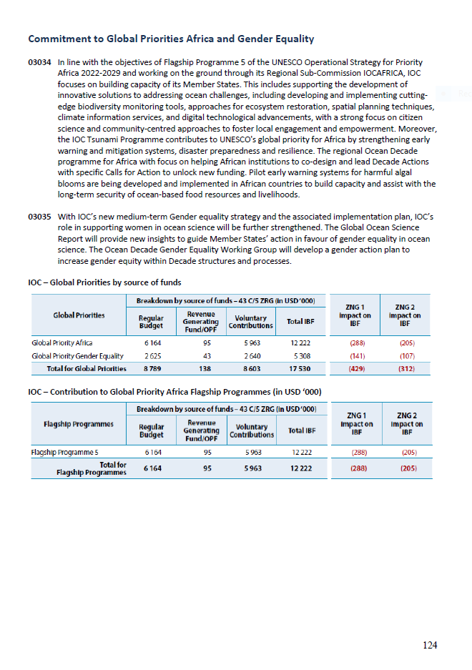
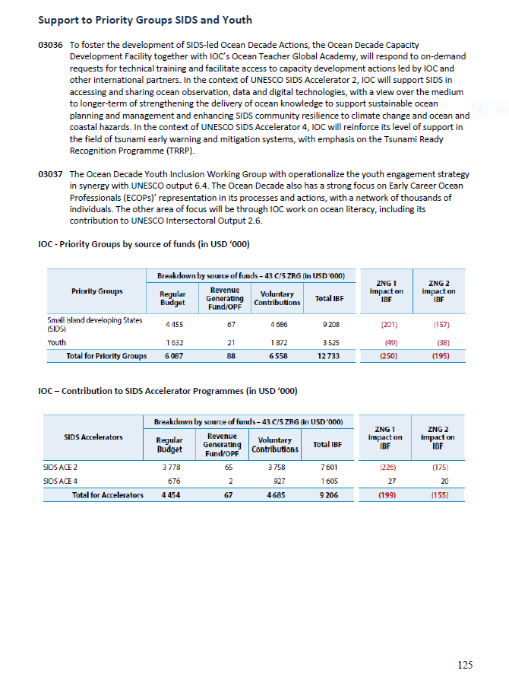
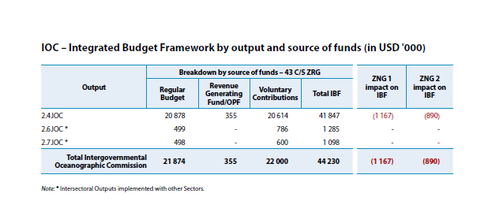

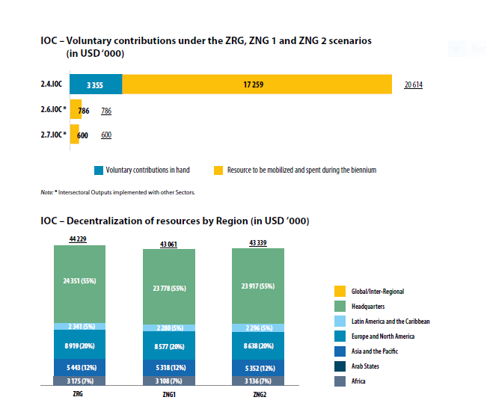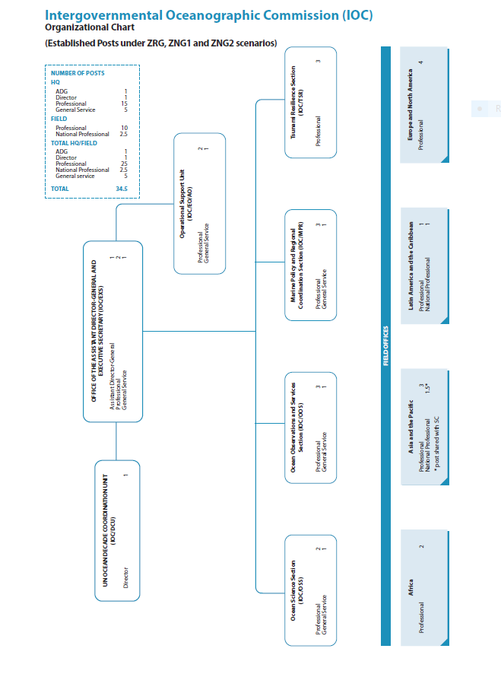

Part II
DETAILED IOC WORKPLAN 2026–2027

Based on Member States’ priorities as per IOC Resolutions A-32/4 and EC-57/2

- In developing its proposals for the detailed workplans for the first biennium of the last quadrennium of its current Medium-Term Strategy (2022–2029), the IOC Secretariat was guided by the Commission’s Mission statement, Vision and High-Level Objectives.
- This programme falls at a critical time in the second half of implementation of the Ocean Decade and the finishing line for the SDGs of 2030 Agenda. It reflects Member States’ priorities as reaffirmed in the IOC Governing Bodies’ resolutions and decisions.
- In this context, and pending the outcome of the ongoing ‘IOC and the Future of the Ocean’ process consultation that will further inform the process and may introduce adjustments at future Governing Bodies’ sessions, it is proposed that the IOC’s work in the first biennium of the 43C/5 will focus on:
- Delivering on the IOC Output:
‘Member States critically supported in strengthening their capacity to conduct marine scientific research, generate knowledge, and develop and implement science-based tools, services and policies in order to reverse the decline in ocean health and accelerate the transition towards sustainable management of ocean-related risks and opportunities’,
- Giving priority to key action areas:
- Upscaling and sustaining the Global Ocean Observing System (GOOS) infrastructure to address user needs including Member States own needs and providing data and information to support implementation UN conventions and frameworks including in relation to climate, biodiversity and ocean health.
- Expanding the Ocean Data & Information System (ODIS) and the Ocean Biodiversity Information System (OBIS) to achieve global coverage and operationalizing a coordinated IOC data architecture.
  - Strengthened coordination in relation to marine biodiversity to better support Member States in fulfilling commitments in implementation of the Kunming-Montreal Global Biodiversity Framework and the BBNJ Agreement, as well as regional policy frameworks.
  - Advancing the Tsunami Programme ambition to achieve 100% of communities at risk to be Tsunami Ready and initiating planning and implementation of broader multi-hazard early warning systems to support climate resilience, sustainable biodiversity and ecosystem management, and food security.
  - Supporting Sustainable Ocean Planning and Management including through strengthened regional delivery mechanisms and acting as global knowledge partner for Member States’ commitments to develop and implement Sustainable Ocean Plans.
  - Enhancing Member State’s capacity to engage in and benefit from IOC programmes with a particular focus on Africa & SIDS.
  - Enhancing delivery of the Ocean Decade to strengthen the collective impact of IOC-led and partner-led Decade programmes and projects to inform societal decision making at all scales and lay the foundation for the post-2030 legacy of the Decade
- Contributing to UNESCO Intersectoral Outputs on Environmental Education and Early Warning for All with focus on SIDS.

- Work across these action areas will depend on Member State investment in ocean observations and science, and will in turn serve as evidence of the societal and economic benefits of such investments. The efforts will be supported by cross-cutting actions in capacity development, ocean literacy, and strategic communications.
- IOC-led assessment and knowledge synthesis products, and IOC’s contributions to partner-led products will be key elements of the work to deliver global and regional information across the science-policy-society interface. Actions will be tailored to regional needs and will have a specific focus on priority groups including Africa, SIDS and Early Career Ocean Professionals. Partnerships within and outside the UN system will be actively pursued and strengthened to ensure effective delivery of IOC’s work.
- With its vision of ‘the ocean we need for the future we want’, the Ocean Decade coordinated by the IOC, will continue to provide an overarching framework for IOC programmes to innovate and trial transformative approaches to the generation of timely, relevant and co-designed knowledge that has direct applicability to decision making. The Ocean Decade fosters the ability of IOC programmes to work in new ways, with new partners, and focusing on emerging issues, thus building the foundation of the future IOC for the post-Decade era. The Ocean Decade will continue to highlight the societal benefits of IOC and its programmes and support the evolution of ocean science to be able to deliver beyond the diagnostics of existing or emerging problems to co-design effective solutions for implementation by actors across society. The consultation work that was requested by the Executive Council as part of the ‘IOC and Future of the Ocean’ process will ensure that the knowledge and experience generated through the Ocean Decade can be leveraged to meet the evolving needs and expectations of Member States.
- In accordance with IOC Resolutions A-32/4 and EC-57/4, this draft programme and budget for 2026-2027 reflects the IOC priorities in terms of long-term sustained observations and data and information management, as IOC aspires to generate and apply scientific knowledge to achieve the following High-Level Objectives (HLO), with particular attention to ensuring that all Member States have the capacity to meet them:
- Healthy ocean and sustained ocean ecosystem services
- Effective warning systems and preparedness for tsunamis and other ocean-related hazards
- Resilience to climate change and contribution to its mitigation
- Scientifically founded services for the sustainable ocean economy; and
- Foresight on emerging ocean science issues.

- Implementation of the HLOs is organized as a framework of six functions – A. Ocean research, B. Observing system/data management, C. Early warning and services, D. Assessment and information for policy, E. Sustainable management and governance, F. Capacity Development - realised through IOC’s and co-sponsored programmes, work of IOC regional and technical subsidiary bodies.

Proposal for a New, Distinct IOC Results Framework

- Based on findings emerging from the IOC Governance and Management Assessment, initial results of the Phase 1 consultation for ‘IOC and the Future of the Ocean’ as well as consultations with IOC programmes, it is proposed that the IOC develops a new and distinct results framework to better align with the Medium-Term Strategy. This will enable the IOC to better monitor progress towards achievement of the Medium-Term Strategy in the period 2026–2027.
- The engagement of and input of Member States will be paramount to the design of a new results framework.
- The framework identifies sub-objectives and Key Performance Indicators (KPIs) for each High-Level Objective (HLO). Through a mixture of qualitative and quantitative reporting, the results framework will track status, gaps and needs in relation to IOC support to Member States. It explicitly focuses on the role of IOC in delivering observations, data, products and services to underpin scientific research to inform decision making. As such, the sub-objectives and KPIs contained in the results framework have been selected to measure progress across IOC programmes contributing to the fulfilment of the HLOs and do not attempt to measure parameters related to the state of the ocean, ocean ecosystems or ocean-dependent communities which are captured in other assessments both by IOC and partners. The KPIs have been selected to reflect the most substantive areas of contribution of functions to the sub-objectives, or to highlight specific issues that merit tracking in the next biennium.
- The results framework will continue to be refined in line with the outcomes of the ‘IOC and the Future of the Ocean’ consultation process and discussions at the 33rd Session of the IOC Assembly.

IOC High Level Objectives (HLOs) from the IOC Medium-Term Strategy

Sub-objectives based on aggregated ‘bullet points’ from the IOC Medium-Term Strategy – tentatively 3 per HLO

KPIs across IOC value chain to support:

- Generation of Knowledge
- Sharing of Knowledge
- Application of Knowledge

Draft IOC Results Framework 2026–2027

High Level Objectives | Sub-Objectives
1. Healthy ocean and sustained ocean ecosystem services | 1.1 Enhanced observations and data for increased understanding of ocean vulnerability to multiple stressors | 1.2 Enhanced access to scientific knowledge adapted to regional and national needs to inform sustainable management of ecosystems | 1.3 Enhanced application of best practices, tools and approaches for ecosystem-based management
KPIs & targets | Number of Member States routinely collecting and managing FAIR EOV data on biodiversity and ecosystems through GOOS, ODIS and OBIS  Target 2027: 100  Increase in the number of open-access biodiversity datasets in OBIS available to Member States  Target 2027: Increase of 700 | Number of global and regional assessment methods and products addressing ocean ecosystems and vulnerability to multiple stressors, disaggregated by IOC-led or IOC-contributions  Target 2027: 3  Number of Member States making use of ODIS to discover and access ocean data and information  Target 2027: 50 | Number of Sustainable Ocean Planning and Management (incl. Marine Spatial Planning) guidelines / tools specifically addressing ecosystem-based management approaches, biodiversity issues and/or multiple ocean stressors  Target 2027 for MSP: 5  Target 2027 for SOP: 2  Number of capacity development initiatives provided to Member States to fulfil national commitments related to biodiversity under multilateral agreements including CBD and BBNJ  Target 2027: 5
2. Effective warning systems and preparedness for tsunamis and other ocean-related hazards | 2.1 Improved ocean observations and data to underpin models and forecasting for ocean hazards | 2.2 Increased access to data and information products for coastal planning and hazard mitigation | 2.3 Enhanced deployment of regionally or nationally adapted decision support tools including multi-hazard early warning and mitigation systems
KPIs & targets | Number of Member States engaged in advancing ocean observations and managing FAIR data required for monitoring tsunamis and other ocean-related hazards through GOOS and ODIS  Target 2027: 134 (tsunami-geophysical), 94 (Africa 12, SIDS 14) (hydrometeorological hazards), 25 (ocean stressors) | Number of Member States conducting ocean research aimed at supporting forecasting and early warning systems for tsunamis and other ocean-related and coastal hazards, including sea level rise, marine heatwaves, ocean acidification, harmful algal blooms and pest species  Target 2027: 20 (tsunami), 20 (hydrometeorological hazards), 10 (sea level rise, 25 (ocean stressors) | Number of Member States supported to pilot or implement tsunami and other IOC supported EWS, including through capacity development initiatives  Target 2027: 100 [Africa 15; SIDS 20]  Number of communities recognized as Tsunami Ready  Target 2027: 200 communities in 48 MS (5 Africa MS, 21 SIDS MS)

3. Resilience to climate change and contribution to its mitigation | 3.1 Enhanced observations and data for increased scientific understanding of the ocean dimension in climate change | 3.2 Enhanced access to scientific knowledge on impacts of climate change on the ocean and on ocean-based climate solutions | 3.3 Enhanced application of fit for purpose tools for Member States to integrate ocean issues in National Adaptation Plans and Nationally Determined Contributions
KPIs & targets | Number of Member States routinely collecting and managing FAIR EOV data on climate through GOOS or ODIS  Target 2027: 80  Number of Member States supported with capacity development for collecting and managing observations related to climate change trends including ocean acidification and sea level rise  Target 2027: 100 [Africa 15; SIDS 29] | Number of Member States engaged in ocean climate research networks including ocean acidification, deoxygenation and blue carbon  Target 2027: 115 (Africa 29, SIDS 21) | Number of Member States supported to integrate ocean issues in Nationally Determined Contributions or National Adaptation Plans, including through capacity development initiatives  Target 2027: 5
4. Scientifically founded services for the sustainable ocean economy | 4.1 Enhanced evidence base on the societal and economic return on investment in ocean science and ocean science infrastructure | 4.2 Enhanced dissemination of relevant scientific knowledge to marine industries and economic actors | 4.3 Enhanced application of fit for purpose knowledge-based sustainable ocean planning and management tools
KPIs & targets | Number of knowledge products, case studies, analyses contributing to the evidence base on societal, environmental and economic return on investment in ocean science and ocean science infrastructure, disaggregated by IOC-led or IOC-contributions.  Target 2027: 5  Number of MS contributing information to the Global Ocean Science Report relating to investment in ocean science and ocean science infrastructure  Target 2027: 75 (Africa 21, SIDS 10) | Number of partnerships / networks with private sector actors related to ocean science, data cooperation and co-design of knowledge  Target 2027: 5 | Number of Member States engaged in and supported by IOC-led activities on Sustainable Ocean Planning and Management (incl. Marine Spatial Planning) , including through capacity development initiatives  Target 2027 for MSP: 125; Africa = 32; SIDS = 22)  Target 2027 for SOP: 20
5. Foresight on emerging ocean science issues. | 5.1 Improved capacity and processes to anticipate and prioritize emerging ocean science and technology issues | 5.2 Enhanced dissemination of scientific understanding of priority emerging ocean science issues | 5.3 Improved ability to account for and respond to priority emerging issues in decision making
KPIs & targets | Number of Member States, including through GOOS Regional Alliances, undertaking planning or risk assessment processes for ensuring observation systems are adaptable to emerging science and technology issues  Target 2027: 5 | Number of global and regional assessment products addressing emerging ocean science issues disaggregated by IOC-led or IOC-contributions  Target 2027: 3 | Number of capacity development initiatives delivered on emerging ocean science issues  Target 2027: 2

KEY ELEMENTS OF PROGRAMME DELIVERY AT FUNCTION LEVEL

Function A – Ocean Research

Focus 2026–2027:

- The focus of activities under function A remains on supporting international collaboration to foster new knowledge, to translate that knowledge into products for decision making and informed policy development and to build research capacity on those topics that are the focus of activities under function A. These include activities focused on climate and ocean variability, ocean acidification, ocean deoxygenation, blue carbon and the ocean carbon cycle more broadly, as well as ocean stressors and delivery into multi-lateral processes and next generation climate and biodiversity accounting and financial Continued support frameworks. Strategic partnerships continue to ensure a wide scientific and geographical coverage and engagement. Resources are primarily directed towards funding expert groups, coordination of international networks and direct engagement as well as targeted capacity development. Ongoing support will be provided to Ocean Decade programmes coordinated under the function and synergies with the UN Decade of Action for Cryospheric Sciences, particularly in relation to co-sponsorship of the World Climate Research Program.
Key deliverables:
- Delivery of climate predictions into IPCC processes
- Expansion of the Global Ocean Acidification Observing Network and Global Oxygen Observing Network, including engagement by African States and SIDS
- Methodologies and standards for measuring carbon (including blue carbon), ocean acidification, deoxygenation and attributing impacts of stressors on the marine environment
- Delivery of a global oxygen database and atlas (GO2DAT) as part of the UN Ocean Decade
- Strategic white papers, guidance documents and summaries for policymakers on climate change, ocean carbon coastal blue carbon ecosystems and anthropogenic stressors and impacts

Function B – Observing system/Data management

International Data & Information Exchange (IODE)

Focus 2026–2027:
  - Increasing the number of national as well as other entities participating in international ocean data and information sharing through the IODE network of data centres, the IOC Ocean Data and Information System (ODIS) and the Ocean Biodiversity Information System (OBIS);
  - Maintaining and further developing global online data and information products such as AquaDocs, OceanExpert, Ocean Best Practices System, the ODIS Catalogue of Sources (ODISCat);
  - Commencing the implementation of the Ocean Data 2030 Decade Action, expanding the ocean data ecosystem;
  - Increasing the volume of quality content (data, information and knowledge) shared by, and available to Member States and other partners to underpin their sustainable ocean planning and management;
  - Encouraging IODE data centres to co-design user focused national activities that deliver necessary products and services for sustainable ocean planning and management and assist with decision support, SDG reporting, contributing to reporting mechanisms and frameworks;
  - Enabling Member States to actively and equitably participate in and benefit from IODE programme activities through the OceanTeacher Global Academy (OTGA) and through IODE best practices, guidelines and methodologies in ocean data and information management and sharing..

Key deliverables:
- Global ocean data and information systems providing trusted, quality controlled and securely archived ocean data and information;
- Member States enabled to share and use quality ocean data and information applicable to SDG reporting, contributing to GOSR, StOR and other reporting mechanisms and legal frameworks.

Global Ocean Observing System (GOOS)

Focus 2026–2027:

- The focus remains on coordinating the Global Ocean Observing System (GOOS), strengthening and building the coordination and partnerships needed to grow an integrated, responsive and sustained ocean observing system that supports the needs of Member States. This contributes to IOC output as well as across all five high level objectives of the IOC Medium Term Implementation Strategy 2022–2029. The work takes into account the need to support each part of the Global Ocean Observing System (GOOS)—sponsors, steering committee, the three Essential Ocean Variable expert groups, observing networks, coordination groups, regional alliances, national focal points and partners—helping to build an integrated and responsive system to provide data for forecasting, climate, ocean health and ecosystems.
- The focus for GOOS is on the following key objectives
  - GOOS coordination and management across all GOOS components
  - Observation system integration, design, development and delivery
  - Maintain and strengthen data integration and delivery
  - System implementation: i) at national and regional level and ii) and for applications
  - Outreach: projects, partners and communications
  - GOOS Reform

Key deliverables:
- Strategic leadership and planning provided to support and improve coordination and implementation across all GOOS components
- GOOS biodiversity plan, coordinated with OBIS
- GOOS carbon plan
- Proposal of an international framework of ocean indicators
- Lead the WMO Rolling Review of Requirements (RRR) Ocean Earth System Application Category (ESAC).
- IOC-wide data architecture plan and demonstration products
- Member States and Regional Alliances supported to enhance their capacity to share and use EOV data and contribute and report to GOOS
- Support WMO/IOC Joint Collaborative Board, including to expand WMO Global Basic Observing Network (GBON)
- Partnership with UN and non-UN partners strengthened and/or broadened to deliver on GOOS
- Review of mission, scope, structure of GOOS and proposal for reform

Function C – Early warning and services

Focus 2026–2027:
- Focus remains on supporting international collaboration to provide a key direct contribution to the implementation of the UN Sendai Framework for Disaster Risk Reduction (2015–2030) by coordinating the intergovernmental network of four regional tsunami warning and mitigation systems; acting as global standard setter for global tsunami warning and mitigation and coordinating 13 Tsunami Service Providers (TSPs) running round-the-clock operational services.
- Coordinating a large network of National Tsunami Warning Centres (NTWC) and Tsunami Warning Focal Points (TWFP), IOC will be able to achieve major improvements in accuracy and timeliness of tsunami warnings. Through a partnership with the UN Office for Disaster Risk Reduction (UNDRR) and other partners IOC will target a 100% increase, over the currently existing level, of the number of communities recognized as Tsunami Ready under the IOC-UNESCO Tsunami Ready Recognition Programme (TRRP).
- Within the context of the Research, Development and Implementation Plan for the Ocean Decade Tsunami Programme (2024–2030) Member States will be supported to develop technical foundations to integrate services for tsunamis generated from non-seismic sources like volcano-generated tsunamis and to develop integrated early warning operating procedures for geophysical hazards.
- As part of delivery into the IOC Medium Term Strategy, activities supporting the expansion of early warning systems and associated capacity development will be conducted. This includes expanding pilot efforts in Africa focused on developing and implementing early warning systems for harmful algal blooms and planning out activities supporting the development of IOC coordinated early warning systems to support climate resilience, sustainable management of biodiversity resources and food security. Associated, ongoing support for the Intergovernmental Panel on Harmful Algal Blooms will be provided and support for cross UN and IOG expert groups (including with the IMO, FAO and ICES) focused on delivering outputs on harmful algal blooms, invasive species and fouling for use in management and decision-making will continue.
Key deliverables:
- 15 additional sea level stations in Africa contributing to the Global Sea Level Observing System (GLOSS) for coastal hazards, including tsunamis. Restoration of at least two GLOSS Core Networks (GCN) stations in North Africa
- 2 new Tsunami Warning Focal Points (TWFP) in Africa. 3 new National Tsunami Ready Boards in Africa and 7 in SIDS
- 6 new Tsunami Ready communities recognised in 5 SIDS in the Caribbean Region, 2 communities in 2 SIDS in the Indian Ocean, and 5 communities in 5 SIDS in the Pacific Ocean (total of 13 new Tsunami Ready communities in 12 SIDS)
- Stepped up intersectoral cooperation with the Science Sector and the UNESCO Pacific Office to foster collective learning to better address common threats from geohazards (earthquakes, landslides, volcanoes, and tsunamis) in the Pacific Islands
- An implementation plan for expansion of IOC coordinated early warning systems with thematic focus on events such as marine heatwaves, ocean acidification, harmful algal blooms, pest species and flooding
- Expanded development and implementation of early warning systems for harmful algal blooms, including an increase in the capacity of African Member States to gather, store and apply ocean observations for the development of early warning systems
- Strategic white papers, guidance documents, summaries for policymakers and improved model-based predictions for harmful algal blooms and invasive species.
Function D – Assessment and Information for Policy

Focus 2026–2027:
- The focus will be on strengthening engagement and contributions of IOC to global assessment initiatives such as the World Ocean Assessment, the Intergovernmental Panel on Climate Change (IPCC), the Intergovernmental Policy-Policy Platform on Biodiversity and Ecosystem Services (IPBES), as well strengthening its own assessment process and products (from design to dissemination), such as the State of the Ocean Report (SToR), the Global Ocean Science Report and products developed through GESAMP. This will include identification and integration of key environmental and socio-economic indicators that can be monitored and reported on through time via the StOR that support wider reporting mechanisms including those under the Ocean Decade and the World Ocean Assessment. Activities will also focus on further developing the methods, standards and capacity for national reporting processes associated with the SDG targets 14.1, 14.3. and 14.a and streamlining and simplifying Member State reporting into the GOSR. Partnerships focused on delivering an implementation roadmap for addressing the impacts of pollution will be progressed.
- In the framework of multi-lateral meetings such as CBD COP 17, UNFCCC COP 31 and 32, continued engagement in the UNFCCC SBSTA and CBD SBSTTA will be supported and targeted policy briefs will be developed to inform and raise awareness of Member States on latest scientific findings and key messages for advancing the outcomes of agreements, as well as their own national ocean management frameworks. In addition, continued engagement in the preparatory process associated with the Agreement on Marine Biodiversity of Areas beyond National Jurisdiction (BBNJ)will be supported. Further partnership with other UN and non-UN partners will be broadened to deliver on this function, including by enhancing the science delivery of IOC Sub-Commissions to relevant regional ocean policy mechanisms. Contribution to GEBCO will be strengthened with particular focus on expanding the global coverage of seabed mapped, leveraging the Ocean Decade work in this area, through international collaboration, technological innovation, capacity development, and outreach.
Key deliverables:
- Expanded reporting of the 14.3.1 and 14.a.1 SDG indicators and finalisation of SDG Indicator 14.1.1.
- The third edition of the Global Ocean Science Report
- The 2026 edition of the State of the Ocean Report
- Identification of a pilot set of indicators for inclusion in the StOR and greater uptake into the World Ocean Assessment
- Regular engagement in multi-lateral processes through participation in the UNFCCC, CBD and the BBNJ Preparatory Commission.
- Regional training courses on ocean assessment implemented in 2 regions (Africa, Caribbean)
- GEBCO Strategy (2024-2030) implemented through the GEBCO Guiding Committee
- Two regional science-policy fora organised through IOC Regional Sub-Commissions;
- Assessment of end-user needs related to essential data and information to support the implementation of the Sustainable Ocean Planning and Management

Function E – Sustainable management & governance

Focus 2026–2027:
- IOC will build on its leadership in Marine Spatial Planning to deliver technical support at the national and regional level working in close collaboration with the IOC Regional Sub-commissions. The implementation of an IOC-wide strategy on Sustainable Ocean Planning and Management, as well as the implementation of the dedicated Ocean Decade Programme on SOP will identify national user needs to guide the development and application of decision support tools and the provision of technical training. Partnerships will be enhanced with the GEF, UNDP and the European Commission to deliver ecosystem-based management applications and transboundary management approaches such as Large Marine Ecosystems, and strengthen the science/policy interface at the regional and national level. Efforts to promote the economic and policy value of the IOC end-to-end value chain of activities, with new work looking at methods to analyse the return on investment into ocean science will be conducted.
- The Commission will strengthen its relationship with other UN Agencies through UN-Oceans and other partnership arrangements, to enhance the delivery of scientific data and knowledge in support of ocean governance and the sustainable development agenda. The Commission will revamp its communication strategy, review its vision statement and identify priority communication themes, audiences and channels, leveraging the ecosystem of the Ocean Decade. The work of Regional Sub-Commissions will be enhanced by creating stronger synergies with national and regional ocean policy mechanisms and other relevant science end-users, building on the outcomes of the IOC and the Future of the Ocean consultation.
- The IOC Secretariat to will continue to coordinate the implementation of the Ocean Decade, focusing on four main pillars of activity: (i) Decade Actions; (ii) Governance and coordination structures and informal working groups; (iii) Resource mobilization; and (iv) Stakeholder engagement and outreach.As the Decade enters the second half of its implementation, and in the lead up to the 2027 Ocean Decade Conference, increased efforts will be made to consolidate the impacts of the portfolio of Decade Actions and ensure the uptake of science and knowledge to inform decision making. A key focus of the next period will be on the continued operationalisation of the recommendations of the 2024 Ocean Decade Conference and the implementation of actions to address key findings of the mid-term evaluation, and its action plan that will be developed on the basis of the management response.
Key deliverables:
- International guidance developed and disseminated on the inclusion of climate change, conservation, indigenous and local knowledge in MSP processes
- Technical support provided to foster regional/transboundary cooperation in sustainable ocean planning , national processes supported through training and rapid assessment
- New IOC communication strategy developed
- High-level event organised at UNFCCC, CBD, and UNOC in partnership with Member States and partners (UN and non-UN).
- 8-10 Countries supported through MSP rapid assessment assistance
- Implemented priority actions of Ocean Decade Action Plan in response to Mid Term Evaluation
- Organisation of the 2027 Ocean Decade Conference

Function F – Capacity development

Coordination

Focus 2026–2027:

- Activities will be guided by the priorities of the IOC Capacity Development Strategy (2023–2030), with a focus on actioning the Implementation Plan for the IOC Capacity Development Strategy and finalising the IOC Plan of Action for Ocean Literacy (2026-2030). Activities will be supported by IOC Ocean Capacity Development Hub, the Ocean Teacher Global Academy platform and the Decade Coordination Office for Challenge 10.
Key deliverables:
- A finalised Implementation Plan for the IOC Capacity Development Strategy (2023-2030)
- A pilot biennial capacity development survey, implemented in close collaboration with the regions and that delivers into the Global Ocean Science Report
- Expanded use of the IOC Capacity Development Hub in alignment with the Decade Capacity Development Facility
- Regular meetings of the Group of Experts on Capacity Development will guide the implementation, co-designed in close collaboration with Regional Subsidiary Bodies’ secretariats as well as global programmes and technical subsidiary bodies
- Increased awareness of IOC’s capacity development activities and outputs, including of the strategy and implementation plan
- Production of outputs including policy briefs, brochures, and other materials.

GLOBAL PRIORITY AFRICA

- Member States in Africa have unique challenges in relation to the generation and application of ocean science and knowledge for sustainable economic development and are thus a focus of IOC’s efforts including through the Ocean Decade, and its African Roadmap, and the coordination provided by the IOCAFRICA Secretariat.
- Key priorities will focus on enhancing regional capacity in ocean science and data services by leveraging IOC’s global technical expertise and training platforms to strengthen the capacities of scientists and institutions in ocean observation and data management—foundational elements for informed decision-making and sustainable ocean-based economic development. In doing so, articulating the work of the IOCAFRICA Sub-Commission with regional frameworks such as the African Union Blue Economy Strategy, and Agenda 2063 will be key, as well as fostering collaboration with the African Union and UN Regional Commission for Africa.
- The Decade SEAWARD Africa programme, structured around four thematic components addressing sustainable management of marine resources; climate change and marine biodiversity; ocean pollution; and extreme events and disaster risk reduction, will provide a coordinated framework for the implementation of the Ocean Decade Africa Roadmap formulated in 2023. Through IOCAFRICA, efforts will focus on strengthening the GOOS Africa network and coordination of observing systems with the aim to expend these and ensure delivery of data to end-users. Ocean observing capacity will be expanded through the coordination of deployment of instruments, to enhance real-time monitoring of ocean variables for climate, ecosystem and coastal hazards forecasting.

Key deliverables 2026–2027:
- Operationalization of the African Ocean Observing System (AfOOS): Scale up regional observation infrastructure through national implementation roadmaps, standardized data protocols, and integration of GOOS-Africa outputs into national early warning and marine policy systems
- Development of African Ocean Data Guidelines: In partnership with IODE and regional data centres, initiate the co-development of continental guidelines on ocean data collection, management, interoperability, and sharing, tailored to African institutional capacities and aligned with FAIR principles. These will serve as reference for national policies, regional platforms and international collaboration
- Strengthening national ocean science policies: Support at least 10 countries in the development or revision of national ocean science plans and strategies
- Scaling the multi-hazard early warning dashboard: Expand the pilot ocean early warning dashboard from West Africa to at least two additional subregions, incorporating sea-level rise, HABs, coastal flooding and marine heatwave indicators
- Launch of the African Ocean Literacy Strategy: Coordinate the roll-out of a continent-wide framework for advancing ocean literacy, including national action plans, teacher training modules, and promotion into education curricula
- African Ocean Innovation Incubator: Establish a multi-partner innovation facility to fund and mentor ocean science startups and community-led solutions focused on sustainable ocean economy, nature-based adaptation and marine technology
- Strengthening of the regional research vessel network: Coordinate access to oceanographic research vessels through and African charter mechanism, linking national research institutions, donor agencies, and vessel operators to support priority data collection missions
- Expanded ECOP Leadership Programme: Formalize a continent-wide leadership and mentoring scheme for Early Career Ocean Professionals, linked to national Decade Committees and UNESCO Chairs, to cultivate African leadership in ocean science and governance
- Support to 10-15 countries in Marine Spatial Planning (MSP) processes and piloting of MSP transboundary cooperation in one sub-region;
- The OceanTeacher Global Academy will expand its network of training centres in Africa and make full use of regional and local expertise to deliver needs-tailored training.

SMALL ISLAND DEVELOPING STATES

- The Antigua and Barbuda Agenda for SIDS (ABAS) adopted in 2024 by the UNGA will guide the work of IOC towards SIDS across the whole science value chain, considering the unique challenges that SIDS face due to their geographic isolation, vulnerability to climate change, reliance on ocean resources, and limited technical and financial capacity. Alliances with SIDS focused-partner organizations in the Atlantic and Pacific will ensure engagement of ocean basins not covered by IOC regional subsidiary bodies, whilst the four IOC Sub-Commissions will identify and address SIDS needs through their programmatic frameworks in their respective regions.
- Targeted investments will allow customized approaches to capacity development based on SIDS-specific requirements and priorities. Ocean literacy and Intersectoral Programme IP2 dedicated action will be strengthened in SIDS. Leveraging its global expertise, IOC will focus on increasing SIDS technical and scientific capacity for climate resilience, marine related hazards responses, including invasive species, through adequate early detection/early warning systems and the use of innovation and technology for (near) real-time data collection for research, monitoring, enforcement, and decision making. Capacities of SIDS to implement Marine Spatial Planning/ Sustainable Ocean Planning Management will be supported through the application of SIDS-focused rapid assessment tools for SOPM, and targeted training provided through the MSP Global programme.
- Ocean Decade Regional Task Forces and Capacity Development Facility will provide support for the formulation of SIDS-led Decade Actions, underpinned by technical training focusing on co-design, science-policy interface, national accounting, Marine Spatial Planning, and the use of indigenous and local knowledge in ocean management. Pacific SIDS will be supported to enhance coastal ecosystem resilience through ocean science collaborative action delivered by and for Pacific SIDS-based organizations and individuals.
- With particular focus on resilience to tsunamis and other ocean-related hazards, the goal is that, by 2030, 100% of at-risk communities in the Caribbean, Pacific Ocean and Indian Ocean SIDS are recognized as Tsunami Ready.
Key deliverables:
- Programme for Sustainable Ocean Plans developed in SIDS within the context of the Ocean Decade Sustainable Ocean Planning Programme (SOP)
- Regional Indigenous and local knowledge (ILK) framework established and supported to ensure the full engagement of ILK holders in the Ocean Decade and ensure exchange and collaboration of alternative knowledge systems to complement ocean science for sustainable ocean management
- Regular SIDS capacity development assessment part of IOC CD Strategy Ocean Decade Capacity Development Facility acting as match-making platform for addressing SIDS needs
- Country Assistance though Rapid Assessment for Marine Spatial Planning process – leading to national action plan (
- Support to Pacific SIDS in climate resilience through Online/In person Training, Community of Practice, SIDS Forum established in partnership with The Pacific Community
- 30% increase in number of SIDS (5 new) that have established a National Tsunami Ready Board (NTRB) and have got recognition for at least 1 new Tsunami Ready recognized community in the framework of the Tsunami Ready Recognition Programme (TRRP)
- eDNA monitoring (invasive species/biodiversity assessment) initiatives conducted in 5 SIDS.
PROPOSED 2026–2027 BUDGETARY ALLOCATIONS

- In preparing its proposals for the Draft 43 C/5 allocations, the Secretariat was guided by Member States’ definition of priorities as reflected in IOC Resolution A-32/4 and EC-57/2. With all proposed scenarios implying a reduction of the non-staff (activity) portion of the budget, the cut across the board in the two UNESCO zero nominal grown (ZNG) scenarios keeps the proportional increases to GOOS, IODE, Capacity Development and Regional Subsidiary Bodies already agreed in the 42 C/5 approved. The zero real growth (ZRG) scenario allows to keep those ‘critically vulnerable’ areas at the same budgetary level as in the 42 C/5 approved and to earmark some funding toward planning the design, development and implementation of IOC-coordinated multi-hazard warning systems and of evolving the IOC Ocean Best Practices System from a GOOS-IODE project based activity to a cross IOC programme.

Chart 1: Comparison 42 C/5 Approved & Draft 43 C/5 – Integrated Budgetary Framework (Regular Budget and Voluntary Contributions (VC) to mobilise)

Table 2: Comparison of allocations of regular budget non-staff component

Chart 2: IOC regular budget staff/non-staff ratio

Table 3: IOC Integrated Budgetary Framework 2026-2027 – Draft 43 C/5 – details of proposed fund allocations
IOC Function/Workplan | Fund center | 42 C/5 Approved EC-57 |  | Draft 43 C/5
IOC Function/Workplan | Fund center | Regular Budget | IBF |  |  |  | Voluntary Contributions | Total IBF - ZRG
 |  |  |  | ZNG 1 | ZNG 2 | ZRG | Voluntary Contributions
 |  | $ | % | $ | $ | $ | $ | $ | %
FUNCTION A - Ocean Research |  | 522 779 | 6% | 431 873 | 448 647 | 448 647 | 1 024 565 | 1 473 212 | 5%
WCRP | IOC | 50 000 |  | 41 306 | 42 910 | 42 910
Ocean Carbon Sources & Sinks | IOC | 236 389 |  | 195 284 | 202 869 | 202 869
CC impact on ocean & coastal ecosystems | IOC | 236 389 |  | 195 284 | 202 869 | 202 869
FUNCTION B - Observing System & Data Management |  | 2 957 473 | 26% | 2 443 201 | 2 538 093 | 2 986 159 | 4 900 000 | 7 886 159 | 28%
GOOS design, development, engagement & impact | IOC | 833 369 |  | 688 455 | 715 194 | 833 369
GOOS Africa through IOCAFRICA | NAI | 109 328 |  | 90 317 | 93 825 | 109 328
PI-GOOS | BGK | 71 881 |  | 59 382 | 61 688 | 71 881
IOGOOS | JAK | 71 881 |  | 59 382 | 61 688 | 71 881
IOCARIBE-GOOS | CTG | 71 878 |  | 59 379 | 61 685 | 71 878
Observing system integration & delivery | IOC | 363 429 |  | 300 233 | 311 894 | 363 429
Ocean forecast systems & applications | IOC | 138 626 |  | 114 520 | 118 968 | 138 626
Africa InfoHub | NAI | 150 000 |  | 123 917 | 128 729 | 150 000
IODE & OBIS core systems | OSE | 432 155 |  | 357 008 | 370 874 | 432 155
IODE & OBIS products & services | OSE | 432 155 |  | 357 008 | 370 874 | 432 155
IODE & OBIS training & education | OSE | 282 771 |  | 233 600 | 242 673 | 282 771
OBPS | IOC |  |  |  |  | 28 686
FUNCTION C - Early Warning & Services |  | 1 087 734 | 16% | 898 589 | 933 490 | 1 133 490 | 3 378 000 | 4 511 490 | 16%
Promote integrated & sustained warning systems | IOC | 329 389 |  | 272 112 | 282 680 | 282 680
Tsunami Ready - Caribbean | BRI |  |  | 63 217 | 65 672 | 65 672
Tsunami Ready - Pacific | SUV |  |  | 63 217 | 65 672 | 65 672
Tsunami Ready - Indian Ocean | JAK |  |  | 63 217 | 65 672 | 65 672
Tsunami Ready - NEAM | IOC |  |  | 63 217 | 65 672 | 65 672
Tsunami-Ready - Educating communities at risk | IOC | 128 850 |  | 106 445 | 110 579 | 110 579
Tsunami-Ready - Caribbean | BRI | 86 808 |  | 71 713 | 74 498 | 74 498
Tsunami-Ready - Pacific | SUV | 90 434 |  | 74 709 | 77 610 | 77 610
Building capacities for assessment | IOC | 163 814 |  | 135 329 | 140 585 | 140 585
Building capacities for assessment Indian Ocean | JAK | 117 100 |  | 96 738 | 100 495 | 100 495
Building capacities for assessment Indian Ocean | PRT
HAB & NIS Research & Moritoring | CPH | 171 339 |  | 141 545 | 147 043 | 147 043
Multi-hazard EWS | IOC |  |  |  |  | 200 000
FUNCTION D - Assessment & Information for Policy |  | 585 584 | 6% | 483 758 | 502 546 | 502 546 | 1 050 000 | 1 552 546 | 5%
Follow-up to SDGs, WOA & StOR | IOC | 147 527 |  | 121 874 | 126 608 | 126 608
GEBCO | IOC | 78 681 |  | 64 999 | 67 524 | 67 524
Reducing nutrient enrichment | CPH | 171 339 |  | 141 545 | 147 043 | 147 043
CC adaptation in coastal zones Africa | NAI | 93 037 |  | 76 859 | 79 844 | 79 844
CC adaptation in coastal zones | IOC | 95 000 |  | 78 481 | 81 529 | 81 529

IOC Function/Workplan | Fund center | 42 C/5 Approved EC-57 |  | Draft 43 C/5
IOC Function/Workplan | Fund center | Regular Budget | IBF |  |  |  | Voluntary Contributions | Total IBF - ZRG
FUNCTION E - Sustainable Management & Governance |  | 1 415 731 | 27% | 1 169 552 | 1 214 976 | 1 214 976 | 6 388 000 | 7 602 976 | 27%
IOC Governing bodies | IOC | 300 000 |  | 247 833 | 257 459 | 257 459
IOCAFRICA | NAI | 80 000 |  | 66 089 | 68 656 | 68 656
IOCARIBE | CTG | 80 000 |  | 66 089 | 68 656 | 68 656
WESTPAC | BGK | 80 000 |  | 66 089 | 68 656 | 68 656
IOCINDIO | NDL | 80 000 |  | 66 089 | 68 656 | 68 656
IOC Communication & Outreach | IOC | 187 711 |  | 155 070 | 161 093 | 161 093
UN partnerships | IOC | 199 500 |  | 164 809 | 171 210 | 171 210
UN Decade preparation/coordination | IOC | 171 000 |  | 141 265 | 146 752 | 146 752
ICAM & MSP | IOC | 237 521 |  | 196 219 | 203 840 | 203 840
FUNCTION F - Capacity Development |  | 1 708 951 | 20% | 1 411 784 | 1 466 616 | 1 708 951 | 3 873 564 | 5 582 515 | 20%
CD & TMT | OSE | 410 553 |  | 279 162 | 292 335 | 410 553
GOSR | IOC | 118 020 |  | 97 498 | 101 285 | 118 020
CD IOCAFRICA | NAI | 434 944 |  | 419 312 | 433 267 | 434 944
CD IOCARIBE | CTG | 248 478 |  | 205 270 | 213 243 | 248 478
CD WESTPAC | BGK | 248 478 |  | 205 270 | 213 243 | 248 478
CD INCINDIO | NDL | 248 478 |  | 205 270 | 213 243 | 248 478
SUB-TOTAL IOC OUTPUT 1 |  | 8 278 253 | 100% | 6 838 757 | 7 104 369 | 7 994 769 | 20 614 129 | 28 608 898 | 100%
IP 2 - Ocean Literacy - programmatic coordination | VNI | 68 426 |  | 15 000 | 15 000 | 15 000
IP2 - Ocean Literacy HQ - coordination | IOC | 66 000
IP 2 - Ocean Literacy IOCAFRICA | NAI | 70 000 |  | 25 000 | 25 000 | 25 000
IP 2 - Ocean Literacy IOCARIBE | CTG | 50 574 |  | 15 000 | 15 000 | 15 000
IP 2 - Ocean Literacy WESTPAC | BGK | 50 574 |  | 15 000 | 15 000 | 15 000
IP 2 - Ocean Literacy IOCINDIO | NDL | 19 426 |  | 15 000 | 15 000 | 15 000
Sub-total Output 2.6 (OL-IP2) |  |  |  | 85 000 | 85 000 | 85 000 | 785 871 | 870 871
SIDS - Caribbean | BRI |  |  | 50 000 | 50 000 | 50 000
SIDS - Pacific | SUV |  |  | 50 000 | 50 000 | 50 000
SIDS - Africa | NAI |  |  | 50 000 | 50 000 | 50 000
Sub-total Output 2.7 (SIDS) |  |  |  | 150 000 | 150 000 | 150 000 | 600 000 | 750 000
Sub-total Intersectoral Outputs |  | 325 000 |  | 235 000 | 235 000 | 235 000 | 1 385 871 | 1 620 871
Common Country Programming 1% | BSP | 83 727 |  | 73 685 | 76 452 | 76 452
Evaluations 3% | EVA | 251 181 |  | 221 055 | 229 355 | 229 355
IOC Development & co-design | IOC | 45 000 |  | 45 000 | 45 000 | 45 000 | 355 067
IOC Operating costs | IOC | 49 438 |  | 50 000 | 50 000 | 50 000 | 355 067
TOTAL NON-STAFF |  | 9 032 599 |  | 7 463 497 | 7 740 176 | 8 630 577
TOTAL STAFF COSTS |  | 12 102 087 |  | 13 243 823 | 13 243 823 | 13 243 823
TOTAL |  | 21 134 686 |  | 20 707 320 | 20 983 999 | 21 874 400 | 22 355 067 | 44 229 467

Table 4: Proposed budgetary allocations for the IOC Special Account 2026-2027

FUNCTION/ACTIVITY TITLE | Budget code | Amount (US$)
IOC Function A - Ocean Research |  | 700,000
 | 191ORS2043 | 700,000
WCRP | 191ORS2043.1 | 50,000
Ocean Carbon & Acidification | 191ORS2043.2 | 500,000
Impact of climate change on ocean and coastal ecosystems | 191ORS2043.3 | 150,000
IOC Function B - Observing Systems & Data Management |  | 1,350,000
 | 191OSD2043 | 900,000
GOOS design, development, engagement & impact | 191OSD2043.1 | 400,000
Observing system integration & delivery | 191OSD2043.2 | 100,000
Ocean forecast services & applications | 191OSD2043.3 | 100,000
IODE & OBIS | 191OSD2043.4 | 300,000
OceanOPS | 193OPS2043 | 450,000
IOC Function C - Early Warning & Services |  | 2,280,000
 | 191EWS2043 | 1,430,000
ICG NEAMTWS | 191EWS2043.1 | 100,000
ICG PTWS | 191EWS2043.2 | 250,000
ICG CARIBE-EWS | 191EWS2043.3 | 250,000
TOWs & inter-regional coordination | 191EWS2043.4 | 150,000
IOTIC | 191EWS2043.5 | 80,000
GLOSS - tsunami | 191EWS2043.6 | 400,000
HAB & NIS Research & Monitoring | 191EWS2043.7 | 200,000
ICG-IOTWMS Secretariat | 193EWS2043 | 850,000
IOC Function D - Assessment & Information for Policy |  | 400,000
 | 191AIP2043 | 400,000
Follow-up to SDGs, WOA & State of the ocean reporting | 191AIP2043.1 | 100,000
GEBCO | 191AIP2043.2 | 50,000
Science for reducing nutrient enrichment | 191AIP2043.3 | 100,000
Climate change adaptation in coastal zones | 191AIP2043.4 | 150,000
IOC Function E - Sustainable Management & Governance |  | 3,900,000
 | 191RCG2043.1 | 900,000
IOC Governance | 191RCG2043.1 | 100,000
IOCARIBE (office support & intersessional coordination) | 191RCG2043.2 | 100,000
IOCAFRICA (office support & intersessional coordination) | 191RCG2043.3 | 100,000
WESTPAC (office support & intersessional coordination) | 191RCG2043.4 | 200,000
IOCINDIO (intersessional coordination) | 191RCG2043.5 | 100,000
UN partnerships, global governance, policy and outreach | 191RCG2043.6 | 150,000
ICAM & Marine Spatial Planning | 191RCG2043.7 | 150,000
Un Decade of Ocean Science for Sustainable Development |  | 3,000,000
IOC Function F - Capacity Development |  | 1,245,000
 | 191ICD2043 | 1,245,000
CD coordination (incl. TMT) | 191ICD2043.1 | 300,000
GOSR | 191ICD2043.2 | 75,000
Ocean Literacy | 191ICD2043.3 | 200,000
IOCAFRICA Capacity development workplans | 191ICD2043.4 | 200,000
IOCARIBE Capacity development workplans | 191ICD2043.5 | 120,000
WESTPAC Capacity development workplans | 191ICD2043.6 | 250,000
IOCINDIO Capacity development workplans | 191ICD2043.7 | 100,000
TOTAL |  | 9,875,000

