Summary

This document presents the rationale and strategic framework for supporting the Ocean Early Warning System for Africa Programme with the objective of enhancing the resilience to coastal and oceanic hazards, protecting lives and livelihoods. It outlines the objectives, core components, guiding principles, and facilitation mechanisms of a proposed IOCAFRICA regional programme, aligned with Agenda 2063, the Africa Multi-Hazard Early Warning and Early Action System (AMHEWAS), AIMS 2050, the United Nations Early Warnings for All initiative and the UN Ocean Decade. The programme aims to establish an integrated system of hazard monitoring, forecasting and prediction, communication and preparedness activities systems and processes that enables individuals, communities, governments, businesses and others to take timely action to reduce disaster risks in advance of hazardous events
Financial implications: Implementation of this initiative will have financial implications related to programme proposal development, technical assistance, training. These are to be reflected in the work plan and budget of IOCAFRICA.
Decision proposed: The Session is invited to consider the draft decision referenced as Dec. IOCAFRICA-VIII/4.8 in the Provisional Action Paper IOCAFRICA-VIII/AP Prov.

Introduction
- Early Warning Systems (EWS) are crucial for mitigating the impacts of natural hazards by providing timely information that allows communities to prepare and respond effectively. In Africa, EWS are particularly important due to the continent's vulnerability to various natural disasters, including coastal and ocean hazards.

- Africa faces numerous natural hazards such as droughts, floods, coastal erosion, tropical cyclones, and heatwaves. Unfortunately, only about 40% of the African population has access to early warning systems.

- The African Union (AU) has been actively working to improve this coverage through initiatives like the Africa Multi-Hazard Early Warning and Early Action System (AMHEWAS), which aims to provide comprehensive guidance for implementing early warning and action on natural hazards.
- The institutional framework for AMHEWAS was endorsed by the AU Heads of State and Government in February 2022. This framework includes interfaces for monitoring conflict, health disasters, and other man-made hazards, highlighting the importance of a multi-hazard approach. The United Nations Early Warnings for All initiative also aims to extend early warning coverage to all people globally by 2027, with a focus on supporting the most vulnerable populations.

Coastal and ocean hazards in Africa
- Africa's extensive coastline, stretching over 18,950 miles, is home to 40% of the continent's population. Coastal and ocean hazards include rapid-onset events like coastal flooding, storm surges, storm tides, and tsunamis, as well as slow-onset hazards such as coastal erosion, land subsidence, sea level rise, saltwater intrusion, and pollution.

- Coastal flooding and storm surges are significant threats, particularly in low-lying areas. For example, tropical storms and cyclones like Storm Ana and Cyclone Batsirai caused extensive flooding and devastation in East Africa in 2022.

- Coastal erosion is a major issue affecting various African countries at different rates. Factors such as waves, sea level rise, tides, and topography contribute to erosion, which can lead to significant land loss.

- Rising sea levels pose a long-term threat to coastal communities, exacerbating flooding and erosion. This phenomenon is driven by climate change and has serious implications for coastal sustainability.

- Pollution from land-based sources, including agricultural runoff and industrial waste, affects coastal waters and ecosystems. This pollution can lead to habitat degradation and loss of biodiversity

- Efforts to address coastal hazards in Africa include enhancing ocean observation and prediction capabilities. Ongoing initiatives focus on identifying priorities and needs for ocean observations to support coastal sustainability. These efforts aim to improve the accuracy and accessibility of early warning systems, ensuring that communities can take proactive measures to mitigate the impacts of coastal hazards

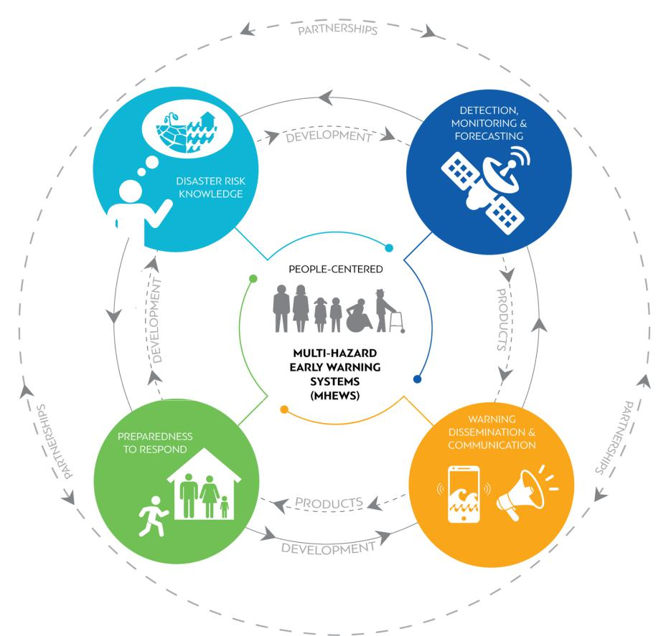

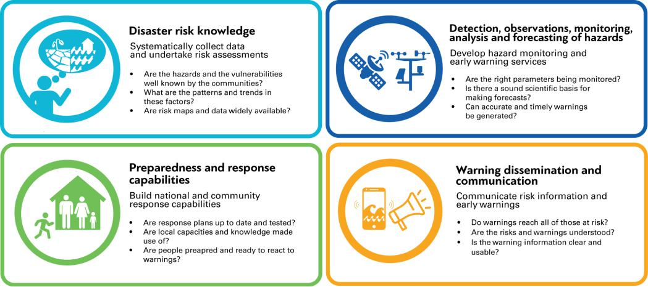
Figure 1: Graphical presentation of a Multi-Hazard Early Warning System (MHEWS)

Objectives of the EWS programme
- This EWS programme aims to:

- Strengthening Infrastructure: The programme will enhance investment in technology by prioritizing investment in advanced monitoring and prediction technologies. Additionally, it will develop and maintain robust ocean observation infrastructure for continuous data collection and monitoring.
- Enhancing Coordination: It will enhance coordination by creating integrated systems for various EWS components to ensure seamless data flow and response coordination. The Programme will foster collaboration among different stakeholders including government agencies, NGOs, and local communities.
- Capacity Building and Training: The Programme will implement comprehensive training programs for local communities and official and conduct awareness campaigns to educate the public on the importance and use of EWS.
- Policy Development: It will contribute to the development and enforcement of policies that support the establishment and sustainability of EWS.

Proposed decision
Recalling objective 2 of the IOC Medium-Term Strategy (2022–2029) on effective warning systems and preparedness for tsunami and other ocean-related hazards;
Emphasizing on the objectives of the UN Decade of Ocean Science for Sustainable Development (2021–2030), particularly the objective on enhancing multi-hazard early warning services for ocean and coastal hazards for mainstreaming of community preparedness and resilience;
Acknowledging Africa Multi-Hazard Early Warning and Early Action System (AMHEWAS), which aims to provide comprehensive guidance for implementing early warning and action on natural hazards;
Recognizing the need for continued implementation of ocean and coastal observing systems, meteorological and climate models and the development of local decision-support tools;
Noting the limited findable, accessible, interoperable and reusable ocean data in Africa along with the intensifying coastal and ocean hazards;
Recognizing the role of IOCAFRICA in supporting Member States to strengthen ocean observations, monitoring and EWS;

The Sub-Commission:
- Endorses the development of the Ocean EWS for Africa programme;
- Requests the IOCAFRICA Secretariat, to collaborate with organizations like the Africa Union Commission, UNDRR, UNEP, WMO, and any other relevant partners to develop the Ocean EWS for Africa programme;
- Invites Member States to support the process of the development of the Programme;
- Urges the Secretariat to initiate resource mobilization efforts for this programme;
- Encourages IOCAFRICA to report on progress and lessons learned at its next session and to explore synergies with other regional and international efforts supporting ocean science, governance, and the implementation of the UN Ocean Decade.

