Summary
This report provides an overview of the implementation of the 2024–2025 budget as at 31 December 2024, including updates on voluntary contributions mobilized, budgetary gap filling by function and staffing situation.
Voluntary contributions (VC) include:
- Cash contributions to the IOC Special Account
- Cash contributions to specific projects/Funds-in-Trust (FITs)
- Additional cash contributions (AC) intended to directly reinforce an existing regular programme budget line
- In-kind contributions.
All financial information in this report is aligned with the authoritative reporting presented to the UNESCO Executive Board at its 221st session. The reference currency in this document is the US dollar. All incurred expenditures are shown at the United Nations operational rate of exchange (UNORE).
Proposed decision: This document is part of the report of the IOC Executive Secretary to the Assembly. It will be further examined by the statutory sessional open-ended Financial Committee and the decision reflected in the Draft Resolution that the Financial Committee will submit for adoption by the Assembly under item 5.4 in accordance with paragraph 15 of the Revised guidelines for the preparation and consideration of draft resolutions (IOC/INF-1315).

OVERVIEW OF BUDGET IMPLEMENTATION

- In compliance with Member States’ decisions, the 2024–2025 budget was based on an Integrated Budgetary Framework (IBF), allowing greater transparency of resources and helping to align resources with the collectively decided priorities.
- Following the approval of the Organization’s Programme and budget for 2024–2025 by the UNESCO General Conference at its 42nd session, the actual working budget of the Commission was set in accordance with the total IBF of $40,290,850: $21,134,686 for the IOC from UNESCO’s regular budget plus $27,156,164 of targeted Voluntary Contributions (of which $7,853,603 were secured at the moment of the budget preparation and $19,302,561 of projected resources to be mobilized and spent during the biennium (gap).
Table 1. IOC Integrated Budgetary Framework 2024–2025 at IOC function level

Table 2. Consolidated report on 2024-2025 expenditure, including obligations, as at 31 December 2024

Chart 1. Expenditure, including obligations, by source of funding (total of $20,209,196)

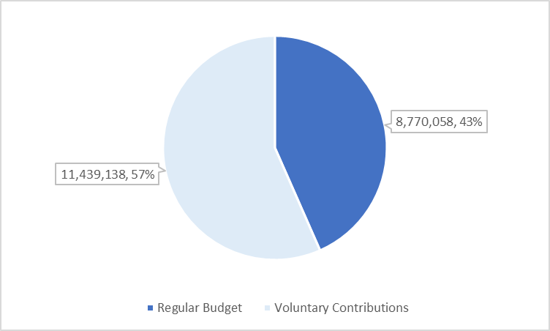
Chart 2. Expenditure, including obligations, by IOC function – all sources
(total of $14,876,400)

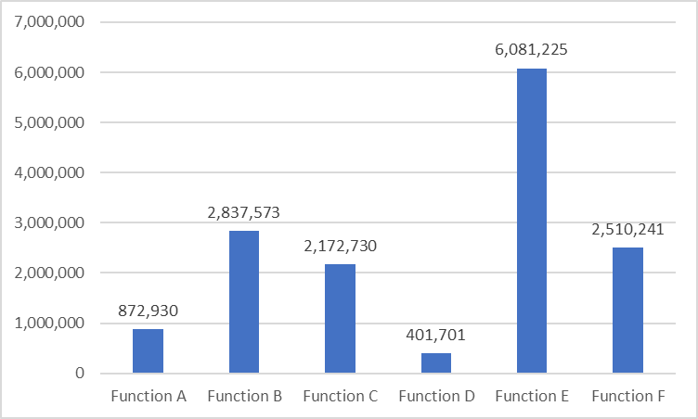

Table 3. Budget and expenditure (total IBF – all sources) on Global Priority Africa and Priority Group SIDS
(in USD’000)

 | Approved 42 C/5 (Total IBF) |  | Expenditure (Total IBF)
 | $ | % of total | $ | % of total
Global Priority Africa | 12,735 | 26.4% | 3,465 | 17.1%
Priority Group SIDS | 9,759 | 20.2% | 2,710 | 13.4%

Table & Chart 4. 2024–2025 Expenditure analysis, including obligations, by main categories of nature of cost as at 31 December 2024

Table & Chart 5. Status of voluntary contributions gap filling by IOC function as at 31 December 2024

IOC Function | 42 C/5 Voluntary Contributions |  |  | In-hand as at 31.12.2024
IOC Function | In-hand (C5 preparation) | resources to be mobilized and spent in 2024-2025 | Total VC target | In-hand as at 31.12.2024
 | $ | $ | $ | $
A | 250,000 | 803,247 | 1,053,247 | 1,358,736
B | 950,000 | 5,632,791 | 6,582,791 | 3,494,840
C | 350,000 | 3,862,986 | 4,212,986 | 2,606,692
D | 400,000 | 916,558 | 1,316,558 | 1,412,191
E | 5,003,603 | 3,159,058 | 8,162,661 | 15,140,365
F (incl. IP2) | 950,000 | 4,777,921 | 5,727,921 | 6,272,235
Total | 7,903,603 | 19,152,561 | 27,056,164 | 30,285,059

Table & Chart 6. Signed funding agreements 1 January 2024–31 December 2024
Rank | Contributor | Amount ($)
1 | Sweden | 1,097,695
2 | Norway | 1,083,262
3 | France | 661,194
4 | Australia | 557,968
5 | Fondation d'entreprise ENGIE | 550,661
6 | REV Ocean Inc | 500,000
7 | Gordon and Betty Moore Foundation | 400,000
8 | Velux Foundation | 345,087
9 | The Nippon Foundation | 294,300
10 | China | 238,522
11 | Denmark | 162,627
12 | Republic of Korea | 149,241
13 | Canada | 134,298
14 | European Union | 129,201
15 | Officine Panerai | 96,519
16 | United Kingdom | 76,250
17 | Société des Explorations de Monaco | 75,922
18 | E.ON Energia SpA | 75,594
19 | Sargasso Sea Project Inc | 54,693
20 | Colombia | 53,247
21 | World Meteorological Organization | 45,300
22 | UNESCAP | 35,813
23 | Dalio Family Fund Inc | 30,000
24 | SAEM Vendée | 24,603
25 | Monaco | 22,371
26 | Portugal | 20,986
27 | Nautilus Next Inc | 14,116
28 | Flanders Marine Institute | 11,186
29 | UNOPS | 10,248
30 | Germany | 7,423
31 | World Resource Institute | 3,895
 | TOTAL | 6,962,222

Table 7. In-kind contributions received in 2024

DETAILED INFORMATION ON EXPENDITURE BY SOURCE OF FUNDS
- REGULAR BUDGET
Table 8. IOC 2024–2025 regular budget allocations and expenditure as at 31 December 2024
DETAILED INFORMATION ON EXPENDITURE BY SOURCE OF FUNDS
- VOLUNTARY CONTRIBUTIONS
ADDITIONAL CONTRIBUTIONS
Table 9.Expenditure as at 31 December 2024

IOC SPECIAL ACCOUNT

Table 10. Expenditure as at 31 December 2024

Function/activity title | Incurred expenditure | Obligations | Total
Function/activity title | $ | $ | $
FUNCTION A (Ocean Research)
Foster ocean research to strengthen knowledge of ocean & coastal processes and human impacts upon them | 150,864 |  | 150,864
Sub-total | 150,864 |  | 150,864
FUNCTION B (Observing Systems/Data Management)
Maintain, strengthen and integrate global ocean observing, data and information systems | 139,738 | 5,326 | 145,064
OceanOPS | 212,276 | 852 | 213,128
Sub-total | 352,014 | 6,178 | 358,192
FUNCTION C (Early Warning & Services)
Develop early warning g systems and preparedness to mitigate the risks of tsunamis and ocean-related hazards | 187,376 | 33,131 | 220,507
IOTWS ICG Secretariat | 313,532 | 11,637 | 325,169
Sub-total | 500,908 | 44,768 | 545,676
FUNCTION D (Assessment & Information for Policy)
Support assessment and information to improve the science policy interface | 95,476 | 42,290 | 137,766
Sub-total | 95,476 | 42,290 | 137,766
FUNCTION E (Sustainable Management & Governance)
Enhance ocean governance through a shared knowledge base and improved regional cooperation | 117,382 | 12,252 | 129,634
UN Decade of Ocean Science for Sustainable Development | 1,079,876 | 310,084 | 1,389,960
Sub-total | 1,197,259 | 322,335 | 1,519,594
FUNCTION F (Capacity Development)
Develop the institutional capacity in all the functions above, as a cross-cutting function | 189,871 | 45,534 | 235,405
Sub-total | 189,871 | 45,534 | 235,405
TOTAL | 2,486,392 | 461,105 | 2,947,497

FUNDS-IN-TRUST

Table 11. Expenditure as at 31 December 2024

ANNEX I

Overview of the IOC staffing 2024
Chart 7. Regular budget staff establishment (42 C/5)

Chart 8. Actual FTE, all sources of funding

Table 12. Vacant fixed-term posts (42 C/5) as at 31 December 2024

ANNEX II

Information on the budget execution of the Special Account
for the 2023 contributions of the United States of America

The focus of this funding is to upscale IOC’s action in:
- Developing an IOC-wide Sustainable Ocean Planning and Management Framework
- Making targeted investments towards building capacity of the IOCARIBE Secretariat and developing a new programmatic framework to address the needs of the Pacific SIDS region

1 Reference IOC Resolution A-32/4 and IOC/A-32/6.1.Doc(1); Resolution EC-57/2 and IOC/EC-57/5.1.Doc(2) and IOC/EC-57/5.2.Doc(2)
3% of total UNESCO regular budget in line with the UNESCO Executive Board’s decision 216 EX/44 and endorsed by the UNESCO General Conference 4in the 42 C/5 Approved (42 C/Resolution 80)
Ref. description of work as presented to the IOC Executive Council in IOC/EC-57/5.1.Doc(1)

