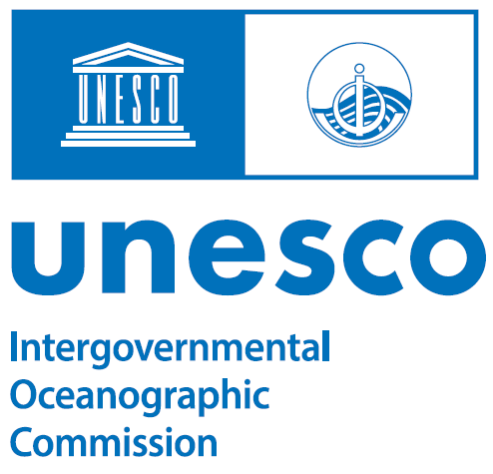
NOMINATION FORM

UNESCO-IOC Intergovernmental Coordination Group

INDIAN OCEAN TSUNAMI WARNING AND MITIGATION SYSTEM (ICG/IOTWMS)
TSUNAMI READY FOCAL POINT (TRFP)

Name of Member State: ________________________________

Do you agree to share your TRFP contact details publicly?
Yes ☐ No ☐ (Please tick one option)

Tsunami Ready Focal Point:
Responsibilities include:

- Act as a national advocate for national implementation of the TRRP or a recognised similar initiative to help make at-risk communities prepared and resilient to any tsunami threat within their Member State.
- Actively contribute to the national implementation of the TRRP or a recognised similar initiative.
- Routinely update the UNESCO-IOC ICG/IOTWMS on the status of the national implementation of the TRRP or a recognised similar initiative.
- Inform relevant national authorities and organisations involved in the implementation of the TRRP, or a recognised similar initiative, on any information and/or updates provided by UNESCO-IOC on activities related to making at-risk communities Tsunami Ready.

It is recommended the person be from a Disaster Management Organisation (DMO) or similar institution involved with community preparedness with respect to hazards, preferably natural hazards.

- Tsunami Ready Focal Point Nomination:
Name:____________________________________________________________
Position: __________________________________________________________
Organisation: ______________________________________________________
E-mail: ___________________________________________________________
Telephone (Office): _________________________________________________
Telephone (Mobile): _________________________________________________
Postal Address: _____________________________________________________
____________________________________________________
_____________________________________________________
- Experience
The candidate has significant experience or expertise in one or more of the following criteria:
# | Criteria | Relevant experience / expertise
1 | Developing community preparedness against natural hazards, preferably the tsunami hazard.
2 | Understanding of evacuation planning and procedures implementation.
3 | Understanding of the requirements, protocols, and Standard Operating Procedures (SOP) for national tsunami warning chains.
4 | Training of at-risk communities in responding to natural hazards, including the planning and implementation of community exercises.
5 | Strong leadership and/or advocacy for helping make at-risk communities prepared and resilient to natural hazards, preferably the tsunami hazard.
6 | Member of National Tsunami Ready Board (NTRB) or similar national body responsible for coordinating the implementation of the UNESCO-IOC Tsunami Ready Recognition Programme (TRRP) if already exists, or a similar initiative.

- Curriculum Vitae / Resume:

Please provide the candidate’s curriculum vitae / resume with the nomination form.

- Tsunami National Contact to Submit:

Name of Tsunami National Contact: ___________________________________________________________
Signature: _________________________________________________
Position: __________________________________________________________
Agency: ______________________________________________________
Date: ___________________________________________________________
Please email the completed form by 15th November 2023 to: Rick Bailey, Head of Secretariat for UNESCO-IOC ICG/IOTWMS at iotwms@unesco.org

