Proposal for Ocean Science Day at IOC 32 – xx June 2023

The objective of the Ocean Science Day is to further increase the visibility and understanding of ocean science, current challenges and emerging issues. (https://oceanexpert.org/document/15489)

The Intergovernmental Oceanographic Commission of UNESCO organizes an Ocean Science Day as part of its Assembly, the governing body of the Commission. The objective of the Ocean Science Day is to further increase the visibility and understanding of ocean science, current challenges and emerging issues. The Ocean Science Day roots in the importance of the role of science and scientists for sustainable societies and in the need to inform and involve decision-makers in science. The event provides an opportunity to show the relevance of ocean science for the sustainability of our planet and to engage the decision-makers in discussions. We believe this also offers a good opportunity for the marine scientific community to discuss on prospects on ocean science with colleagues and also with a wide representation of national stakeholders and Member States representations in UNESCO. The Ocean Science Day intends to focus on emerging issues that require international collaboration in marine science and technology. It also highlights the need to produce new ocean science and technologies for the benefit of society. In consultations with the Officers of the Commission, this year’s scientific programme is organized around 3 themes:

- Global Nutrient Modeling or the LME Concept : IOC Anton Bruun Memorial Lecture, 2023. Candidate to be discussed.

- Ocean change - adaption and mitigation opportunities and challenges. Panel Event.

- IOC in the UN Decade incl IOC M. Ruivo Memorial Lecture, 2023.

To be discussed :IOC N.K. Panikkar Memorial Lecture, 2023.

.

D R A F T Programme and Timetable
Segment | Action | Speaker | Media/Comment
Opening | (5mins) | Chair IOC | Holding slide
10:00 am | A.Bruun Memorial Lecture | Bouwmann or Sherman | Presentation 1
11:00am | Science Panel Event: Ocean change - adaption and mitigation opportunities and challenges  All speaker and moderator on stage |  | Holding slide
11:00am | Opening remarks and presentation of speakers | Moderator | Holding slide
11.05 | Panel presentations | Chris Vivian - CDR, geoengineering | Presentation 2
11.12 | Panel presentations | Chenae Neilson – Blue Carbon Solutions- an Australian perspective | Presentation 3
11.19 | Panel presentations | Steve Widdicombe - ocean science for adaption and mitigation | Presentation 4
11.26 | Panel presentations | Jana Friedrich - ocean adaptation and mitigation, nuclear techniques | Presentation 5
11.33 | Panel presentations | Margaret Linen TBC – ocean-based pathways | Presentation 6
11.40 | Panel presentations | Atsushi Watanabe – ocean solutions – blue economy and policy | Presentation 7
Q&A | ( ca 30 Mins) | Audience
11.47 | Moderator Opens to questions from the audience | All Panel + Moderator | Holding slide
12.15ish | Closing statement | Moderator | Holding slide
Lunch break 12.30-14.00
14.00-14.10 | IOC in the UN Decade Update- Welcome and Introduction | Margaret Leinen or Vidar Helgesen | Presentation 8
14.10 – 15.10 | M. Ruivo Memorial Lecture | ECOP candidate to be identified by DCU mid April | Presentation 9
15/10 – 15.15 | Video interlude – highlights of Decade Actions |  | Video
15.15 – 16.00 | Moderated discussion: IOC role in generating knowledge and solutions in the Ocean Decade (roundtable with audience Q&A) | Moderator + roundtable participants to be drawn from Decade Actions that have IOC leadership or substantive involvement. Participants to be drawn from science, industry, philanthropy, Government and/or UN and to take into account gender, generational and geographic diversity. | Holding Slide
16.00 – 16.05 | Video interlude – highlights of non-IOC Decade Actions to illustrate diversity of initiatives |  | Video
16.05 – 16.50 | Moderated discussion: IOC role in developing and sustaining essential infrastructure in the Ocean Decade (roundtable with audience Q&A) |  | Holding Slide
16.50 – 16.55 | Video interlude – highlights of non-IOC Decade Actions to illustrate diversity of initiatives |  | Video
16.55 _ 17.40 | Moderated discussion: IOC role in changing humanity’s relationship with the Ocean Decade (roundtable with audience Q&A) |  | Holding Slide
17.40 - 17.50 | Wrap-up to Decade Session and Key Messages |  | Holding slide
17.50 – 18.00 | Closing of Ocean Science Day | Chair IOC | Holding Slide

Memorial lectures:

Anton Bruun Memorial Lecture:

The Anton Bruun Memorial Lecture Series is dedicated to the memory of the noted Danish oceanographer and first chairman of the Commission, Dr Anton Frederick Bruun. The Anton Bruun Memorial Lectures were established in accordance with Resolution 19 of the 6th session of the IOC Assembly (1970), in which the Commission proposed that important intersession developments be summarized by speakers in the fields of solid earth studies, physical and chemical oceanography and meteorology, and marine biology.

Candidate 1: Alexander Bouwman, (age 67) University of Utrecht, Netherlands. Title: ‘Nutrient Pollution - The forgotten parameter’. Nominated by: The Secretariat
Justification: In recognition of his outstanding contribution to understand and model global flux of nutrient from land based sources to the Ocean. See CV annexed.

Candidate 2: Ken Sherman (age 91) retired from US NOAA. Title?, Nominated by: Secretariat
Justification: In recognition of his role in the development of the concept of “large marine ecosystems” or LMEs as a way to manage large areas of the ocean by identifying distinct ecosystems based on their bathymetry, currents, productivity and food webs. See CV annexed.

Pannikar Memorial Lecture:

At the Eighteenth Session of the IOC Assembly (1995) it was decided to hold at each IOC
Assembly a “Dr. Panikkar Lecture” “to address capacity building in marine science issues at
regional and/or national levels”. Dr Nedumangattu Kesava Panikkar, from India, was elected
Chairman of IOC in June 1964 at the Third Session of the Assembly. Dr Panikkar also served as chair of the Working Group on Mutual Assistance convened at the Sixth Session of the Assembly in 1969.

Candidate 1: Atanas Palazov Bulgarian Academy of Sciences, The Fridtjof Nansen Institute for Oceanology, Sofia, Bulgaria. Professor and Managing Director.Title: "Building Capacity towards Operational Oceanography in the Black Sea". Nominated by: Permanent Delegation of the Republic of Bulgaria to UNESCO (in 2021).
Justification: Dr. Palazov has made a significant contribution to the development of capacity for operational oceanography in the Black Sea, through the development of monitoring systems, coordination and participation in operational oceanography' projects, organization of workshops and trainings and participation in the management bodies of the GOOS. Dr. Palazov is a member and Chair of the BlackSeaGOOS. He was IOC Vice chair 2011-2015.

Alternative: Postpone to next assembly as challenging with 3 memorial lectures same year.

M. Ruivo Memorial Lecture: TBD by DCU

The Executive Secretary informed the Assembly of a joint initiative with EurOcean and Portugal to establish the Mário Ruivo Memorial Lecture. This Memorial Lecture would be in homage to and recognition of Professor Mário Ruivo's long-life commitment to ocean science and the sustainable development of the ocean, and his significant contributions to the work of IOC, ocean knowledge, international cooperation, capacity development and ocean literacy. The Lecture would be delivered at the IOC Assembly by Early Career Ocean Professionals (ECOPs) selected on a competitive basis. It would focus on the priorities of the Ocean Decade in the spirit of the commitment of Professor Ruivo to solutions-oriented ocean research. The Ocean Decade Informal Working Group for ECOPs has been involved in initial discussions on the initiative and would be engaged in the design and scoping of the Memorial Lecture and in the selection of the candidates for its presentation. The Memorial Lecture would be anchored within the Early Career Ocean Professional Programme that has recently been endorsed as an action of the Ocean Decade.
There is not a formal decision to have a Mário Ruivo Memorial Lecture periodically and the modalities are being set in collaboration with ECOP and therefore has connection with the Ocean Decade for the time being. A call for applications is currently open and will close mid January. The candidate to deliver the Lecture will be selected by the selection committee in April. A 90min slot for the Lecture proposed, however, in the draft programme harmonized to same timeslot as the other memorial lectures.

Science Panel Event:

Ocean change - adaption and mitigation opportunities and challenges

Event description:

Rising CO2 levels in the atmosphere due to the use of fossil resources are not without consequences for the ocean, causing ocean acidification, increasing temperatures, a decline in oxygen, rising sea-level & extreme weather events impacting ocean & human life. However, while the ocean is experiencing these changes it also provides opportunities for adaptation to and mitigation of ocean and climate change impacts. This event will allow to assess the potential of these actions, risks & benefits.

Event significance
This side event will provide a platform to explore the opportunities & challenges for nations and stakeholders related to observing and understanding ocean change; local & regional adaptation mechanisms to a rapidly changing ocean; including the conservation and restoration of carbon rich ecosystems, the safe implementation of ocean carbon dioxide removal technologies; and climate smart ocean management for supporting sustainable development and protecting ocean life and those that depend on it.

Proposed speakers:
Steve Widdicombe (PML, Scientific Director, GOA-ON co-chair, OARS co-lead) Moderator

Chris Vivian (GESAMP, UK)
Chenae Neilson (IPBC, Department of Climate Change, Energy, the Environment and Water, Australia) we ask AU delegation to sponsor
Jana Friedrich (IAEA) self funded we assume
Atsushi Watanabe (OPRI-SPF, Japan) we ask JP delegation to sponsor

IOC in the UN Decade Update Session :

Awaiting input from DCU

Bios and pics for Panel event:

Chris Vivian (GESAMP, UK)
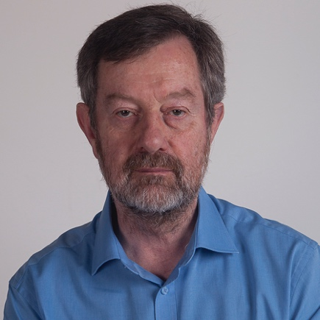
Dr Chris Vivian is currently a co-chair of GESAMP Working Group 41 on ‘Ocean Interventions for Climate Change Mitigation’ (formerly the Working Group on Marine Geoengineering).
He retired from Cefas, the Centre for Environment, Fisheries and Aquaculture Science (an agency of the UK Department for Environment, Food and Rural Affairs) in October 2016 where he had 30 years’ experience in an advisory role to UK Government on national and international issues relating to the environmental impacts of various human activities in the marine environment.
From 1989, he was a UK delegate in international meetings under the Oslo (now OSPAR) and London Conventions dealing with waste disposal at sea in the North-East Atlantic and the whole world respectively. He was the Chairman of the Scientific Groups of the London Convention and London Protocol from 2008 to 2011 and was the Chairman of the OSPAR Convention’s Biodiversity Committee that dealt with species/habitat protection issues as well as the impacts of human activities from 2006 to 2010.
At the London Convention/Protocol meetings Chris was heavily involved in the discussions on ocean fertilisation and marine geoengineering from 2007 and chaired the working group that finalised the amendments to the London Protocol on marine geoengineering in 2013.
He received a BSc in Geology and Oceanography in 1971 and a PhD in Marine Geochemistry in 1975, both from the at University College of Swansea in Wales.

Chenae Neilson (IPBC, Department of Climate Change, Energy, the Environment and Water, Australia)
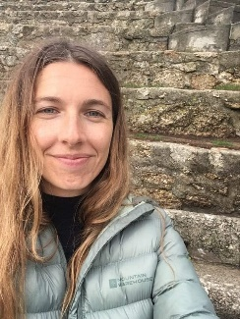
Chenae Neilson is the acting Assistant Director of Blue Carbon and International Partnerships in the Australian Government Department of Climate Change, Energy, the Environment and Water. She also leads on operations for the International Partnership for Blue Carbon, coordinated by the Australian Government and IOC-UNESCO.
Prior to this role, Chenae was the Program Manager for the National Environmental Science Program, at the Australian Government Department of Agriculture, Water and the Environment. She has an interest in building relationships and linkages between academia and government on marine biodiversity and tropical water research, ensuring decision makers are engaged with high-quality and timely environmental information.
Chenae received her Master of Science in Human Geography from the University of Melbourne, Australia.

Steve Widdicombe (PML, Scientific Director, GOA-ON co-chair, OARS co-lead)

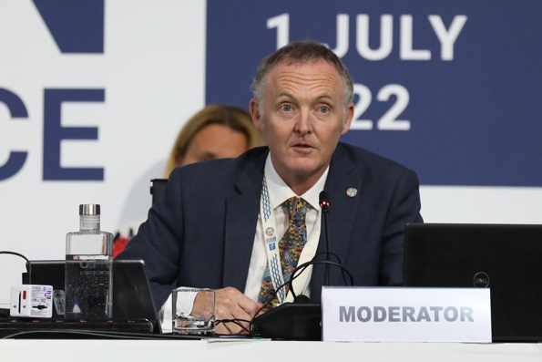
Professor Steve Widdicombe is Director of Science and Deputy Chief Executive of Plymouth Marine Laboratory. As a marine ecologist, Steve has studied the impacts of humans and climate on marine ecosystems and biodiversity for over 30 years. He contributed to the founding of the Global Ocean Acidification Observing Network (GOA-ON) in 2012, becoming Co-Chair of its Executive Council in 2019. In 2021, he co-led the development and endorsement of the UN Ocean Decade Programme OARS (Ocean Acidification Research for Sustainability), which aims to provide society with the observational and scientific evidence needed to sustainably identify, monitor, mitigate and adapt to ocean acidification.

Jana Friedrich (IAEA)
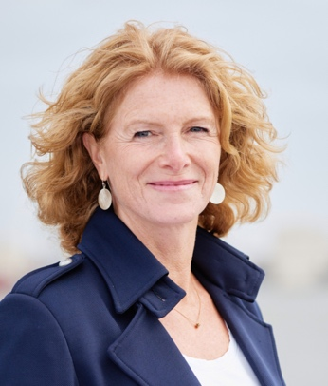
Dr Jana Friedrich is Head of the Radioecology Section at the IAEA Marine Environment Laboratories. Her work as a biogeochemist addresses the effects of climate change and human activities on river to coastal seas ecosystems and their ecosystem services, applying isotopic techniques as tools.

Atsushi Watanabe (OPRI-SPF, Japan)
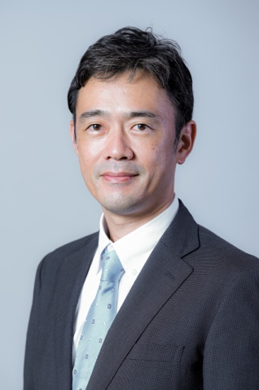
Atsushi Watanabe studied geography and earth and planetary science at the University of Tokyo. He worked as a postdoctoral fellow at the graduate school of environmental studies at Nagoya University from 2004 to 2008, and as an assistant professor at the graduate school of information science and engineering at Tokyo Institute of Technology from 2008-2018. He studied carbon cycles in coral reefs and coastal blue carbon ecosystems and the impact of climate change or local stressors on these ecosystems. Since 2018, he has been working as a senior research fellow of the Ocean Policy Research Institute of the Sasakawa Peace Foundation, leading the blue economy and blue carbon policy research. He is a director of the Japan Blue Economy Association (JBE) since July 2020. Hold a doctorate degree in Science.

BRUUN CANDIDATE 1

A.F. (Lex) Bouwman
Netherlands Environmental Assessment Agency (PBL), PO Box 303, 3720 AH Bilthoven
Department of Earth Sciences – Geochemistry, Faculty of Geosciences, Utrecht University, P.O. Box 80.021, 3508 TA Utrecht, The Netherlands

Dr. Bouwman obtained his PhD in 1995 at Wageningen University and Research Centre. From 1996 he worked on several activities related to global scale agriculture and land use and associated environmental impacts. The current main research at both PBL and Utrecht University includes modelling environmental impacts of agricultural systems and land use and development of global models for riverine biogeochemistry. In 2011, Dr. Bouwman became professor at the Department of Earth Sciences – Geochemistry, Faculty of Geosciences, Utrecht University, concentrating on nutrient transport from land to sea.

Professor Bouwman published around 200 peer-reviewed articles, 3 books and several book chapters. His h-index is 75 according to SCOPUS and 80 according to Google-scholar, with more than 32000 citations.

PERSONAL INFORMATION
Name, nationality, gender Alexander Felix Bouwman, Dutch, male
Date of birth, place 2 August 1956, Eindhoven
ORCID orcid.org/0000-0002-2045-1859
URL http://www.uu.nl/staff/AFBouwman/0
EDUCATION
MSc: Wageningen University, The Netherlands, Soil Science and Land Evaluation, 1974-1982.
PhD: Wageningen University, 1995 (Thesis entitled “Compilation of a global inventory of emissions of nitrous oxide”).
CURRENT POSITIONS
2009-present: Department of Earth Sciences – Geochemistry, Faculty of Geosciences, Utrecht University, Netherlands (0.6 fte), since 2011 Professor (0.2 fte) “Nutrient transport from land to sea”. 1998-present: PBL Netherlands Environmental Assessment Agency, Bilthoven, Netherlands, as senior scientist (0.4 fte, prior to 2009 1.0 fte).
PREVIOUS POSITIONS
1990-1998: Laboratory for Waste Materials and Emissions, Laboratory for Soil and Groundwater, National Institute for Public Health and the Environment (RIVM).
1986-1990: International Soil Reference and Information Centre (ISRIC), Wageningen, Netherlands.
1984-1986: Dutch Directorate General for International Development Cooperation on behalf of the Jamaica Soil Survey Unit, Kingston, Jamaica.
1982-1984: Food and Agriculture Organization of the United Nations, Riobamba and Ambato, Ecuador.
OTHER ACTIVITIES
2003-2004: Member of the task force on nonpoint pollution from crop production of the China Council for International Cooperation on Environment and Development (CCICED).
1995: Visiting scientist at the Food and Agriculture Organization of the United Nations (FAO), Rome.
1991: Visiting scientist at the "La Selva" Research Station of the Organization of Tropical Studies (OTS), Costa Rica.
1990: Visiting scientist at the NASA-Goddard Institute for Space Studies (GISS), New York, USA.
ORGANISATION AND COORDINATION ACTIVITIES
2012-2016: Coordinator of the scientific component of the Global Environment Facility (GEF) / Unesco-IOC project “Global Nutrient Cycle”
2002-2010: Co-chair of the Global Nutrient Export from Watersheds (NEWS) (since 2011 Nutrients and Coastal Impacts Research Programme) of the Unesco-Intergovernmental Oceanographic Commission (IOC).
2008-2012: Co-chair of Scientific Committee on Oceanic Research (SCOR)-LOICZ work group 132 on “Land-based Nutrient Pollution and the Relationship to Harmful Algal Blooms in Coastal Marine Systems”.
2006: Organization of international scientific review of the IMAGE model.
1996-1999: Preparation and organization, including fund raising, of the international workshop on “Scaling of trace gas fluxes between terrestrial and aquatic ecosystems and the atmosphere” and editing of the book of this meeting with the same title (Elsevier).
1990-1996: Coordinator of the N₂O cluster of the Dutch National Research Programme on Global Air Pollution and Climate Change.
1990-1997: Coordinator of inventories of land-use related emissions of NO_{x}, N₂O and NH₃ of the Global Emission Inventories Activity (GEIA) of the International Global Atmospheric Chemistry Programme (IGAC) of IGBP.
1986-1990: Organization of the international conference "Soils and the Greenhouse Effect" (Wageningen, August 1989) and editor of the book “Soils and the Greenhouse Effect” (Wiley and Sons).

BRUUN CANDIDATE 2

https://www.fisheries.noaa.gov/feature-story/ken-sherman-plankton-biologist-global-perspective

